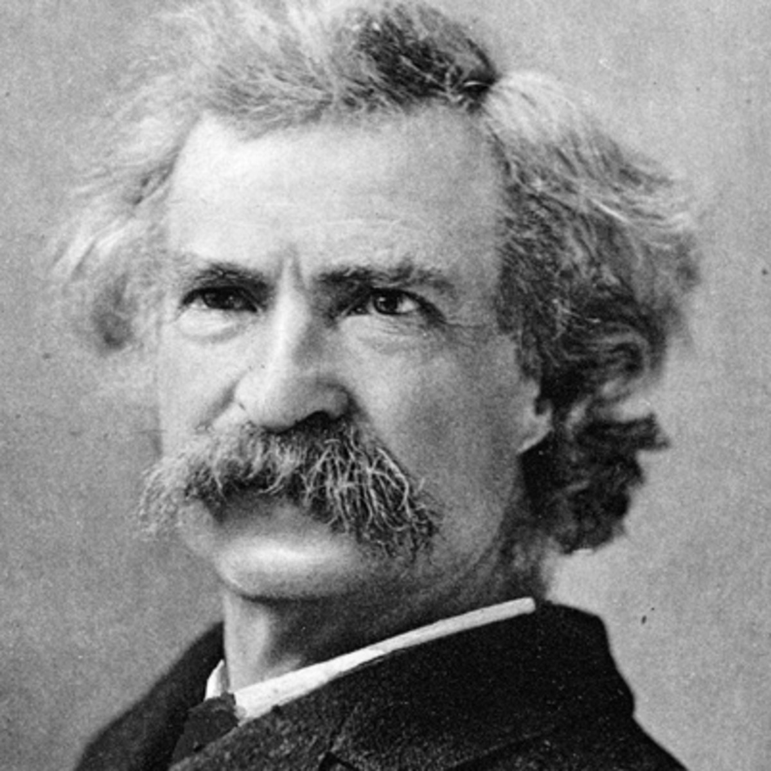
frame-col-ypos:0.810417in; bot-style:none; xpos:1.559722in; wrap-mode:wrapped-both; frame-type:image; ypos:0.810417in; left-style:none; frame-height:3.302083in; top-style:none; position-to:block-above-text; frame-col-xpos:1.559722in; right-style:none; frame-width:3.594444in
Whenever you find that you are on the side of the majority, it is time to pause and reflect.
Mark Twain

italicize_puzzling_numbing_debtor_overhead_catsup

