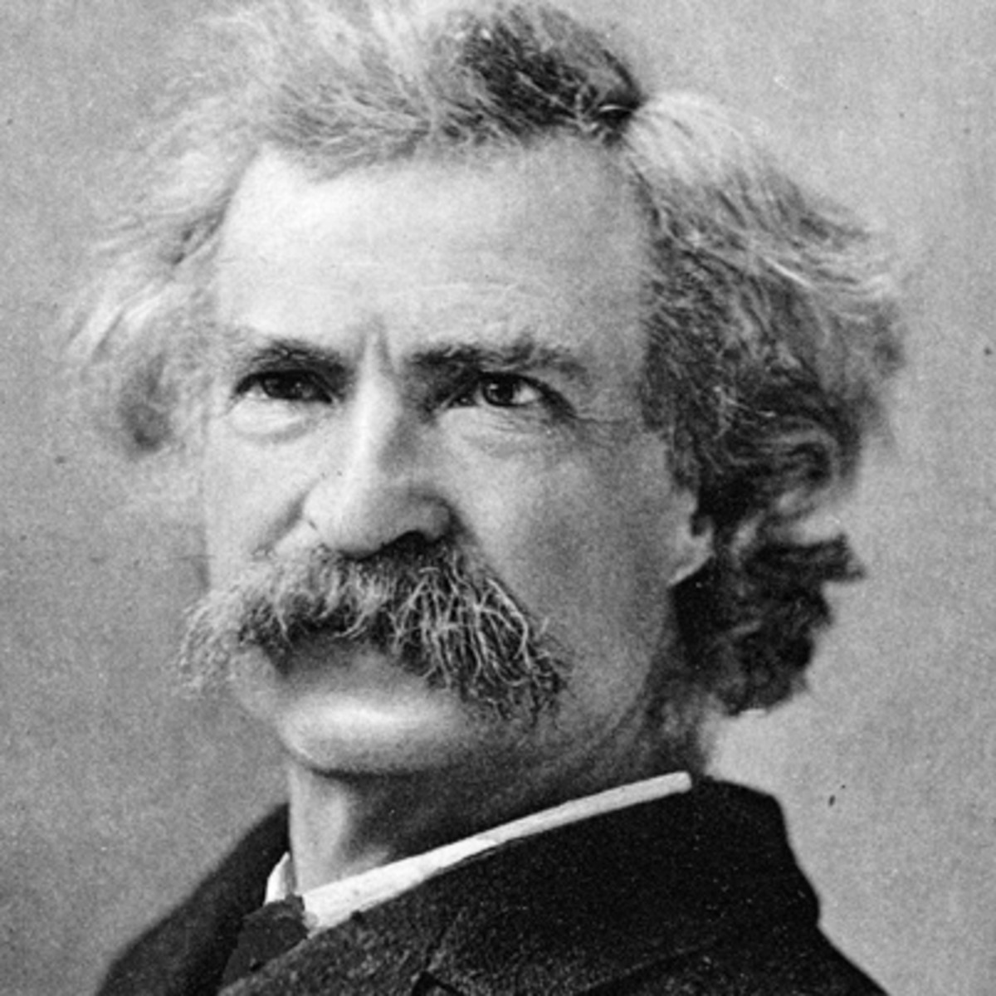
Whenever you find that you are on the side of the majority, it is time to pause and reflect.Mark Twain
ac58313a-4fd8-11e8-b257-f38689bfa0c8

