Champion Document
Feature F7 — Player Movement & Core Stats
IGTTAWAGMTAVSBHVFDAOUM — Team “Married to Vampire Shrimp”
Name: Nishant Patel TL Role: TL6 — Deployment, Pair Programming & Final Demo Mark: _______ / 30

1. Brief Introduction
My feature for IGTTAWAGMTAVSBHVFDAOUM is Player Movement & Core Stats (F7) — the avatar the player controls and the single source of truth for every player-facing number in the game. My code reads input through a platform-agnostic IInputSource (keyboard, gamepad, or touch on the phone build I ship as TL6) and moves the avatar with frame-rate-independent motion. It holds the seven base stats — max HP, move speed, might, pickup radius, cooldown reduction, armour and luck — and resolves each of them through an ordered chain of stackable modifiers, including the permanent bonuses the dating metagame (F3) earns between runs.
At runtime, my code owns incoming damage: it accepts a DamagePacket from any combat feature, applies armour and invulnerability frames, and tracks current HP. When HP reaches zero, my code raises the PlayerDied event exactly once and lets the Run State feature (F1) end the run. My feature also publishes the read-only IStatBlock and the player's world position every frame — the two values almost every other feature in the game reads from, which is why F7 is the MVP core TL1 builds the first playable scene around.
My feature deliberately does not decide what upgrades or bonuses I receive — the level-up draft (F5) and the dating metagame (F3) push modifiers onto my chain, and I only resolve them. It also does not decide when or where enemies appear, what a weapon's delivery shape is, or what a summon fights for, and it does not apply damage to anything other than the player — combat resolution against enemies belongs to Enemies (F4). It does not persist anything to disk either: Summons & Persistence (F3) owns saving and loading and simply hands me a list of permanent-bonus records to convert into modifiers at Initialise.

2. Use Case Diagram with Scenario

Use Case Diagrams
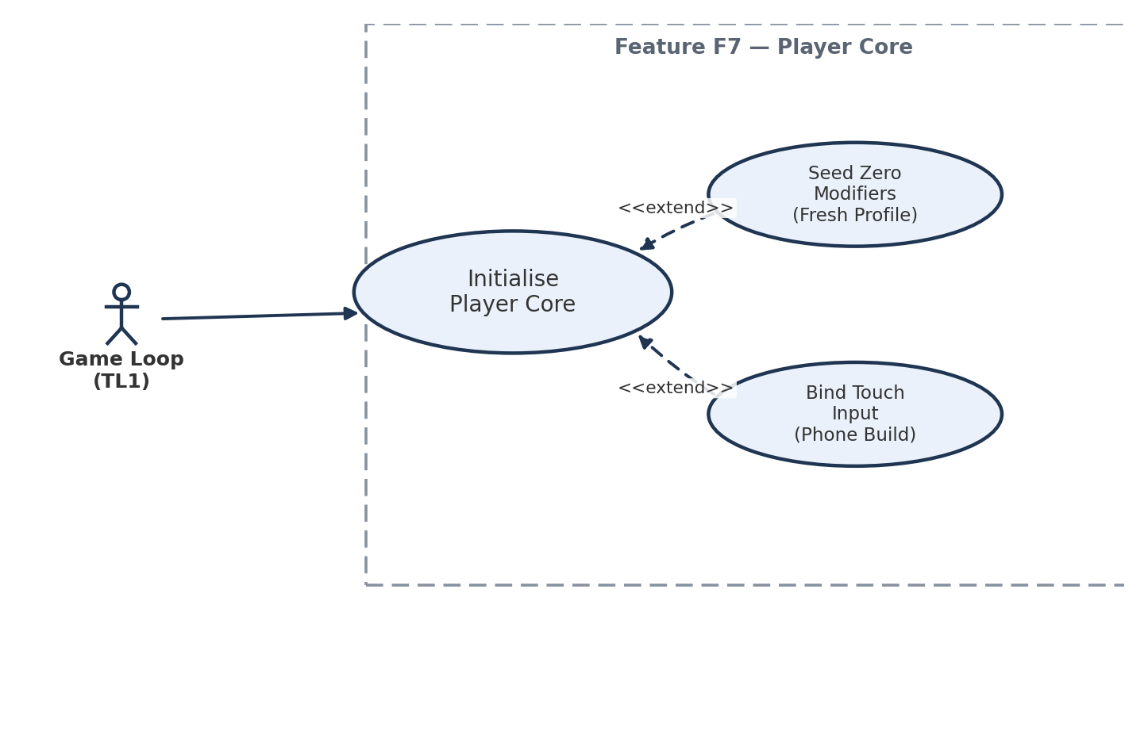
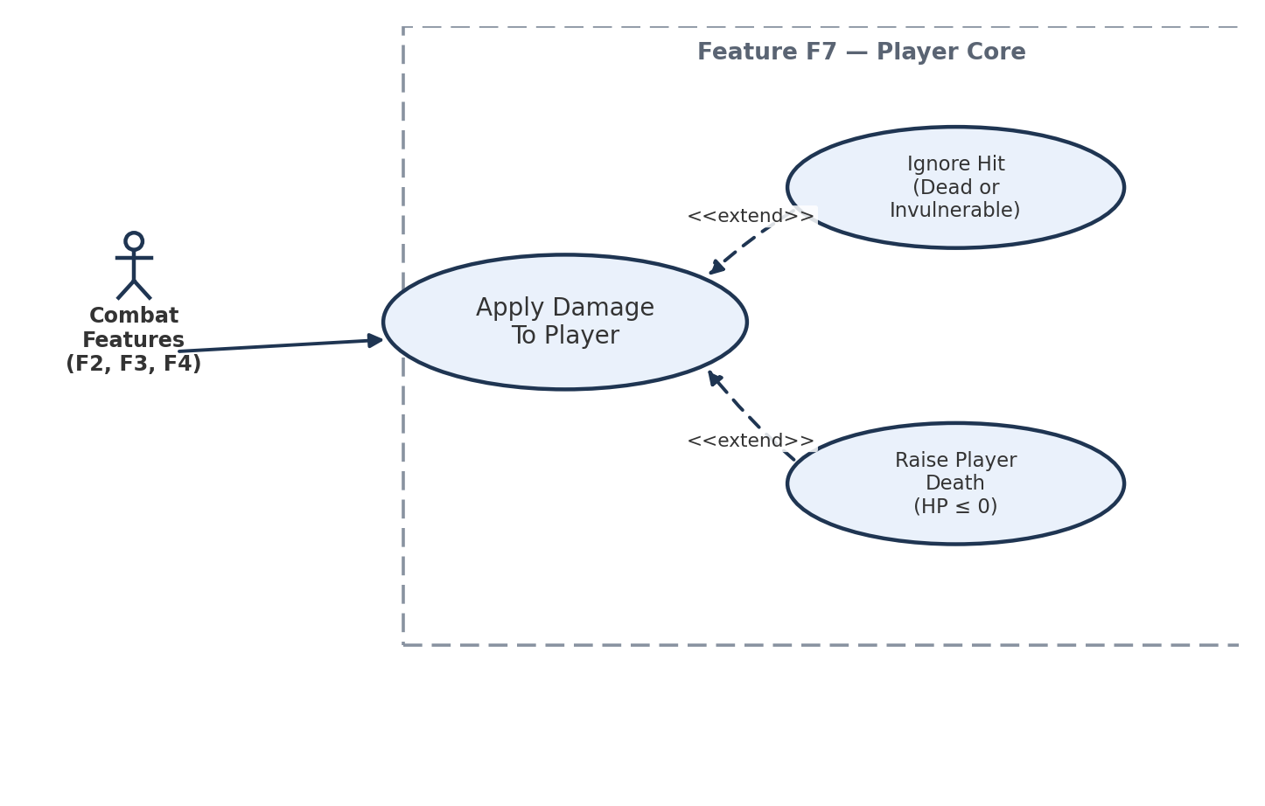

Scenarios
Scenario 1 (first use case diagram)
Name: Initialise Player Core For Run
Summary: Before the first frame of a run, the game loop hands the player feature a loadout so the avatar exists with a fully resolved stat block.
Actors: Game Loop (TL1)
Preconditions: F3 has loaded the save profile; a PlayerLoadout has been assembled from base stats and F3's PermanentBonus records.
Basic sequence:
Step 1: The game loop calls Initialise(loadout) once, before the first Tick.
Step 2: PlayerModel is constructed with base HP, position at the room's spawn point, and a zeroed invulnerability timer.
Step 3: The modifier chain is seeded with a FlatModifier or PercentModifier for each PermanentBonus record in the loadout.
Step 4: StatBlock resolves the seven base stats through the seeded chain in stable order (flat before percent).
Step 5: The default IInputSource (keyboard/gamepad) is bound.
Step 6: The player becomes tick-ready; Position and Stats are safe for any other feature to read.
Exceptions:
Step 3a: The loadout's permanent-bonus list is empty (a fresh profile) — the <<extend>> case. The chain is seeded with zero modifiers and StatBlock resolves to raw base values. The sequence resumes at Step 4.
Step 5a: Initialise runs on the phone build target — the <<extend>> case. SetInputSource(touch) is called instead of Step 5's default, swapping in the touch IInputSource. The sequence resumes at Step 6.
Post conditions: The avatar exists at a valid position with a fully resolved stat block; IStatBlock and Position are safe for any other feature to read.
Priority: 1 (must have)
ID: PC1
Scenario 2 (second use case diagram)
Name: Player Takes Damage And May Die
Summary: A combat feature delivers a damage packet to the player; the player resolves armour and invulnerability, and may die.
Actors: Combat features (Weapons F2, Summons F3, Enemies F4) via ApplyDamage
Preconditions: The player has been initialised and is not already dead; the run phase is active.
Basic sequence:
Step 1: A combat feature builds a DamagePacket and calls player.ApplyDamage(packet).
Step 2: DamageResolver checks whether the player is already dead or inside an active invulnerability window.
Step 3: The packet's raw damage is reduced by the player's Armour stat, read from IStatBlock.
Step 4: Current HP is reduced by the resolved damage and a new invulnerability window begins.
Step 5: The game loop's next Tick advances the invulnerability timer until it expires, after which the player can be damaged again.
Exceptions:
Step 2a: The player is already dead or still inside an active invulnerability window — the <<extend>> case. ApplyDamage returns silently: no HP change, no event, no new i-frame window.
Step 4a: The resolved damage reduces HP to zero or below — the <<extend>> case. PlayerDied is raised exactly once, HP is clamped at zero, and no further ApplyDamage call before the next Initialise has any effect.
Post conditions: The player's HP reflects every non-ignored hit this run; PlayerDied has fired at most once per run.
Priority: 1 (must have)
ID: PC2

3. Interface Contract
Every member below is the whole of F7's outward contract — nothing else in the feature is callable by another directory. Every type is concrete (float, int, an explicit enum or struct), never an adjective, and every row includes a test a teammate who cannot see my code could run against a compiled build to verify it, matching the “concrete types, testable, minimal surface” bar Dr. BC set.

Inputs — calls other features make into F7
Signature (typed) | Type detail | Meaning / who calls it | How a teammate tests it independently
void Initialise(PlayerLoadout loadout) | PlayerLoadout: struct { StatBlock baseStats; IReadOnlyList<PermanentBonus> bonuses; } | Called once by TL1's game loop before the first Tick. | Call twice in EditMode; assert the second call replaces the chain rather than doubling it.
void Tick(float deltaTime) | deltaTime: float, seconds, ≥ 0 | Called once per frame during the Run phase only. | Call with deltaTime = 0 and assert Position and every timer are unchanged.
void ApplyDamage(DamagePacket packet) | DamagePacket: struct { float Amount ≥ 0; DamageSource Source (enum: Weapon, Enemy, Summon); } | Called by any combat feature (F2, F3, F4) to hurt the player. | Assert HP is unchanged when the player is already at 0; assert exactly one HP reduction per non-ignored call.
ModifierHandle PushModifier(StatModifier modifier) | StatModifier: abstract { float Apply(float, StatContext); int Order; } → returns ModifierHandle (opaque int) | Called by F5 (level-up picks) and at Initialise for F3's permanent bonuses. | Push a known FlatModifier(+10) on Might; assert Stats.Get(StatKey.Might) increases by exactly 10.0f.
void PopModifier(ModifierHandle handle) | ModifierHandle: opaque int returned by PushModifier | Called by F5 to remove a timed or conditional effect. | Push then pop the same handle; assert Stats.Get returns to its pre-push value exactly.
void SetInputSource(IInputSource source) | IInputSource: interface { Vector2 MoveAxis { get; } } | Called by TL6's platform bootstrap to swap keyboard/gamepad/touch. | Swap in a scripted fake IInputSource; assert movement follows the scripted axis, not the real device.

Outputs — state other features read from F7
Signature (typed) | Type detail | Meaning / who calls it | How a teammate tests it independently
Vector2 Position { get; } | Vector2: (float x, float y), world-space Unity units | Read every frame by F4 (spawn placement, pursuit), F2 (fire origin), F5 (magnetism) and F3 (summon anchoring). | Drive a fake IInputSource with a known axis for exactly 1.0s; assert |Position − expected| < 0.01 units.
IStatBlock Stats { get; } | IStatBlock: interface { float Get(StatKey key); } over 7 StatKey values: MaxHP, MoveSpeed, Might, PickupRadius, CooldownReduction, Armour, Luck | Read by F2, F4 and F5 to scale damage, speed and pickup radius. Never cached across frames. | Call Stats.Get(StatKey.Might) 100 times in a row; assert identical value and zero heap allocation (no side effects).

Events — notifications F7 raises
Signature (typed) | Type detail | Meaning / who calls it | How a teammate tests it independently
event Action PlayerDied | Action: zero-argument delegate | Raised exactly once when HP first reaches ≤ 0 in a run. F1 subscribes to end the run. | Script 5 ApplyDamage calls that cumulatively bring HP below 0; assert the subscriber is invoked exactly once, not once per call.
Minimality check: six inputs, two outputs and one event is the entire surface. No other public member exists on the player — internal classes (PlayerModel, DamageResolver, ModifierChain, the four StatModifier subclasses) are not referenced by any other developer's directory, which is what keeps this feature's internals free to change without breaking a contract.

4. Data Flow Diagrams
Diagram 0 shows the whole game as the team's own project plan decomposed it — one Gane–Sarson process per feature (F1–F7) — with my feature, Process 7, highlighted. I then zoom into Process 7 and give a decision-tree process description for primitive process 7.4, Apply Damage & Health.
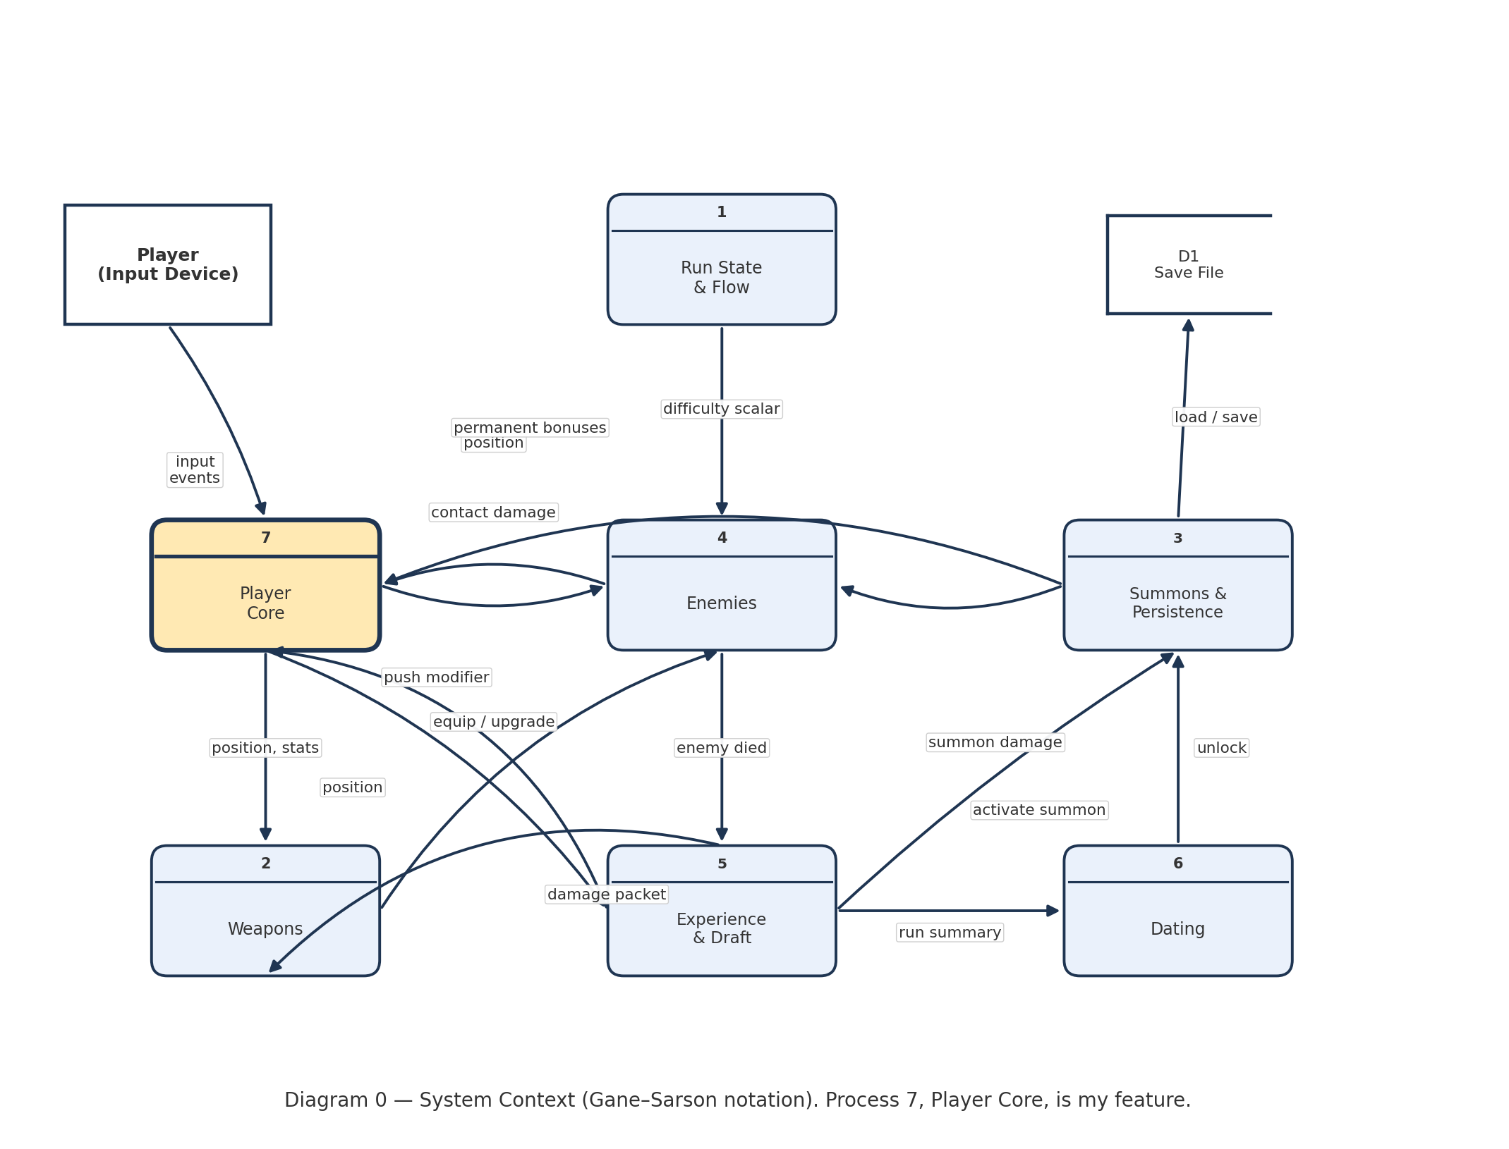
Diagram 0 — System context. Every arrow is a real call or published field named in the project plan's contract-ownership table (Section 6.1) and game-loop order (Section 6.3). No black holes: every flow in has a matching flow out, and the one data store (D1, the save file) is written and read by exactly one process, F3.
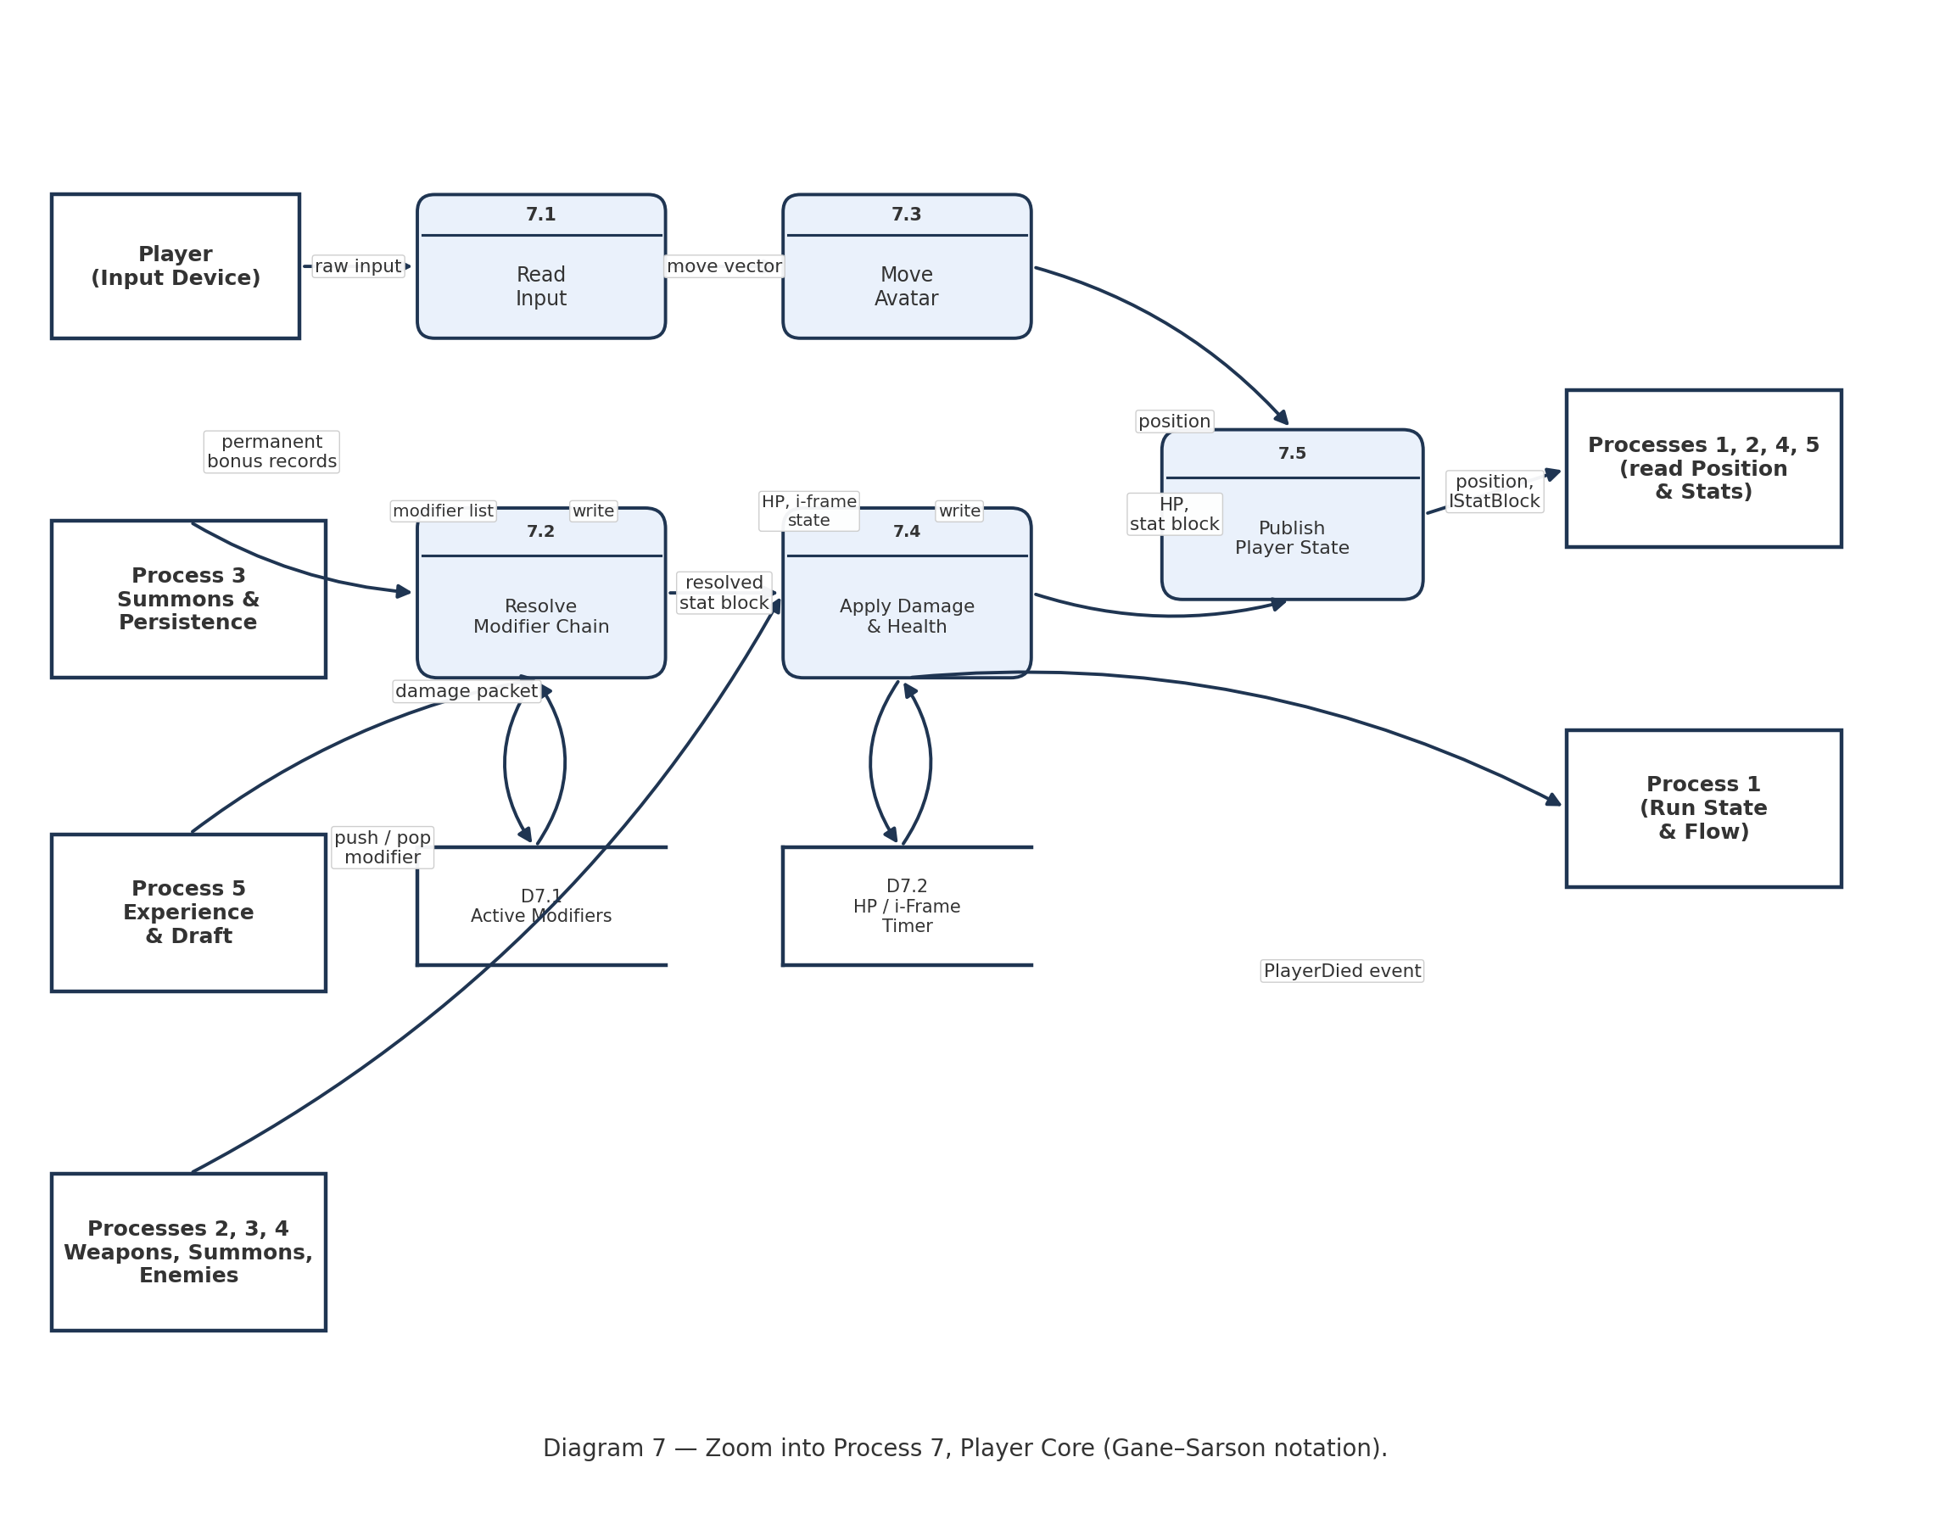
Diagram 7 — Zoom into Process 7, Player Core. Sub-processes 7.1–7.5 cover input, the modifier chain, movement, damage/health, and publishing state. D7.1 and D7.2 are local stores private to this feature — no other developer's directory reads or writes them directly.

Process Description — 7.4 Apply Damage & Health
Process 7.4 is the one primitive process in this feature with real branching, so it gets the decision-tree treatment rather than a one-line description. The tree below is exactly what DamageResolver executes on every ApplyDamage call, and it is what Scenario PC2's two exceptions (Step 2a and Step 4a) trace back to.
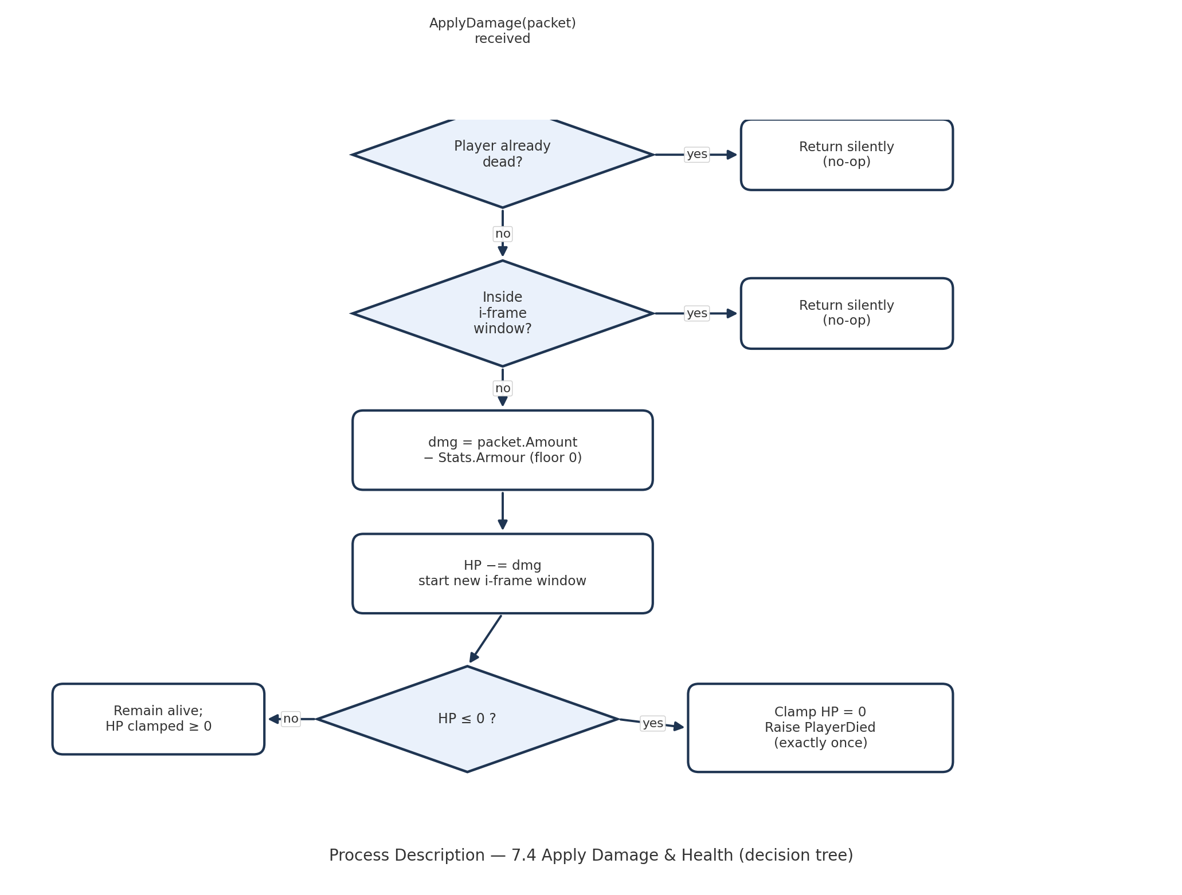
No miracles: every branch either returns silently on a named guard condition or performs one arithmetic step and moves to the next box — there is no step that produces HP-affecting output without a traceable input.

5. Timeline

Work items
These eleven items total the 52 hours the course budgets per developer (Design 9h, Coding 24h, Testing 12h, Documentation 4h, Learning/integration 3h), broken fine enough that no single item is a vague mega-task — the standard TL5 set for the estimate list that feeds TL4's Gantt.
Task | Duration (hours) | Predecessor task(s)
1. Interface design & class diagram | 5 | —
2. Pattern selection (Decorator) & Gate G4 prep | 4 | 1
3. PlayerModel & StatBlock core | 5 | 2
4. Modifier chain + 4 StatModifier subclasses | 6 | 3
5. Input abstraction (keyboard/gamepad) + movement Tick | 5 | 3
6. Touch IInputSource (phone build) | 3 | 5
7. Damage, armour, i-frames, death | 5 | 3
8. Modifier / stat EditMode tests | 5 | 4
9. Input, damage & death EditMode tests | 7 | 8, 6, 7
10. Champion document + interface docs | 4 | 9
11. Learning, TL1 integration support, AI interaction log | 3 | 3

PERT diagram
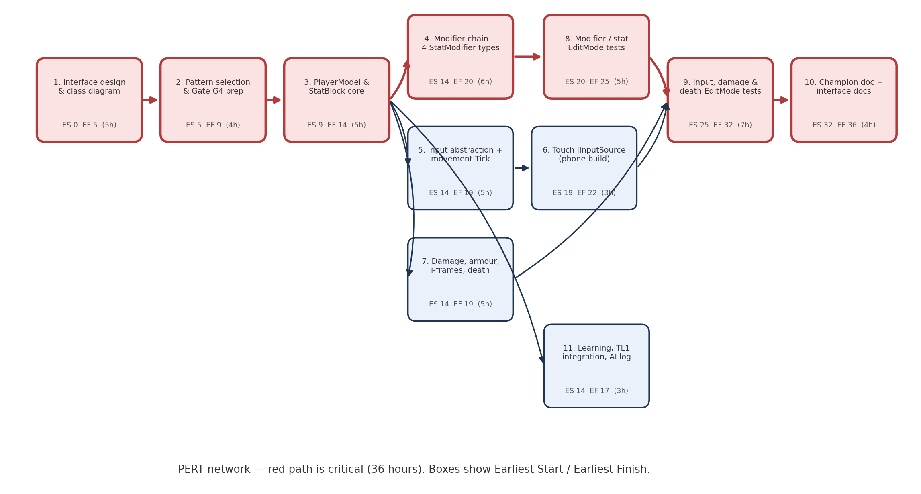
The critical path is 1 → 2 → 3 → 4 → 8 → 9 → 10, totalling 36 hours. Task 7 carries 6 hours of slack, tasks 5 and 6 carry 3 hours each, and task 11 (learning/integration/AI log) carries 19 hours of slack — it can run any time before the Week-13 freeze.

Gantt timeline
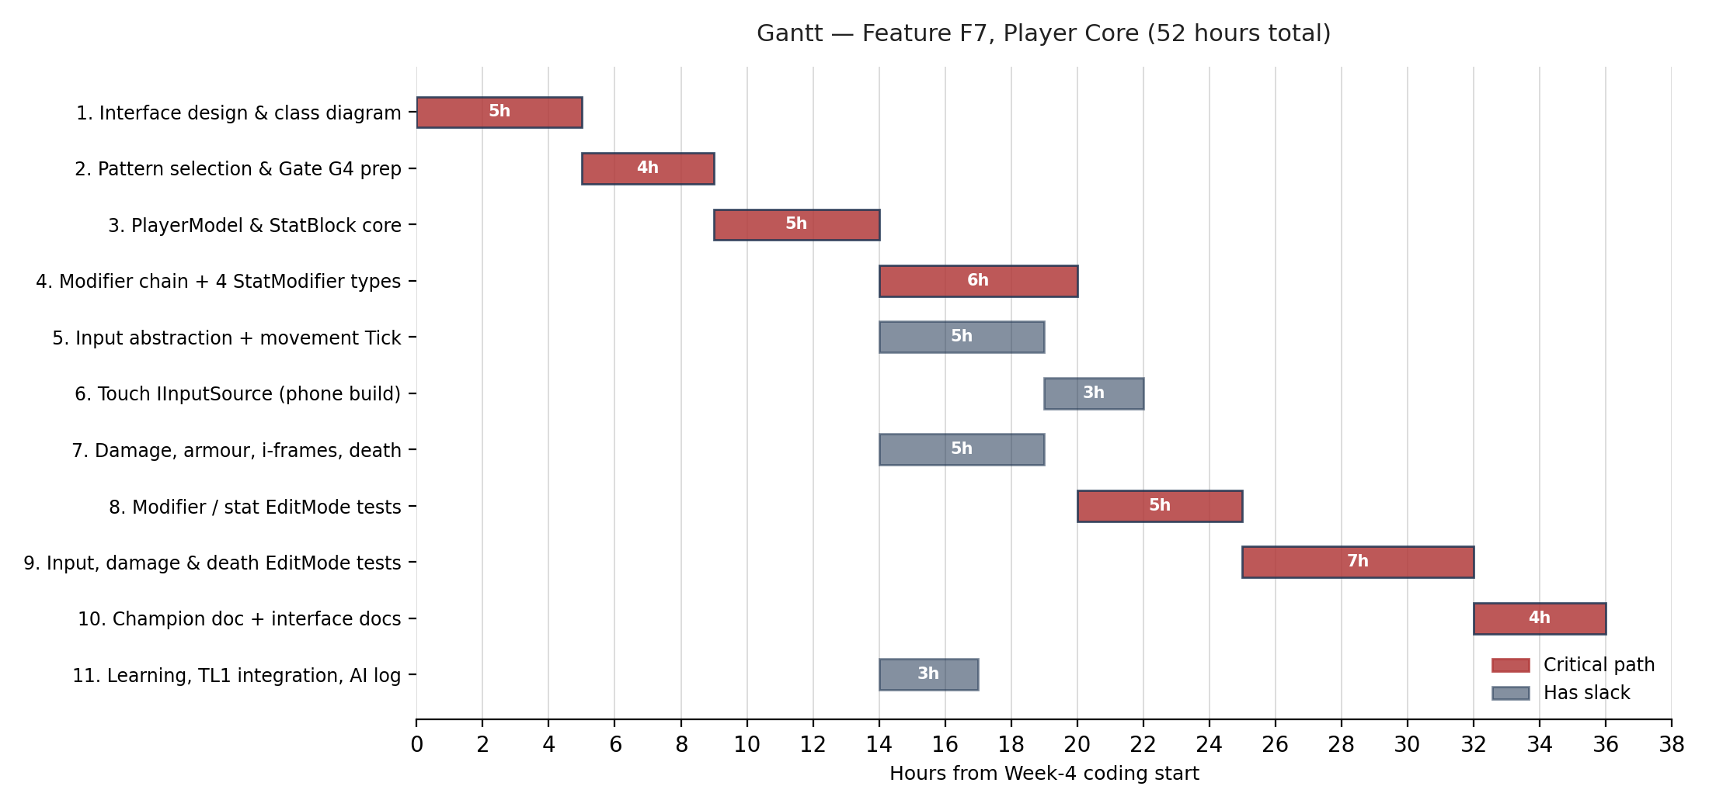
Honesty check against the project plan's own Gantt (Section 8): F7's Week-4 cell is the MVP avatar handed to TL1, which is items 1–3 here: it lands at hour 14, comfortably inside Week 4's 6-hour budget. Items 5–6 (touch input) are deliberately not on the critical path — the plan's Week-11 cell for phone profiling is where they get exercised, not built.

AI Drafting & Verification Log — Summary
I drafted this Champion with Claude from my F7 feature specification in the team's AI Project Plan (Section 3, F7 — Player Movement & Core Stats). Before submitting, I made the following substantive changes and verified the sections below against what Dr. BC taught. This section is required by the course AI policy — replace the bracketed prompts with my own record before submitting.
[Fill in before submitting] What I changed after the first draft, and why (e.g. an exception that wasn't really a branch, a DFD flow with no matching return, an hour estimate that assumed something I'm not building):
Section | What the AI drafted | What I changed / verified | Why
Use Case | [ ] | [ ] | [ ]
Interface Contract | [ ] | [ ] | [ ]
DFD | [ ] | [ ] | [ ]
Timeline | [ ] | [ ] | [ ]
Full question log submitted alongside this document, per the AI interaction log policy; conversation saved for TL5's audit before the oral exam.

