Enemy Spawning and Behaviour Champion
Name Shenghao Zhu | Team role TL3 | Feature F4 — Enemies | Mark ____ / 30

1. Brief Introduction
I own enemy spawning and behaviour during an active run. My feature turns the difficulty scalar into spawn decisions, places enemies outside the camera view, steers them toward or around the player, resolves incoming damage, and publishes enemy deaths for the experience system. I own the enemy prefab and its runtime state. F1 owns the run clock and difficulty curve. F7 supplies the player position and receives enemy attack damage. F2 and F3 submit weapon and summon hits, and F5 decides which rewards to create from enemy deaths.

Current Unity prototype
- MonsterSpawner chooses a random camera edge, instantiates its configured prefab, and assigns the player through EnemyController.SetTarget. Script defaults are one spawn every 2 seconds and a cap of 20 spawned instances. Scene overrides may differ.
- EnemyController calls virtual methods on its current EnemyState. Chase drives the rigidbody toward the target, Attack stops movement and previews damage in the Console, and Dead stops movement. The attack preview does not change player health.
- The separate EnemyBehavior component computes chase velocity and weapon-specific damage amounts. EnemyBehaviorBasicTests contains three assertions-based cases for the default chase and damage rules. The snapshot also includes the TL3_scress_test scene.
- Spawned-prefab animation is an open PlayMode verification item. Pooling, shared archetypes, four distinct brains, and the full combat and reward handoffs are planned below.

Planned design and integration
Boundary | Contract
F1 → F4 | Active run state and difficulty scalar drive the wave director. The run seed makes spawn tests repeatable.
F7 → F4 | Player position supplies a target for spawning and steering.
F2 and F3 ↔ F4 | IEnemyQuery exposes live targets. Weapons and summons send hits through F4's ApplyDamage entry point.
F4 → F7 | Enemy contact attacks submit damage through the player damage entry point.
F4 → F5 | EnemyDied reports a defeat and its position so the reward system can create pickups.
GoF pattern — Flyweight. ArchetypeRegistry returns one shared, immutable EnemyArchetype per type. It holds base stats, visual references, and tuning values. Current health, position, cooldowns, and behaviour state belong to each enemy instance. A prewarmed Unity pool reuses hosts, with each host's runtime fields reset on checkout.
Dynamic binding. The prototype dispatches Tick and FixedTick through EnemyState. The planned graded hierarchy calls EnemyBrain.ComputeDesiredVelocity(BrainContext) through the base type. Chaser pursues directly, Swarmer adds separation, Ranged maintains a preferred distance, and Vampire Elite alternates approach and mist dash. If the call used only base behaviour, those types would all pursue directly. The class diagram will identify the virtual method, its overrides, and the shared archetype reference for Gate G4.

2. Use Case Diagram with Scenarios
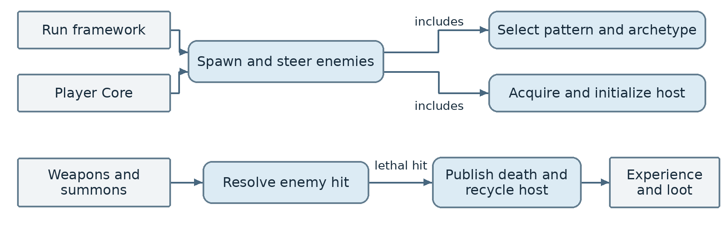

EN1 Spawn and steer enemies
Actors Run framework and Player Core.
Preconditions The run is active, the player is available, and the enemy pool is ready.
Priority 1 (must have).
1. The wave director reads difficulty and remaining capacity.
2. It selects Ring, Cluster, or Boss and generates spawn positions using the run seed and current spawn context.
3. It acquires a host and initializes its position, archetype, brain, target, and runtime state.
4. The host applies its brain's desired velocity and displays the assigned visuals.
5. When the enemy can attack, it submits damage through the player damage interface.
Exceptions At step 1, a paused run, missing player, or full cap prevents spawning. At step 3, a host that cannot be initialized is returned to the pool before it enters the live roster.
Postconditions Each successful spawn is registered once and the live count stays at or below the cap.

EN2 Resolve a hit and publish defeat
Actors Weapons, summons, and Experience and Loot.
Preconditions The hit targets a live enemy.
Priority 1 (must have).
1. A weapon or summon submits a damage packet to F4.
2. F4 validates the target and applies the resolved damage to enemy health.
3. If health reaches zero, F4 marks the enemy defeated and removes it from the live roster.
4. F4 publishes one EnemyDied event with the death position and returns the host to the pool.
Exceptions At step 2, a stale target or a hit on an already defeated enemy produces no health change or death event. At step 3, a surviving enemy remains in the roster.
Postconditions Each defeat produces exactly one event, and the host can be reused.

3. Data Flow Diagrams

Level 0 Enemy feature context
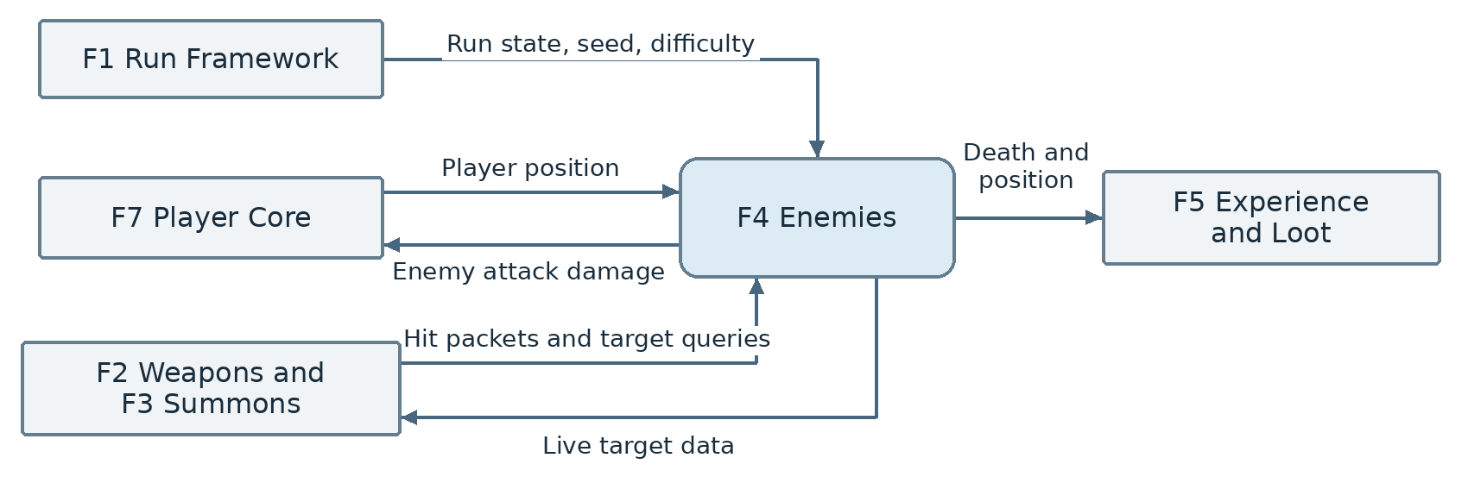

Level 1 Enemy feature processes
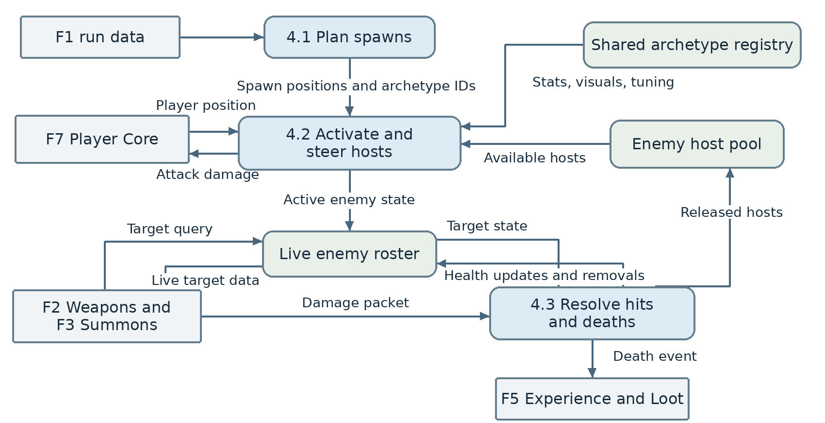

4. Acceptance Tests
The rows define pass criteria. Results require a Unity run. The prototype tests are separate from the planned feature checks.
ID | Mode | Procedure | Pass bound
A1 | EditMode | Run the three cases in EnemyBehaviorBasicTests. | Unknown weapon returns 10 damage on a base value of 10. In-range velocity is (2, 0) within 0.001 per axis. Out-of-range returns false and zero velocity.
A2 | PlayMode | Spawn three prototype enemies from the configured prefab. Inspect each clone in the Game view and Hierarchy. Keep the player outside attack range during the observation. | 3/3 clones have the player target, show at least two distinct swim frames during a full animation cycle, and move closer to the player.
A3 | EditMode, planned | For each of three spawn patterns, run twice with identical inputs and seed at the minimum and maximum configured difficulty. | All six replay pairs produce identical ordered positions and counts. At each difficulty, output matches the approved pattern fixture and available capacity.
A4 | EditMode, planned | Call each of the four brain implementations through an EnemyBrain reference. Include ranged at its preferred distance and two swarmers at identical positions. | 4/4 use the intended override and match their scenario expectations. The ranged enemy holds distance at the boundary. Overlapping swarmers produce finite velocity.
A5 | EditMode, planned | Request the same archetype 100 times. | 100/100 references point to the same object.
A6 | PlayMode, planned | Prewarm 10 hosts. Spawn all 10, damage and recycle them, then spawn all 10 again with new positions and targets. | 0 new hosts instantiated on the second batch. All 10 restart with fresh health, target, and cooldown state.
A7 | EditMode, planned | Send two lethal hits for the same enemy within one update and observe the roster, pool release, and event. | One death event at the defeat position, one roster removal, and one pool release.
A8 | PlayMode, planned | At the configured cap, request another spawn. Then test a paused run below the cap. | 0 extra spawns in either case.
A9 | PlayMode, planned | In the stress scene, prewarm each tested cap, raise the concurrent count in steps of 25, and record 30 seconds of steady-state samples per step on the same test machine. | Report the highest tested count with mean frame time at or below 16.7 ms and the first count above budget, if reached. Capture F4 steady-state allocations and verify 0 bytes per frame from enemy updates and pool operations.
Seeded test record. For A3, record the seed, pattern, difficulty, live cap, expected count and positions, and actual results. Use the same seed and spawn context for both runs of a pair.

5. Timeline
Estimated effort 52 hours. The durations below are planning estimates for the Champion scope, including implementation and verification.
ID | Work item | Hours | Predecessors
D1 | Specify ownership, contracts, and acceptance fixtures | 4 | —
D2 | Design the brain hierarchy and Flyweight class diagram | 4 | D1
C1 | Integrate the host, prefab animation, and pool | 7 | D2
C2 | Implement the four enemy brains | 8 | C1
C3 | Implement three spawn patterns and difficulty integration | 7 | C1
C4 | Integrate damage, live roster, and death events | 6 | C2
T1 | Verify seeded patterns, brain dispatch, and archetype identity | 5 | C2, C3
T2 | Verify prefab animation, pool reuse, and damage and death integration | 4 | C3, C4
T3 | Profile the stress scene and record the frame-budget limit | 4 | T1, T2
DOC1 | Update the Champion and record test evidence | 3 | T3
Total |  | 52
Critical path D1 → D2 → C1 → C2 → C4 → T2 → T3 → DOC1, totaling 40 hours based on dependencies. The 52 hours represent total effort for one developer.
Milestone | Completion evidence
Design | Public boundaries and Gate G4 class diagram
Core enemy loop | Animated hosts, four brains, three spawn patterns, and damage/death integration
Verification | EditMode results, PlayMode results, and stress threshold with test machine details
Handoff | Champion and test results under docs/TL3-Shenghao/

