TL1 Feature Document
TL1 – Adam Yaw
Game - IGTTAWAGMTAVSBHVFDAOUM
Feature – Run State and Flow Integration
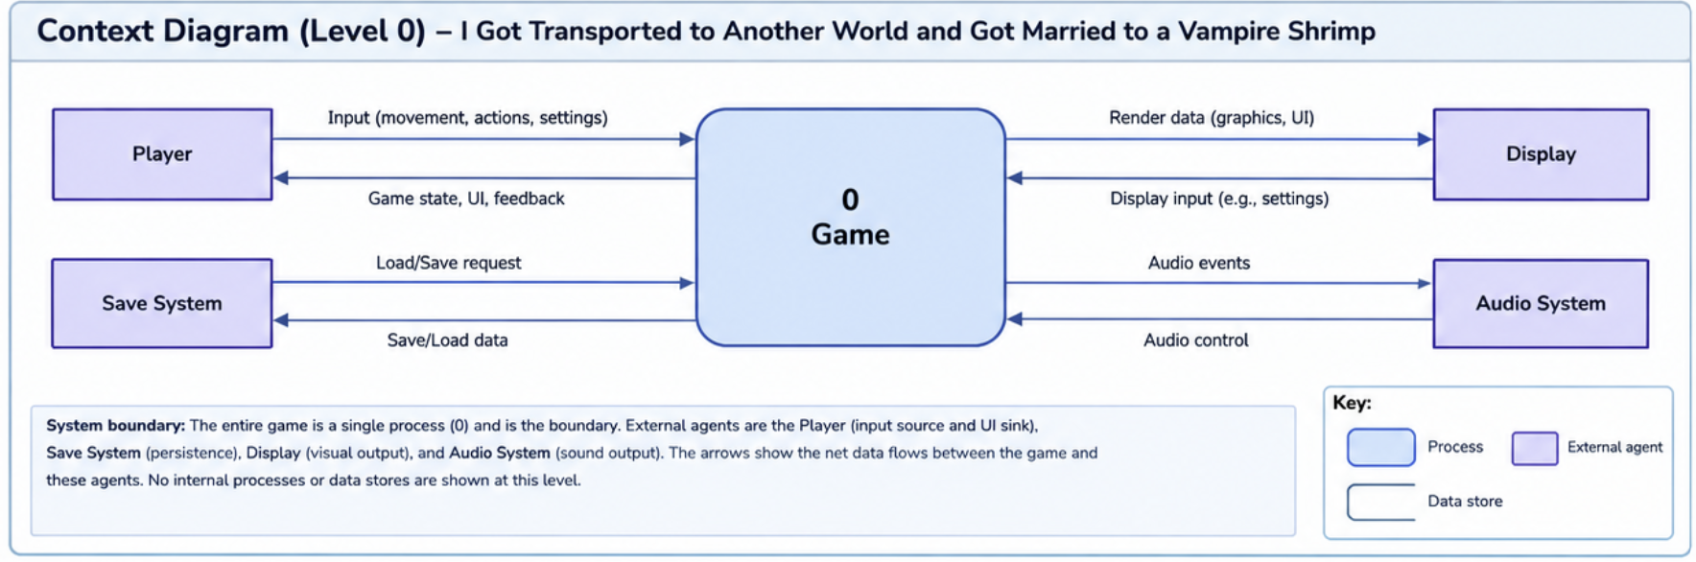
Section One – Level Zero Diagram
The level zero diagram is an expansion on the context diagram for the project that includes more detail regarding the individual processes, and where the TL1 Feature integrates into the game operations.
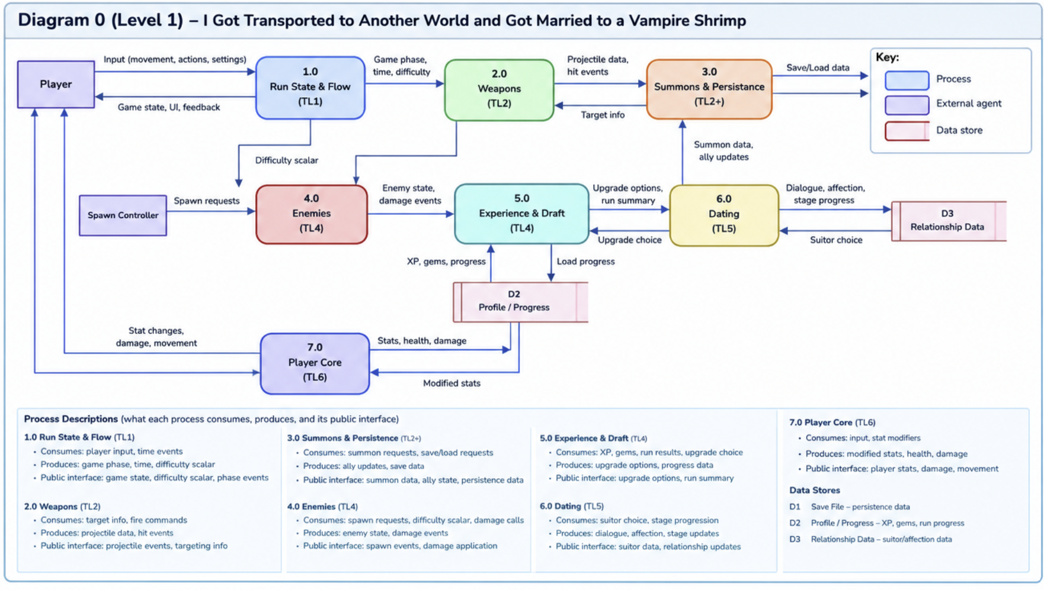
Run state and flow integration is the heart of a Unity project, think something akin to “GameManager” that controls datastores for many features, and manages scoring, and other critical aspects of the game experience.
Section Two - Introduction
<AI Prompt> MeetGreet_TL5_AI_Prompt-1.docx, along with instructions to focus on the implementation of the TL1 section of the troubleshooting. (Here: | F1 | TL1 | Run State & Flow | Game phases, run clock, pause, difficulty scalar | State | GameState → Boot / Run / LevelUp / Dating / GameOver |)
NOTE – TL5 created all context and level 0 diagrams, and I do not have prompts available for them, and document formatting was added by humans.
My feature owns the runtime shell of the game: the player, camera, run lifecycle, game loop, composition root, and the minimum playable scene. At startup it creates the run context, loads the MVP scene, initializes the independent feature services through documented public interfaces, and transitions the run into PLAYING. During play it owns the frame/tick order and routes typed pause, level-up-pause, defeat, restart, and shutdown events.
The game is a Vampire-Survivors-like Unity/C# project in which monsters spawn and roam, defeated monsters provide XP, leveling adds weapons/items, and a dating-based metaprogression system provides permanent bonuses and summons. The project has seven developers, with approximately 52 hours of work per developer. This feature therefore has a 52-hour estimate including design, coding, testing, documentation, debugging, and learning.
This feature deliberately does NOT implement enemy spawning/AI, weapon firing/damage, pickups/XP calculations or the three-card draft, courtship/affection/family approval/save logic, or ally AI/coordinator logic. Those remain owned by their respective features. Run Framework only initializes, ticks, pauses, resumes, and shuts down those features through public interfaces. It also does not modify another developer's source directory.
Design commitments: the runtime state machine is a non-MonoBehaviour class hierarchy using virtual/override methods for dynamic binding; the State pattern is the primary GOF pattern; Controller, Indirection, Low Coupling, High Cohesion, Polymorphism, Pure Fabrication, and Protected Variations are the principal GRASP applications.
other critical aspects of the game experience.
Section Three – Use Case “1” Scenario
The diagram set follows the sample Champion structure: two use-case diagrams, each followed by a numbered scenario. Exceptions are branches from exact basic-sequence steps.
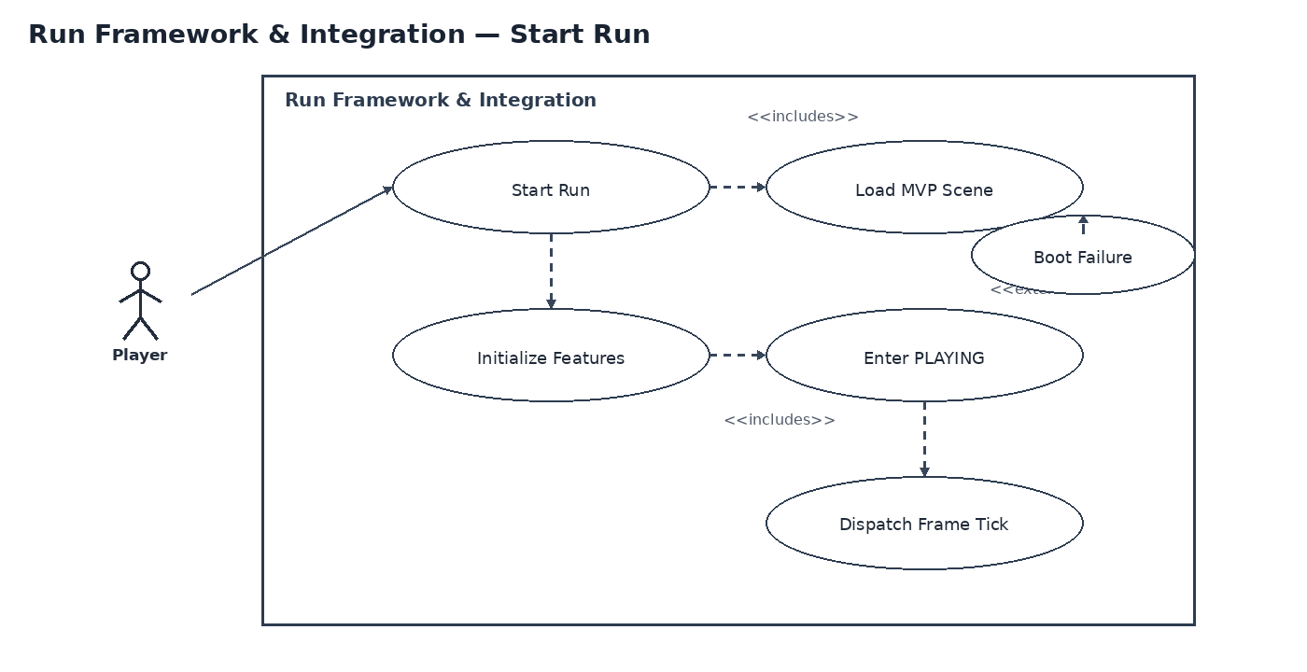
Figure 1. Use case diagram — Start Run.
Scenario 1 — Start Run
Summary: The player starts a run; the composition root creates the run context, initializes the six feature services, loads the MVP scene, and begins the game loop.
Actors: Player; Unity Runtime
Preconditions: Unity has loaded the application bootstrap scene; all feature assemblies are available; the MVP scene reference is valid.
Step 1: The player issues Start Run from the title/MVP entry point.
Step 2: The composition root creates a typed RunConfig and RunSession state.
Step 3: The composition root registers the Enemy, Weapon, Pickups/XP, Courtship/Meta, and Summons feature interfaces.
Step 4: The composition root calls each feature's Initialize method in the documented initialization order.
Step 5: The framework loads or activates the MVP scene and binds the player and camera.
Step 6: The lifecycle state transitions from READY to PLAYING and RunStarted is published.
Step 7: The game loop begins dispatching one Tick(deltaTime) call to each registered active feature per frame.
Exceptions:
Step 4a: A feature initialization call returns false or raises a documented initialization failure. The framework records the feature ID, does not enter PLAYING, publishes RunStartFailed, and leaves the session in READY/ERROR state.
Step 5a: The MVP scene reference is invalid or the scene load fails. The framework publishes RunStartFailed and does not dispatch gameplay ticks. No feature is treated as initialized merely because a scene load was requested.
Step 7a: A registered feature reports an execution fault. The framework catches only the documented feature-boundary exception, logs the feature ID and frame number, disables that feature for the remainder of the run, and continues only if the feature contract marks the fault recoverable.
Post conditions: PLAYING is active, the player and camera are bound, all required features report initialized, and the run loop has a deterministic dispatch order.
Priority: 1 (must have) ID: RF1

Section Four – Use Case “2” Scenario
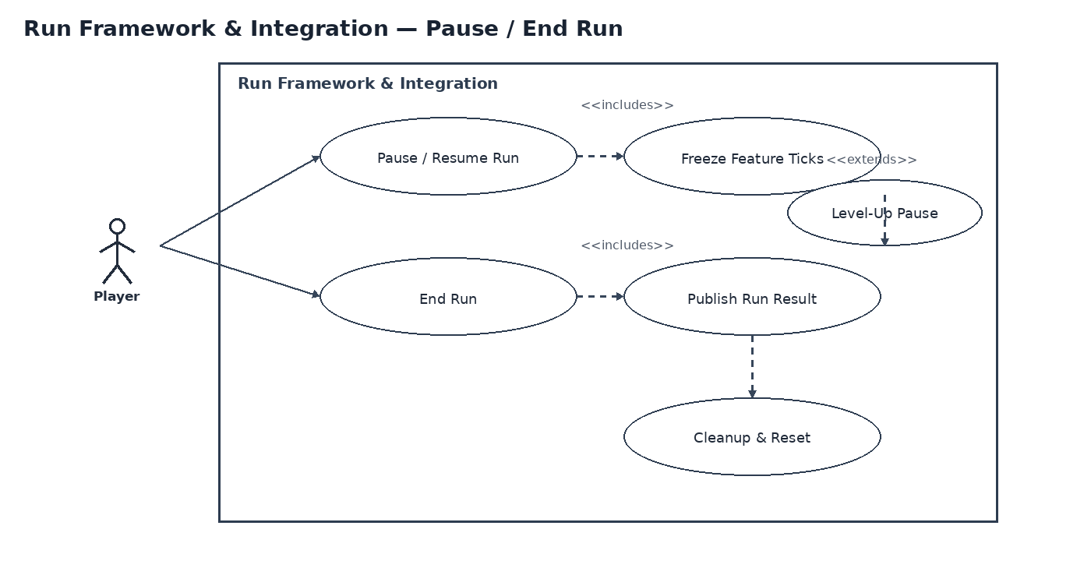
Figure 2. Use case diagram — Pause / End Run.
Scenario 2 — Pause, Resume, and End Run
Summary: The framework handles player pause, level-up pause, resume, defeat, and run cleanup without allowing gameplay features to continue ticking while paused.
Actors: Player; Pickups/XP feature; Unity Runtime
Preconditions: A run is in PLAYING or LEVEL_UP_PAUSED state.
Step 1: The player or a feature publishes a typed pause request with a PauseReason.
Step 2: The framework validates the request against the current RunState.
Step 3: The framework transitions to PAUSED or LEVEL_UP_PAUSED and publishes RunPaused.
Step 4: The game loop stops gameplay Tick calls while retaining UI/input processing needed for resume.
Step 5: The player resolves the pause condition and issues Resume, or the defeat condition is raised.
Step 6: The framework transitions to PLAYING and publishes RunResumed, or transitions to GAME_OVER and publishes RunEnded.
Step 7: On GAME_OVER/restart, the framework calls feature cleanup interfaces, clears the session registry, and returns to the MVP entry state.
Exceptions:
Step 2a: A pause request arrives while the run is already PAUSED or LEVEL_UP_PAUSED. The request is idempotent: no second state transition is emitted and the existing pause reason remains authoritative.
Step 5a: Resume is requested while a mandatory level-up draft is still open. The framework rejects Resume with a typed ResumeRejected result and remains LEVEL_UP_PAUSED.
Step 7a: A feature cleanup call fails. The framework records the failure, clears its own registry anyway, and returns the player to the MVP entry state; cleanup failure never causes duplicate feature registration on the next run.
Post conditions: either PLAYING resumes with no gameplay ticks lost during the paused interval, or the run is ended and all framework-owned runtime registrations are cleared.
Priority: 1 (must have) ID: RF2

Section Five – Interface Contracts
3. Interface Contract
The following is the proposed public contract derived from the feature requirements. Types and bounds are intentionally explicit so TL1 can write tests without depending on another developer's implementation.
3.1 Framework-owned types
Type | Fields / values | Testable contract
RunConfig | int seed; int targetLevel; float maxRunSeconds | seed is any int; targetLevel >= 1; maxRunSeconds > 0
RunState | enum READY, PLAYING, PAUSED, LEVEL_UP_PAUSED, GAME_OVER | only documented transitions are accepted
PauseReason | enum PLAYER, LEVEL_UP, SYSTEM | LEVEL_UP is mandatory until draft completion
RunResult | bool victory; int level; float elapsedSeconds; int enemiesDefeated | level >= 1; elapsedSeconds >= 0; counts >= 0
FrameContext | int frame; float deltaTime; RunState state | frame >= 0; 0 <= deltaTime <= 0.25 for normal gameplay tick
RunHandle | Guid runId; RunState state | runId is unique per run; state matches lifecycle state
3.2 Public methods
Method | Input | Output | Contract / bound
Initialize | RunConfig config | RunHandle | creates exactly one session; returns READY or typed failure; no Tick before success
StartRun | Guid runId | bool | true only once per READY session; publishes RunStarted on success
Tick  (Unity Update) | FrameContext frame | void | dispatches exactly once to each enabled feature when state is PLAYING
RequestPause | PauseReason reason | bool | idempotent while already paused; LEVEL_UP pause cannot be bypassed
Resume | — | bool | false while LEVEL_UP_PAUSED has an unresolved draft; true only on transition to PLAYING
EndRun | EndReason reason | RunResult | publishes RunEnded once; moves to GAME_OVER; no gameplay ticks afterward
Reset | — | void | clears framework registry and returns to READY/MVP entry; safe to call twice
3.3 Feature boundary calls
Run Framework calls only documented interfaces. Proposed minimum integration surface:
Feature | Initialize | Per-frame call | Shutdown
Enemy Spawn Director & AI | Initialize(EnemyInitContext) : bool | Tick(FrameContext) : void | Shutdown() : void
Weapon Arsenal & Combat | Initialize(WeaponInitContext) : bool | Tick(FrameContext) : void | Shutdown() : void
Pickups, XP & Upgrade Draft | Initialize(PickupInitContext) : bool | Tick(FrameContext) : void | Shutdown() : void
Courtship & Meta-Progression | Initialize(MetaInitContext) : bool | Tick(FrameContext) : void | Shutdown() : void
Summons & Allied Combat | Initialize(SummonInitContext) : bool | Tick(FrameContext) : void | Shutdown() : void
3.4 Events
Event | Payload | Testable trigger
RunStarted | RunHandle | exactly once after successful StartRun
RunPaused | PauseReason | exactly once on PLAYING -> PAUSED/LEVEL_UP_PAUSED
RunResumed | RunHandle | exactly once on PAUSED -> PLAYING
RunEnded | RunResult | exactly once on GAME_OVER transition
LevelUpPauseRequested | int newLevel | causes LEVEL_UP_PAUSED before next gameplay tick
RunStartFailed | FeatureId + FailureCode | only when initialization/scene boot fails
3.5 Contract acceptance tests
Test | Runs | Observed / target | Pass bound | Expected
Initialization order | 100 run starts | All 5 dependent gameplay features receive Initialize exactly once before first Tick | 0 ordering violations; 0 ticks before successful initialization | Pass
Tick dispatch | 10,000 PLAYING frames | Each enabled feature receives one Tick per frame | 50,000 feature ticks ±0; no duplicate/missing calls | Pass
Pause freeze | 500 pause/resume cycles | Gameplay features receive no Tick while paused | 0 gameplay Tick calls during PAUSED/LEVEL_UP_PAUSED | Pass
Level-up gate | 200 draft pauses | Resume is rejected until draft-complete event | 0 premature resumes | Pass
Reset idempotence | 200 end/reset/restart cycles | No duplicate registrations or stale delegates | 0 duplicate registrations; 0 stale callbacks | Pass
Phone stress | 30 s with 1,500 active enemies + 5 allies + 5 weapons | Run orchestration remains within its own overhead budget | Run Framework orchestration <= 0.50 ms/frame on the TL6 reference phone | Pass

Section Six – Interface Contracts
Diagram 0 shows the whole game and highlights the Run Framework process. Diagram 1 then zooms into the Run Framework and names the concrete processes, data stores, and flows. The diagrams use Gane–Sarson-style process rectangles and data-store notation, matching the sample's required approach.
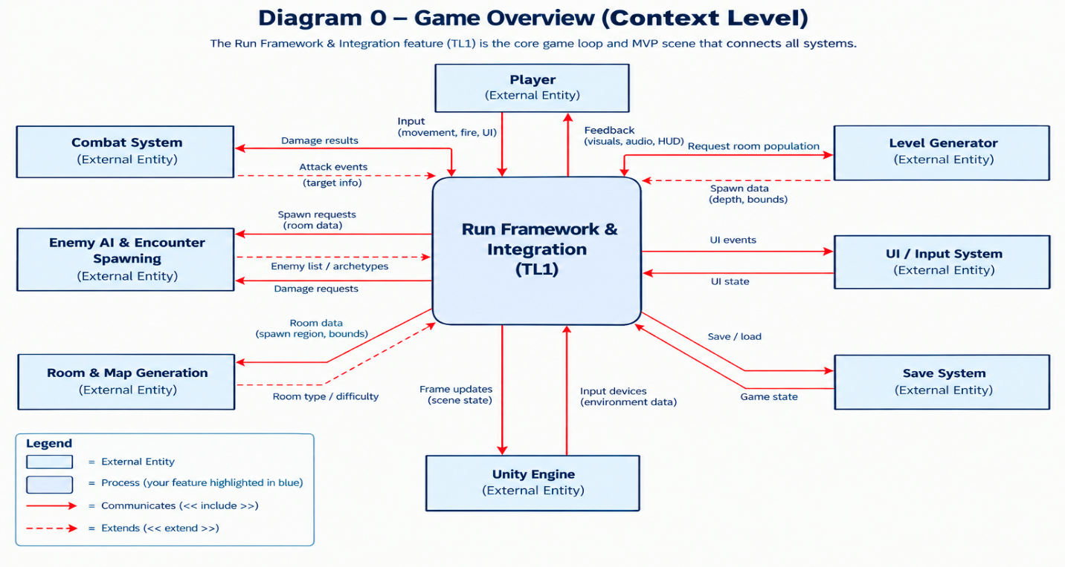
Figure 3. Diagram 0 (early revision) — whole-game context with Run Framework highlighted.
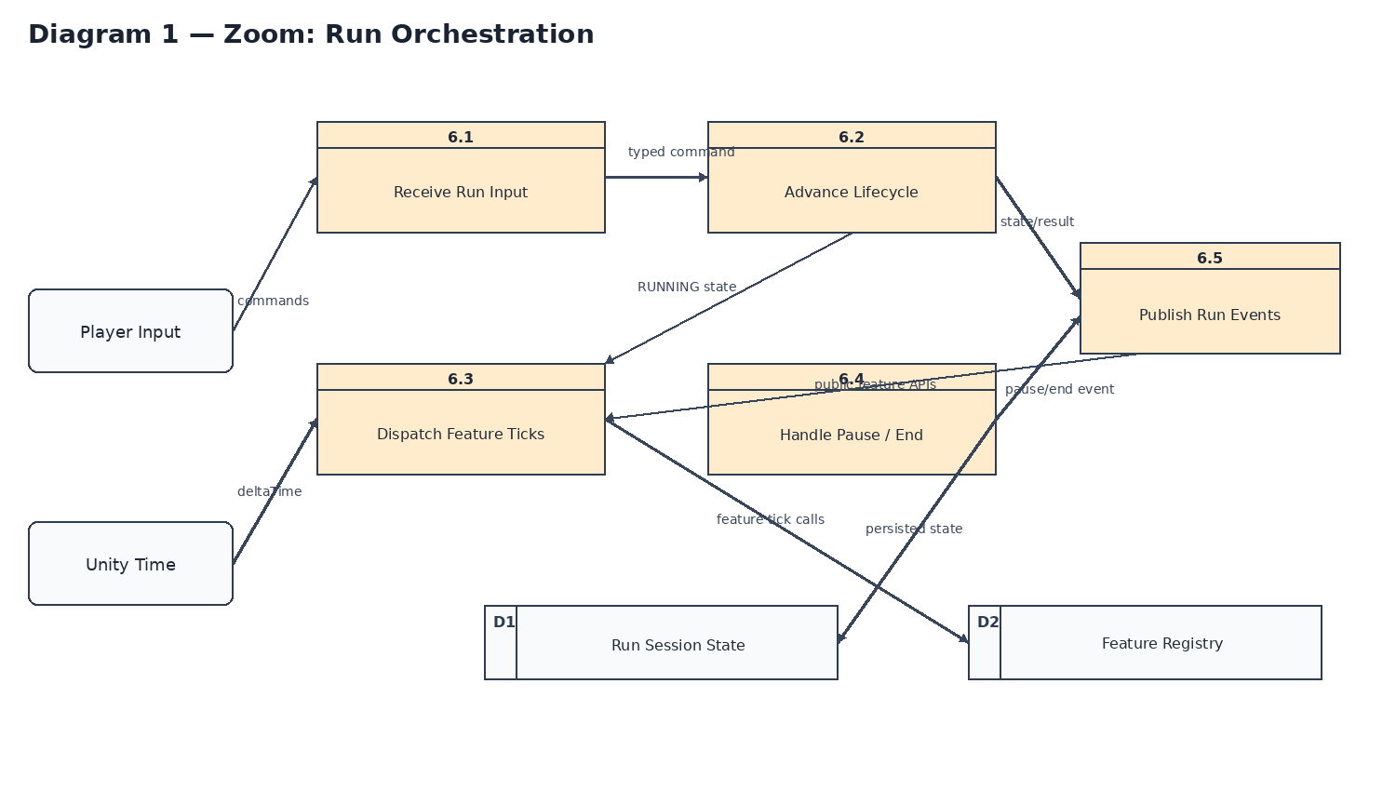
Figure 4. Diagram 1 (Early Revision) — zoom into Run Orchestration.
Process Description — 6.2 Advance Lifecycle
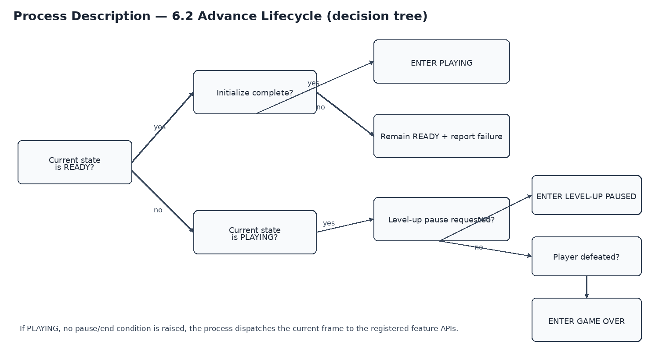
Figure 5. Decision tree for the lifecycle process.
No flow is implicit: player commands enter through the input boundary; Unity time supplies deltaTime; the lifecycle process reads and writes Run Session State; feature ticks go through the Feature Registry; and externally visible lifecycle changes leave through typed run events. The framework does not manufacture damage, XP, affection, enemy positions, weapon targets, or ally decisions.

Section Seven – Timeline
The estimate is 52 hours total, matching the course expectation of approximately 52 hours per developer. The hours include design, coding, testing, documentation, debugging, and integration learning rather than coding alone.
Task | Duration (hours) | Predecessor task(s)
1. Architecture & scene contract | 3 | —
2. Composition root | 4 | 1
3. Player controller | 6 | 1
4. Camera follow / lock | 4 | 1, 3
5. Run lifecycle state | 6 | 2, 3
6. Game loop scheduler | 5 | 2, 5
7. MVP scene + adapters | 5 | 2, 5, 6
8. Pause / level-up handshake | 4 | 5, 6
9. Shutdown / reset | 3 | 5, 6
10. Integration diagnostics | 4 | 7
11. Tests + phone stress | 5 | 7, 8, 9, 10
12. Docs + contract audit | 3 | 11
Total estimated work for this Champion: 52 hours. Critical path: 1 → 3 → 5 → 6 → 7 → 10 → 11 → 12 = 37 hours. Tasks 2, 4, 8, and 9 contain slack and can move without extending the critical path until their slack is consumed.
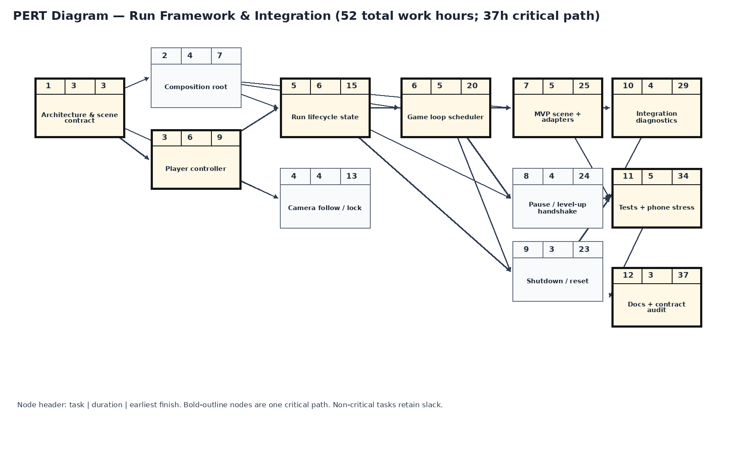
Figure 6. PERT network. Bold-outline tasks form one critical path.
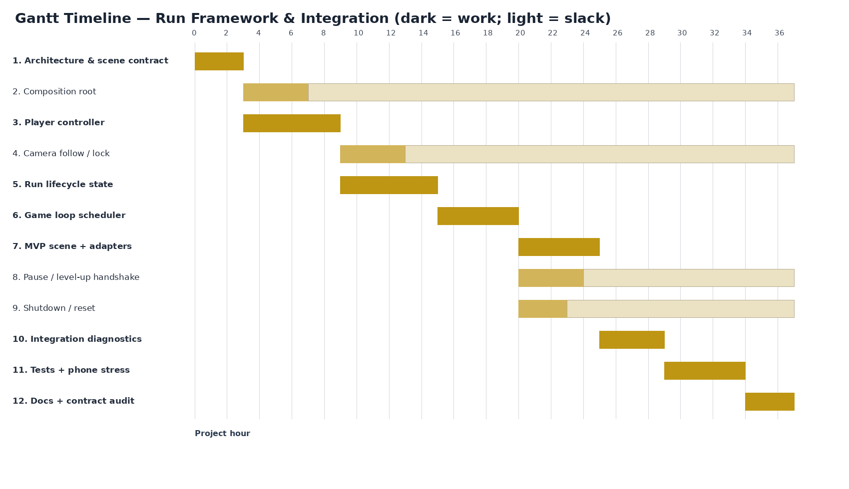
Figure 7. Gantt-style project-hour timeline, matching the sample's timeline presentation.
Team TL Estimate Snapshot
TL Member | Feature / Responsibility | Estimated Hours | Basis / Notes
TL1 | Run Framework & Integration | 52 | Approximately 52 hours per developer.
TL2 | Enemy Spawn Director & AI | 52 | Approximately 52 hours per developer.
TL3 | Weapon Arsenal & Combat | 52 | Approximately 52 hours per developer.
TL4 | Pickups, XP & Upgrade Draft | 52 | Approximately 52 hours per developer.
TL5 | Courtship & Meta-Progression | 52 | Approximately 52 hours per developer.
TL6 | Summons & Allied Combat | 52 | Approximately 52 hours per developer.
Total |  | 312 | Six listed TL estimates.
Tracking note: TL4 should compare actual hours against these estimates and record reasons for material variance before refreshing the Gantt.
TL4 weekly tracking view
TL1 | W4 | W5 | W6 | W7 | W8 | W9 | W10 | W11–12
Run Framework | Architecture + root | Player + camera | Lifecycle + test plan | Loop + MVP integration | Midterm: pause/reset | Feature adapter integration | Stress + diagnostics | Docs, hardening, buffer
Tracking rule: TL4 should compare actual hours against the estimates above, not replace the estimates after the fact. If actual time exceeds an item by more than 20%, the reason should be recorded (for example, Unity integration defect, scene-loading issue, or contract change) before the Gantt is refreshed.

