**Lab 1**

***Question: What is your understanding of the differences between Oracle database and MySQL database?***

***ANS:***

***Any available answers for example,***

**https://www.flexmonster.com/blog/mysql-vs-oracle-core-differences-and-similarities/**

**---------------------------------------------------------------------------------------------------------Lab 2**

***Question 1: What is your understanding of the SGA? What is the size of the SGA? How much memory was allocated to Buffer Cache, Shared Pool, and Large Pool?***

ANS:

SGA –System Global Area is Oracle Memory structure.

It is group of shared memory structures, known as SGA components, that contain data and control information for one instance.

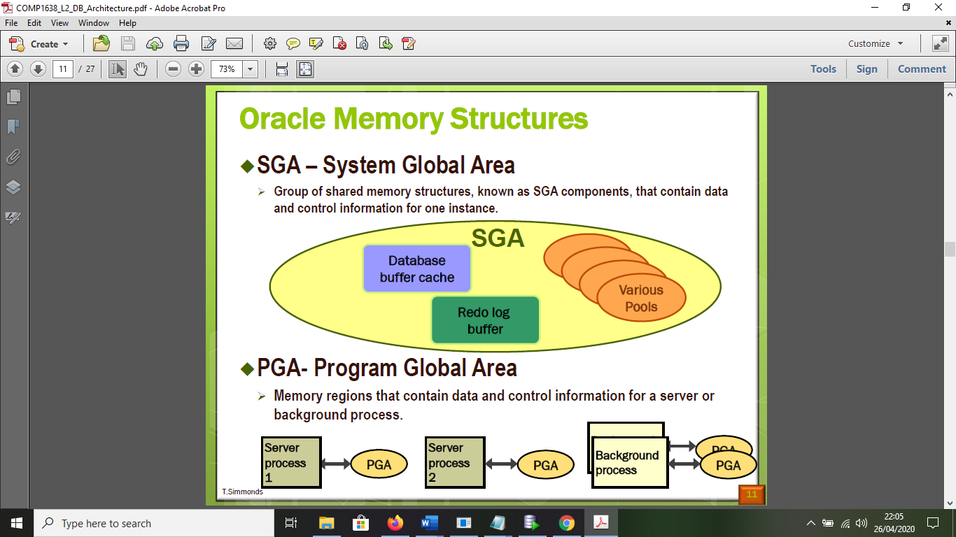

In my database,

SGA=1.6 GB

Buffer Cache= 496 MB

Shared Pool= 432 MB

Large Pool= 32MB

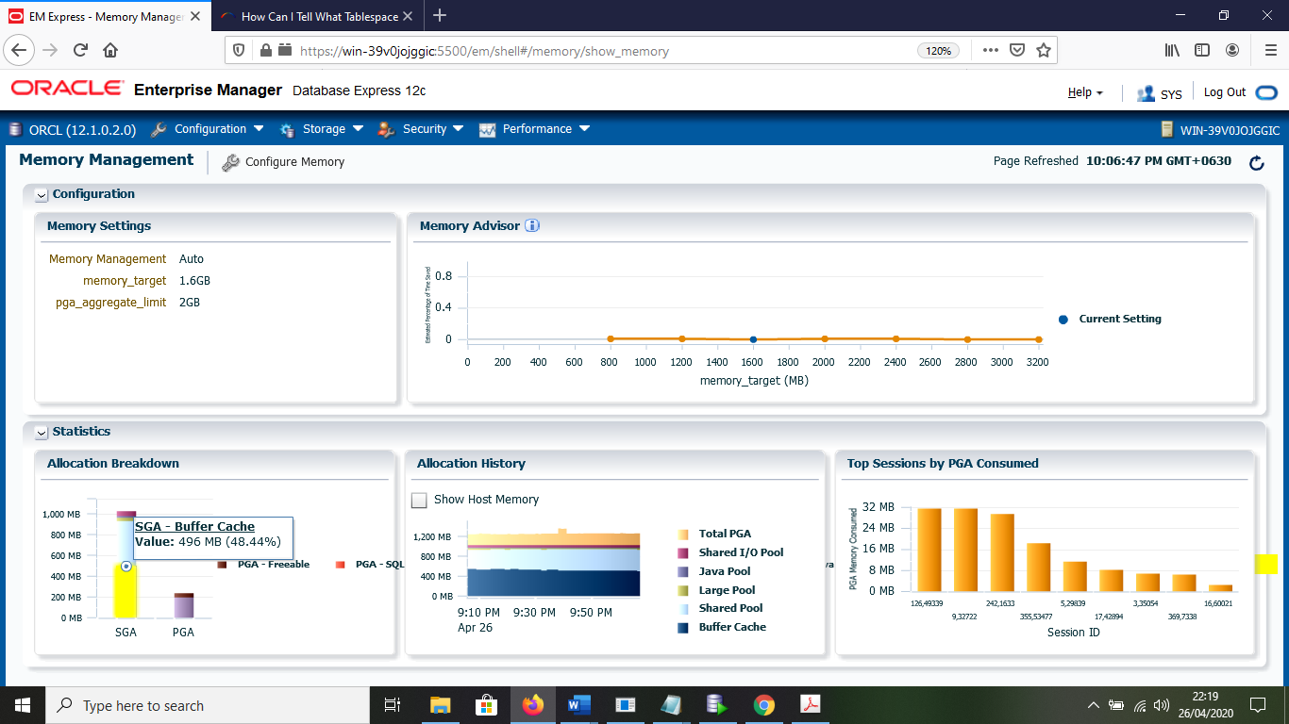

***Question 2: What is your understanding of the control file? How many control files have been created in your database and where? Find your control files in the Windows Explorer, provide a screen-shot of the location and explain.***

ANS:

A control file is a small binary file that is part of an Oracle database. The control file is used to keep track of the database's status and physical structure. Every Oracle Database must have at least one control file.

There are two control files in my database. They are under

C:\ORACLE\FAST_RECOVERY_AREA\ORCL\

And

C:\ORACLE\ORADATA\ORCL\

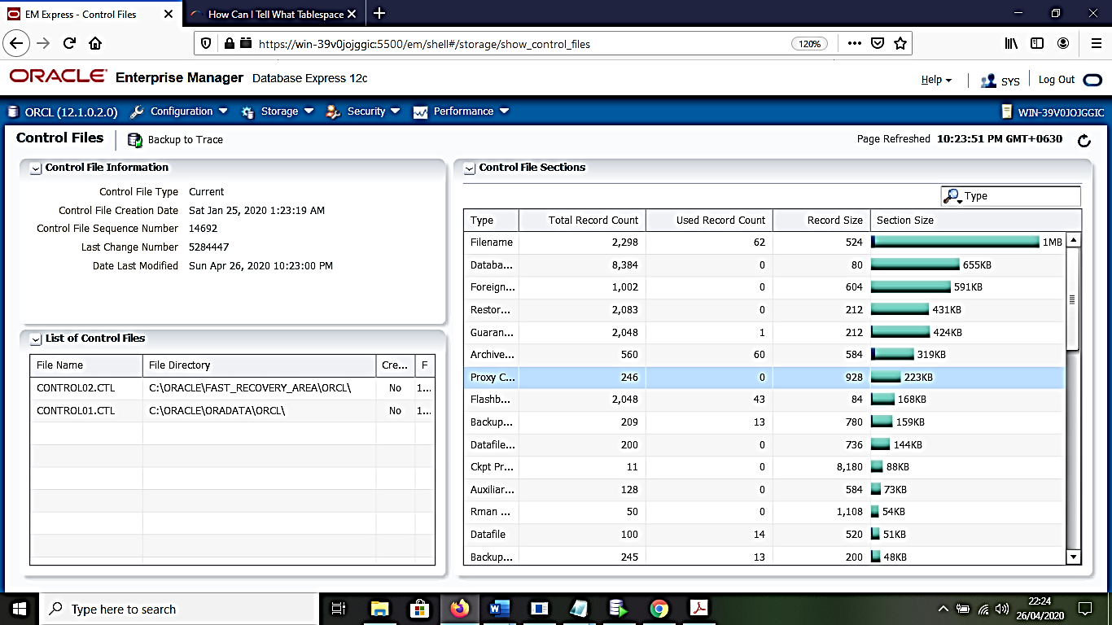

In Oracle Enterprise Manager, we can find them in storage tab > control files. The control file information and the list of control files can be seen in this figure.

***Question 3: What is a redo log? How many redo log groups have been created? Find the location of the online redo log files in the Windows Explorer? Explain and provide a screen-shot.***

ANS: Redo log is to store redo information (used for instance recovery). It is physical redo log file that stored on the disk.

There are three Redo log group. The location can be seen in the figure.

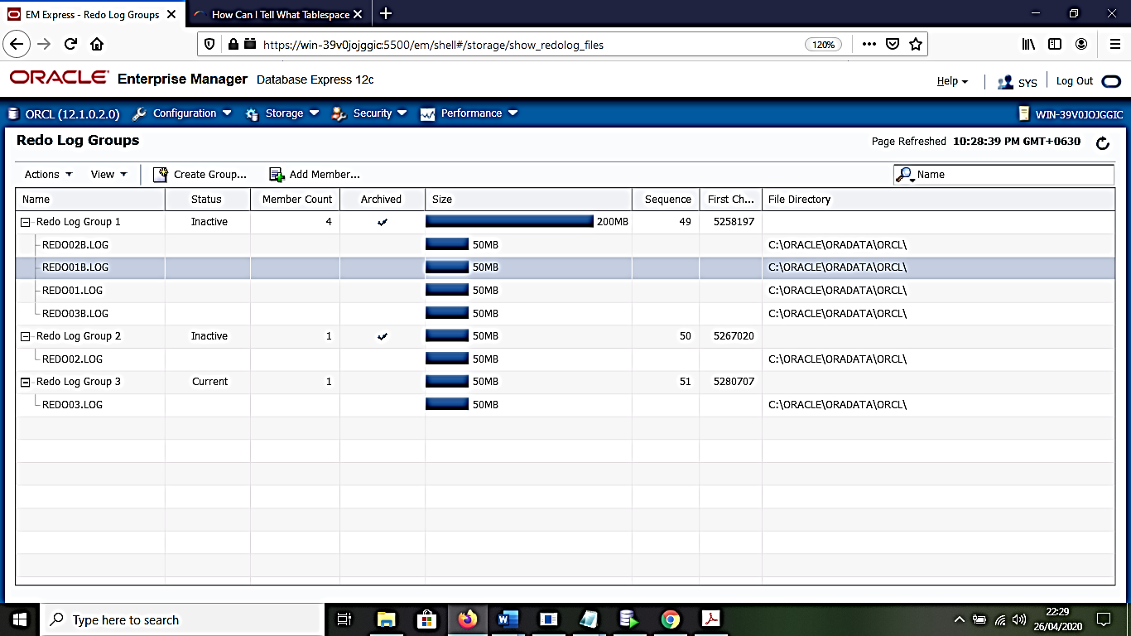

***Question 4: What is the tablespace? How many tablespaces have been created in your database?***

ANS:

An Oracle database consists of one or more logical storage units called tablespaces, which collectively store all of the database's data. Each tablespace in an Oracle database consists of one or more files called datafiles, which are physical structures that conform to the operating system in which Oracle is running.

There are eleven table spaces have been created in my database.

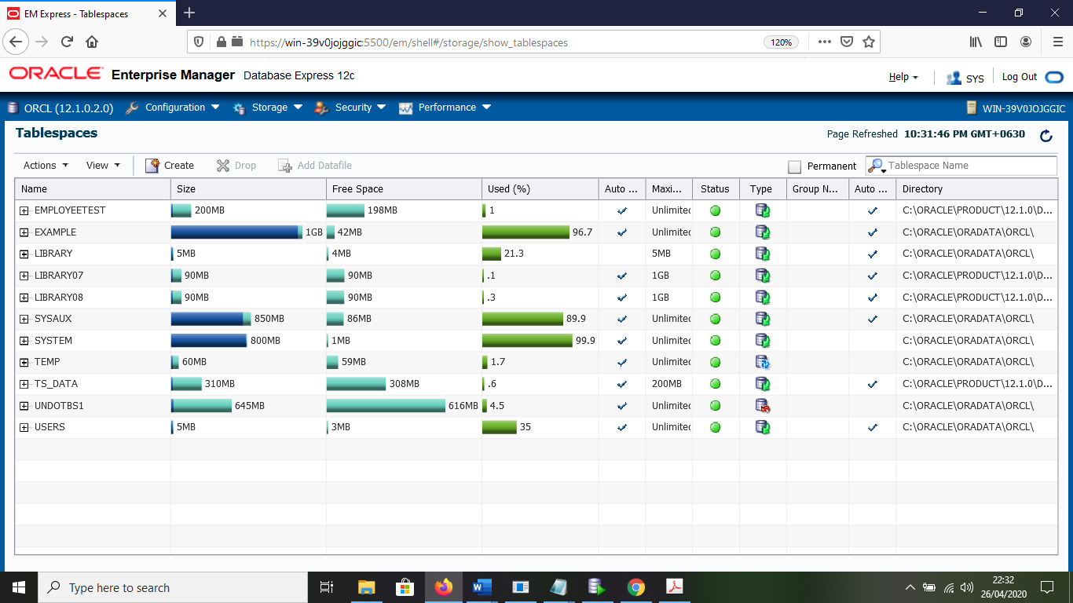

***Question 5: What is data file? How many data files have been created in your database and where? Find the location of the data files in the Window Explorer, provide a screen-shot.***

ANS:

Data files are the operating system files that store the data within the database. The data is written to these files in an Oracle proprietary format that cannot be read by other programs.

There are 13 Data files in my database. In Oracle SQL Developer,

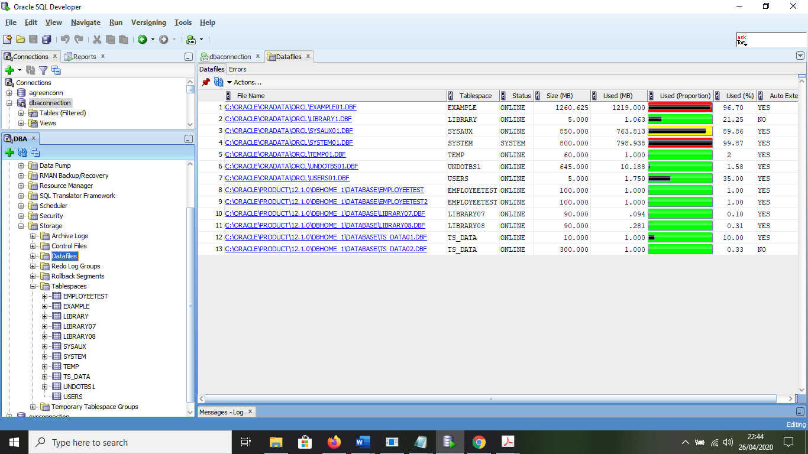

**---------------------------------------------------------------------------------------------------------**

**Lab 3**

***Question 1:*** Describe what is happening with the instance and the database in each step of the startup command.

ANS:

You must first be **logged into an account that has sysdba or sysoper privileges such as the SYS account.**

You can start an instance in various modes:

**NOMOUNT:** Starts the instance without mounting a database. This does not allow access to the database and usually would be done only for database creation or the re-creation of control files. NOMOUNT mode requires a parameter file and usually is needed for some types of recovery operations, like control file recovery.

-SQL> startup nomount;

**MOUNT**: *Starts the instance and mounts the database, but leaves it closed.*

This state allows for certain DBA activities, but does not allow general access to the database.

MOUNT mode requires the control file and usually is needed for datafile recovery operations.

SQL>alter database mount;

**OPEN**: Starts the instance*, and mounts and opens* the database.

This can be done in unrestricted mode, allowing access to all users, or in restricted mode, allowing access for database administrators only. OPEN mode requires the datafiles and online redo log files.

SQL>alter database open;

(ii) **During the NOMOUNT stage**, Oracle first opens and reads the initialization parameter file (init.ora) to see how the database is configured. After the parameter file is accessed, the memory areas associated with the database instance are allocated and the background processes are started.

**When the startup command enters the MOUNT stage**, it opens and reads the control file to determine the location of the datafiles and online redo log files.

**When the startup command enters the OPEN stage**, it accesses all of the datafiles associated with the database and makes database available for users. You can also start the database in restricted mode. Restricted mode will only allow users with special privileges to access the database (typically DBA’s), even though the database is technically open. Use the *startup restricts* command to open the database in restricted mode.

***Question 2***: What is the type of the parameter OPEN_CURSORS - static or dynamic? What is its purpose? Explain the difference between dynamic and static initialisation parameters.

ANS:

For every SQL statement execution in Oracle Database, certain area in the memory is allocated. Oracle PL/SQL allows you to name this area. This private SQL area is called context area or cursor.

The cursor count is per session. The Oracle parameter open_cursors sets the maximum number of cursors per session. A cusror can be thought of as a sql statement. So if 100 cursors are open it would indicate that a process has 100 sql statements open simultaneously.

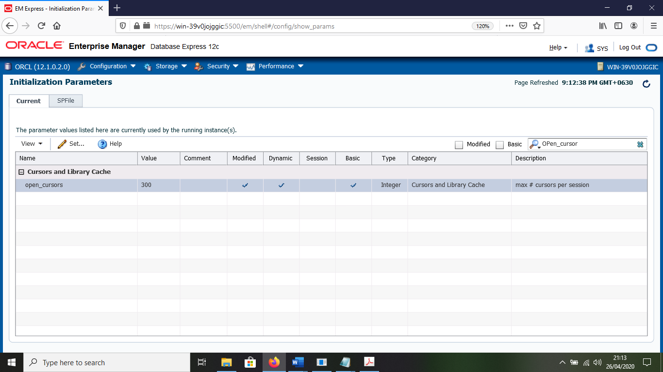

The type of the parameter of OPEN_CURSORS is dynamic.

The purpose of dynamic parameter is

- Parameters can be changed while the instance is running

- Changes take effect immediately

-Optionally be written out to the spfile.

- If the change is not saved to the spfile, then the change will only persist until the instance is stopped.

The parameters used to build the instance come from Initialisation Parameter file. Difference between dynamic and static parameter is as shown in the following table.

|  |  |  |
| --- | --- | --- |
| Initialization  parameter | Dynamic | Static |
|  | - Parameters can be changed while the instance is running  - Changes take effect immediately  -Optionally be written out to the spfile.  - If the change is not saved to the spfile, then the change will only persist until the instance is stopped. | - Parameters cannot be changed for the current instance.  - Must change parameters in the text initialization file or sever parameter file and then restart the database.  - Then it will come into effect at the next startup. |

***Question 3***: Earlier in this lab, you’ve changed the OPEN_CURSORS parameter to 200, what is the value now. Provide the screen-shot. Explain why the value is different now.

ANS:

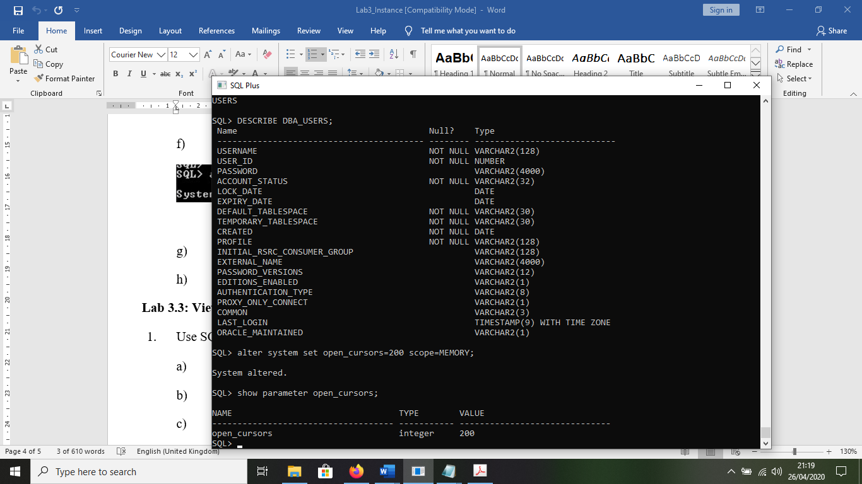

The value is different because it is dynamic parameter. Parameters can be changed while the instance is running and changes take effect immediately.

**---------------------------------------------------------------------------------------------------------**

**Lab 4**

***Question 1:*** What is the status of the tablespace USERS? Explain the meaning of different statuses and different modes of the tablespace.

ANS:

The status of tablespace USERS is “ONLINE”. In SQLDeveloper, we can check as follow by using SYS account.

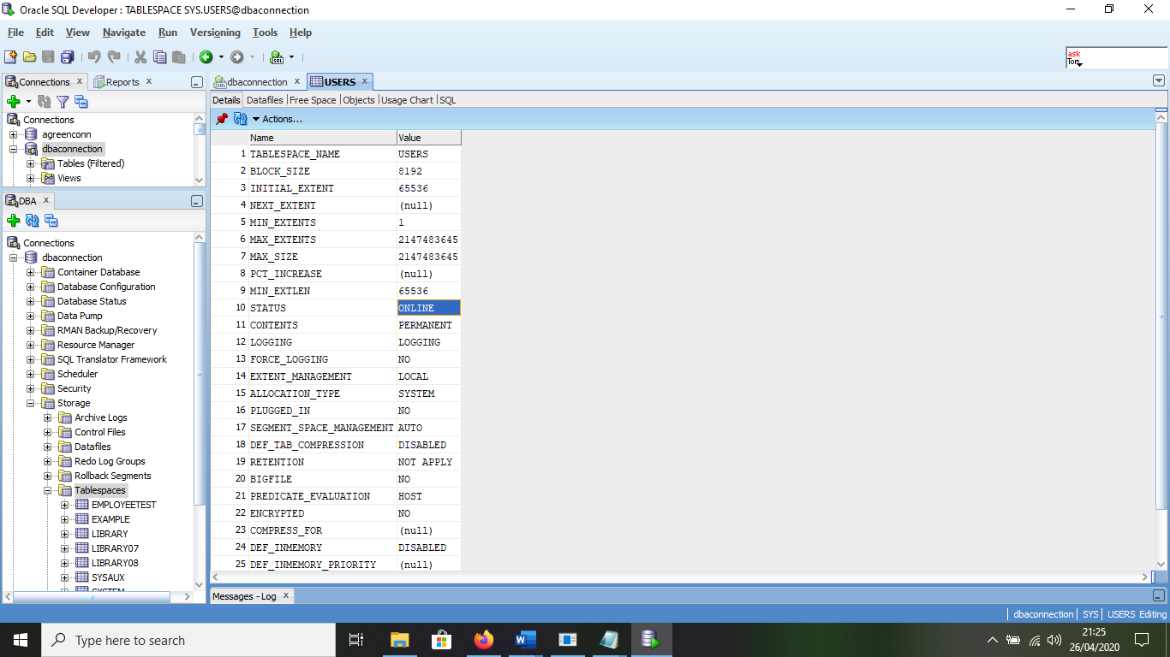

Two different tablespace modes are Online and Offline.

**1. Online**

i)Read Write

- Users can read and write to the tablespace after it is created

- This is the default status

ii) Read Only

- If the tablespace is created Read Only, then the tablespace cannot be written to until its status is changed to Read Write

**2. Offline**

-If the tablespace has a status of Offline, then no users can access it

-You might change the status of a tablespace to Offline before performing maintenance or recovery on the data files associated with that tablespace

***Question 2:***How many data files are used by USERS tablespace? What their names and location? Make a screenshot and provide an explanation.

**ANS:**

Only one data file is used by USERS tablespace. It can be found in Datafiles tab in USERS tablespace.

The name of data file is user01.dbf. It is located in c:\oracle\oradata\orcl\.

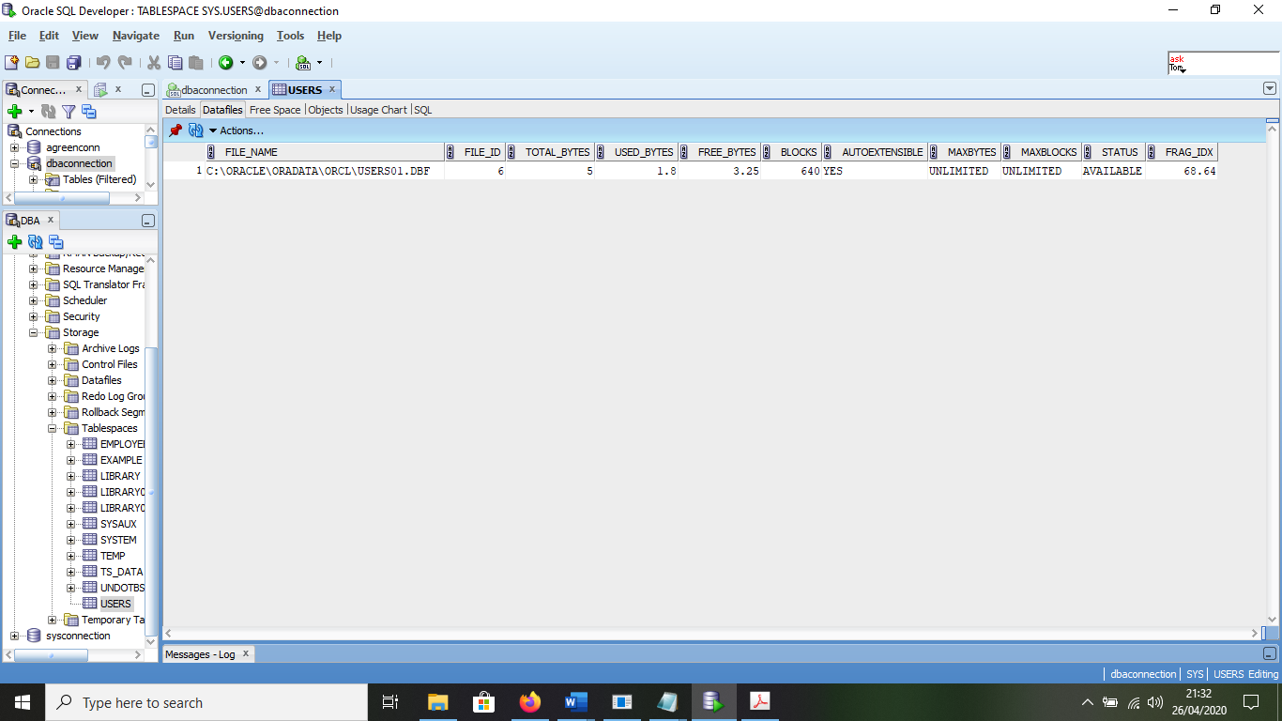

The Oracle database stores data logically in tablespaces and physically in data files.

Data files:

- Can belong to only one tablespace and one database

- Are a repository for schema object data

***Question 3:*** How many tables are stored in the tablespace USERS? Make a screenshot and explain how you found this information.

**ANS:**

There are 60 tables in tablespace “USERS”. We can find by using following SQL,

SQL> select owner, table_name, tablespace_name from dba_tables

where tablespace_name='USERS' order by owner, table_name;

or

SQL> select COUNT(table_name) from dba_tables where tablespace_name='USERS';

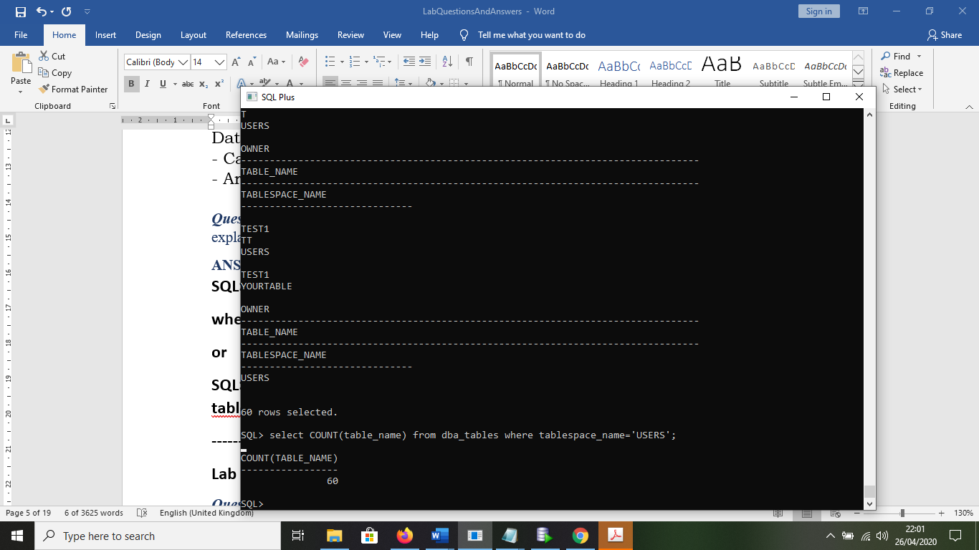

**-----------------------------------------------------------------------------------------------**

**Lab 5**

***Question 1:*** If the properties of the profile are set to DEFAULT, what **actual values** will be assigned to each property?

**ANS:**

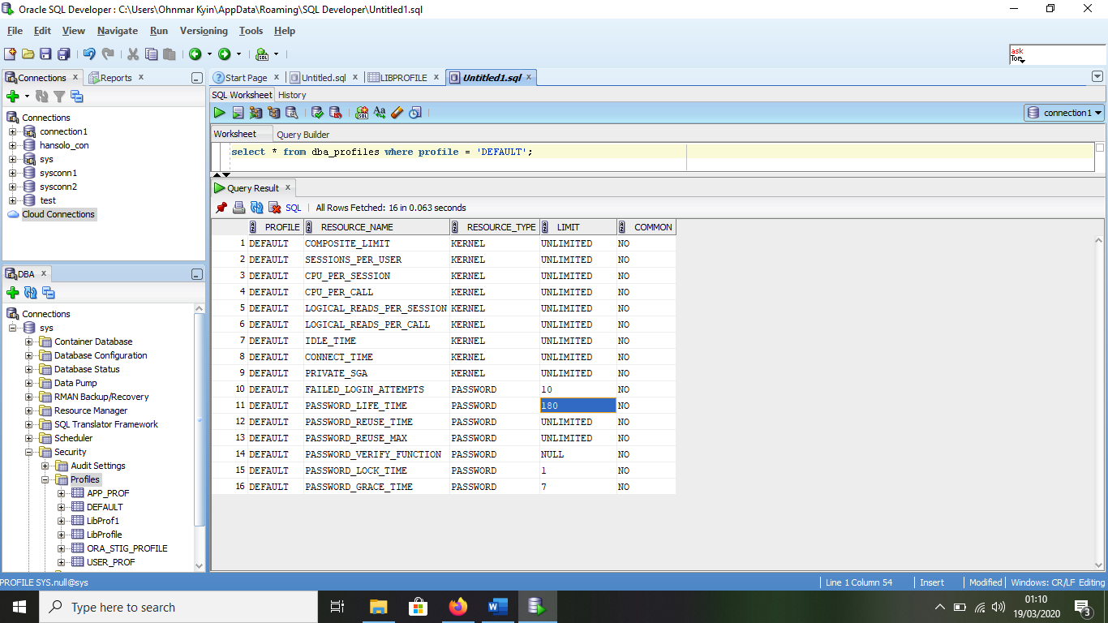

***Question 2:*** What SQL command is needed to create the profile **LIBPROFILE**? Write down the command and provide explanation.

ANS:

SQL> CREATE PROFILE **LIBPROFILE**

**LIMIT**

SESSIONS_PER_USER UNLIMITED

CPU_PER_SESSION UNLIMITED

CONNECT_TIME 45;

FAILED_LOGIN_ATTEMPTS 3

PASSWORD_LOCK_TIME 1

PASSWORD_LIFE_TIME 60

PASSWORD_REUSE_TIME 45

PASSWORD_REUSE_MAX 4;

Explanation:

The user with this profile can have any number of concurrent sessions ; in a single session, the user can consume an unlimited amount of CPU time; a single session cannot last for more than 45 minutes will be locked after 3 failed login attempts; it will be locked for 1 day; the password will expire in 60 days; the user has to wait for 45 days before re-using the same password; the same password can be reused 4 times.

//to change profile setting for example,

SQL>ALTER PROFILE LIBPROFILE LIMIT IDLE TIME 30;

***Question 3:*** What is the purpose and the benefits of using profiles? Explain.

**ANS:**

* A profile is a named set of resource limits and password parameters that restrict database usage and instance resources for a user.
* Each user can have only one profile, and creating a new one supersedes an earlier version.
* Profiles are used to manage the resource limits of related users.
* DBA needs to create and manage user profiles only if resource limits are a requirement of your database security policy.

See some

* We can enforce a limit on resource utilization using resource limit parameters.
* We can maintain database security by using password management feature.

**---------------------------------------------------------------------------------------------------------**

**Lab 6**

***Question 1.*** Provide a screen-shot and explain how you as a DBA can verify certain details of the user account (for example, default tablespace and quota)?

ANS:

DBA can be able to verify certain details of the user account by using username in where condition as shown in SQL below.

SQL> SELECT * FROM DBA_USERS where username='AGREEN';

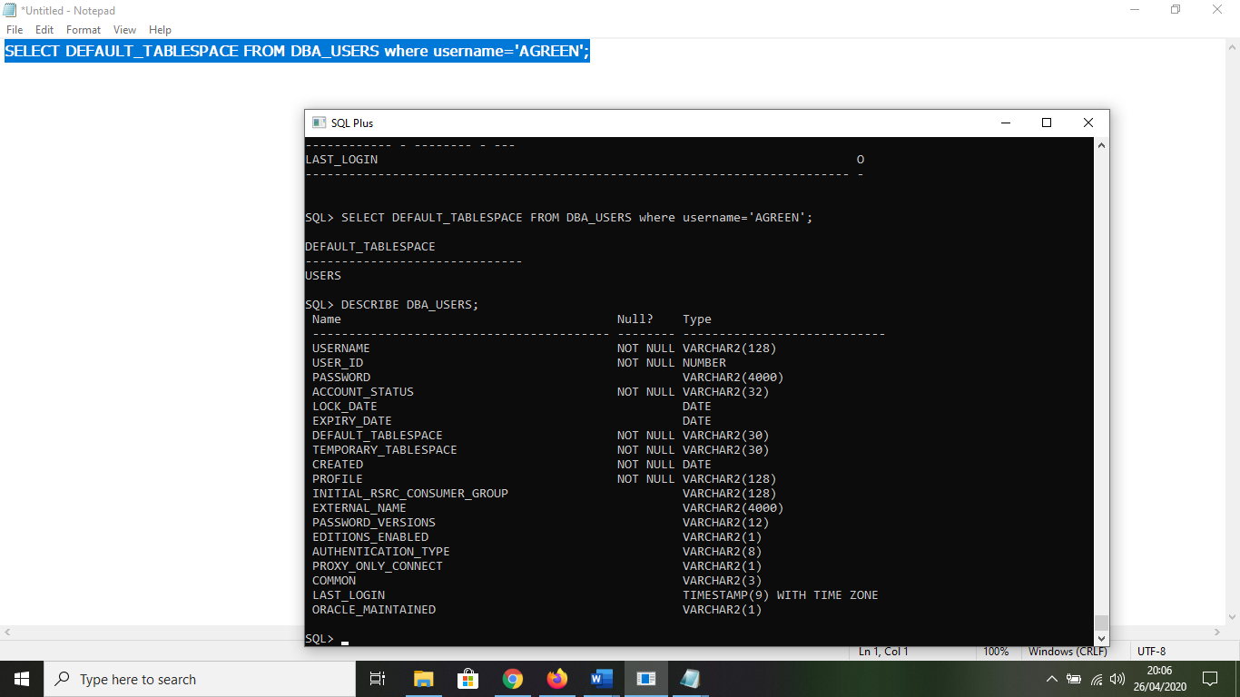

***Question 2:*** Provide a screen-shot of the SQL command for creating books_main table and its result. Make sure that all constraints have user-defined names as specified in the specification above. Explain every line of the code.

ANS:

CREATE TABLE AGREEN.BOOKS_MAIN (

BOOK_ID NUMBER(7) constraint book_id_pk PRIMARY KEY,

TITLE VARCHAR2(100) constraint book_title_nn NOT NULL,

CODE VARCHAR2(20) constraint book_code_nn NOT NULL,

REORDER_THRESHOLD NUMBER(5) CONSTRAINT book_reord_chk CHECK (REORDER_THRESHOLD>0),

PRICE NUMBER(5,2)

) tablespace LIBRARY;

table name “**BOOKS_MAIN**” in “**AGREEN**” is created with the statement “**CREATE TABLE AGREEN.BOOKS_MAIN**”, using schema.table naming database object.

- **BOOK_ID** is defined by CONSTRAINT **book_id_pk** user defined primary key constraint and defined on a column level. Datatype is used by NUMBER.

- Datatype of **TITLE** is VARCHAR2(100). It is defined by **book_title_nn** user defined NOT NULL constraint and it is defined only on a column level.

- Datatype of **CODE** is VARCHAR2(20). It is defined by **st_fname_NN** user defined NOT NULL constraint and it is defined only on a column level.

- **REORDER_THRESHOLD** is NUMBER(5) and defined by CONSTRAINT **st_gen_CK** user defined check constraint CHECK (REORDER_THRESHOLD>0).

PRICE is data type NUMBER(5,2).

It is created in tablespace LIBRARY.

***Question 3:*** Write SQL statement to create hr.dept_stats view and explain your code.

ANS:

CREATE VIEW AGREEN. DEPT_STATS

("DEPARTMENT_NAME","STAFF","AVG_SALARY","MAX_SALARY","MIN_SALARY")

AS

SELECT D.DEPARTMENT_NAME AS DEPARTMENT_NAME,

COUNT (E.EMPLOYEE_ID) AS STAFF,

AVG(E.SALARY) AS AVG_SALARY,

MAX(E.SALARY) AS MAX_SALARY,

MIN(E.SALARY) AS MIN_SALARY

FROM HR.DEPARTMENTS D, HR.EMPLOYEES E

WHERE D.DEPARTMENT_ID=E.DEPARTMENT_ID

AND D.DEPARTMENT_NAME IS NOT NULL

GROUP BY D. DEPARTMENT_ID, D.DEPARTMENT_NAME

ORDER BY D.DEPARTMENT_NAME;

We create view name DEPT_STATS in AGREEN Schema with

CREATE VIEW command CREATE VIEW AGREEN.DEPT_STATS

And the attributes of views are

DEPARTMENT_NAME,STAFF,AVG_SALARY,MAX_SALARY,MIN_SALARY

And we use “AS” keyword to define SELECT command.

**To Query View, we can write SQL as below**

**SQL> SELECT * FROM AGREEN.dept_stats;**

***Question 4:*** Discuss the benefits and drawbacks of using views.

**ANS:**

A SQL view is a virtual table constructed from other tables or views. A view has no data of its own, but rather depends on the data in tables or other views.

Once the view is created, it can be used in the FROM clause of a SELECT statement as though it is a table.

**Benefits**

Security: Views can be used to hide columns. This is done to simplify results or to prevent the display of sensitive data.

Simplicity: Views can be used to show the results of computed columns without requiring the user to enter the computation expression. Views can be used to hide complicated SQL syntax.

Logical data independence: View can make the application and database tables to a certain extent independent. If there is no view, the application must be based on a table. With the view, the program can be established in view of above, to view the program with a database table to be separated.

Layer built-in function: For example, you can construct a view that computes a variable and then write an SQL statement that uses that view that uses the computed variable in a WHERE clause.

**Drawbacks**

Performance: Views create the appearance of a table, but the DBMS must still translate queries against the view into queries against the underlying source tables. If the view is defined by a complex, multi-table query then simple queries on the views may take considerable time.

Update restrictions**:** When a user tries to update rows of a view, the DBMS must translate the request into an update on rows of the underlying source tables. This is possible for simple views, but more complex views are often restricted to read-only.

**---------------------------------------------------------------------------------------------------------**

**Lab 7**

***Question 1:*** Explain why RPATEL sees the different phone number for the employee 110 from the phone number visible to PJONES at the moment. Explain where the old number is stored at this stage.

ANS:

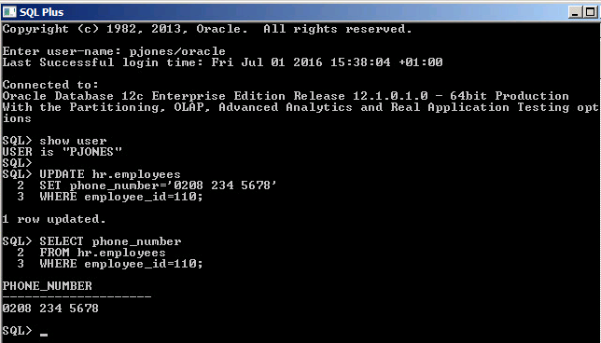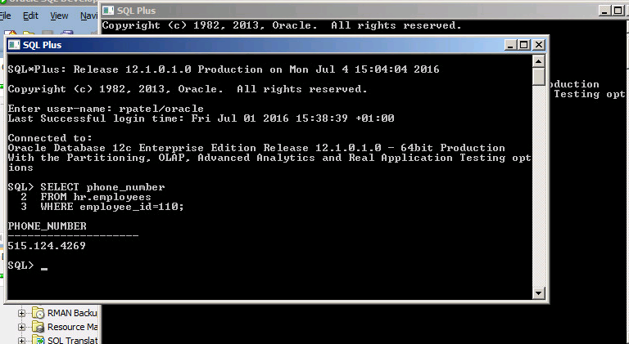

This is done by data concurrency. Data concurrency ensures that different transactions can be updating different rows within the same table without interfering with one another.

- Prevents multiple sessions from changing the same data at the same time.

- It is implemented through locking mechanism. It works before the database allows a session to modify data, the session must first lock the data that is being modified.

- Concept of Lock: When the DML operation is done on a table then oracle puts on the row which is going to be affected because of DML statement do that the concerned row cannot be updated by any other transaction. This is called row lock. Before putting a row lock, it also puts a table lock so that the table cannot be altered by other transactions.

- Lock held until the transaction ends (with the commit or rollback operation)

- Oracle supports both manual and automatic locking. But no lock require for queries.

- Automatic locking mechanism provides the data concurrency needed for most applications. The lock mechanism defaults to a fine-grained, row-level locking mode. This means that different transactions can be updating different rows within the same table without interfering with one another.

- Lock are not released until the user commits or makes full rollback. Users can also try to acquire locks directly or indirectly while holding another lock and most of the locks are exclusive (only one transaction can acquire lock). This may bring the situation of deadlock.

***Question 2:*** Discuss the Data Concurrency concept and how it is implemented in the Oracle database.

ANS:

Data Concurrency ensures that different transactions can be updating different rows within the same table without interfering with one another

- prevents multiple sessions from changing the same data at the same time

- is implemented through the locking mechanism

-Before the database allows a session to modify data, the session must first lock the data that is being modified

-Locks held until the transaction ends (with the COMMIT or ROLLBACK operation)

-Oracle supports both manual and automatic locking

- No locks required for queries

The automatic locking mechanism provides the data concurrency needed for most applications

The lock mechanism defaults to a fine-grained, row-level locking mode

Different transactions can be updating different rows within the same table without interfering with one another

***Question 3:*** Explain what is happening in this step (Lab7.3, 1a) and the reason why.

ANS:

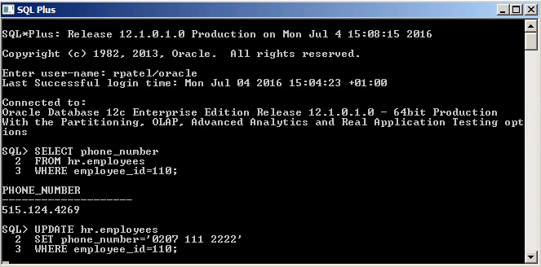

When employee_id=110 is updated by RPATEL’s account while Pjones was updating and have not committed yet, **lock conflicts occurs.**

Because of uncommitted updated from PJONES.

This conflict can be resolved by terminating (by killing) the session holding the lock.

Open SQL Developer navigate menu Tools->Monitor Sessions: find the blocking session and with the help of the right mouse click choose Kill Session menu.

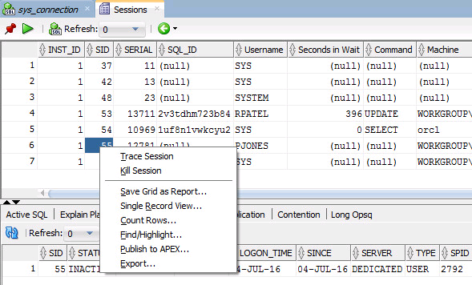

**Lab 8**

***Question 1***: What SQL command do you need to execute to check the existence of the table books_main in the agreen schema using **dba_tables data dictionary view**? Execute the command in SQL*Plus. Make a screen-shot of the result and explain.

ANS:

SQL> SELECT table_name FROM dba_tables where owner=’AGREEN’ and table_name=’books_main’;

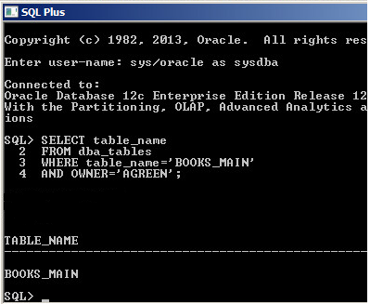

Explanation:

Relational database stores not only user data, but also a metadata. Metadata is stored in data dictionary. It contains the names and attributes of all objects in the database. This information is stored in the base tables of the data dictionary. There are three kinds of Data Dictionary views as shown in figure below.

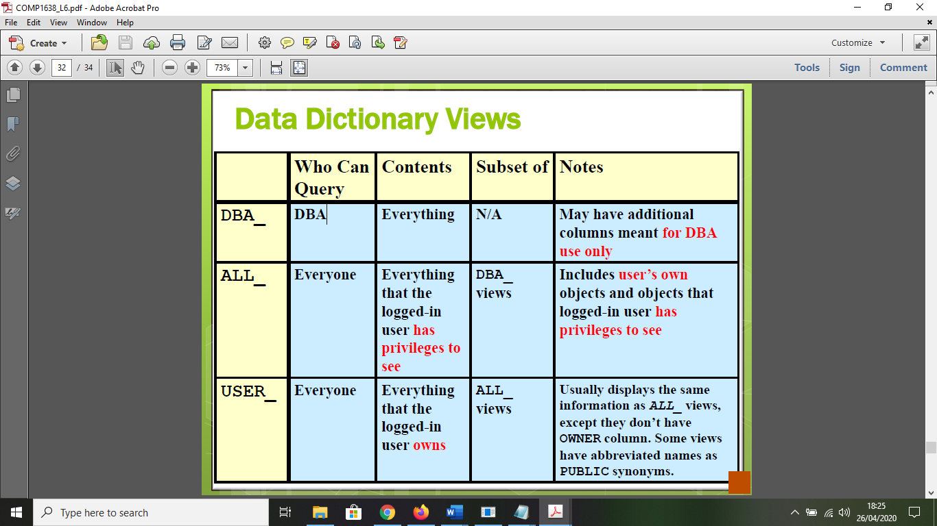

1. dba_tables : SQL> SELECT * FROM dba_tables;

2. all_tables: SQL>SELECT * FROM all_tables;

3. user_tables: SQL>SELECT * FROM user_tables;

In order to check the existence of the table ‘BOOKS_MAIN’ in AGREEN schema, we use data_tables view with the conditions owner=’AGREEN’ and table_name=’BOOKS_MAIN’. We display table_name in this schema as SQL result as follow.

SELECT table_name FROM dba_tables where owner=’AGREEN’ and table_name=’BOOKS_MAIN’;

***Question 2***: What SQL command do you need to execute to recover completely table books_main after it has been dropped accidently? Explain how this feature is implemented.

**ANS:**

In order to drop table books_main, we can use SQL command

SQL>drop table books_main;

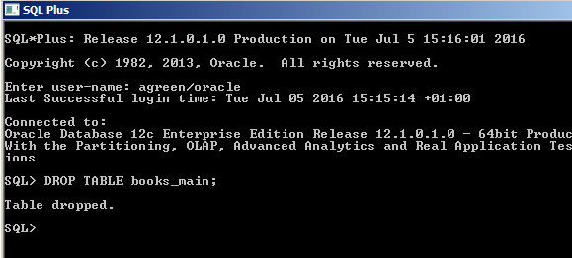

The books_main table is dropped into the RECYCLE BIN. We can check the content of the **Recycle Bin** in SQL*Plus:

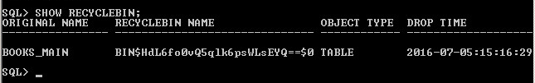

To recover table books_main, we can use **Flashback Drop** functionality.

SQL> FLASHBACK TABLE AGREEN.BOOKS_MAIN TO BEFORE DROP;

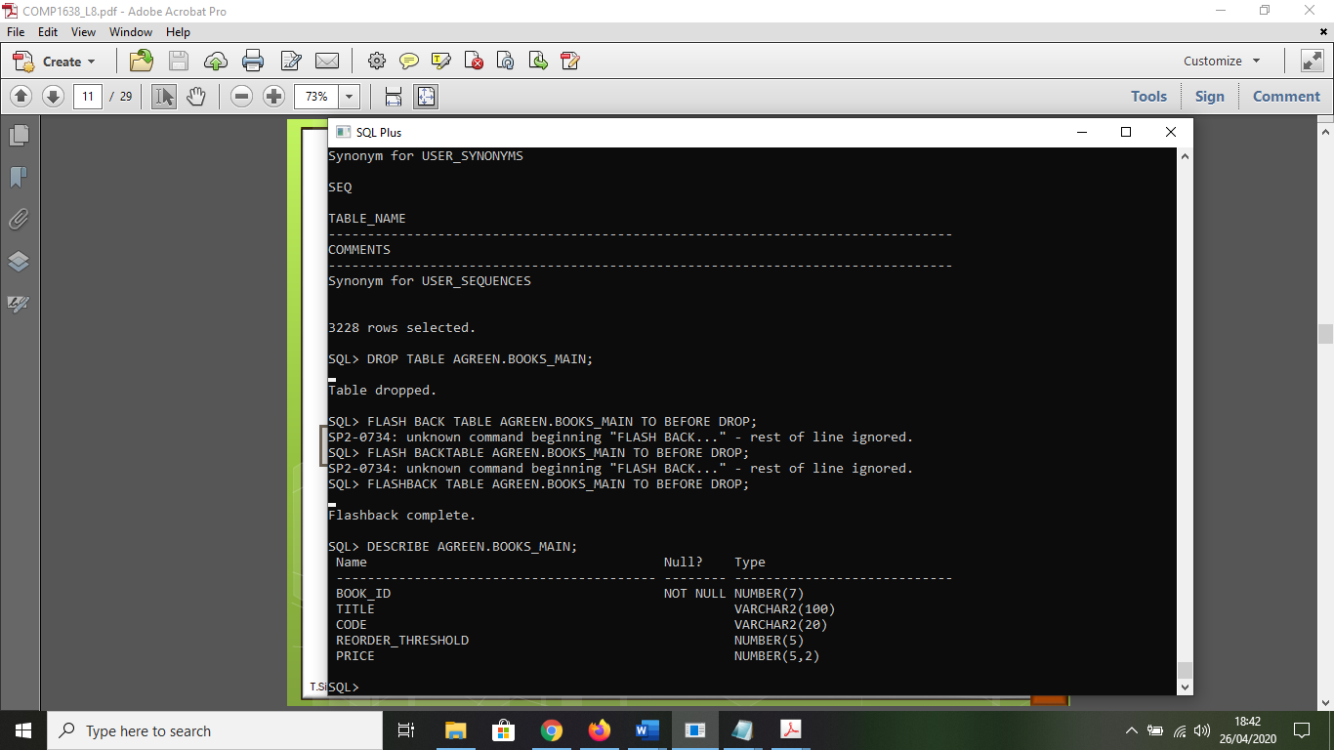

Flashback technology can be used when a logical corruption occurs in an Oracle database and you need to recover data quickly and easily

Starting from Oracle 10g, the DROP TABLE statement moves a table or object to the recycle bin and gives to a table and its associated objects system-generated names.

The recycle bin itself is a data dictionary table that maintains the relationships between the original names of dropped objects and their system-generated names.

You can query the content of the recycle bin by using the DBA_RECYCLEBIN view. A user can view only objects that she or he has access to in the recycle bin. (SQL>show recyclebin;)

The RECYCLEBIN initialization parameter is used to control whether the Flashback Drop capability is enabled.

If the parameter is set to OFF, then dropped tables do not go into the Recycle Bin. If this parameter is set to ON, the dropped tables go into the Recycle Bin and can be recovered. By default, RECYCLEBIN is set to ON.

SQL>alter database FLASHBACK ON;

SQL>alter database FLASHBACK OFF;

***Question 3:*** What is the result of the ROLLBACK command? Explain why it didn’t succeed; discuss the database principles that are implemented here to provide this behaviour***.***

**ANS:**

For example, I updated the title of the book to ‘Facebook for Dummies’ in the last record, but I forgot to put ‘where’ condition into your update command and therefore updated all records and **committed** that transaction:

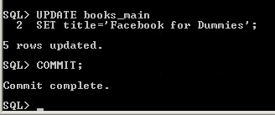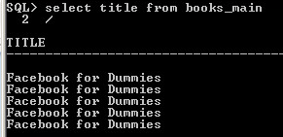

When I query the title of books_main, all the records are same. I realised that you made a mistake, try to roll back the changes using ROLLBACK command. But it did not succeed. Because A transaction ends with one of the A COMMIT or ROLLBACK statements issued. So, I could not rollback after I had committed. It ensures data consistency principle in ACID properties since the database must be left in a consistent state.

In this situation, we can recover that erroneous transaction with the help of FLASHBACK TABLE command using the correct SCN in SQLPlus as follow.

We can get System Change Number (SCN) by following SQL command first.

SQL> SELECT versions_xid , versions_startscn, versions_operation

FROM Books_main VERSIONS BETWEEN SCN MINVALUE AND MAXVALUE;

Or in SQLDeveloper,

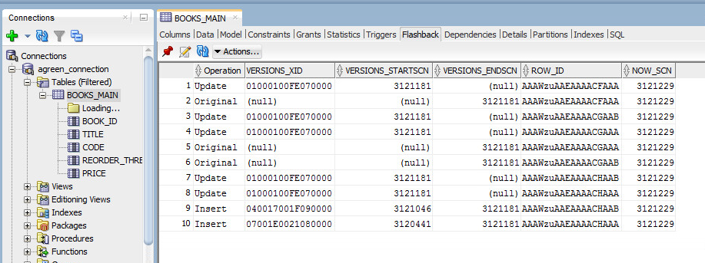

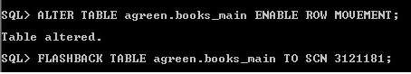

**----------------------------------------------------------------------------------------------------------**

**Lab 9**

Question 1. One of the main responsibilities of the DBA is to protect the database and be able to recover it from various failures in the timely manner.

What is your understanding of logical and physical database backup?

ANS: Logical backups of a database contains logical data such as tables and stored procedures.

Logical backups exported from a database with an Oracle export utility and stored in a binary file, for later re-importing into a database using the corresponding import utility.

The records are read independently of their physical location.

Export file will contain the commands necessary to completely re-create all the chosen objects and data.

**Data Pump** Import utility is used to import the data.

Physical backups are the foundation of any sound backup and recovery strategy

A physical backup involves copying the files that constitute the database (datafiles, control files, and archived redo logs)

Logical backups are a useful supplement to physical backups but are not sufficient protection against data loss without physical backups

An effective backup strategy must be based on physical backups.

Backup strategies:

Whole: A backup of the control file and all datafiles that belong to a database

Partial: A portion of the database

Backup types:

Full: A non-incremental RMAN backup

Incremental: Only information that has changed since some previous backup

Backups modes:

Offline: Consistent, also referred to as cold backup

Online: Inconsistent, also referred to as hot backup

Backups storage:

Image copies: Duplicate data and log files in OS format

Backup sets: Binary, compressed files in Oracle proprietary format

1. What are the differences between those two types of the backup?

ANS: Physical backup is the operating system saves the database files onto tape or some other media. This is useful to restore the system to an earlier point whenever needed.

Physical backups are the foundation of any sound backup and recovery strategy

A physical backup involves copying the files that constitute the database (datafiles, control files, and archived redo logs)

In logical backup technique, the IMPORT/EXPORT utilities are used to create the backup of the database. A logical backup backs-up the contents of the database.

Logical backups are a useful supplement to physical backups but are not sufficient protection against data loss without physical backups.

In logical backup, we don't take the copies of any physical things, we only extract the data from the data files into dump files. (ex : using export )

1. Provide examples when each type would be the most beneficial.

ANS: Logical backups are a useful supplement to physical backups but are not sufficient protection against data loss without physical backups.

Logical backup is useful when we want to back database and other schema objects.

Logical backup is done at schema level which is solely Oracle structure and OS systems cannot see those. It is done via export datapump utility, in brief expdp. This backup is very flexible as it backups up only precisely defined objects within schema=user ownership.

Physical backup is useful when media failure occurs and Oracle Database is unable to write to a physical file. This may occur because of a disk head crash or other disk failure, because needed devices are not powered on, or because a file is corrupt. The advantage of RMAN backups is also possibility to reverse to a certain SCN, SCN standing for system change number, virtually allowing to restore the physical layer of data to any state where any change occurred. RMAN does this using redologs storing all changes made to the database.