
National Clearing Company of Pakistan Limited

Doc. # IT-BAS-SRS-016/16
CRF No. NCCPL-OPS/189/2016, NCCPL-OPS/171/2015, NCCPL-OPS/129/2014
Software Requirements Specification

For
Multiple NCS Account for same UIN
NCS for BATS & NDM (Phase 1)
Exposure Drop-Out for Affirmed NCS Transactions

Version 1.0

Internal & Confidential

Disclaimer

The information contained in this document is the proprietary and exclusive property of National Clearing Company of Pakistan Limited (NCCPL). Any reproduction, transmission or usage for any purpose of this document, in whole or in part, without the prior written permission of NCCPL is strictly prohibited. Any violation of the said will be subjected to legal action against the violator.

Document Overview

Title | Multiple NCS Account for same UIN  NCS for BATS & NDM (Phase 1)
Type of Document | Software Requirements Specification
Issuing Group/Section | AMG
Issuing Department | IT
Author | Sahar Afshan
Document # | IT-BAS-SRS-016/16
Version # | 1.0
Release Date | February 22, 2016
Status
Classification | Internal & Confidential

Document History

Version | Author(s) | Date | Comments | Reviewed / Approved By | Reviewer’s / Approver’s Designation | Reviewed / Approved On
1.0 | Sahar Afshan

Table of Contents
Introduction: 6
2. Business Case: 7
3. Screens 10
4. Reports/Downloads 17
5. Procedures 18
6. BATS & NDM Markets 19
7. Dropout Mechanism For NCS Trades 53
8. SECURITY Practices Checklist 54

Introduction:

Purpose:
This document has been managed to provide the comprehend approach which will be followed by NCCPL during the development of the proposed changes/new development into the Multiple NCS Account for same UIN & NCS for BATS & NDM (Phase 1)
Scope:
This document addresses the Business case in brief and basic software requirements in detail of the Screens and the download required in the development of aforesaid system.

Intended Audience:
The intended audience of this document consists of:
  - Operations Department Personnel/ PD – Mainly those who will review the SRS to grant approval of completion for further processing
  - AMG – Application Management Group responsible for design and coding of the system.
  - QMG - Quality Management Group responsible for configuration management and quality assurance of the system changes.

Document Organization:
The rest of the document is organized as follows:
- Business Case – this section describes the business case for Multiple NCS Account for same UIN & NCS for BATS & NDM by this SRS.
- Screens- this section determine the new screen and changes in the existing functionalities.
- Procedures- this section determine the new procedures and changes in the existing procedures.
- Reports- this section determine the new reports and changes in the existing reports.
- Business Case:
Multiple NCS Account for same UIN
Presently, NCS system does not allow creating multiple NCS Accounts for same UIN. However, following modifications are required in the system to cater the requirements of registering multiple NCS accounts for same UIN. This shall facilitate to register and segregate ledger and reports of clients working with different Mutual Funds.
- NCS Account Registration Screen
- Option shall be provided to select NCS Type i.e. “Normal Client” or “SMA/Others”(Specially Managed Account)
- When “Normal Client” is selected, system process shall remain the same.
- One time setup of Mutual Funds and no separate screen will be developed
- UIS User ID will be generated as per existing mechanism and no suffix of 01, 02 etc will be added in creating in UIS User ID.
- System shall allow to define several mutual funds for same SMA which shall be tagged with their respective sub-accounts
- For SMA Clients, Multiple UIS accounts will be opened under same UIN. Email ID & Password will be performed accordingly
- Multiple NCS Accounts will be opened by Admin User & marked with relevant UIS ID.
- UIN Add Screen
- Modification shall be made on the screen so that when a CM selects NCS Client Type, an option shall be made available to select NCS type of the mentioned defined UIN.
- If “Normal Client” is selected, sub-account not bind with any mutual fund shall be reflected.
- If “SMA/Others” is selected, system shall require to select name of the Mutual Fund from drop down menu.
- Once Mutual Fund is selected, the CDS Account as provided in the NCS Registration Screen will automatically be tagged with such client code registered by BCM.
- BCM can create multiple client codes with each mutual fund as required
- Ledger
- For “Normal Clients”, security and fund ledger position, and handling will remain same as per current process.
- For “SMA/Others” accounts maintained with single or multiple mutual funds, Security and Fund Ledger positions shall be managed at UIN and Mutual Fund level. Allocation of Funds/Securities shall also be made at NCS A/c Level.
- Netting for affirmation shall only be allowed between trades of a “Mutual Fund” Client having same sub-account.
- Affirmation
- Accordingly, all NCS transaction affirmation of SMA Accounts will be based on BCM, UIN and Mutual Fund level.
- For “Normal Clients”, same process will remain applicable.
- UIS/NCS Reports
- For NCS Type “Normal Client” reports shall remain same.
- For NCS Type “Mutual Fund” reports shall only show trades/transactions carried out on the sub-account of logged-in user.
BATS and NDM Markets
Presently NCS facility is available for Regular ad ODD Lot Market trades. However, for the facilitation of the investors to avail NCS functionality for all other market segments, necessary changes are required in NCSS so that trades of all markets be settled under NCS.
NCS clients shall be allowed to trade in BATS and NDM Market in the following manner:

- Trades – Initiation and Confirmation:

- Trades of NCS Client will be executed by the respective Trading CM(s) at Pakistan stock exchange with the client code having category “NCS”.

- Trades once executed by Trading CM for NCS clients, such trades will be transmitted by Pakistan stock exchange to NCSS like other NCS trades. Accordingly, NCS clients’ trades shall be auto-initiated to NCCPL.

- Such auto-initiated trades will be auto-affirmed by NCCPL subject to the availability of cash/ Securities balances of client with NCCPL.

- Auto-initiated trades failing validation will remain un-affirmed in NCSS. Accordingly, such un- affirmed trades shall be settled by initiating Trading CM as per existing mechanism.

- Clearing and Settlement Process

- All affirmed NCS trades will be settled in NCSS through Clearing Account of NCCPL on the
respective settlement date. For securities settlement, NCSS will generate Balance Orders
(BOs) in the respective CDS sub-accounts of NCS clients as per normal BO generation
process.

- For cash settlement, bank account of NCCPL will be debited /credited through existing pay &
collect mechanism of NCSS.

- Disbursement of funds to NCS Clients will be carried-out as per existing NCS mechanism.

Impact on Funds/ Security Ledgers is missing
- Screens
To create multiple NCS Accounts for same UIN, the following screens, reports, downloads will be modified accordingly.
- Allocation process of Funds/Securities will be at NCS Account Level/UIS Account
- As CDS Sub Account is unique for all Normal/SMA Clients, therefore handling of NCS Fund and Security Ledger on UIS/NCS User Level
  - NCS Client Registration Screen
NCS client registration screen will be modified as
- Unique CDS Sub account will be required to register for all SMA and Normal Clients
- To create multiple NCS account, separate UIS Ids will be generated
- Multiple NCS Accounts will be opened by Admin user and marked with the relevant UIS ID
- NCS Type will be added in NCS Client registration screen which has two options
  - Normal
  - SMA/Others
- By selecting SMA/Other, the dropdown of Mutual Fund will be auto populated. Mutual Fund will be setup once and no screen will be developed to register or create mutual fund
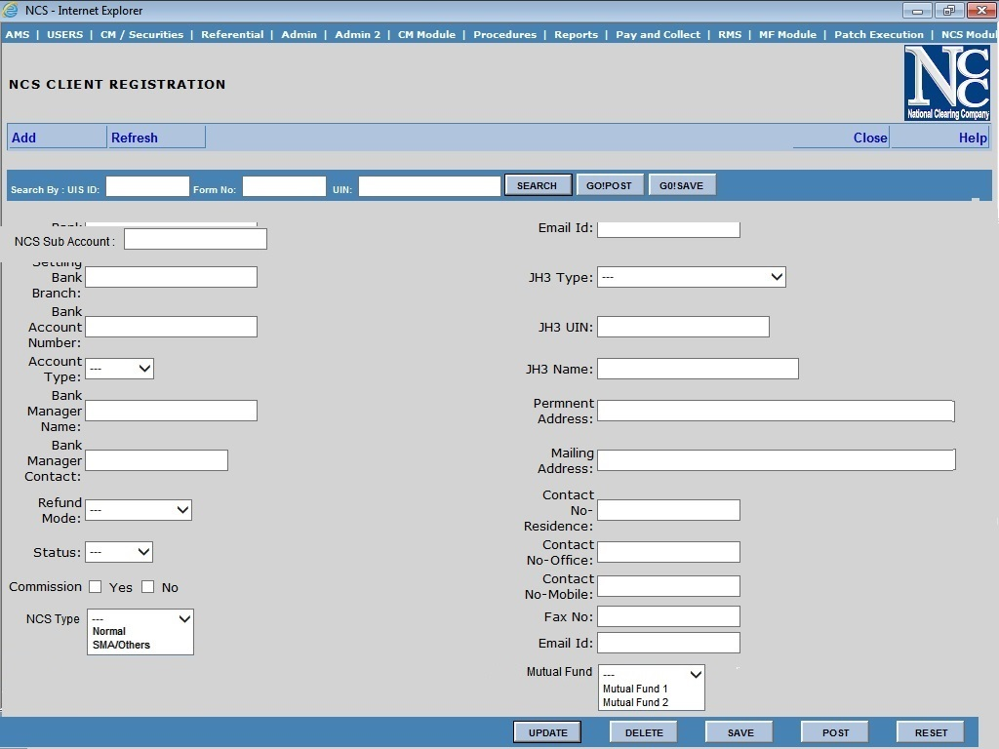
  - UIN Add Screen
- SMA Clients should be register in NCS before open a client code to broker
- When the broker select NCS Category, then a dropdown of NCS Type will be enable
  - If the broker select NCS Type as Normal, processing will remain same and the CDS account number will be populated
  - If the broker select NCS Type as SMA, then a list of CDS Account number will be populated which are associated with the mentioned Mutual Fund
- CDS Sub Account must be unique for each UIS ID for NCS clients
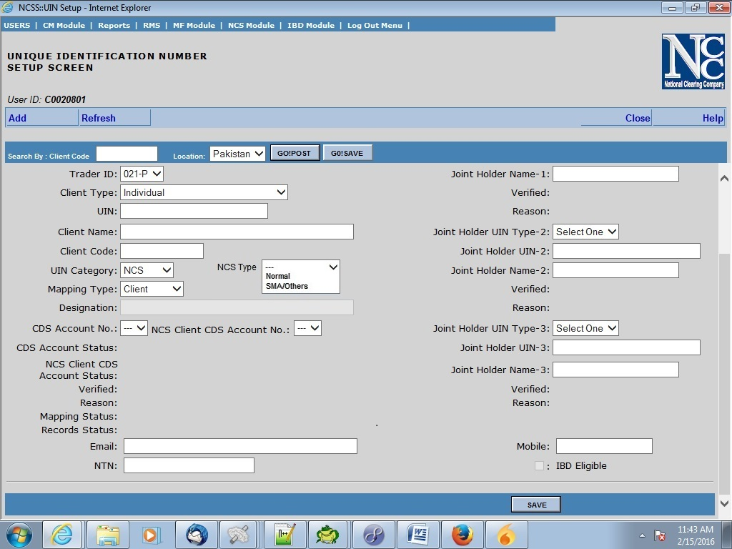

  - Fund Add/Refund Screen in NCSS System
- NCS ID will be mandatory field
- Funds Add / Refund will be based on NCS ID for both Normal and SMA Clients
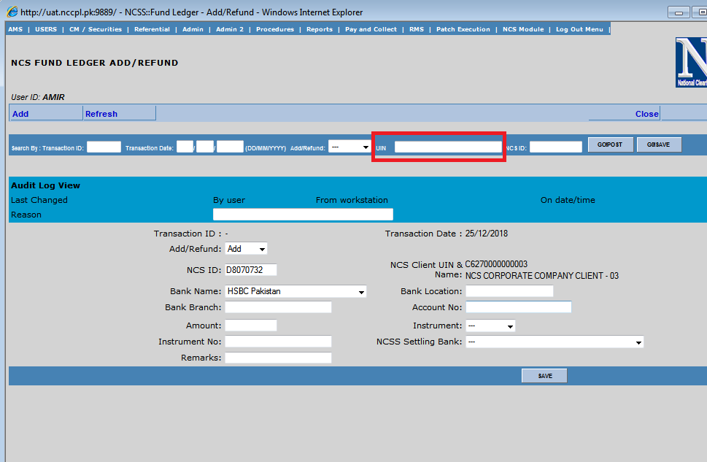
  - Fund Add/Refund Screen in UIS System
- NCS ID will be mandatory field
- Funds Add / Refund will be based on NCS ID for both Normal and SMA Clients
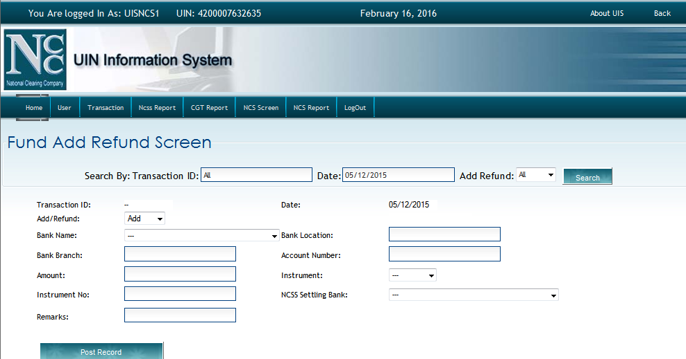

  - Fund Depost/Release Approval/Rejection Screen
- Funds will be approved by admin on NCS UIS ID

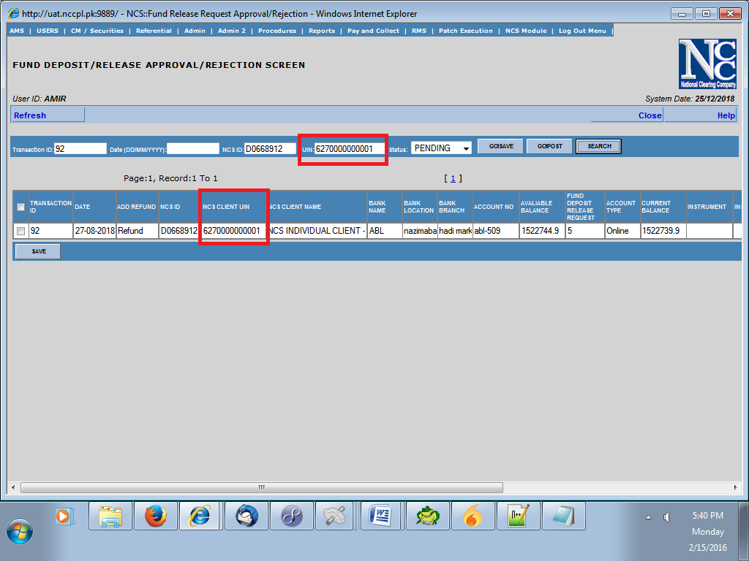

  - NCS Brokerage Commission
- NCS Brokerage Commission screen will be modified and UIN will be replaced with NCS UIS ID for all Normal and SMA Clients
- All the processing of commission will be shifted to NCS UIS ID and no UIN will impact on commission/taxes calculation
- In list, the column of NCS UIS Id will be appended before UIN

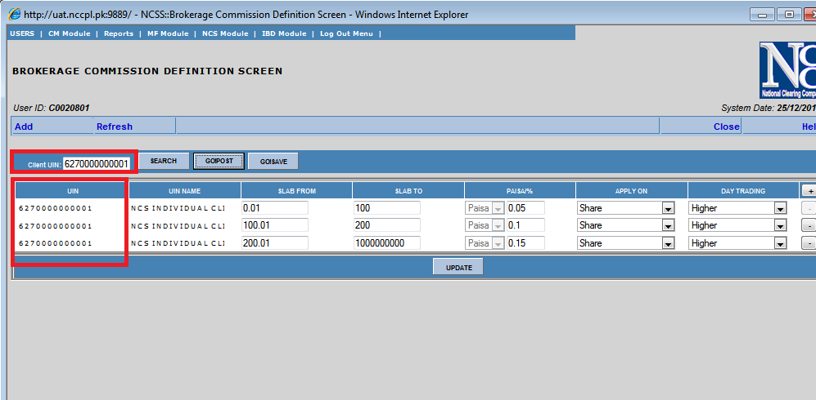

  - NCS CDS Charges Upload
- In existing mechanism, while saving CDS charges, UIN associated with the CDS account number is saved
- After modification for Multiple NCS Account for same UIN, the mechanism will be changed and UIS ID associated with the unique CDS sub account will be saved
- All processing of CDS charges will be shifted to NCS A/CId for all Normal and SMA Clients
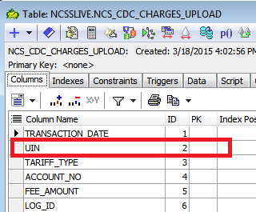

  - NCS CDS Balance Upload
- In existing mechanism, while saving CDS Balance, UIN associated with the CDS account number is saved
- After modification for Multiple NCS Account for same UIN, the mechanism will be changed and UIS ID associated with the unique CDS sub account will be saved
- All processing of CDS Balance will be shifted to NCS UIS Id for all Normal and SMA Clients

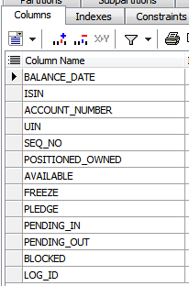

  - NCS Fund Allocation
- Allocation process of Funds/Securities will be at NCS Account Level

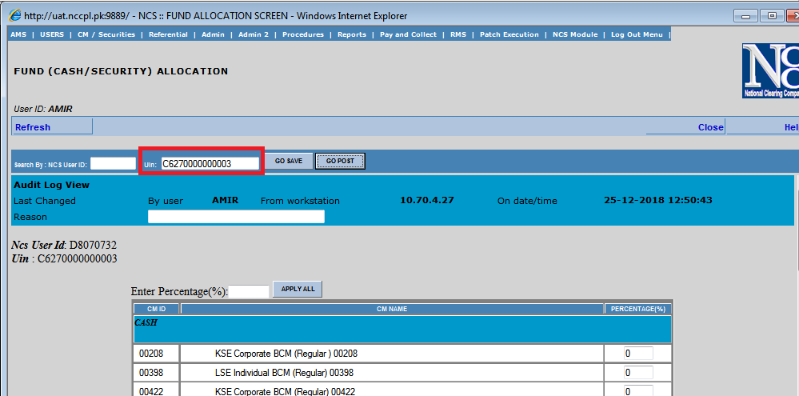
- Reports/Downloads
NCSS System
The following reports will be modified in NCSS system
- Client Position Report
- Fund Ledger
- Account Statement
- Funds Reconciliation
- Bank and Client Wise Detail Report
- Security Ledger
- Security Reconciliation
- Auto Confirm Procedure Control
- Fund Add Refund
- Client Fund Balance
- Client Security Balance
- Fund Add Refund History
- NCS Levy Detail
- Levy Commission Brokerage Detail
- NCS Levy Summary
- Fund Security Allocation
- Account Statement Detail

UIS System
The following reports will be modified in UIS system. These reports will be fetched on CDS Account number w.r.t UIS ID for SMA Clients.
- UIN Save/Post Report
- UIN Purchase/Sale Summary
- UIN Purchase/Sale Detail
- Non Exchange Transactions

- Procedures
The following procedures will be modified
- NCS Affirmed process
- NCS Brokerage Commission Calculation
- NCS Fund Security Ledger
- NCS Data History
Details regarding changes expected in Online Data Transmission for NCS Clients to BCM are missing.

Note: The whole NCS Module will be verified on QAT/UAT to verify the impact of multiple NCS account for same UIN.

- BATS & NDM Markets
- New CM ID will be setup for NCS category for BATS
- Client code created with UIN category NCS will be used to initiate the trades
- Trades will be auto initiated
- If the Securities/Cash balance fulfill the trades requirement then that trade will be affirmed, otherwise un-affirm trades will be settled by Initiating CM
- Securities will be settled in NCS Client CDS Sub Account and cash will be settled through existing pay and collect mechanism
- No RMS for NCS trades will be calculated
- No netting will be performed for NDM and BATS Market

Buy Case of TFC Market (Security)
- In Security ledger report, column of Gross Buy and Sell for Pending BO-NDM & BATS , Unsettled Gross Buy and Sell Position of NDM and BATS and Current Day Buy and Sell Trade Position NDM & BATS will be added.
National Clearing Company of Pakistan Limited
DATE |  | System Date |  |  |  |  |  |  |  |  |  |  |  |  |  |  |  |  |  |  |  |  | For Admin/Client
CM ID |  | All/Specific |  |  |  |  |  |  |  |  |  |  |  |  |  |  |  |  |  |  |  |  | Page
UIN |  | All/Specific |  |  |  |  |  |  |  |  |  |  |  |  |  |  |  |  |  |  |  |  | User ID
NCS USER ID |  | All/Specific |  |  |  |  |  |  |  |  |  |  |  |  |  |  |  |  |  |  |  |  | Date
 |  |  |  |  |  |  |  |  |  |  |  |  |  |  |  |  |  |  |  |  |  |  | Time
Day-1 Without Trading
Client Info |  |  | Clearing Member Info |  | Security Info |  | PSD | Balance as Per CDS Sub-Account |  |  | Pending BO  REG & ODL  Buy / (Sell) | Pending BO - NDM & BATS |  | Un-Settled  Buy / (Sell) Volume | Unsettled Position  NDM & BATS |  | Security Allocation |  | Current Day Trade Position  Reg & ODL |  | Current Day Trade Position  NDM & BATS |  | Shares Balance Available For
ID | UIN | Name | ID | Name | Symbol | Name |  | Available | Pledged / Freezed | Blocked | Pending BO  REG & ODL  Buy / (Sell) | Gross Buy | Gross Sell | Un-Settled  Buy / (Sell) Volume | Gross Buy | Gross Sell | Percentage | Shares | Net Affirmed Balance | Un-Affirmed Sell | Buy | Sell | FD / Pledge Movement | Trading | Affirmation
ABC1 | 123456789 | ABCD XYZ | 01234 | ABC Securities | ABLTFC1 | ABL TFC - 1 |  | 25,000 | 5,000 | 0 | 0 |  |  | 0 |  |  | 70% | 17,500 | 0 | 0 | 0 | 0 |  | 17,500 | 17,500
ABC1 | 123456789 | ABCD XYZ | 54321 | XYZ SECURITIES | ABLTFC1 | ABL TFC - 1 |  | 25,000 | 5,000 | 0 | 0 |  |  | 0 |  |  | 30% | 7,500 | 0 | 0 | 0 | 0 |  | 7,500 | 7,500
 |  |  |  |  |  | Security Wise Total |  | 25,000 | 5,000 |  |  |  |  |  |  |  |  |  |  |  |  |  | 25,000
 |  |  |  |  |  | UIN Wise Total |  | As per Sub-Account |  |  |  |  |  |  |  |  |  |  |  |  |  |  | As per Sub-Account
 |  |  |  |  |  | Grand Total
Day-1
After Trading
Client Info |  |  | Clearing Member Info |  | Security Info |  | PSD | Balance as Per CDS Sub-Account |  |  | Pending BO  REG & ODL  Buy / (Sell) | Pending BO - NDM & BATS |  | Un-Settled  Buy / (Sell) Volume | Unsettled Position  NDM & BATS |  | Security Allocation |  | Current Day Trade Position  Reg & ODL |  | Current Day Trade Position  NDM & BATS |  | Shares Balance Available For
ID | UIN | Name | ID | Name | Symbol | Name |  | Available | Pledged / Freezed | Blocked | Pending BO  REG & ODL  Buy / (Sell) | Gross Buy | Gross Sell | Un-Settled  Buy / (Sell) Volume | Gross Buy | Gross Sell | Percentage | Shares | Net Affirmed Balance | Un-Affirmed Sell | Buy | Sell | FD / Pledge Movement | Trading | Affirmation
ABC1 | 123456789 | ABCD XYZ | 01234 | ABC Securities | ABLTFC1 | ABL TFC - 1 |  | 25,000 | 5,000 | 0 | 0 |  |  | 0 |  |  | 70% | 17,500 | 0 | 0 | 5,000 | (500) |  | 17,000 | 17,500
ABC1 | 123456789 | ABCD XYZ | 54321 | XYZ SECURITIES | ABLTFC1 | ABL TFC - 1 |  | 25,000 | 5,000 | 0 | 0 |  |  | 0 |  |  | 30% | 7,500 | 0 | 0 | 0 | (500) |  | 7,000 | 7,500
 |  |  |  |  |  | Security Wise Total |  | 25,000 | 5,000 |  | 0 | 0 | 0 | 0 | 0 | 0 |  |  | 0 |  |  | (1,000) | 24,000
 |  |  |  |  |  | UIN Wise Total |  | As per Sub-Account |  |  |  |  |  |  |  |  |  |  |  |  |  |  | As per Sub-Account
 |  |  |  |  |  | Grand Total
Day-2
Settlement Day
Client Info |  |  | Clearing Member Info |  | Security Info |  | PSD | Balance as Per CDS Sub-Account |  |  | Pending BO  REG & ODL  Buy / (Sell) | Pending BO - NDM & BATS |  | Un-Settled  Buy / (Sell) Volume | Unsettled Transaction  NDM & BATS |  | Security Allocation |  | Current Day Trade Position  Reg & ODL |  | Current Day Trade Position  NDM & BATS |  | Shares Balance Available For
ID | UIN | Name | ID | Name | Symbol | Name |  | Available | Pledged / Freezed | Blocked | Pending BO  REG & ODL  Buy / (Sell) | Gross Buy | Gross Sell | Un-Settled  Buy / (Sell) Volume | Gross Buy | Gross Sell | Percentage | Shares | Net Affirmed Balance | Un-Affirmed Sell | Buy | Sell | FD / Pledge Movement | Trading | Affirmation
ABC1 | 123456789 | ABCD XYZ | 01234 | ABC Securities | ABLTFC1 | ABL TFC - 1 |  | 25,000 | 5,000 | 0 | 0 | 5,000 | (500) | 0 |  |  | 70% | 16,800 | 0 | 0 | 0 | 0 |  | 16,800 | 16,800
ABC1 | 123456789 | ABCD XYZ | 54321 | XYZ SECURITIES | ABLTFC1 | ABL TFC - 1 |  | 25,000 | 5,000 | 0 | 0 |  | (500) | 0 |  |  | 30% | 7,200 | 0 | 0 | 0 | 0 |  | 7,200 | 7,200
 |  |  |  |  |  | Security Wise Total |  | 25,000 | 5,000 |  | 0 | 5,000 | (1,000) | 0 | 0 | 0 |  | 24,000 | 0 |  |  | 0 | 24,000
 |  |  |  |  |  | UIN Wise Total |  | As per Sub-Account |  |  |  |  |  |  |  |  |  |  |  |  |  |  | As per Sub-Account
 |  |  |  |  |  | Grand Total
Day-2 Settlement Day - Sell Delivered
Client Info |  |  | Clearing Member Info |  | Security Info |  | PSD | Balance as Per CDS Sub-Account |  |  | Pending BO  REG & ODL  Buy / (Sell) | Pending BO - NDM & BATS |  | Un-Settled  Buy / (Sell) Volume | Unsettled Transaction  NDM & BATS |  | Security Allocation |  | Current Day Trade Position  Reg & ODL |  | Current Day Trade Position  NDM & BATS |  | Shares Balance Available For
ID | UIN | Name | ID | Name | Symbol | Name |  | Available | Pledged / Freezed | Blocked | Pending BO  REG & ODL  Buy / (Sell) | Gross Buy | Gross Sell | Un-Settled  Buy / (Sell) Volume | Gross Buy | Gross Sell | Percentage | Shares | Net Affirmed Balance | Un-Affirmed Sell | Buy | Sell | FD / Pledge Movement | Trading | Affirmation
ABC1 | 123456789 | ABCD XYZ | 01234 | ABC Securities | ABLTFC1 | ABL TFC - 1 |  | 24,000 | 5,000 | 0 | 0 | 5,000 |  | 0 |  |  | 70% | 16,800 | 0 | 0 | 0 | 0 |  | 16,800 | 16,800
ABC1 | 123456789 | ABCD XYZ | 54321 | XYZ SECURITIES | ABLTFC1 | ABL TFC - 1 |  | 24,000 | 5,000 | 0 | 0 |  | 0 | 0 |  |  | 30% | 7,200 | 0 | 0 | 0 | 0 |  | 7,200 | 7,200
 |  |  |  |  |  | Security Wise Total |  | 24,000 | 5,000 |  | 0 | 5,000 | 0 | 0 | 0 | 0 |  | 24,000 | 0 |  |  | 0 | 24,000
 |  |  |  |  |  | UIN Wise Total |  | As per Sub-Account |  |  |  |  |  |  |  |  |  |  |  |  |  |  | As per Sub-Account
 |  |  |  |  |  | Grand Total
Day-2
Settlement Day - Delivery received
Client Info |  |  | Clearing Member Info |  | Security Info |  | PSD | Balance as Per CDS Sub-Account |  |  | Pending BO  REG & ODL  Buy / (Sell) | Pending BO - NDM & BATS |  | Un-Settled  Buy / (Sell) Volume | Unsettled Transaction  NDM & BATS |  | Security Allocation |  | Current Day Trade Position  Reg & ODL |  | Current Day Trade Position  NDM & BATS |  | Shares Balance Available For
ID | UIN | Name | ID | Name | Symbol | Name |  | Available | Pledged / Freezed | Blocked | Pending BO  REG & ODL  Buy / (Sell) | Gross Buy | Gross Sell | Un-Settled  Buy / (Sell) Volume | Gross Buy | Gross Sell | Percentage | Shares | Net Affirmed Balance | Un-Affirmed Sell | Buy | Sell | FD / Pledge Movement | Trading | Affirmation
ABC1 | 123456789 | ABCD XYZ | 01234 | ABC Securities | ABLTFC1 | ABL TFC - 1 |  | 29,000 | 5,000 |  | 0 | 0 |  | 0 |  |  | 70% | 20,300 | 0 | 0 | 0 | 0 |  | 20,300 | 20,300
ABC1 | 123456789 | ABCD XYZ | 54321 | XYZ SECURITIES | ABLTFC1 | ABL TFC - 1 |  | 29,000 | 5,000 |  | 0 |  | 0 | 0 |  |  | 30% | 8,700 | 0 | 0 | 0 | 0 |  | 8,700 | 8,700
 |  |  |  |  |  | Security Wise Total |  | 29,000 | 5,000 | 0 | 0 | 0 | 0 | 0 | 0 | 0 |  | 29,000 | 0 |  |  | 0 | 29,000
 |  |  |  |  |  | UIN Wise Total |  | As per Sub-Account |  |  |  |  |  |  |  |  |  |  |  |  |  |  | As per Sub-Account
 |  |  |  |  |  | Grand Total
Sell Case of TFC Market (Security)

National Clearing Company of Pakistan Limited
DATE |  | System Date |  |  |  |  |  |  |  |  |  |  |  |  |  |  |  |  |  |  |  |  | For Admin/Client
CM ID |  | All/Specific |  |  |  |  |  |  |  |  |  |  |  |  |  |  |  |  |  |  |  |  | Page
UIN |  | All/Specific |  |  |  |  |  |  |  |  |  |  |  |  |  |  |  |  |  |  |  |  | User ID
NCS USER ID |  | All/Specific |  |  |  |  |  |  |  |  |  |  |  |  |  |  |  |  |  |  |  |  | Date
 |  |  |  |  |  |  |  |  |  |  |  |  |  |  |  |  |  |  |  |  |  |  | Time
Day-1 Without Trading
Client Info |  |  | Clearing Member Info |  | Security Info |  | PSD | Balance as Per CDS Sub-Account |  |  | Pending BO  REG & ODL  Buy / (Sell) | Pending BO - NDM & BATS |  | Un-Settled  Buy / (Sell) Volume | Unsettled Position  NDM & BATS |  | Security Allocation |  | Current Day Trade Position  Reg & ODL |  | Current Day Trade Position  NDM & BATS |  | Shares Balance Available For
ID | UIN | Name | ID | Name | Symbol | Name |  | Available | Pledged / Freezed | Blocked | Pending BO  REG & ODL  Buy / (Sell) | Gross Buy | Gross Sell | Un-Settled  Buy / (Sell) Volume | Buy | Sell | Percentage | Shares | Net Affirmed Balance | Un-Affirmed Sell | Buy | Sell | FD / Pledge Movement | Trading | Affirmation
ABC1 | 123456789 | ABCD XYZ | 01234 | ABC Securities | ABLTFC1 | ABL TFC - 1 |  | 25,000 | 5,000 | 0 | 0 |  |  | 0 |  |  | 70% | 17,500 | 0 | 0 | 0 | 0 |  | 17,500 | 17,500
ABC1 | 123456789 | ABCD XYZ | 54321 | XYZ SECURITIES | ABLTFC1 | ABL TFC - 1 |  | 25,000 | 5,000 | 0 | 0 |  |  | 0 |  |  | 30% | 7,500 | 0 | 0 | 0 | 0 |  | 7,500 | 7,500
 |  |  |  |  |  | Security Wise Total |  | 25,000 | 5,000 |  |  |  |  |  |  |  |  |  |  |  |  |  | 25,000
 |  |  |  |  |  | UIN Wise Total |  | As per Sub-Account |  |  |  |  |  |  |  |  |  |  |  |  |  |  | As per Sub-Account
 |  |  |  |  |  | Grand Total
Day-1
After Trading
Client Info |  |  | Clearing Member Info |  | Security Info |  | PSD | Balance as Per CDS Sub-Account |  |  | Pending BO  REG & ODL  Buy / (Sell) | Pending BO - NDM & BATS |  | Un-Settled  Buy / (Sell) Volume | Unsettled Position  NDM & BATS |  | Security Allocation |  | Current Day Trade Position  Reg & ODL |  | Current Day Trade Position  NDM & BATS |  | Shares Balance Available For
ID | UIN | Name | ID | Name | Symbol | Name |  | Available | Pledged / Freezed | Blocked | Pending BO  REG & ODL  Buy / (Sell) | Gross Buy | Gross Sell | Un-Settled  Buy / (Sell) Volume | Buy | Sell | Percentage | Shares | Net Affirmed Balance | Un-Affirmed Sell | Buy | Sell | FD / Pledge Movement | Trading | Affirmation
ABC1 | 123456789 | ABCD XYZ | 01234 | ABC Securities | ABLTFC1 | ABL TFC - 1 |  | 25,000 | 5,000 | 0 | 0 |  |  | 0 |  |  | 70% | 17,500 | 0 | 0 | 500 | (5,000) |  | 12,500 | 17,500
ABC1 | 123456789 | ABCD XYZ | 54321 | XYZ SECURITIES | ABLTFC1 | ABL TFC - 1 |  | 25,000 | 5,000 | 0 | 0 |  |  | 0 |  |  | 30% | 7,500 | 0 | 0 | 500 | 0 |  | 7,500 | 7,500
 |  |  |  |  |  | Security Wise Total |  | 25,000 | 5,000 |  | 0 | 0 | 0 | 0 | 0 | 0 |  |  | 0 |  |  | (5,000) | 20,000
 |  |  |  |  |  | UIN Wise Total |  | As per Sub-Account |  |  |  |  |  |  |  |  |  |  |  |  |  |  | As per Sub-Account
 |  |  |  |  |  | Grand Total
Day-2
Settlement Day
Client Info |  |  | Clearing Member Info |  | Security Info |  | PSD | Balance as Per CDS Sub-Account |  |  | Pending BO  REG & ODL  Buy / (Sell) | Pending BO - NDM & BATS |  | Un-Settled  Buy / (Sell) Volume | Unsettled Transaction  NDM & BATS |  | Security Allocation |  | Current Day Trade Position  Reg & ODL |  | Current Day Trade Position  NDM & BATS |  | Shares Balance Available For
ID | UIN | Name | ID | Name | Symbol | Name |  | Available | Pledged / Freezed | Blocked | Pending BO  REG & ODL  Buy / (Sell) | Gross Buy | Gross Sell | Un-Settled  Buy / (Sell) Volume | Buy | Sell | Percentage | Shares | Net Affirmed Balance | Un-Affirmed Sell | Buy | Sell | FD / Pledge Movement | Trading | Affirmation
ABC1 | 123456789 | ABCD XYZ | 01234 | ABC Securities | ABLTFC1 | ABL TFC - 1 |  | 25,000 | 5,000 | 0 | 0 | 500 | (5,000) | 0 |  |  | 70% | 14,000 | 0 | 0 | 0 | 0 |  | 14,000 | 14,000
ABC1 | 123456789 | ABCD XYZ | 54321 | XYZ SECURITIES | ABLTFC1 | ABL TFC - 1 |  | 25,000 | 5,000 | 0 | 0 | 500 | 0 | 0 |  |  | 30% | 6,000 | 0 | 0 | 0 | 0 |  | 6,000 | 6,000
 |  |  |  |  |  | Security Wise Total |  | 25,000 | 5,000 |  | 0 | 1,000 | (5,000) | 0 | 0 | 0 |  | 20,000 | 0 |  |  | 0 | 20,000
 |  |  |  |  |  | UIN Wise Total |  | As per Sub-Account |  |  |  |  |  |  |  |  |  |  |  |  |  |  | As per Sub-Account
 |  |  |  |  |  | Grand Total
Day-2
Settlement Day - Sell Delivered
Client Info |  |  | Clearing Member Info |  | Security Info |  | PSD | Balance as Per CDS Sub-Account |  |  | Pending BO  REG & ODL  Buy / (Sell) | Pending BO - NDM & BATS |  | Un-Settled  Buy / (Sell) Volume | Unsettled Transaction  NDM & BATS |  | Security Allocation |  | Current Day Trade Position  Reg & ODL |  | Current Day Trade Position  NDM & BATS |  | Shares Balance Available For
ID | UIN | Name | ID | Name | Symbol | Name |  | Available | Pledged / Freezed | Blocked | Pending BO  REG & ODL  Buy / (Sell) | Gross Buy | Gross Sell | Un-Settled  Buy / (Sell) Volume | Buy | Sell | Percentage | Shares | Net Affirmed Balance | Un-Affirmed Sell | Buy | Sell | FD / Pledge Movement | Trading | Affirmation
ABC1 | 123456789 | ABCD XYZ | 01234 | ABC Securities | ABLTFC1 | ABL TFC - 1 |  | 20,000 | 5,000 | 0 | 0 | 500 |  | 0 |  |  | 70% | 14,000 | 0 | 0 | 0 | 0 |  | 14,000 | 14,000
ABC1 | 123456789 | ABCD XYZ | 54321 | XYZ SECURITIES | ABLTFC1 | ABL TFC - 1 |  | 20,000 | 5,000 | 0 | 0 | 500 | 0 | 0 |  |  | 30% | 6,000 | 0 | 0 | 0 | 0 |  | 6,000 | 6,000
 |  |  |  |  |  | Security Wise Total |  | 20,000 | 5,000 |  | 0 | 1,000 | 0 | 0 | 0 | 0 |  | 20,000 | 0 |  |  | 0 | 20,000
 |  |  |  |  |  | UIN Wise Total |  | As per Sub-Account |  |  |  |  |  |  |  |  |  |  |  |  |  |  | As per Sub-Account
 |  |  |  |  |  | Grand Total
Day-2
Settlement Day - Delivery received
Client Info |  |  | Clearing Member Info |  | Security Info |  | PSD | Balance as Per CDS Sub-Account |  |  | Pending BO  REG & ODL  Buy / (Sell) | Pending BO - NDM & BATS |  | Un-Settled  Buy / (Sell) Volume | Unsettled Transaction  NDM & BATS |  | Security Allocation |  | Current Day Trade Position  Reg & ODL |  | Current Day Trade Position  NDM & BATS |  | Shares Balance Available For
ID | UIN | Name | ID | Name | Symbol | Name |  | Available | Pledged / Freezed | Blocked | Pending BO  REG & ODL  Buy / (Sell) | Gross Buy | Gross Sell | Un-Settled  Buy / (Sell) Volume | Buy | Sell | Percentage | Shares | Net Affirmed Balance | Un-Affirmed Sell | Buy | Sell | FD / Pledge Movement | Trading | Affirmation
ABC1 | 123456789 | ABCD XYZ | 01234 | ABC Securities | ABLTFC1 | ABL TFC - 1 |  | 21,000 | 5,000 |  | 0 | 0 |  | 0 |  |  | 70% | 14,700 | 0 | 0 | 0 | 0 |  | 14,700 | 14,700
ABC1 | 123456789 | ABCD XYZ | 54321 | XYZ SECURITIES | ABLTFC1 | ABL TFC - 1 |  | 21,000 | 5,000 |  | 0 |  | 0 | 0 |  |  | 30% | 6,300 | 0 | 0 | 0 | 0 |  | 6,300 | 6,300
 |  |  |  |  |  | Security Wise Total |  | 21,000 | 5,000 | 0 | 0 | 0 | 0 | 0 | 0 | 0 |  | 21,000 | 0 |  |  | 0 | 21,000
 |  |  |  |  |  | UIN Wise Total |  | As per Sub-Account |  |  |  |  |  |  |  |  |  |  |  |  |  |  | As per Sub-Account
 |  |  |  |  |  | Grand Total

Buy Case of TFC Market (Fund)
- In Fund ledger report, column of Gross Buy and Sell for Pending BO-NDM & BATS , Unsettled Gross Buy and Sell Position of NDM and BATS and Current Day Buy and Sell Trade Position NDM & BATS will be added.

Fund Ledger
DATE |  | System Date |  |  |  |  |  |  |  |  |  |  |  |  |  |  |  | For Admin/Client
CM ID |  | All/Specific |  |  |  |  |  |  |  |  |  |  |  |  |  |  |  | Page
UIN |  | All/Specific |  |  |  |  |  |  |  |  |  |  |  |  |  |  |  | User ID
NCS USER ID |  | All/Specific |  |  |  |  |  |  |  |  |  |  |  |  |  |  |  | Date
 |  |  |  |  |  |  |  |  |  |  |  |  |  |  |  |  |  | Time
Day-1 Without Trading
Client Info |  |  | CM Info |  | Balance Amount | Pending BO - NDM & BATS |  | Un-Settled  Buy / (Sell) Amount | Unsettled Position  NDM & BATS |  | Fund Allocation |  | Current Day Trade Position  Reg & ODL |  | Current Day Trade Position  NDM & BATS |  | Amount Available For
ID | UIN | Name | ID | Name | Balance Amount | Gross Buy | Gross Sell | Un-Settled  Buy / (Sell) Amount | Buy | Sell | Percentage | Amount | Net Affirmed Amount | Un-Affirmed  Buy Amount | Buy | Sell | Release | Trading | Affirmation
ABC1 | 123456789 | ABCD XYZ | 01234 | ABC Securities | 100,000 |  |  | 0 |  |  | 70% | 70,000 | 0 | 0 |  |  |  | 70,000 | 70,000
ABC1 | 123456789 | ABCD XYZ | 54321 | XYZ DECURITIES | 100,000 |  |  | 0 |  |  | 30% | 30,000 |  |  |  |  |  | 30,000 | 30,000
 |  |  |  | UIN Wise Total | 100,000 |  |  |  |  |  |  | 100,000 |  |  | 0 | 0 | 100,000 | 99,999
 |  |  |  | Grand Total
Day-1 | After Trading
Client Info |  |  | CM Info |  | Balance Amount | Pending BO - NDM & BATS |  | Un-Settled  Buy / (Sell) Amount | Unsettled Position  NDM & BATS |  | Fund Allocation |  | Current Day Trade Position  Reg & ODL |  | Current Day Trade Position  NDM & BATS |  | Amount Available For
ID | UIN | Name | ID | Name | Balance Amount | Gross Buy | Gross Sell | Un-Settled  Buy / (Sell) Amount | Buy | Sell | Percentage | Amount | Net Affirmed Amount | Un-Affirmed  Buy Amount | Buy | Sell | Release | Trading | Affirmation
ABC1 | 123456789 | ABCD XYZ | 01234 | ABC Securities | 100,000 |  |  | 0 |  |  | 70% | 70,000 | 0 | 0 | (50,000) | 10,000 |  | 20,000 | 70,000
ABC1 | 123456789 | ABCD XYZ | 54321 | XYZ DECURITIES | 100,000 |  |  | 0 |  |  | 30% | 30,000 |  |  |  | 10,000 |  | 30,000 | 30,000
 |  |  |  | UIN Wise Total | 100,000 |  |  |  |  |  |  | 100,000 |  |  | (50,000) | 20,000 | 50,000 | 49,999
 |  |  |  | Grand Total
Day-2 - | Settlement Day- Funds Deducted againt Buy
Client Info |  |  | CM Info |  | Balance Amount | Pending BO - NDM & BATS |  | Un-Settled  Buy / (Sell) Amount | Unsettled Position  NDM & BATS |  | Fund Allocation |  | Current Day Trade Position  Reg & ODL |  | Current Day Trade Position  NDM & BATS |  | Amount Available For
ID | UIN | Name | ID | Name | Balance Amount | Gross Buy | Gross Sell | Un-Settled  Buy / (Sell) Amount | Buy | Sell | Percentage | Amount | Net Affirmed Amount | Un-Affirmed  Buy Amount | Buy | Sell | Release | Trading | Affirmation
ABC1 | 123456789 | ABCD XYZ | 01234 | ABC Securities | 50,000 |  | 10,000 |  |  |  | 70% | 35,000 | 0 | 0 |  |  |  | 35,000 | 35,000
ABC1 | 123456789 | ABCD XYZ | 54321 | XYZ DECURITIES | 50,000 |  | 10,000 |  |  |  | 30% | 15,000 | 0 |  |  |  |  | 15,000 | 15,000
 |  |  |  | UIN Wise Total | 50,000 |  |  | 0 |  |  |  | 50,000 | 0 |  |  |  | 50,000 | 50,000
 |  |  |  | Grand Total
Day-2 - | Settlement Day- Funds Credit against Successful completion of Sell BO
Client Info |  |  | CM Info |  | Balance Amount | Pending BO - NDM & BATS |  | Un-Settled  Buy / (Sell) Amount | Unsettled Position  NDM & BATS |  | Fund Allocation |  | Current Day Trade Position  Reg & ODL |  | Current Day Trade Position  NDM & BATS |  | Amount Available For
ID | UIN | Name | ID | Name | Balance Amount | Gross Buy | Gross Sell | Un-Settled  Buy / (Sell) Amount | Buy | Sell | Percentage | Amount | Net Affirmed Amount | Un-Affirmed  Buy Amount | Buy | Sell | Release | Trading | Affirmation
ABC1 | 123456789 | ABCD XYZ | 01234 | ABC Securities | 70,000 |  | 0 |  |  |  | 70% | 49,000 | 0 | 0 |  |  |  | 49,000 | 49,000
ABC1 | 123456789 | ABCD XYZ | 54321 | XYZ DECURITIES | 70,000 |  | 0 |  |  |  | 30% | 21,000 | 0 |  |  |  |  | 21,000 | 21,000
 |  |  |  | UIN Wise Total | 70,000 |  |  | 0 |  |  |  | 70,000 | 0 |  |  |  | 70,000 | 70,000
 |  |  |  | Grand Total

Sell Case of TFC Market (Fund)
Fund Ledger
DATE |  | System Date |  |  |  |  |  |  |  |  |  |  |  |  |  |  |  | For Admin/Client
CM ID |  | All/Specific |  |  |  |  |  |  |  |  |  |  |  |  |  |  |  | Page
UIN |  | All/Specific |  |  |  |  |  |  |  |  |  |  |  |  |  |  |  | User ID
NCS USER ID |  | All/Specific |  |  |  |  |  |  |  |  |  |  |  |  |  |  |  | Date
 |  |  |  |  |  |  |  |  |  |  |  |  |  |  |  |  |  | Time
Day-1 Without Trading
Client Info |  |  | CM Info |  | Balance Amount | Pending BO - NDM & BATS |  | Un-Settled  Buy / (Sell) Amount | Unsettled Position  NDM & BATS |  | Fund Allocation |  | Current Day Trade Position  Reg & ODL |  | Current Day Trade Position  NDM & BATS |  | Amount Available For
ID | UIN | Name | ID | Name | Balance Amount | Gross Buy | Gross Sell | Un-Settled  Buy / (Sell) Amount | Buy | Sell | Percentage | Amount | Net Affirmed Amount | Un-Affirmed  Buy Amount | Buy | Sell | Release | Trading | Affirmation
ABC1 | 123456789 | ABCD XYZ | 01234 | ABC Securities | 100,000 |  |  | 0 |  |  | 70% | 70,000 | 0 | 0 |  |  |  | 70,000 | 70,000
ABC1 | 123456789 | ABCD XYZ | 54321 | XYZ DECURITIES | 100,000 |  |  | 0 |  |  | 30% | 30,000 |  |  |  |  |  | 30,000 | 30,000
 |  |  |  | UIN Wise Total | 100,000 |  |  |  |  |  |  | 100,000 |  |  | 0 | 0 | 100,000 | 99,999
 |  |  |  | Grand Total
Day-1 | After Trading
Client Info |  |  | CM Info |  | Balance Amount | Pending BO - NDM & BATS |  | Un-Settled  Buy / (Sell) Amount | Unsettled Position  NDM & BATS |  | Fund Allocation |  | Current Day Trade Position  Reg & ODL |  | Current Day Trade Position  NDM & BATS |  | Amount Available For
ID | UIN | Name | ID | Name | Balance Amount | Gross Buy | Gross Sell | Un-Settled  Buy / (Sell) Amount | Buy | Sell | Percentage | Amount | Net Affirmed Amount | Un-Affirmed  Buy Amount | Buy | Sell | Release | Trading | Affirmation
ABC1 | 123456789 | ABCD XYZ | 01234 | ABC Securities | 100,000 |  |  | 0 |  |  | 70% | 70,000 | 0 | 0 | (10,000) | 50,000 |  | 60,000 | 70,000
ABC1 | 123456789 | ABCD XYZ | 54321 | XYZ DECURITIES | 100,000 |  |  | 0 |  |  | 30% | 30,000 |  |  | (10,000) |  |  | 20,000 | 30,000
 |  |  |  | UIN Wise Total | 100,000 |  |  |  |  |  |  | 100,000 |  |  | (20,000) | 50,000 | 80,000 | 79,999
 |  |  |  | Grand Total
Day-2 - | Settlement Day- Funds Deducted againt Buy
Client Info |  |  | CM Info |  | Balance Amount | Pending BO - NDM & BATS |  | Un-Settled  Buy / (Sell) Amount | Unsettled Position  NDM & BATS |  | Fund Allocation |  | Current Day Trade Position  Reg & ODL |  | Current Day Trade Position  NDM & BATS |  | Amount Available For
ID | UIN | Name | ID | Name | Balance Amount | Gross Buy | Gross Sell | Un-Settled  Buy / (Sell) Amount | Buy | Sell | Percentage | Amount | Net Affirmed Amount | Un-Affirmed  Buy Amount | Buy | Sell | Release | Trading | Affirmation
ABC1 | 123456789 | ABCD XYZ | 01234 | ABC Securities | 80,000 |  | 50,000 |  |  |  | 70% | 56,000 | 0 | 0 |  |  |  | 56,000 | 56,000
ABC1 | 123456789 | ABCD XYZ | 54321 | XYZ DECURITIES | 80,000 |  |  |  |  |  | 30% | 24,000 | 0 |  |  |  |  | 24,000 | 24,000
 |  |  |  | UIN Wise Total | 80,000 |  |  | 0 |  |  |  | 80,000 | 0 |  |  |  | 80,000 | 80,000
 |  |  |  | Grand Total
Day-2 - | Settlement Day- Funds Credit against Successful completion of Sell BO
Client Info |  |  | CM Info |  | Balance Amount | Pending BO - NDM & BATS |  | Un-Settled  Buy / (Sell) Amount | Unsettled Position  NDM & BATS |  | Fund Allocation |  | Current Day Trade Position  Reg & ODL |  | Current Day Trade Position  NDM & BATS |  | Amount Available For
ID | UIN | Name | ID | Name | Balance Amount | Gross Buy | Gross Sell | Un-Settled  Buy / (Sell) Amount | Buy | Sell | Percentage | Amount | Net Affirmed Amount | Un-Affirmed  Buy Amount | Buy | Sell | Release | Trading | Affirmation
ABC1 | 123456789 | ABCD XYZ | 01234 | ABC Securities | 130,000 |  | 0 |  |  |  | 70% | 91,000 | 0 | 0 |  |  |  | 91,000 | 91,000
ABC1 | 123456789 | ABCD XYZ | 54321 | XYZ DECURITIES | 130,000 |  | 0 |  |  |  | 30% | 39,000 | 0 |  |  |  |  | 39,000 | 39,000
 |  |  |  | UIN Wise Total | 130,000 |  |  | 0 |  |  |  | 130,000 | 0 |  |  |  | 130,000 | 130,000
 |  |  |  | Grand Total

Sell Case of NDM Market (Fund)
Fund Ledger
DATE |  | System Date |  |  |  |  |  |  |  |  |  |  |  |  |  |  |  | For Admin/Client
CM ID |  | All/Specific |  |  |  |  |  |  |  |  |  |  |  |  |  |  |  | Page
UIN |  | All/Specific |  |  |  |  |  |  |  |  |  |  |  |  |  |  |  | User ID
NCS USER ID |  | All/Specific |  |  |  |  |  |  |  |  |  |  |  |  |  |  |  | Date
 |  |  |  |  |  |  |  |  |  |  |  |  |  |  |  |  |  | Time
Day-1 Without Trading
Client Info |  |  | CM Info |  | Balance Amount | Pending BO - NDM & BATS |  | Un-Settled  Buy / (Sell) Amount | Unsettled Position  NDM & BATS |  | Fund Allocation |  | Current Day Trade Position  Reg & ODL |  | Current Day Trade Position  NDM & BATS |  | Amount Available For
ID | UIN | Name | ID | Name | Balance Amount | Gross Buy | Gross Sell | Un-Settled  Buy / (Sell) Amount | Buy | Sell | Percentage | Amount | Net Affirmed Amount | Un-Affirmed  Buy Amount | Buy | Sell | Release | Trading | Affirmation
ABC1 | 123456789 | ABCD XYZ | 01234 | ABC Securities | 100,000 |  |  | 0 |  |  | 70% | 70,000 | 0 | 0 |  |  |  | 70,000 | 70,000
ABC1 | 123456789 | ABCD XYZ | 54321 | XYZ DECURITIES | 100,000 |  |  | 0 |  |  | 30% | 30,000 |  |  |  |  |  | 30,000 | 30,000
 |  |  |  | UIN Wise Total | 100,000 |  |  |  |  |  |  | 100,000 |  |  | 0 | 0 | 100,000 | 100,000
 |  |  |  | Grand Total
Day-1 | After Trading
Client Info |  |  | CM Info |  | Balance Amount | Pending BO - NDM & BATS |  | Un-Settled  Buy / (Sell) Amount | Unsettled Position  NDM & BATS |  | Fund Allocation |  | Current Day Trade Position  Reg & ODL |  | Current Day Trade Position  NDM & BATS |  | Amount Available For
ID | UIN | Name | ID | Name | Balance Amount | Gross Buy | Gross Sell | Un-Settled  Buy / (Sell) Amount | Buy | Sell | Percentage | Amount | Net Affirmed Amount | Un-Affirmed  Buy Amount | Buy | Sell | Release | Trading | Affirmation
ABC1 | 123456789 | ABCD XYZ | 01234 | ABC Securities | 100,000 |  |  | 0 |  |  | 70% | 70,000 | 0 | 0 | (10,000) | 50,000 |  | 60,000 | 70,000
ABC1 | 123456789 | ABCD XYZ | 54321 | XYZ DECURITIES | 100,000 |  |  | 0 |  |  | 30% | 30,000 |  |  | (10,000) |  |  | 20,000 | 30,000
 |  |  |  | UIN Wise Total | 100,000 |  |  |  |  |  |  | 100,000 |  |  | (20,000) | 50,000 | 80,000 | 80,000
 |  |  |  | Grand Total
Day-2 | Opening Balance & Re-Allocation
Client Info |  |  | CM Info |  | Balance Amount | Pending BO - NDM & BATS |  | Un-Settled  Buy / (Sell) Amount | Unsettled Position  NDM & BATS |  | Fund Allocation |  | Current Day Trade Position  Reg & ODL |  | Current Day Trade Position  NDM & BATS |  | Amount Available For
ID | UIN | Name | ID | Name | Balance Amount | Gross Buy | Gross Sell | Un-Settled  Buy / (Sell) Amount | Buy | Sell | Percentage | Amount | Net Affirmed Amount | Un-Affirmed  Buy Amount | Buy | Sell | Release | Trading | Affirmation
ABC1 | 123456789 | ABCD XYZ | 01234 | ABC Securities | 100,000 |  |  |  | (10,000) | 50,000 | 70% | 56,000 | 0 | 0 |  |  |  | 56,000 | 56,000
ABC1 | 123456789 | ABCD XYZ | 54321 | XYZ DECURITIES | 100,000 |  |  |  | (10,000) |  | 30% | 24,000 | 0 |  |  |  |  | 24,000 | 24,000
 |  |  |  | UIN Wise Total | 100,000 |  |  | 0 | (20,000) | 50,000 |  | 80,000 | 0 |  |  |  | 80,000 | 80,000
 |  |  |  | Grand Total
Day-3 - | Settlement Day- Funds Deducted againt Buy
Client Info |  |  | CM Info |  | Balance Amount | Pending BO - NDM & BATS |  | Un-Settled  Buy / (Sell) Amount | Unsettled Position  NDM & BATS |  | Fund Allocation |  | Current Day Trade Position  Reg & ODL |  | Current Day Trade Position  NDM & BATS |  | Amount Available For
ID | UIN | Name | ID | Name | Balance Amount | Gross Buy | Gross Sell | Un-Settled  Buy / (Sell) Amount | Buy | Sell | Percentage | Amount | Net Affirmed Amount | Un-Affirmed  Buy Amount | Buy | Sell | Release | Trading | Affirmation
ABC1 | 123456789 | ABCD XYZ | 01234 | ABC Securities | 80,000 |  | 50,000 |  |  |  | 70% | 56,000 | 0 | 0 |  |  |  | 56,000 | 56,000
ABC1 | 123456789 | ABCD XYZ | 54321 | XYZ DECURITIES | 80,000 |  |  |  |  |  | 30% | 24,000 | 0 |  |  |  |  | 24,000 | 24,000
 |  |  |  | UIN Wise Total | 80,000 |  |  | 0 |  |  |  | 80,000 | 0 |  |  |  | 80,000 | 80,000
 |  |  |  | Grand Total
Day-3 - | Settlement Day- Funds Credit against Successful completion of Sell BO
Client Info |  |  | CM Info |  | Balance Amount | Pending BO - NDM & BATS |  | Un-Settled  Buy / (Sell) Amount | Unsettled Position  NDM & BATS |  | Fund Allocation |  | Current Day Trade Position  Reg & ODL |  | Current Day Trade Position  NDM & BATS |  | Amount Available For
ID | UIN | Name | ID | Name | Balance Amount | Gross Buy | Gross Sell | Un-Settled  Buy / (Sell) Amount | Buy | Sell | Percentage | Amount | Net Affirmed Amount | Un-Affirmed  Buy Amount | Buy | Sell | Release | Trading | Affirmation
ABC1 | 123456789 | ABCD XYZ | 01234 | ABC Securities | 130,000 |  | 0 |  |  |  | 70% | 91,000 | 0 | 0 |  |  |  | 91,000 | 91,000
ABC1 | 123456789 | ABCD XYZ | 54321 | XYZ DECURITIES | 130,000 |  | 0 |  |  |  | 30% | 39,000 | 0 |  |  |  |  | 39,000 | 39,000
 |  |  |  | UIN Wise Total | 130,000 |  |  | 0 |  |  |  | 130,000 | 0 |  |  |  | 130,000 | 130,000
 |  |  |  | Grand Total

Buy Case of NDM Market (Fund)
Fund Ledger
DATE |  | System Date |  |  |  |  |  |  |  |  |  |  |  |  |  |  |  | For Admin/Client
CM ID |  | All/Specific |  |  |  |  |  |  |  |  |  |  |  |  |  |  |  | Page
UIN |  | All/Specific |  |  |  |  |  |  |  |  |  |  |  |  |  |  |  | User ID
NCS USER ID |  | All/Specific |  |  |  |  |  |  |  |  |  |  |  |  |  |  |  | Date
 |  |  |  |  |  |  |  |  |  |  |  |  |  |  |  |  |  | Time
Day-1 Without Trading
Client Info |  |  | CM Info |  | Balance Amount | Pending BO - NDM & BATS |  | Un-Settled  Buy / (Sell) Amount | Unsettled Position  NDM & BATS |  | Fund Allocation |  | Current Day Trade Position  Reg & ODL |  | Current Day Trade Position  NDM & BATS |  | Amount Available For
ID | UIN | Name | ID | Name | Balance Amount | Gross Buy | Gross Sell | Un-Settled  Buy / (Sell) Amount | Buy | Sell | Percentage | Amount | Net Affirmed Amount | Un-Affirmed  Buy Amount | Buy | Sell | Release | Trading | Affirmation
ABC1 | 123456789 | ABCD XYZ | 01234 | ABC Securities | 100,000 |  |  | 0 |  |  | 70% | 70,000 | 0 | 0 |  |  |  | 70,000 | 70,000
ABC1 | 123456789 | ABCD XYZ | 54321 | XYZ DECURITIES | 100,000 |  |  | 0 |  |  | 30% | 30,000 |  |  |  |  |  | 30,000 | 30,000
 |  |  |  | UIN Wise Total | 100,000 |  |  |  |  |  |  | 100,000 |  |  | 0 | 0 | 100,000 | 100,000
 |  |  |  | Grand Total
Day-1 | After Trading
Client Info |  |  | CM Info |  | Balance Amount | Pending BO - NDM & BATS |  | Un-Settled  Buy / (Sell) Amount | Unsettled Position  NDM & BATS |  | Fund Allocation |  | Current Day Trade Position  Reg & ODL |  | Current Day Trade Position  NDM & BATS |  | Amount Available For
ID | UIN | Name | ID | Name | Balance Amount | Gross Buy | Gross Sell | Un-Settled  Buy / (Sell) Amount | Buy | Sell | Percentage | Amount | Net Affirmed Amount | Un-Affirmed  Buy Amount | Buy | Sell | Release | Trading | Affirmation
ABC1 | 123456789 | ABCD XYZ | 01234 | ABC Securities | 100,000 |  |  | 0 |  |  | 70% | 70,000 | 0 | 0 | (50,000) | 10,000 |  | 20,000 | 70,000
ABC1 | 123456789 | ABCD XYZ | 54321 | XYZ DECURITIES | 100,000 |  |  | 0 |  |  | 30% | 30,000 |  |  |  | 10,000 |  | 30,000 | 30,000
 |  |  |  | UIN Wise Total | 100,000 |  |  |  |  |  |  | 100,000 |  |  | (50,000) | 20,000 | 50,000 | 50,000
 |  |  |  | Grand Total
Day-2 | Opening Balance & Re-Allocation
Client Info |  |  | CM Info |  | Balance Amount | Pending BO - NDM & BATS |  | Un-Settled  Buy / (Sell) Amount | Unsettled Position  NDM & BATS |  | Fund Allocation |  | Current Day Trade Position  Reg & ODL |  | Current Day Trade Position  NDM & BATS |  | Amount Available For
ID | UIN | Name | ID | Name | Balance Amount | Gross Buy | Gross Sell | Un-Settled  Buy / (Sell) Amount | Buy | Sell | Percentage | Amount | Net Affirmed Amount | Un-Affirmed  Buy Amount | Buy | Sell | Release | Trading | Affirmation
ABC1 | 123456789 | ABCD XYZ | 01234 | ABC Securities | 100,000 |  |  |  | (50,000) | 10,000 | 70% | 35,000 | 0 | 0 |  |  |  | 35,000 | 35,000
ABC1 | 123456789 | ABCD XYZ | 54321 | XYZ DECURITIES | 100,000 |  |  |  |  | 10,000 | 30% | 15,000 | 0 |  |  |  |  | 15,000 | 15,000
 |  |  |  | UIN Wise Total | 100,000 |  |  | 0 | (50,000) | 20,000 |  | 50,000 | 0 |  |  |  | 50,000 | 50,000
 |  |  |  | Grand Total
Day-3 - | Settlement Day- Funds Deducted againt Buy
Client Info |  |  | CM Info |  | Balance Amount | Pending BO - NDM & BATS |  | Un-Settled  Buy / (Sell) Amount | Unsettled Position  NDM & BATS |  | Fund Allocation |  | Current Day Trade Position  Reg & ODL |  | Current Day Trade Position  NDM & BATS |  | Amount Available For
ID | UIN | Name | ID | Name | Balance Amount | Gross Buy | Gross Sell | Un-Settled  Buy / (Sell) Amount | Buy | Sell | Percentage | Amount | Net Affirmed Amount | Un-Affirmed  Buy Amount | Buy | Sell | Release | Trading | Affirmation
ABC1 | 123456789 | ABCD XYZ | 01234 | ABC Securities | 50,000 |  | 10,000 |  |  |  | 70% | 35,000 | 0 | 0 |  |  |  | 35,000 | 35,000
ABC1 | 123456789 | ABCD XYZ | 54321 | XYZ DECURITIES | 50,000 |  | 10,000 |  |  |  | 30% | 15,000 | 0 |  |  |  |  | 15,000 | 15,000
 |  |  |  | UIN Wise Total | 50,000 |  |  | 0 |  |  |  | 50,000 | 0 |  |  |  | 50,000 | 50,000
 |  |  |  | Grand Total
Day-3 - | Settlement Day- Funds Credit against Successful completion of Sell BO
Client Info |  |  | CM Info |  | Balance Amount | Pending BO - NDM & BATS |  | Un-Settled  Buy / (Sell) Amount | Unsettled Position  NDM & BATS |  | Fund Allocation |  | Current Day Trade Position  Reg & ODL |  | Current Day Trade Position  NDM & BATS |  | Amount Available For
ID | UIN | Name | ID | Name | Balance Amount | Gross Buy | Gross Sell | Un-Settled  Buy / (Sell) Amount | Buy | Sell | Percentage | Amount | Net Affirmed Amount | Un-Affirmed  Buy Amount | Buy | Sell | Release | Trading | Affirmation
ABC1 | 123456789 | ABCD XYZ | 01234 | ABC Securities | 70,000 |  | 0 |  |  |  | 70% | 49,000 | 0 | 0 |  |  |  | 49,000 | 49,000
ABC1 | 123456789 | ABCD XYZ | 54321 | XYZ DECURITIES | 70,000 |  | 0 |  |  |  | 30% | 21,000 | 0 |  |  |  |  | 21,000 | 21,000
 |  |  |  | UIN Wise Total | 70,000 |  |  | 0 |  |  |  | 70,000 | 0 |  |  |  | 70,000 | 70,000
 |  |  |  | Grand Total
Security Sell Case of NDM Market
National Clearing Company of Pakistan Limited
DATE |  | System Date |  |  |  |  |  |  |  |  |  |  |  |  |  |  |  |  |  |  |  |  | For Admin/Client
CM ID |  | All/Specific |  |  |  |  |  |  |  |  |  |  |  |  |  |  |  |  |  |  |  |  | Page
UIN |  | All/Specific |  |  |  |  |  |  |  |  |  |  |  |  |  |  |  |  |  |  |  |  | User ID
NCS USER ID |  | All/Specific |  |  |  |  |  |  |  |  |  |  |  |  |  |  |  |  |  |  |  |  | Date
 |  |  |  |  |  |  |  |  |  |  |  |  |  |  |  |  |  |  |  |  |  |  | Time
Day-1 Without Trading
Client Info |  |  | Clearing Member Info |  | Security Info |  | PSD | Balance as Per CDS Sub-Account |  |  | Pending BO  REG & ODL  Buy / (Sell) | Pending BO - NDM & BATS |  | Un-Settled  Buy / (Sell) Volume | Unsettled Position  NDM & BATS |  | Security Allocation |  | Current Day Trade Position  Reg & ODL |  | Current Day Trade Position  NDM & BATS |  | Shares Balance Available For
ID | UIN | Name | ID | Name | Symbol | Name |  | Available | Pledged / Freezed | Blocked | Pending BO  REG & ODL  Buy / (Sell) | Gross Buy | Gross Sell | Un-Settled  Buy / (Sell) Volume | Buy | Sell | Percentage | Shares | Net Affirmed Balance | Un-Affirmed Sell | Buy | Sell | FD / Pledge Movement | Trading | Affirmation
ABC1 | 123456789 | ABCD XYZ | 01234 | ABC Securities | ABLTFC1 | ABL TFC - 1 |  | 25,000 | 5,000 | 0 | 0 |  |  | 0 |  |  | 70% | 17,500 | 0 | 0 | 0 | 0 |  | 17,500 | 17,500
ABC1 | 123456789 | ABCD XYZ | 54321 | XYZ SECURITIES | ABLTFC1 | ABL TFC - 1 |  | 25,000 | 5,000 | 0 | 0 |  |  | 0 |  |  | 30% | 7,500 | 0 | 0 | 0 | 0 |  | 7,500 | 7,500
 |  |  |  |  |  | Security Wise Total |  | 25,000 | 5,000 |  |  |  |  |  |  |  |  |  |  |  |  |  | 25,000
 |  |  |  |  |  | UIN Wise Total |  | As per Sub-Account |  |  |  |  |  |  |  |  |  |  |  |  |  |  | As per Sub-Account
 |  |  |  |  |  | Grand Total
Day-1 | After Trading
Client Info |  |  | Clearing Member Info |  | Security Info |  | PSD | Balance as Per CDS Sub-Account |  |  | Pending BO  REG & ODL  Buy / (Sell) | Pending BO - NDM & BATS |  | Un-Settled  Buy / (Sell) Volume | Unsettled Position  NDM & BATS |  | Security Allocation |  | Current Day Trade Position  Reg & ODL |  | Current Day Trade Position  NDM & BATS |  | Shares Balance Available For
ID | UIN | Name | ID | Name | Symbol | Name |  | Available | Pledged / Freezed | Blocked | Pending BO  REG & ODL  Buy / (Sell) | Gross Buy | Gross Sell | Un-Settled  Buy / (Sell) Volume | Buy | Sell | Percentage | Shares | Net Affirmed Balance | Un-Affirmed Sell | Buy | Sell | FD / Pledge Movement | Trading | Affirmation
ABC1 | 123456789 | ABCD XYZ | 01234 | ABC Securities | ABLTFC1 | ABL TFC - 1 |  | 25,000 | 5,000 | 0 | 0 |  |  | 0 |  |  | 70% | 17,500 | 0 | 0 | 500 | (5,000) |  | 12,500 | 17,500
ABC1 | 123456789 | ABCD XYZ | 54321 | XYZ SECURITIES | ABLTFC1 | ABL TFC - 1 |  | 25,000 | 5,000 | 0 | 0 |  |  | 0 |  |  | 30% | 7,500 | 0 | 0 | 500 | 0 |  | 7,500 | 7,500
 |  |  |  |  |  | Security Wise Total |  | 25,000 | 5,000 |  | 0 | 0 | 0 | 0 | 0 | 0 |  |  | 0 |  |  | (5,000) | 20,000
 |  |  |  |  |  | UIN Wise Total |  | As per Sub-Account |  |  |  |  |  |  |  |  |  |  |  |  |  |  | As per Sub-Account
 |  |  |  |  |  | Grand Total
Day-2 | Opening Balance & Re-allocation
Client Info |  |  | Clearing Member Info |  | Security Info |  | PSD | Balance as Per CDS Sub-Account |  |  | Pending BO  REG & ODL  Buy / (Sell) | Pending BO - NDM & BATS |  | Un-Settled  Buy / (Sell) Volume | Unsettled Position  NDM & BATS |  | Security Allocation |  | Current Day Trade Position  Reg & ODL |  | Current Day Trade Position  NDM & BATS |  | Shares Balance Available For
ID | UIN | Name | ID | Name | Symbol | Name |  | Available | Pledged / Freezed | Blocked | Pending BO  REG & ODL  Buy / (Sell) | Gross Buy | Gross Sell | Un-Settled  Buy / (Sell) Volume | Gross Buy | Gross Sell | Percentage | Shares | Net Affirmed Balance | Un-Affirmed Sell | Buy | Sell | FD / Pledge Movement | Trading | Affirmation
ABC1 | 123456789 | ABCD XYZ | 01234 | ABC Securities | PSO | Pakistan State Oil |  | 25,000 | 5,000 | 0 | 0 |  |  | 0 | 500 | (5,000) | 70% | 14,000 | 0 | 0 |  |  |  | 14,000 | 14,000
ABC1 | 123456789 | ABCD XYZ | 54321 | XYZ SECURITIES | PSO | Pakistan State Oil |  | 25,000 | 5,000 | 0 | 0 |  |  | 0 | 500 |  | 30% | 6,000 | 0 | 0 |  |  |  | 6,000 | 6,000
 |  |  |  |  |  | Security Wise Total |  | 25,000 | 5,000 |  | 0 | 0 | 0 | 0 | 1,000 | (5,000) |  |  | 0 |  |  | 0 | 20,000
 |  |  |  |  |  | UIN Wise Total |  | As per Sub-Account |  |  |  |  |  |  |  |  |  |  |  |  |  |  | As per Sub-Account
 |  |  |  |  |  | Grand Total
Day-3 | Settlement Day
Client Info |  |  | Clearing Member Info |  | Security Info |  | PSD | Balance as Per CDS Sub-Account |  |  | Pending BO  REG & ODL  Buy / (Sell) | Pending BO - NDM & BATS |  | Un-Settled  Buy / (Sell) Volume | Unsettled Transaction  NDM & BATS |  | Security Allocation |  | Current Day Trade Position  Reg & ODL |  | Current Day Trade Position  NDM & BATS |  | Shares Balance Available For
ID | UIN | Name | ID | Name | Symbol | Name |  | Available | Pledged / Freezed | Blocked | Pending BO  REG & ODL  Buy / (Sell) | Gross Buy | Gross Sell | Un-Settled  Buy / (Sell) Volume | Buy | Sell | Percentage | Shares | Net Affirmed Balance | Un-Affirmed Sell | Buy | Sell | FD / Pledge Movement | Trading | Affirmation
ABC1 | 123456789 | ABCD XYZ | 01234 | ABC Securities | PSO | Pakistan State Oil |  | 25,000 | 5,000 | 0 | 0 | 500 | (5,000) | 0 |  |  | 70% | 14,000 | 0 | 0 | 0 | 0 |  | 14,000 | 14,000
ABC1 | 123456789 | ABCD XYZ | 54321 | XYZ SECURITIES | PSO | Pakistan State Oil |  | 25,000 | 5,000 | 0 | 0 | 500 | 0 | 0 |  |  | 30% | 6,000 | 0 | 0 | 0 | 0 |  | 6,000 | 6,000
 |  |  |  |  |  | Security Wise Total |  | 25,000 | 5,000 |  | 0 | 1,000 | (5,000) | 0 | 0 | 0 |  | 20,000 | 0 |  |  | 0 | 20,000
 |  |  |  |  |  | UIN Wise Total |  | As per Sub-Account |  |  |  |  |  |  |  |  |  |  |  |  |  |  | As per Sub-Account
 |  |  |  |  |  | Grand Total
Day-3 | Settlement Day - Sell Delivered
Client Info |  |  | Clearing Member Info |  | Security Info |  | PSD | Balance as Per CDS Sub-Account |  |  | Pending BO  REG & ODL  Buy / (Sell) | Pending BO - NDM & BATS |  | Un-Settled  Buy / (Sell) Volume | Unsettled Transaction  NDM & BATS |  | Security Allocation |  | Current Day Trade Position  Reg & ODL |  | Current Day Trade Position  NDM & BATS |  | Shares Balance Available For
ID | UIN | Name | ID | Name | Symbol | Name |  | Available | Pledged / Freezed | Blocked | Pending BO  REG & ODL  Buy / (Sell) | Gross Buy | Gross Sell | Un-Settled  Buy / (Sell) Volume | Buy | Sell | Percentage | Shares | Net Affirmed Balance | Un-Affirmed Sell | Buy | Sell | FD / Pledge Movement | Trading | Affirmation
ABC1 | 123456789 | ABCD XYZ | 01234 | ABC Securities | PSO | Pakistan State Oil |  | 20,000 | 5,000 | 0 | 0 | 500 |  | 0 |  |  | 70% | 14,000 | 0 | 0 | 0 | 0 |  | 14,000 | 14,000
ABC1 | 123456789 | ABCD XYZ | 54321 | XYZ SECURITIES | PSO | Pakistan State Oil |  | 20,000 | 5,000 | 0 | 0 | 500 | 0 | 0 |  |  | 30% | 6,000 | 0 | 0 | 0 | 0 |  | 6,000 | 6,000
 |  |  |  |  |  | Security Wise Total |  | 20,000 | 5,000 |  | 0 | 1,000 | 0 | 0 | 0 | 0 |  | 20,000 | 0 |  |  | 0 | 20,000
 |  |  |  |  |  | UIN Wise Total |  | As per Sub-Account |  |  |  |  |  |  |  |  |  |  |  |  |  |  | As per Sub-Account
 |  |  |  |  |  | Grand Total
Day-3 | Settlement Day - Delivery received
Client Info |  |  | Clearing Member Info |  | Security Info |  | PSD | Balance as Per CDS Sub-Account |  |  | Pending BO  REG & ODL  Buy / (Sell) | Pending BO - NDM & BATS |  | Un-Settled  Buy / (Sell) Volume | Unsettled Transaction  NDM & BATS |  | Security Allocation |  | Current Day Trade Position  Reg & ODL |  | Current Day Trade Position  NDM & BATS |  | Shares Balance Available For
ID | UIN | Name | ID | Name | Symbol | Name |  | Available | Pledged / Freezed | Blocked | Pending BO  REG & ODL  Buy / (Sell) | Gross Buy | Gross Sell | Un-Settled  Buy / (Sell) Volume | Buy | Sell | Percentage | Shares | Net Affirmed Balance | Un-Affirmed Sell | Buy | Sell | FD / Pledge Movement | Trading | Affirmation
ABC1 | 123456789 | ABCD XYZ | 01234 | ABC Securities | PSO | Pakistan State Oil |  | 21,000 | 5,000 |  | 0 | 0 |  | 0 |  |  | 70% | 14,700 | 0 | 0 | 0 | 0 |  | 14,700 | 14,700
ABC1 | 123456789 | ABCD XYZ | 54321 | XYZ SECURITIES | PSO | Pakistan State Oil |  | 21,000 | 5,000 |  | 0 |  | 0 | 0 |  |  | 30% | 6,300 | 0 | 0 | 0 | 0 |  | 6,300 | 6,300
 |  |  |  |  |  | Security Wise Total |  | 21,000 | 5,000 | 0 | 0 | 0 | 0 | 0 | 0 | 0 |  | 21,000 | 0 |  |  | 0 | 21,000
 |  |  |  |  |  | UIN Wise Total |  | As per Sub-Account |  |  |  |  |  |  |  |  |  |  |  |  |  |  | As per Sub-Account
 |  |  |  |  |  | Grand Total

Security Buy Case of NDM Market

National Clearing Company of Pakistan Limited
DATE |  |  |  | System Date |  |  |  |  |  |  |  |  |  |  |  |  |  |  |  |  |  |  |  |  |  |  |  |  |  |  |  |  |  |  | For Admin/Client
CM ID |  |  |  | All/Specific |  |  |  |  |  |  |  |  |  |  |  |  |  |  |  |  |  |  |  |  |  |  |  |  |  |  |  |  |  |  | Page
UIN |  |  |  | All/Specific |  |  |  |  |  |  |  |  |  |  |  |  |  |  |  |  |  |  |  |  |  |  |  |  |  |  |  |  |  |  | User ID
NCS USER ID |  |  |  | All/Specific |  |  |  |  |  |  |  |  |  |  |  |  |  |  |  |  |  |  |  |  |  |  |  |  |  |  |  |  |  |  | Date
 |  |  |  |  |  |  |  |  |  |  |  |  |  |  |  |  |  |  |  |  |  |  |  |  |  |  |  |  |  |  |  |  |  |  | Time
Day-1 Without Trading
Client Info |  |  |  |  | Clearing Member Info |  |  | Security Info |  |  |  | PSD | Balance as Per CDS Sub-Account |  |  |  |  | Pending BO  REG & ODL  Buy / (Sell) | Pending BO - NDM & BATS |  |  | Un-Settled  Buy / (Sell) Volume | Unsettled Position  NDM & BATS |  |  | Security Allocation |  |  | Current Day Trade Position  Reg & ODL |  |  | Current Day Trade Position  NDM & BATS |  |  | Shares Balance Available For
ID |  | UIN |  | Name | ID |  | Name | Symbol |  | Name |  |  | Available |  | Pledged / Freezed | Blocked |  | Pending BO  REG & ODL  Buy / (Sell) | Gross Buy | Gross Sell |  | Un-Settled  Buy / (Sell) Volume | Gross Buy |  | Gross Sell | Percentage |  | Shares | Net Affirmed Balance | Un-Affirmed Sell |  | Buy | Sell |  | FD / Pledge Movement | Trading |  | Affirmation
ABC1 |  | 123456789 |  | ABCD XYZ | 01234 |  | ABC Securities | PSO |  | Pakistan State Oil |  |  | 25,000 |  | 5,000 | 0 |  | 0 |  |  |  | 0 |  |  |  | 70% |  | 17,500 | 0 | 0 |  | 0 | 0 |  |  | 17,500 |  | 17,500
ABC1 |  | 123456789 |  | ABCD XYZ | 54321 |  | XYZ SECURITIES | PSO |  | Pakistan State Oil |  |  | 25,000 |  | 5,000 | 0 |  | 0 |  |  |  | 0 |  |  |  | 30% |  | 7,500 | 0 | 0 |  | 0 | 0 |  |  | 7,500 |  | 7,500
 |  |  |  |  |  |  |  |  |  | Security Wise Total |  |  | 25,000 |  | 5,000 |  |  |  |  |  |  |  |  |  |  |  |  |  |  |  |  |  |  |  | 25,000
 |  |  |  |  |  |  |  |  |  | UIN Wise Total |  |  | As per Sub-Account |  |  |  |  |  |  |  |  |  |  |  |  |  |  |  |  |  |  |  |  |  | As per Sub-Account
 |  |  |  |  |  |  |  |  |  | Grand Total
Day-1 |  | After Trading
Client Info |  |  |  |  | Clearing Member Info |  |  | Security Info |  |  |  | PSD | Balance as Per CDS Sub-Account |  |  |  |  | Pending BO  REG & ODL  Buy / (Sell) | Pending BO - NDM & BATS |  |  | Un-Settled  Buy / (Sell) Volume | Unsettled Position  NDM & BATS |  |  | Security Allocation |  |  | Current Day Trade Position  Reg & ODL |  |  | Current Day Trade Position  NDM & BATS |  |  | Shares Balance Available For
ID |  | UIN |  | Name | ID |  | Name | Symbol |  | Name |  |  | Available |  | Pledged / Freezed | Blocked |  | Pending BO  REG & ODL  Buy / (Sell) | Gross Buy | Gross Sell |  | Un-Settled  Buy / (Sell) Volume | Gross Buy |  | Gross Sell | Percentage |  | Shares | Net Affirmed Balance | Un-Affirmed Sell |  | Buy | Sell |  | FD / Pledge Movement | Trading |  | Affirmation
ABC1 |  | 123456789 |  | ABCD XYZ | 01234 |  | ABC Securities | PSO |  | Pakistan State Oil |  |  | 25,000 |  | 5,000 | 0 |  | 0 |  |  |  | 0 |  |  |  | 70% |  | 17,500 | 0 | 0 |  | 5,000 | (500) |  |  | 17,000 |  | 17,500
ABC1 |  | 123456789 |  | ABCD XYZ | 54321 |  | XYZ SECURITIES | PSO |  | Pakistan State Oil |  |  | 25,000 |  | 5,000 | 0 |  | 0 |  |  |  | 0 |  |  |  | 30% |  | 7,500 | 0 | 0 |  | 0 | (500) |  |  | 7,000 |  | 7,500
 |  |  |  |  |  |  |  |  |  | Security Wise Total |  |  | 25,000 |  | 5,000 |  |  | 0 | 0 | 0 |  | 0 | 0 |  | 0 |  |  |  | 0 |  |  |  | (1,000) |  | 24,000
 |  |  |  |  |  |  |  |  |  | UIN Wise Total |  |  | As per Sub-Account |  |  |  |  |  |  |  |  |  |  |  |  |  |  |  |  |  |  |  |  |  | As per Sub-Account
 |  |  |  |  |  |  |  |  |  | Grand Total
Day-2 |  | Opening Balance & Re-allocation
Client Info |  |  |  |  | Clearing Member Info |  |  | Security Info |  |  |  | PSD | Balance as Per CDS Sub-Account |  |  |  |  | Pending BO  REG & ODL  Buy / (Sell) | Pending BO - NDM & BATS |  |  | Un-Settled  Buy / (Sell) Volume | Unsettled Position  NDM & BATS |  |  | Security Allocation |  |  | Current Day Trade Position  Reg & ODL |  |  | Current Day Trade Position  NDM & BATS |  |  | Shares Balance Available For
ID |  | UIN |  | Name | ID |  | Name | Symbol |  | Name |  |  | Available |  | Pledged / Freezed | Blocked |  | Pending BO  REG & ODL  Buy / (Sell) | Gross Buy | Gross Sell |  | Un-Settled  Buy / (Sell) Volume | Gross Buy |  | Gross Sell | Percentage |  | Shares | Net Affirmed Balance | Un-Affirmed Sell |  | Buy | Sell |  | FD / Pledge Movement | Trading |  | Affirmation
ABC1 |  | 123456789 |  | ABCD XYZ | 01234 |  | ABC Securities | PSO |  | Pakistan State Oil |  |  | 25,000 |  | 5,000 | 0 |  | 0 |  |  |  | 0 | 5,000 |  | (500) | 70% |  | 16,800 | 0 | 0 |  |  |  |  |  | 16,800 |  | 16,800
ABC1 |  | 123456789 |  | ABCD XYZ | 54321 |  | XYZ SECURITIES | PSO |  | Pakistan State Oil |  |  | 25,000 |  | 5,000 | 0 |  | 0 |  |  |  | 0 |  |  | (500) | 30% |  | 7,200 | 0 | 0 |  |  |  |  |  | 7,200 |  | 7,200
 |  |  |  |  |  |  |  |  |  | Security Wise Total |  |  | 25,000 |  | 5,000 |  |  | 0 | 0 | 0 |  | 0 | 5,000 |  | (1,000) |  |  |  | 0 |  |  |  | 0 |  | 24,000
 |  |  |  |  |  |  |  |  |  | UIN Wise Total |  |  | As per Sub-Account |  |  |  |  |  |  |  |  |  |  |  |  |  |  |  |  |  |  |  |  |  | As per Sub-Account
 |  |  |  |  |  |  |  |  |  | Grand Total
Day-3 |  | Settlement Day
Client Info |  |  |  |  | Clearing Member Info |  |  | Security Info |  |  |  | PSD | Balance as Per CDS Sub-Account |  |  |  |  | Pending BO  REG & ODL  Buy / (Sell) | Pending BO - NDM & BATS |  |  | Un-Settled  Buy / (Sell) Volume | Unsettled Transaction  NDM & BATS |  |  | Security Allocation |  |  | Current Day Trade Position  Reg & ODL |  |  | Current Day Trade Position  NDM & BATS |  |  | Shares Balance Available For
ID |  | UIN |  | Name | ID |  | Name | Symbol |  | Name |  |  | Available |  | Pledged / Freezed | Blocked |  | Pending BO  REG & ODL  Buy / (Sell) | Gross Buy | Gross Sell |  | Un-Settled  Buy / (Sell) Volume | Gross Buy |  | Gross Sell | Percentage |  | Shares | Net Affirmed Balance | Un-Affirmed Sell |  | Buy | Sell |  | FD / Pledge Movement | Trading |  | Affirmation
ABC1 |  | 123456789 |  | ABCD XYZ | 01234 |  | ABC Securities | PSO |  | Pakistan State Oil |  |  | 25,000 |  | 5,000 | 0 |  | 0 | 5,000 | (500) |  | 0 |  |  |  | 70% |  | 16,800 | 0 | 0 |  | 0 | 0 |  |  | 16,800 |  | 16,800
ABC1 |  | 123456789 |  | ABCD XYZ | 54321 |  | XYZ SECURITIES | PSO |  | Pakistan State Oil |  |  | 25,000 |  | 5,000 | 0 |  | 0 |  | (500) |  | 0 |  |  |  | 30% |  | 7,200 | 0 | 0 |  | 0 | 0 |  |  | 7,200 |  | 7,200
 |  |  |  |  |  |  |  |  |  | Security Wise Total |  |  | 25,000 |  | 5,000 |  |  | 0 | 5,000 | (1,000) |  | 0 | 0 |  | 0 |  |  | 24,000 | 0 |  |  |  | 0 |  | 24,000
 |  |  |  |  |  |  |  |  |  | UIN Wise Total |  |  | As per Sub-Account |  |  |  |  |  |  |  |  |  |  |  |  |  |  |  |  |  |  |  |  |  | As per Sub-Account
 |  |  |  |  |  |  |  |  |  | Grand Total
Day-3 |  | Settlement Day - Sell Delivered
Client Info |  |  |  |  | Clearing Member Info |  |  | Security Info |  |  |  | PSD | Balance as Per CDS Sub-Account |  |  |  |  | Pending BO  REG & ODL  Buy / (Sell) | Pending BO - NDM & BATS |  |  | Un-Settled  Buy / (Sell) Volume | Unsettled Transaction  NDM & BATS |  |  | Security Allocation |  |  | Current Day Trade Position  Reg & ODL |  |  | Current Day Trade Position  NDM & BATS |  |  | Shares Balance Available For
ID |  | UIN |  | Name | ID |  | Name | Symbol |  | Name |  |  | Available |  | Pledged / Freezed | Blocked |  | Pending BO  REG & ODL  Buy / (Sell) | Gross Buy | Gross Sell |  | Un-Settled  Buy / (Sell) Volume | Gross Buy |  | Gross Sell | Percentage |  | Shares | Net Affirmed Balance | Un-Affirmed Sell |  | Buy | Sell |  | FD / Pledge Movement | Trading |  | Affirmation
ABC1 |  | 123456789 |  | ABCD XYZ | 01234 |  | ABC Securities | PSO |  | Pakistan State Oil |  |  | 24,000 |  | 5,000 | 0 |  | 0 | 5,000 |  |  | 0 |  |  |  | 70% |  | 16,800 | 0 | 0 |  | 0 | 0 |  |  | 16,800 |  | 16,800
ABC1 |  | 123456789 |  | ABCD XYZ | 54321 |  | XYZ SECURITIES | PSO |  | Pakistan State Oil |  |  | 24,000 |  | 5,000 | 0 |  | 0 |  | 0 |  | 0 |  |  |  | 30% |  | 7,200 | 0 | 0 |  | 0 | 0 |  |  | 7,200 |  | 7,200
 |  |  |  |  |  |  |  |  |  | Security Wise Total |  |  | 24,000 |  | 5,000 |  |  | 0 | 5,000 | 0 |  | 0 | 0 |  | 0 |  |  | 24,000 | 0 |  |  |  | 0 |  | 24,000
 |  |  |  |  |  |  |  |  |  | UIN Wise Total |  |  | As per Sub-Account |  |  |  |  |  |  |  |  |  |  |  |  |  |  |  |  |  |  |  |  |  | As per Sub-Account
 |  |  |  |  |  |  |  |  |  | Grand Total
Day-3 |  | Settlement Day - Delivery received
Client Info |  |  |  |  | Clearing Member Info |  |  | Security Info |  |  |  | PSD | Balance as Per CDS Sub-Account |  |  |  |  | Pending BO  REG & ODL  Buy / (Sell) | Pending BO - NDM & BATS |  |  | Un-Settled  Buy / (Sell) Volume | Unsettled Transaction  NDM & BATS |  |  | Security Allocation |  |  | Current Day Trade Position  Reg & ODL |  |  | Current Day Trade Position  NDM & BATS |  |  | Shares Balance Available For
ID |  | UIN |  | Name | ID |  | Name | Symbol |  | Name |  |  | Available |  | Pledged / Freezed | Blocked |  | Pending BO  REG & ODL  Buy / (Sell) | Gross Buy | Gross Sell |  | Un-Settled  Buy / (Sell) Volume | Gross Buy |  | Gross Sell | Percentage |  | Shares | Net Affirmed Balance | Un-Affirmed Sell |  | Buy | Sell |  | FD / Pledge Movement | Trading |  | Affirmation
ABC1 |  | 123456789 |  | ABCD XYZ | 01234 |  | ABC Securities | PSO |  | Pakistan State Oil |  |  | 29,000 |  | 5,000 |  |  | 0 | 0 |  |  | 0 |  |  |  | 70% |  | 20,300 | 0 | 0 |  | 0 | 0 |  |  | 20,300 |  | 20,300
ABC1 |  | 123456789 |  | ABCD XYZ | 54321 |  | XYZ SECURITIES | PSO |  | Pakistan State Oil |  |  | 29,000 |  | 5,000 |  |  | 0 |  | 0 |  | 0 |  |  |  | 30% |  | 8,700 | 0 | 0 |  | 0 | 0 |  |  | 8,700 |  | 8,700
 |  |  |  |  |  |  |  |  |  | Security Wise Total |  |  | 29,000 |  | 5,000 | 0 |  | 0 | 0 | 0 |  | 0 | 0 |  | 0 |  |  | 29,000 | 0 |  |  |  | 0 |  | 29,000
 |  |  |  |  |  |  |  |  |  | UIN Wise Total |  |  | As per Sub-Account |  |  |  |  |  |  |  |  |  |  |  |  |  |  |  |  |  |  |  |  |  | As per Sub-Account
 |  |  |  |  |  |  |  |  |  | Grand Total
DATE |  |  |  | System Date |  |  |  |  |  |  |  |  |  |  |  |  |  |  |  |  |  |  |  |  |  |  |  |  |  |  |  |  |  |  | For Admin/Client
CM ID |  |  |  | All/Specific |  |  |  |  |  |  |  |  |  |  |  |  |  |  |  |  |  |  |  |  |  |  |  |  |  |  |  |  |  |  | Page
UIN |  |  |  | All/Specific |  |  |  |  |  |  |  |  |  |  |  |  |  |  |  |  |  |  |  |  |  |  |  |  |  |  |  |  |  |  | User ID
 | NCS USER ID |  |  |  |  | All/Specific |  |  |  |  |  |  |  |  |  |  |  |  |  |  |  |  |  |  |  |  |  |  |  |  |  |  |  |  |  |  |  |  |  |  |  |  |  |  |  |  |  |  |  | Date
 |  |  |  |  |  |  |  |  |  |  |  |  |  |  |  |  |  |  |  |  |  |  |  |  |  |  |  |  |  |  |  |  |  |  |  |  |  |  |  |  |  |  |  |  |  |  |  |  |  | Time
 | Day-1 Without Trading
 | Client Info |  |  |  |  |  |  |  | Clearing Member Info |  |  |  |  | Security Info |  |  |  |  |  |  | PSD |  |  | Balance as Per CDS Sub-Account |  |  |  |  |  |  |  |  |  | Pending BO  REG & ODL  Buy / (Sell) |  |  | Pending BO - NDM & BATS |  |  |  | Un-Settled  Buy / (Sell) Volume | Unsettled Position  NDM & BATS |  | Security Allocation |  | Current Day Trade Position  Reg & ODL |  | Current Day Trade Position  NDM & BATS |  | Shares Balance Available For
 | ID |  | UIN |  |  | Name |  |  | ID |  | Name |  |  | Symbol |  |  | Name |  |  |  |  |  |  | Available |  |  | Pledged / Freezed |  |  |  | Blocked |  |  |  |  |  | Gross Buy |  | Gross Sell |  | Un-Settled  Buy / (Sell) Volume | Buy | Sell | Percentage | Shares | Net Affirmed Balance | Un-Affirmed Sell | Buy | Sell | FD / Pledge Movement | Trading | Affirmation
 | ABC1 |  | 123456789 |  |  | ABCD XYZ |  |  | 01234 |  | ABC Securities |  |  | ABLTFC1 |  |  | ABL TFC - 1 |  |  |  |  |  |  | 25,000 |  |  | 5,000 |  |  |  | 0 |  |  | 0 |  |  |  |  |  |  | 0 |  |  | 70% | 17,500 | 0 | 0 | 0 | 0 |  | 17,500 | 17,500
 | ABC1 |  | 123456789 |  |  | ABCD XYZ |  |  | 54321 |  | XYZ SECURITIES |  |  | ABLTFC1 |  |  | ABL TFC - 1 |  |  |  |  |  |  | 25,000 |  |  | 5,000 |  |  |  | 0 |  |  | 0 |  |  |  |  |  |  | 0 |  |  | 30% | 7,500 | 0 | 0 | 0 | 0 |  | 7,500 | 7,500
 |  |  |  |  |  |  |  |  |  |  |  |  |  |  |  |  | Security Wise Total |  |  |  |  |  |  | 25,000 |  |  | 5,000 |  |  |  |  |  |  |  |  |  |  |  |  |  |  |  |  |  |  |  |  |  |  | 25,000
 |  |  |  |  |  |  |  |  |  |  |  |  |  |  |  |  | UIN Wise Total |  |  |  |  |  |  | As per Sub-Account |  |  |  |  |  |  |  |  |  |  |  |  |  |  |  |  |  |  |  |  |  |  |  |  |  | As per Sub-Account
 |  |  |  |  |  |  |  |  |  |  |  |  |  |  |  |  | Grand Total
 | Day-1 |  | After Trading
 | Client Info |  |  |  |  |  |  |  | Clearing Member Info |  |  |  |  | Security Info |  |  |  |  |  |  | PSD |  |  | Balance as Per CDS Sub-Account |  |  |  |  |  |  |  |  |  | Pending BO  REG & ODL  Buy / (Sell) |  |  | Pending BO - NDM & BATS |  |  |  | Un-Settled  Buy / (Sell) Volume | Unsettled Position  NDM & BATS |  | Security Allocation |  | Current Day Trade Position  Reg & ODL |  | Current Day Trade Position  NDM & BATS |  | Shares Balance Available For
 | ID |  | UIN |  |  | Name |  |  | ID |  | Name |  |  | Symbol |  |  | Name |  |  |  |  |  |  | Available |  |  | Pledged / Freezed |  |  |  | Blocked |  |  |  |  |  | Gross Buy |  | Gross Sell |  | Un-Settled  Buy / (Sell) Volume | Buy | Sell | Percentage | Shares | Net Affirmed Balance | Un-Affirmed Sell | Buy | Sell | FD / Pledge Movement | Trading | Affirmation
 | ABC1 |  | 123456789 |  |  | ABCD XYZ |  |  | 01234 |  | ABC Securities |  |  | ABLTFC1 |  |  | ABL TFC - 1 |  |  |  |  |  |  | 25,000 |  |  | 5,000 |  |  |  | 0 |  |  | 0 |  |  |  |  |  |  | 0 |  |  | 70% | 17,500 | 0 | 0 | 500 | (5,000) |  | 12,500 | 17,500
 | ABC1 |  | 123456789 |  |  | ABCD XYZ |  |  | 54321 |  | XYZ SECURITIES |  |  | ABLTFC1 |  |  | ABL TFC - 1 |  |  |  |  |  |  | 25,000 |  |  | 5,000 |  |  |  | 0 |  |  | 0 |  |  |  |  |  |  | 0 |  |  | 30% | 7,500 | 0 | 0 | 500 | 0 |  | 7,500 | 7,500
 |  |  |  |  |  |  |  |  |  |  |  |  |  |  |  |  | Security Wise Total |  |  |  |  |  |  | 25,000 |  |  | 5,000 |  |  |  |  |  |  | 0 |  |  | 0 |  | 0 |  | 0 | 0 | 0 |  |  | 0 |  |  | (5,000) | 20,000
 |  |  |  |  |  |  |  |  |  |  |  |  |  |  |  |  | UIN Wise Total |  |  |  |  |  |  | As per Sub-Account |  |  |  |  |  |  |  |  |  |  |  |  |  |  |  |  |  |  |  |  |  |  |  |  |  | As per Sub-Account
 |  |  |  |  |  |  |  |  |  |  |  |  |  |  |  |  | Grand Total
 | Day-2 |  | Opening Balance & Re-allocation
 | Client Info |  |  |  |  |  |  |  | Clearing Member Info |  |  |  |  | Security Info |  |  |  |  |  |  | PSD |  |  | Balance as Per CDS Sub-Account |  |  |  |  |  |  |  |  |  | Pending BO  REG & ODL  Buy / (Sell) |  |  | Pending BO - NDM & BATS |  |  |  | Un-Settled  Buy / (Sell) Volume | Unsettled Position  NDM & BATS |  | Security Allocation |  | Current Day Trade Position  Reg & ODL |  | Current Day Trade Position  NDM & BATS |  | Shares Balance Available For
 | ID |  | UIN |  |  | Name |  |  | ID |  | Name |  |  | Symbol |  |  | Name |  |  |  |  |  |  | Available |  |  | Pledged / Freezed |  |  |  | Blocked |  |  |  |  |  | Gross Buy |  | Gross Sell |  | Un-Settled  Buy / (Sell) Volume | Gross Buy | Gross Sell | Percentage | Shares | Net Affirmed Balance | Un-Affirmed Sell | Buy | Sell | FD / Pledge Movement | Trading | Affirmation
 | ABC1 |  | 123456789 |  |  | ABCD XYZ |  |  | 01234 |  | ABC Securities |  |  | PSO |  |  | Pakistan State Oil |  |  |  |  |  |  | 25,000 |  |  | 5,000 |  |  |  | 0 |  |  | 0 |  |  |  |  |  |  | 0 | 500 | (5,000) | 70% | 14,000 | 0 | 0 |  |  |  | 14,000 | 14,000
 | ABC1 |  | 123456789 |  |  | ABCD XYZ |  |  | 54321 |  | XYZ SECURITIES |  |  | PSO |  |  | Pakistan State Oil |  |  |  |  |  |  | 25,000 |  |  | 5,000 |  |  |  | 0 |  |  | 0 |  |  |  |  |  |  | 0 | 500 |  | 30% | 6,000 | 0 | 0 |  |  |  | 6,000 | 6,000
 |  |  |  |  |  |  |  |  |  |  |  |  |  |  |  |  | Security Wise Total |  |  |  |  |  |  | 25,000 |  |  | 5,000 |  |  |  |  |  |  | 0 |  |  | 0 |  | 0 |  | 0 | 1,000 | (5,000) |  |  | 0 |  |  | 0 | 20,000
 |  |  |  |  |  |  |  |  |  |  |  |  |  |  |  |  | UIN Wise Total |  |  |  |  |  |  | As per Sub-Account |  |  |  |  |  |  |  |  |  |  |  |  |  |  |  |  |  |  |  |  |  |  |  |  |  | As per Sub-Account
 |  |  |  |  |  |  |  |  |  |  |  |  |  |  |  |  | Grand Total
 | Day-3 |  | Settlement Day
 | Client Info |  |  |  |  |  |  |  | Clearing Member Info |  |  |  |  | Security Info |  |  |  |  |  |  | PSD |  |  | Balance as Per CDS Sub-Account |  |  |  |  |  |  |  |  |  | Pending BO  REG & ODL  Buy / (Sell) |  |  | Pending BO - NDM & BATS |  |  |  | Un-Settled  Buy / (Sell) Volume | Unsettled Transaction  NDM & BATS |  | Security Allocation |  | Current Day Trade Position  Reg & ODL |  | Current Day Trade Position  NDM & BATS |  | Shares Balance Available For
 | ID |  | UIN |  |  | Name |  |  | ID |  | Name |  |  | Symbol |  |  | Name |  |  |  |  |  |  | Available |  |  | Pledged / Freezed |  |  |  | Blocked |  |  |  |  |  | Gross Buy |  | Gross Sell |  | Un-Settled  Buy / (Sell) Volume | Buy | Sell | Percentage | Shares | Net Affirmed Balance | Un-Affirmed Sell | Buy | Sell | FD / Pledge Movement | Trading | Affirmation
 | ABC1 |  | 123456789 |  |  | ABCD XYZ |  |  | 01234 |  | ABC Securities |  |  | PSO |  |  | Pakistan State Oil |  |  |  |  |  |  | 25,000 |  |  | 5,000 |  |  |  | 0 |  |  | 0 |  |  | 500 |  | (5,000) |  | 0 |  |  | 70% | 14,000 | 0 | 0 | 0 | 0 |  | 14,000 | 14,000
 | ABC1 |  | 123456789 |  |  | ABCD XYZ |  |  | 54321 |  | XYZ SECURITIES |  |  | PSO |  |  | Pakistan State Oil |  |  |  |  |  |  | 25,000 |  |  | 5,000 |  |  |  | 0 |  |  | 0 |  |  | 500 |  | 0 |  | 0 |  |  | 30% | 6,000 | 0 | 0 | 0 | 0 |  | 6,000 | 6,000
 |  |  |  |  |  |  |  |  |  |  |  |  |  |  |  |  | Security Wise Total |  |  |  |  |  |  | 25,000 |  |  | 5,000 |  |  |  |  |  |  | 0 |  |  | 1,000 |  | (5,000) |  | 0 | 0 | 0 |  | 20,000 | 0 |  |  | 0 | 20,000
 |  |  |  |  |  |  |  |  |  |  |  |  |  |  |  |  | UIN Wise Total |  |  |  |  |  |  | As per Sub-Account |  |  |  |  |  |  |  |  |  |  |  |  |  |  |  |  |  |  |  |  |  |  |  |  |  | As per Sub-Account
 |  |  |  |  |  |  |  |  |  |  |  |  |  |  |  |  | Grand Total
 | Day-3 |  | Settlement Day - Sell Delivered
 | Client Info |  |  |  |  |  |  |  | Clearing Member Info |  |  |  |  | Security Info |  |  |  |  |  |  | PSD |  |  | Balance as Per CDS Sub-Account |  |  |  |  |  |  |  |  |  | Pending BO  REG & ODL  Buy / (Sell) |  |  | Pending BO - NDM & BATS |  |  |  | Un-Settled  Buy / (Sell) Volume | Unsettled Transaction  NDM & BATS |  | Security Allocation |  | Current Day Trade Position  Reg & ODL |  | Current Day Trade Position  NDM & BATS |  | Shares Balance Available For
 | ID |  | UIN |  |  | Name |  |  | ID |  | Name |  |  | Symbol |  |  | Name |  |  |  |  |  |  | Available |  |  | Pledged / Freezed |  |  |  | Blocked |  |  |  |  |  | Gross Buy |  | Gross Sell |  | Un-Settled  Buy / (Sell) Volume | Buy | Sell | Percentage | Shares | Net Affirmed Balance | Un-Affirmed Sell | Buy | Sell | FD / Pledge Movement | Trading | Affirmation
 | ABC1 |  | 123456789 |  |  | ABCD XYZ |  |  | 01234 |  | ABC Securities |  |  | PSO |  |  | Pakistan State Oil |  |  |  |  |  |  | 20,000 |  |  | 5,000 |  |  |  | 0 |  |  | 0 |  |  | 500 |  |  |  | 0 |  |  | 70% | 14,000 | 0 | 0 | 0 | 0 |  | 14,000 | 14,000
 | ABC1 |  | 123456789 |  |  | ABCD XYZ |  |  | 54321 |  | XYZ SECURITIES |  |  | PSO |  |  | Pakistan State Oil |  |  |  |  |  |  | 20,000 |  |  | 5,000 |  |  |  | 0 |  |  | 0 |  |  | 500 |  | 0 |  | 0 |  |  | 30% | 6,000 | 0 | 0 | 0 | 0 |  | 6,000 | 6,000
 |  |  |  |  |  |  |  |  |  |  |  |  |  |  |  |  | Security Wise Total |  |  |  |  |  |  | 20,000 |  |  | 5,000 |  |  |  |  |  |  | 0 |  |  | 1,000 |  | 0 |  | 0 | 0 | 0 |  | 20,000 | 0 |  |  | 0 | 20,000
 |  |  |  |  |  |  |  |  |  |  |  |  |  |  |  |  | UIN Wise Total |  |  |  |  |  |  | As per Sub-Account |  |  |  |  |  |  |  |  |  |  |  |  |  |  |  |  |  |  |  |  |  |  |  |  |  | As per Sub-Account
 |  |  |  |  |  |  |  |  |  |  |  |  |  |  |  |  | Grand Total
 | Day-3 |  | Settlement Day - Delivery received
 | Client Info |  |  |  |  |  |  |  | Clearing Member Info |  |  |  |  | Security Info |  |  |  |  |  |  | PSD |  |  | Balance as Per CDS Sub-Account |  |  |  |  |  |  |  |  |  | Pending BO  REG & ODL  Buy / (Sell) |  |  | Pending BO - NDM & BATS |  |  |  | Un-Settled  Buy / (Sell) Volume | Unsettled Transaction  NDM & BATS |  | Security Allocation |  | Current Day Trade Position  Reg & ODL |  | Current Day Trade Position  NDM & BATS |  | Shares Balance Available For
 | ID |  | UIN |  |  | Name |  |  | ID |  | Name |  |  | Symbol |  |  | Name |  |  |  |  |  |  | Available |  |  | Pledged / Freezed |  |  |  | Blocked |  |  |  |  |  | Gross Buy |  | Gross Sell |  | Un-Settled  Buy / (Sell) Volume | Buy | Sell | Percentage | Shares | Net Affirmed Balance | Un-Affirmed Sell | Buy | Sell | FD / Pledge Movement | Trading | Affirmation
 | ABC1 |  | 123456789 |  |  | ABCD XYZ |  |  | 01234 |  | ABC Securities |  |  | PSO |  |  | Pakistan State Oil |  |  |  |  |  |  | 21,000 |  |  | 5,000 |  |  |  |  |  |  | 0 |  |  | 0 |  |  |  | 0 |  |  | 70% | 14,700 | 0 | 0 | 0 | 0 |  | 14,700 | 14,700
 | ABC1 |  | 123456789 |  |  | ABCD XYZ |  |  | 54321 |  | XYZ SECURITIES |  |  | PSO |  |  | Pakistan State Oil |  |  |  |  |  |  | 21,000 |  |  | 5,000 |  |  |  |  |  |  | 0 |  |  |  |  | 0 |  | 0 |  |  | 30% | 6,300 | 0 | 0 | 0 | 0 |  | 6,300 | 6,300
 |  |  |  |  |  |  |  |  |  |  |  |  |  |  |  |  | Security Wise Total |  |  |  |  |  |  | 21,000 |  |  | 5,000 |  |  |  | 0 |  |  | 0 |  |  | 0 |  | 0 |  | 0 | 0 | 0 |  | 21,000 | 0 |  |  | 0 | 21,000
 |  |  |  |  |  |  |  |  |  |  |  |  |  |  |  |  | UIN Wise Total |  |  |  |  |  |  | As per Sub-Account |  |  |  |  |  |  |  |  |  |  |  |  |  |  |  |  |  |  |  |  |  |  |  |  |  | As per Sub-Account
 |  |  |  |  |  |  |  |  |  |  |  |  |  |  |  |  | Grand Total

7. Dropout Mechanism For NCS Trades
Dropout of NCS confirmed trades will be exposed to Pakistan Stock Exchange on agreed format via staging Server. The table NCS_Trades will be created in FIRMS schema for NCS Dropout mechanism.

8. SECURITY Practices Checklist
This section refers to the security needs pertaining to the changes covered under the SRS. The use cases and descriptions throughout the SRS cover all the below mentioned controls, under their respective details, where ever applicable. For details of all the controls reference to the Java Programming Standards can be made.

Input Validations
Output Encoding
Authentication and Password Management
Session Management
Access Control
Cryptographic Practices
Error Handling & Logging
Data Protection
Communication Security
System Configuration
Database Security
File Management
Memory Management
General Coding Practices

