Foreign Client (“FC”) placed order to Brok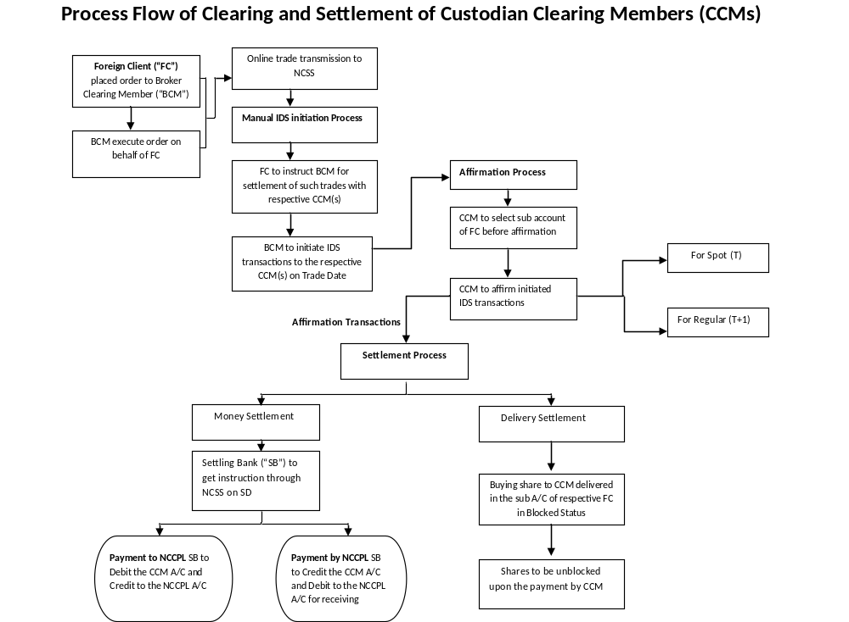er Clearing Member (“BCM”)
BCM execute order on behalf of FC
Online trade transmission to NCSS
Manual IDS initiation Process
FC to instruct BCM for settlement of such trades with respective CCM(s)
Affirmation Process
CCM to affirm initiated IDS transactions
CCM to select sub account of FC before affirmation
For Spot (T)
For Regular (T+1)
Settlement Process

BCM to initiate IDS transactions to the respective CCM(s) on Trade Date

Affirmation Transactions
Payment to NCCPL SB to Debit the CCM A/C and Credit to the NCCPL A/C
Payment by NCCPL SB to Credit the CCM A/C and Debit to the NCCPL A/C for receiving member

Money Settlement
Delivery Settlement
Settling Bank (“SB”) to get instruction through NCSS on SD
Buying share to CCM delivered in the sub A/C of respective FC in Blocked Status
Shares to be unblocked upon the payment by CCM

