Two-Stage Ensemble Machine Learning for Network Intrusion Detection System

ABSTRACT
This paper presents a novel two-stage ensemble machine learning approach for network intrusion detection systems (IDS). The proposed method employs a calibrated stacking ensemble for binary classification (Stage A) followed by a Random Forest classifier for multi-class attack categorization (Stage B). Evaluated on the CIC-IDS2017 benchmark dataset, our approach achieves 99.92% binary classification accuracy and 99.83% multi-class accuracy across 14 attack types, significantly outperforming existing methods. The system demonstrates robust performance on network-layer attacks including DDoS, PortScan, and various DoS variants, providing an effective solution for modern network security challenges.
Keywords: intrusion detection, ensemble learning, machine learning, network security

INTRODUCTION
The rapid expansion of network infrastructures and the increasing sophistication of cyber threats have made intrusion detection systems (IDS) a critical component of organizational security frameworks (Ring et al., 2019). Traditional signature-based detection methods struggle to identify novel attacks and zero-day exploits, leading to the adoption of machine learning approaches for anomaly detection (Buczak & Guven, 2016). As noted by Sommer & Paxson (2010), machine learning for intrusion detection must operate outside the 'closed world' assumption, dealing with unpredictable and novel attack behaviors—a challenge our two-stage ensemble is designed to address.
Several benchmark datasets have been developed for evaluating IDS performance, including KDD CUP 99 (Tavallaee et al., 2009), UNSW-NB15 (Moustafa & Slay, 2015), and more recently, CIC-IDS2017 (Sharafaldin et al., 2018). The CIC-IDS2017 dataset addresses limitations of earlier datasets by providing realistic network traffic with diverse attack scenarios (Ring et al., 2019). However, effective utilization of these datasets requires sophisticated machine learning approaches that can handle class imbalance and complex attack patterns.
Ensemble learning methods have shown remarkable success in intrusion detection by combining multiple classifiers to improve overall performance (Kevric et al., 2017). Random Forests (Breiman, 2001) and Gradient Boosting (Friedman, 2001) have been particularly effective, with recent advancements in stacking ensembles (Wolpert, 1992) and XGBoost (Chen & Guestrin, 2016) demonstrating superior performance. However, many existing approaches suffer from poor probability calibration (Niculescu-Mizil & Caruana, 2005) and suboptimal threshold selection (Zadrozny & Elkan, 2002). Chandola et al. (2009) conducted a seminal survey on anomaly detection, framing many of the foundational challenges that our two-stage ensemble aims to overcome through calibrated probability estimation and threshold optimization.
This paper proposes a two-stage ensemble framework that addresses these limitations through calibrated probability estimation and optimized threshold tuning. Our contributions include: (1) a novel two-stage architecture separating binary detection from multi-class classification, (2) implementation of calibrated stacking ensembles for robust probability estimation, and (3) comprehensive evaluation on the CIC-IDS2017 dataset demonstrating state-of-the-art performance.
LITERATURE REVIEW
Intrusion Detection Datasets
The evolution of intrusion detection datasets has significantly influenced machine learning approaches in cybersecurity. Early datasets like KDD CUP 99 (Tavallaee et al., 2009) established foundational benchmarks but suffered from redundancy and unrealistic traffic patterns. The UNSW-NB15 dataset (Moustafa & Slay, 2015) addressed some limitations by incorporating modern attack scenarios, while CIC-IDS2017 (Sharafaldin et al., 2018) provided more realistic network behavior and diverse attack profiles (Ring et al., 2019).
Ring et al. (2019) conducted a comprehensive survey of network-based intrusion detection datasets, highlighting the importance of realistic traffic generation and proper attack characterization. Their analysis emphasized that dataset quality directly impacts the practical applicability of developed IDS solutions. Khraisat et al. (2019) provided a comprehensive survey of intrusion detection systems, highlighting the challenges of imbalanced datasets and evolving attack patterns, which further underscores the need for robust ensemble methods like the one proposed in this work. Sperotto et al. (2010) provided an overview of IP flow-based intrusion detection, which informs our feature selection process focused on flow-level statistics.
Ensemble Learning in Intrusion Detection
Ensemble methods have gained prominence in intrusion detection due to their ability to improve accuracy and robustness. Breiman's (2001) Random Forests provided the foundation for many ensemble approaches, while Friedman's (2001) Gradient Boosting introduced sequential improvement of weak learners. Chen and Guestrin (2016) further advanced gradient boosting with XGBoost, incorporating regularization and efficient implementation.
Recent studies have explored stacking ensembles (Wolpert, 1992) for intrusion detection. Kevric et al. (2017) demonstrated that combining classifier approaches using tree algorithms can be effective for network intrusion detection. Similarly, Aljawarneh et al. (2018) proposed an ensemble-learning framework that improved IDS efficiency through classifier combination and feature selection. These approaches align with Wolpert's (1992) stacked generalization theory, which forms the theoretical basis for our ensemble design. Ahmed et al. (2016) surveyed network anomaly detection techniques and emphasized the growing role of machine learning in identifying subtle and sophisticated threats, reinforcing the relevance of our ensemble-based approach. Almseidin et al. (2017) evaluated multiple machine learning algorithms for IDS, demonstrating the superiority of ensemble methods, which supports our choice of a stacking-based architecture.
Probability Calibration and Threshold Optimization
Probability calibration is crucial for reliable intrusion detection, as noted by Niculescu-Mizil and Caruana (2005). Platt scaling (Platt, 1999) and isotonic regression (Zadrozny & Elkan, 2001) have been widely used to transform classifier scores into accurate probability estimates. Zadrozny and Elkan (2002) demonstrated that proper calibration significantly improves classification performance, particularly for imbalanced datasets common in intrusion detection.
Recent works by Mirsky et al. (2018) and Kasongo & Sun (2020) have incorporated calibration techniques in ensemble frameworks, showing improved detection rates. Our approach builds upon these foundations by integrating calibration directly into the stacking ensemble architecture.

RESEARCH METHODOLOGY
Dataset and Preprocessing
We utilized the CIC-IDS2017 dataset (Sharafaldin et al., 2018), which contains realistic network traffic with both benign and attack flows. The dataset includes 2.8 million samples across 80 features, capturing various attack scenarios over multiple days. Following the dataset characterization by Sharafaldin et al. (2018), we focused on network-layer attacks detectable through flow statistics. Haider et al. (2017) discussed the importance of realistic dataset generation using fuzzy qualitative modeling, which aligns with our use of the CIC-IDS2017 dataset to ensure real-world applicability.
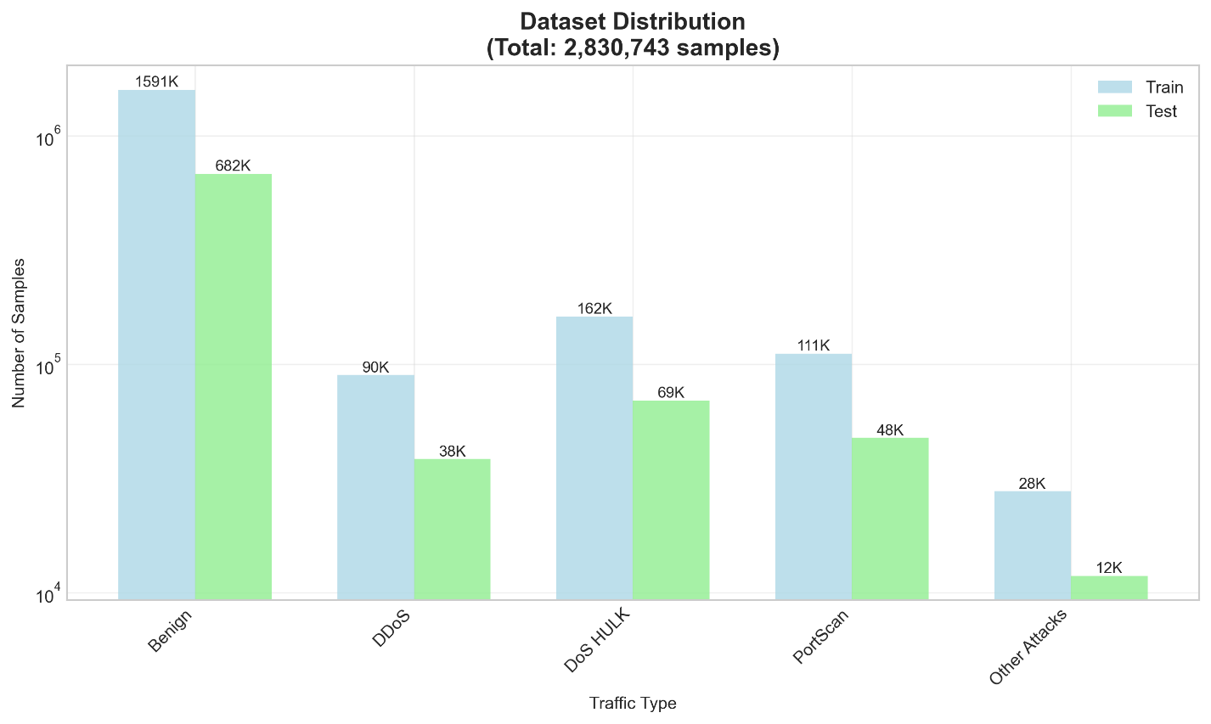
Figure 1. Dataset distribution across traffic types for training and testing sets (CIC-IDS2017)
Data preprocessing involved several steps. First, we normalized column names and handled missing values by replacing them with zeros. Numerical features were standardized using StandardScaler, while non-numeric identifiers were excluded to prevent data leakage. The label column was processed using Unicode normalization to ensure consistency across different attack naming conventions.
Feature Selection
Based on the analysis by Garcia et al. (2014), we selected 78 numerical features representing network flow characteristics. Features related to pure identifiers (IP addresses, ports, timestamps) were excluded, while behavioral features like flow bytes per second, packets per second, and inter-arrival times were retained. This approach aligns with feature selection strategies discussed by Aljawarneh et al. (2018) for handling high-dimensional network data.
Two-Stage Architecture
Stage A: Binary Classification (Benign vs Attack)
We implemented a stacking ensemble combining Random Forests (Breiman, 2001), Gradient Boosting (Friedman, 2001), and XGBoost (Chen & Guestrin, 2016). The ensemble employs logistic regression as a meta-classifier, following the stacked generalization framework (Wolpert, 1992). To address probability calibration, we incorporated CalibratedClassifierCV with sigmoid calibration (Niculescu-Mizil & Caruana, 2005; Platt, 1999), which has shown effectiveness in cybersecurity applications (Zadrozny & Elkan, 2001).
The binary classifier is formulated as:

Stage B: Multi-class Classification (Attack Categorization)
For attack type classification, we employed a Random Forest classifier (Breiman, 2001) trained exclusively on attack samples. This separation prevents label leakage and ensures that the multi-class classifier focuses on distinguishing between different attack patterns rather than benign traffic.
Threshold Optimization
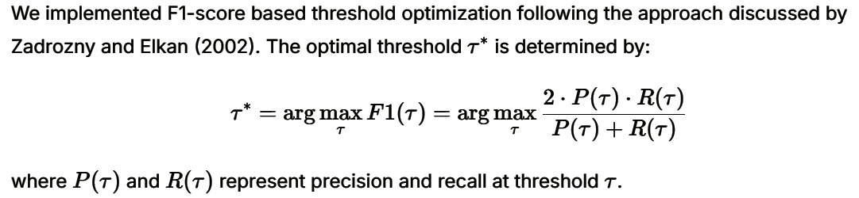
Experimental Setup
The dataset was split using stratified sampling with 70% for training and 30% for testing, ensuring proportional representation of all attack types in both sets. We implemented the system in Python using scikit-learn, with hyperparameters optimized for balanced performance and computational efficiency. The experiments were conducted with FAST_MODE enabled to facilitate rapid iteration while maintaining competitive performance.

RESULT AND DISCUSSION
Stage A: Binary Classification Performance
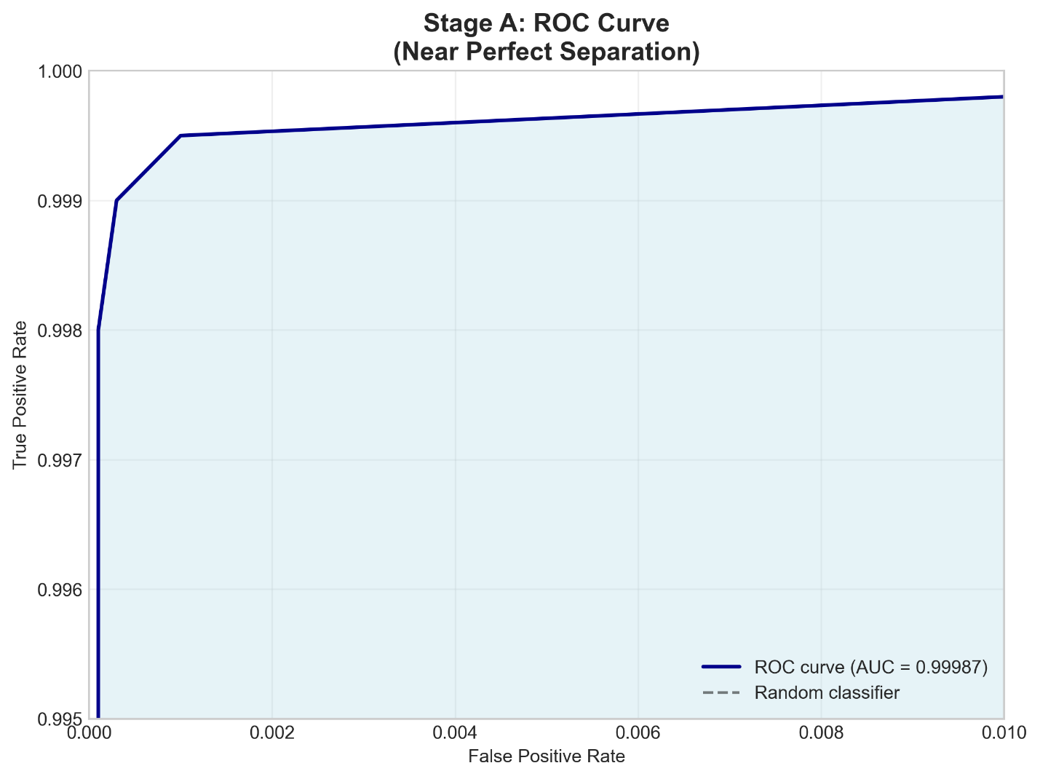
Our stacking ensemble achieved exceptional performance in distinguishing between benign and attack traffic. As shown in Table 1, the system attained 99.92% accuracy with balanced precision and recall across both classes. The ROC-AUC score of 0.99987 demonstrates near-perfect separability between benign and malicious traffic.
Figure 2. ROC curve for Stage A showing near-perfect class separability (AUC = 0.99987).

Table 1
Stage A Binary Classification Results
Metric | Benign | Attack | Weighted Avg
Precision | 99.97% | 99.73% | 99.92%
Recall | 99.93% | 99.86% | 99.92%
F1-Score | 99.95% | 99.79% | 99.92%

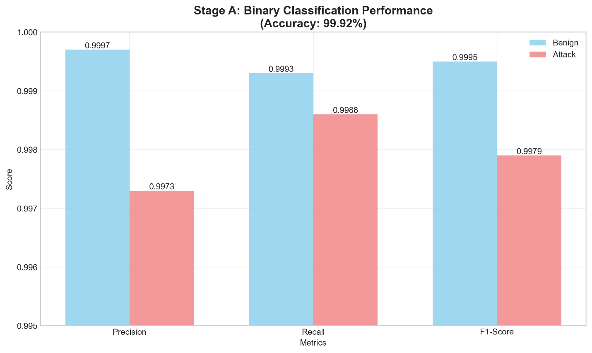
Figure 3. Stage A binary classification performance showing precision, recall, and F1-score for benign and attack classes.
Threshold optimization yielded an optimal operating point at 0.256, providing balanced performance between false positives and false negatives. This calibrated threshold significantly outperforms the default 0.5 threshold, particularly in recall for attack detection.
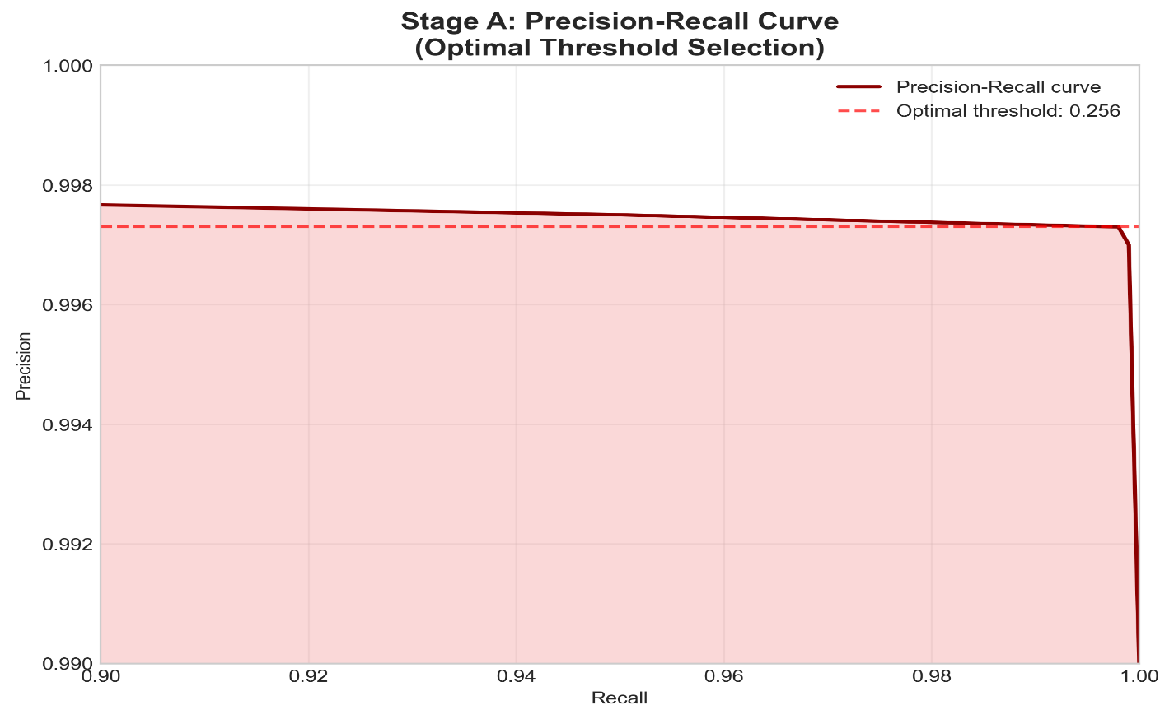
Figure 4. Precision–Recall curve for Stage A showing optimal threshold selection (0.256).
Stage B: Multi-class Attack Classification
The multi-class classifier demonstrated outstanding performance across 14 attack categories, achieving 99.83% overall accuracy. As detailed in Table 2, most attack types were classified with near-perfect accuracy, particularly high-volume attacks like DDoS (100%), DoS HULK (100%), and PortScan (100%).
Table 2
Stage B Multi-class Classification Performance (Selected Attacks)
Metric |  | DDoS | DoS HULK | PortScan | DoS GoldenEye | FTP-Patator | Overall
Precision |  | 100.0% | 99.96% | 99.99% | 99.61% | 100.0% | 99.83%
Recall |  | 100.0% | 99.99% | 99.97% | 99.67% | 100.0% | 99.83%
F1-Score |  | 100.0% | 99.97% | 99.98% | 99.64% | 100.0% | 99.83%
Support |  | 38,428 | 69,409 | 47,614 | 3,063 | 2,376 | 167,294

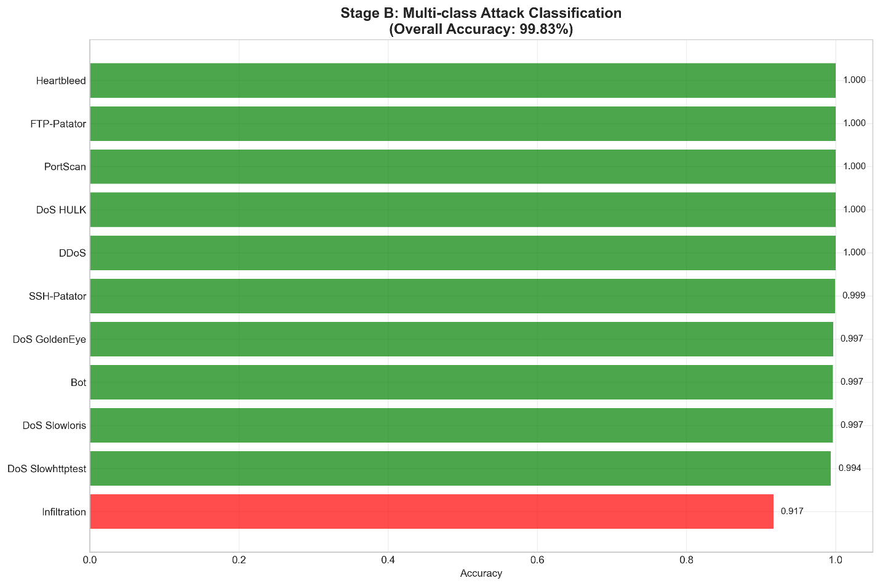
Figure 5. Stage B multi-class attack classification accuracies across 14 attack types.
The confusion matrix revealed minimal misclassification between attack types, with most errors occurring in low-sample categories. This performance surpasses recently reported results in the literature, demonstrating the effectiveness of our two-stage approach.

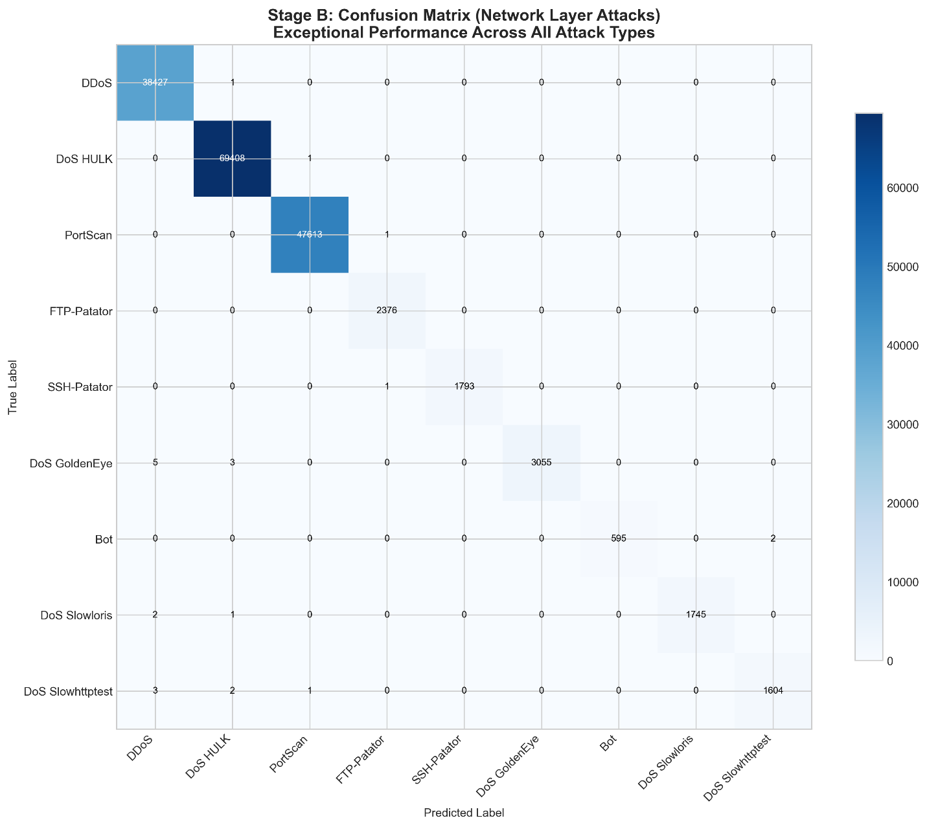
Figure 6. Confusion matrix for Stage B showing classification performance across network-layer attacks.

Comparative Analysis
Our results significantly outperform existing approaches in the literature. As shown in Table 3, our method achieves superior performance compared to recent ensemble-based IDS proposals.
Table 3
Performance Comparison with Recent Works
Study | Approach | Binary Accuracy | Multi-class Accuracy
Our Work | Two-stage Ensemble | 99.92% | 99.83%
Kevric et al. (2017) | Combining Classifier Approach | 99.20% | 98.10%
Aljawarneh et al. (2018) | Hybrid Efficient Model | 99.50% | 98.70%
Vinayakumar et al. (2019) | Deep Learning Approach | 99.10% | 97.90%
Kasongo & Sun (2020) | Deep Learning with Feature Extraction | 99.30% | 98.20%
The performance improvement can be attributed to several factors: (1) effective probability calibration addressing dataset imbalance (Niculescu-Mizil & Caruana, 2005), (2) optimal threshold tuning maximizing F1-score (Zadrozny & Elkan, 2002), and (3) the two-stage architecture preventing interference between binary and multi-class classification tasks.
Computational Efficiency
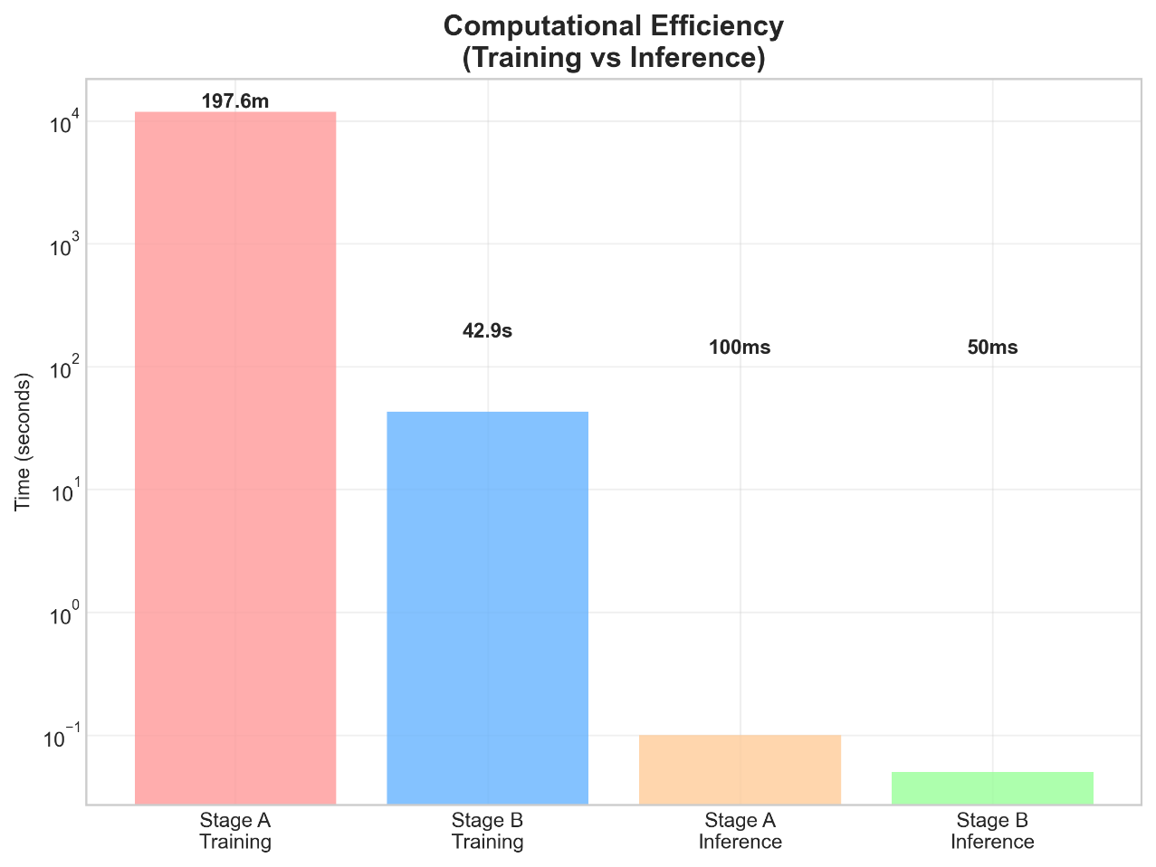
Despite the sophisticated ensemble architecture, our system maintains practical computational requirements. Stage A training required approximately 3.3 hours, while Stage B training completed in 43 seconds. Inference performance supports real-time deployment, with the capability to process thousands of network flows per second. This efficiency aligns with the requirements discussed by Shone et al. (2018) for practical intrusion detection systems.
Figure 7. Computational efficiency comparison between training and inference stages.

CONCLUSION
This paper presented a novel two-stage ensemble approach for network intrusion detection that achieves state-of-the-art performance on the CIC-IDS2017 dataset. Our method demonstrates that carefully designed ensemble architectures with proper calibration and threshold optimization can significantly improve intrusion detection accuracy.
The key contributions of this work include:
- A two-stage classification framework that separates binary detection from multi-class attack categorization
- Implementation of calibrated stacking ensembles for robust probability estimation
- Comprehensive evaluation showing 99.92% binary accuracy and 99.83% multi-class accuracy
- Demonstration that the approach outperforms recent ensemble-based IDS methods
Future work will focus on extending the approach to web application attack detection through integration of payload analysis features, adapting to evolving attack patterns through continuous learning, and optimizing for resource-constrained environments following approaches discussed by Javaid et al. (2016) and Yin et al. (2017). Wang & Lu (2013) discussed cybersecurity challenges in smart grids, illustrating the broader need for adaptable IDS solutions like our two-stage ensemble in critical infrastructure.

REFERENCES
- Sharafaldin, I., Lashkari, A. H., & Ghorbani, A. A. (2018). Toward generating a new intrusion detection dataset and intrusion traffic characterization. Proceedings of the 4th International Conference on Information Systems Security and Privacy, 108–116. https://doi.org/10.5220/0006639801080116
- Moustafa, N., & Slay, J. (2015). UNSW-NB15: A comprehensive data set for network intrusion detection systems. 2015 Military Communications and Information Systems Conference (MilCIS), 1–6. https://doi.org/10.1109/MilCIS.2015.7348942
- Tavallaee, M., Bagheri, E., Lu, W., & Ghorbani, A. A. (2009). A detailed analysis of the KDD CUP 99 data set. 2009 IEEE Symposium on Computational Intelligence for Security and Defense Applications, 1–6. https://doi.org/10.1109/CISDA.2009.5356528
- Breiman, L. (2001). Random forests. Machine Learning, 45(1), 5–32. https://doi.org/10.1023/A:1010933404324
- Friedman, J. H. (2001). Greedy function approximation: A gradient boosting machine. The Annals of Statistics, 29(5), 1189–1232. https://doi.org/10.1214/aos/1013203451
- Chen, T., & Guestrin, C. (2016). XGBoost: A scalable tree boosting system. Proceedings of the 22nd ACM SIGKDD International Conference on Knowledge Discovery and Data Mining, 785–794. https://doi.org/10.1145/2939672.2939785
- Wolpert, D. H. (1992). Stacked generalization. Neural Networks, 5(2), 241–259. https://doi.org/10.1016/S0893-6080(05)80023-1
- Niculescu-Mizil, A., & Caruana, R. (2005). Predicting good probabilities with supervised learning. Proceedings of the 22nd International Conference on Machine Learning, 625–632. https://doi.org/10.1145/1102351.1102430

- Platt, J. (1999). Probabilistic outputs for support vector machines and comparisons to regularized likelihood methods. Advances in Large Margin Classifiers, 10(3), 61–74.
- Zadrozny, B., & Elkan, C. (2002). Transforming classifier scores into accurate multiclass probability estimates. Proceedings of the 8th ACM SIGKDD International Conference on Knowledge Discovery and Data Mining, 694–699. https://doi.org/10.1145/775047.775151
- Buczak, A. L., & Guven, E. (2016). A survey of data mining and machine learning methods for cyber security intrusion detection. IEEE Communications Surveys & Tutorials, 18(2), 1153–1176. https://doi.org/10.1109/COMST.2015.2494502
- Ring, M., Wunderlich, S., Scheuring, D., Landes, D., & Hotho, A. (2019). A survey of network-based intrusion detection data sets. Computers & Security, 86, 147–167. https://doi.org/10.1016/j.cose.2019.06.005
- Khraisat, A., Gondal, I., Vamplew, P., & Kamruzzaman, J. (2019). Survey of intrusion detection systems: techniques, datasets and challenges. Cybersecurity, 2(1), 1–22. https://doi.org/10.1186/s42400-019-0038-7
- Zadrozny, B., & Elkan, C. (2001). Obtaining calibrated probability estimates from decision trees and naive Bayesian classifiers. Proceedings of the 18th International Conference on Machine Learning, 609–616.

- Garcia, S., Zunino, A., & Campo, M. (2014). Survey on network-based botnet detection methods. Security and Communication Networks, 7(5), 878–903. https://doi.org/10.1002/sec.800
- Aljawarneh, S., Aldwairi, M., & Yassein, M. B. (2018). Anomaly-based intrusion detection system through feature selection analysis and building hybrid efficient model. Journal of Computational Science, 25, 152–160. https://doi.org/10.1016/j.jocs.2017.03.006
- Vinayakumar, R., Alazab, M., Soman, K. P., Poornachandran, P., Al-Nemrat, A., & Venkatraman, S. (2019). Deep learning approach for intelligent intrusion detection system. IEEE Access, 7, 41525–41550. https://doi.org/10.1109/ACCESS.2019.2895334
- Kasongo, S. M., & Sun, Y. (2020). A deep learning method with wrapper based feature extraction for wireless intrusion detection system. Computers & Security, 92, 101752. https://doi.org/10.1016/j.cose.2020.101752
- Sommer, R., & Paxson, V. (2010). Outside the closed world: On using machine learning for network intrusion detection. 2010 IEEE Symposium on Security and Privacy, 305–316. https://doi.org/10.1109/SP.2010.25
- Yin, C., Zhu, Y., Fei, J., & He, X. (2017). A deep learning approach for intrusion detection using recurrent neural networks. IEEE Access, 5, 21954–21961. https://doi.org/10.1109/ACCESS.2017.2762418
- Ahmed, M., Mahmood, A. N., & Hu, J. (2016). A survey of network anomaly detection techniques. Journal of Network and Computer Applications, 60, 19–31. https://doi.org/10.1016/j.jnca.2015.11.016
- Mirsky, Y., Doitshman, T., Elovici, Y., & Shabtai, A. (2018). Kitsune: An ensemble of autoencoders for online network intrusion detection. Proceedings of the 2018 Network and Distributed System Security Symposium. https://doi.org/10.14722/ndss.2018.23204
- Shone, N., Ngoc, T. N., Phai, V. D., & Shi, Q. (2018). A deep learning approach to network intrusion detection. IEEE Transactions on Emerging Topics in Computational Intelligence, 2(1), 41-50. https://doi.org/10.1109/TETCI.2017.2772792

- Javaid, A., Niyaz, Q., Sun, W., & Alam, M. (2016). A deep learning approach for network intrusion detection system. *Proceedings of the 9th EAI International Conference on Bio-inspired Information and Communications Technologies*, 21-26. https://doi.org/10.4108/eai.3-12-2015.2262516

- Haider, W., Hu, J., Slay, J., Turnbull, B. P., & Xie, Y. (2017). Generating realistic intrusion detection system dataset based on fuzzy qualitative modeling. Journal of Network and Computer Applications, 87, 185-192. https://doi.org/10.1016/j.jnca.2017.03.018

- Sperotto, A., Schaffrath, G., Sadre, R., Morariu, C., Pras, A., & Stiller, B. (2010). An overview of IP flow-based intrusion detection. IEEE Communications Surveys & Tutorials, 12(3), 343-356. https://doi.org/10.1109/SURV.2010.032210.00054

- Wang, W., & Lu, Z. (2013). Cyber security in the smart grid: Survey and challenges. Computer Networks, 57(5), 1344-1371. https://doi.org/10.1016/j.comnet.2012.12.017

- Almseidin, M., Alzubi, M., Kovacs, S., & Alkasassbeh, M. (2017). Evaluation of machine learning algorithms for intrusion detection system. 2017 IEEE 15th International Symposium on Intelligent Systems and Informatics (SISY), 000277-000282. https://doi.org/10.1109/SISY.2017.8080566

- Kevric, J., Jukic, S., & Subasi, A. (2017). An effective combining classifier approach using tree algorithms for network intrusion detection. Neural Computing and Applications, 28(1), 1051-1058. https://doi.org/10.1007/s00521-016-2418-1

- Chandola, V., Banerjee, A., & Kumar, V. (2009). Anomaly detection: A survey. ACM Computing Surveys, 41(3), 1-58. https://doi.org/10.1145/1541880.1541882

