**Dell Assessment for .Net Full Stack**

Submitted by Rashid Muhammad

Programmer.rashid@gmail.com

Technologies which are using in this assessment listed below.

1. Web Application created and segregated into the following layers:

* Web frontend/website
* Rest APIs

c. In rest Api I use Entity framework to database connectivity with Model classes.

2. TDD is performing by Swagger.

3. Code perfectly build and run without errors on a 2022 version of visual studio

4. Rest API built using .Net core & C#

5 Node js framework use for front-end

6. SQL database for backend

**Note:-** **There is no authentication requirement is mention in assessment so I did not implement Authentication in Rest API**

Rest APi run perfectly and return data in Jason, based on user request like Get, Post, Put, Delete.

There are two controller in API:-

* Document controller
* Department controller

Documents related functionality and logic written in Document controller

Department related functionality and logic written in Document controller

Please refer below Image.

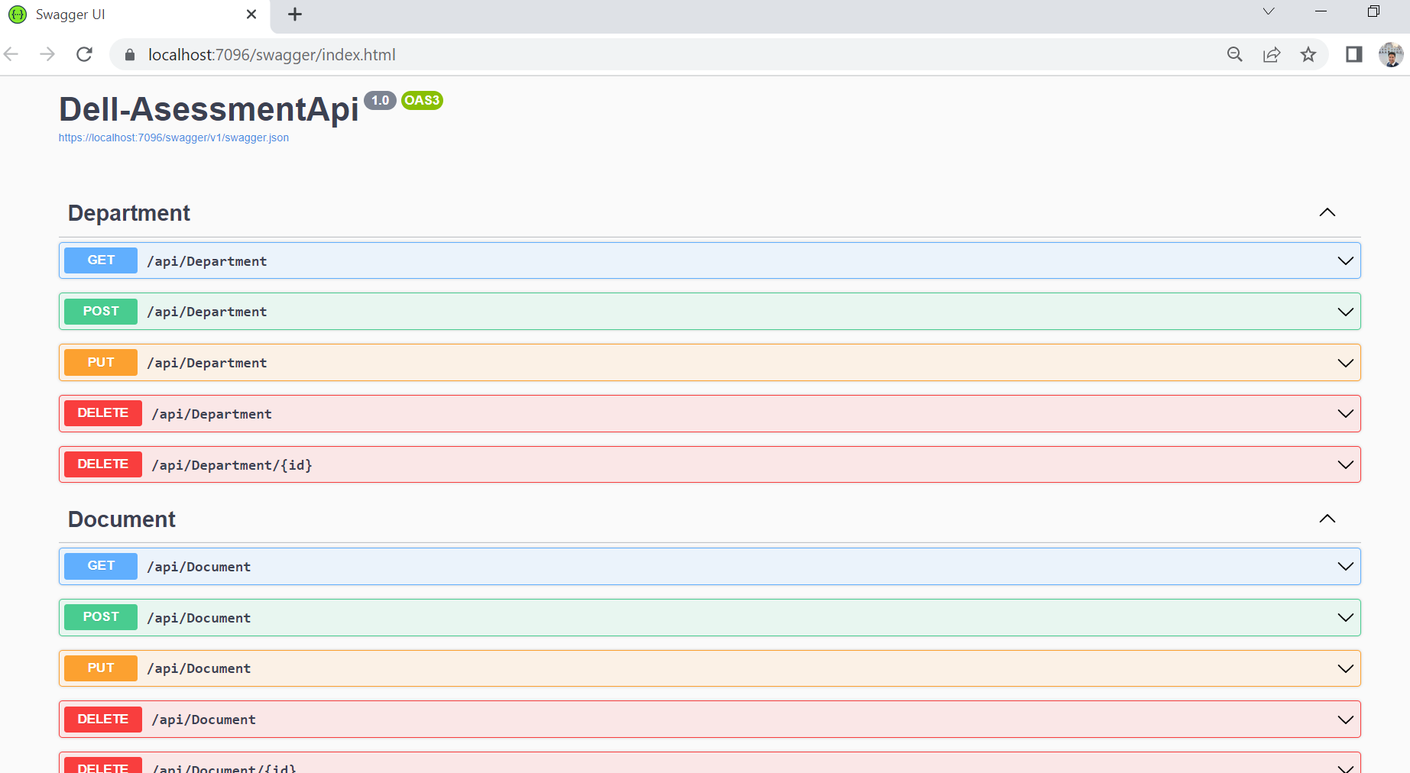

For front end or presentation layer I use react Js.

There are two component to perform crued operation with API response.

**Department Component**

1. Department basically categrise the document the which type of document user have ex. Technical, busnuss or nay other type of depatment user can have. So user simply can insert type of department and save it to database.
2. An user can modify or delete the department name by click on edit option and save it.

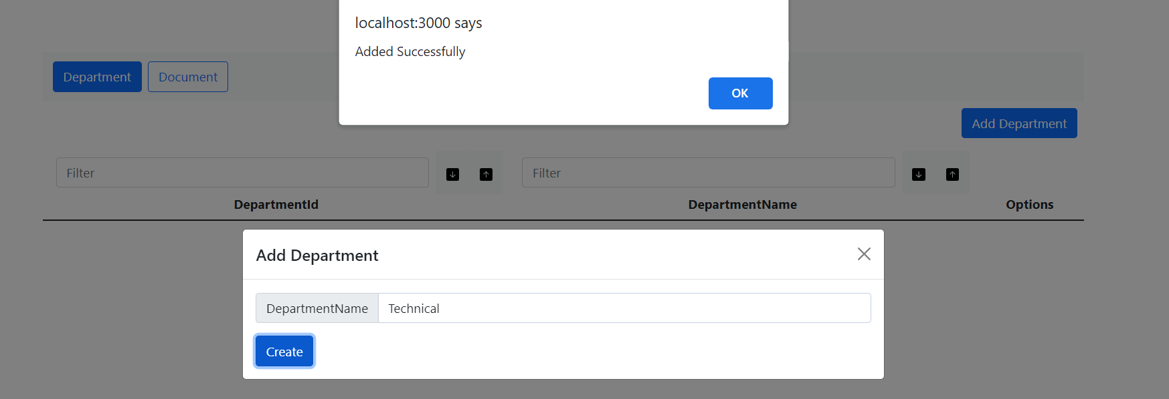

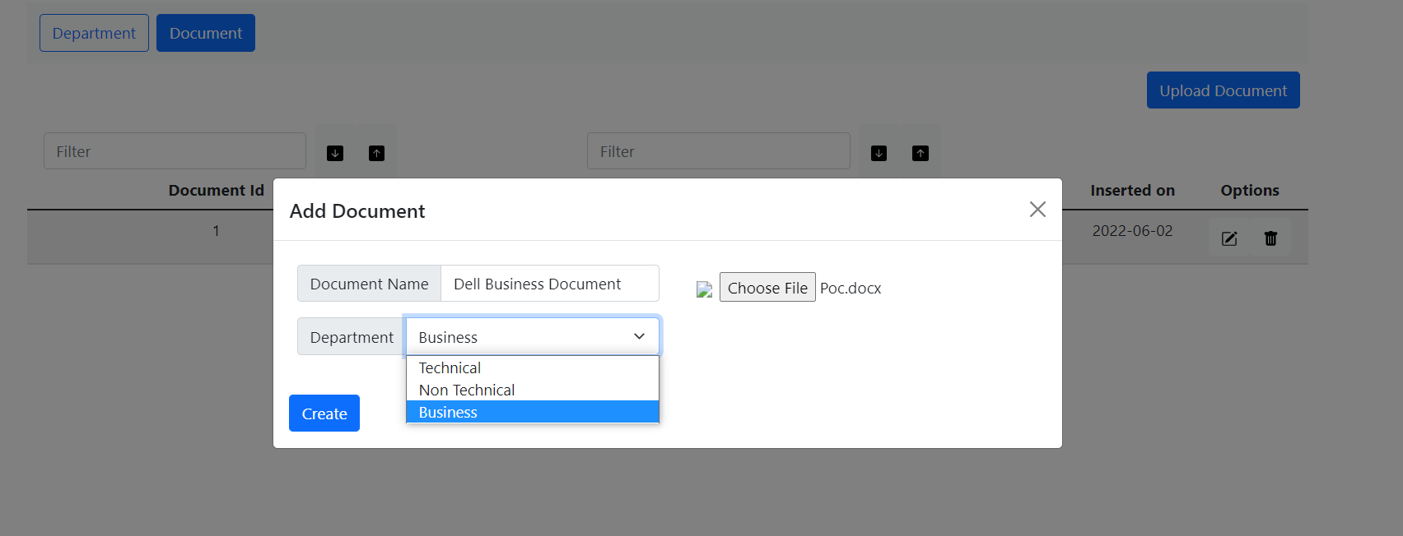

**Document Component**

1. Document component basecally perform functionallity like Save document, Modify document and delete the document by using the option.
2. User can inset the document in .pdf and .docx formate and later can modify it.

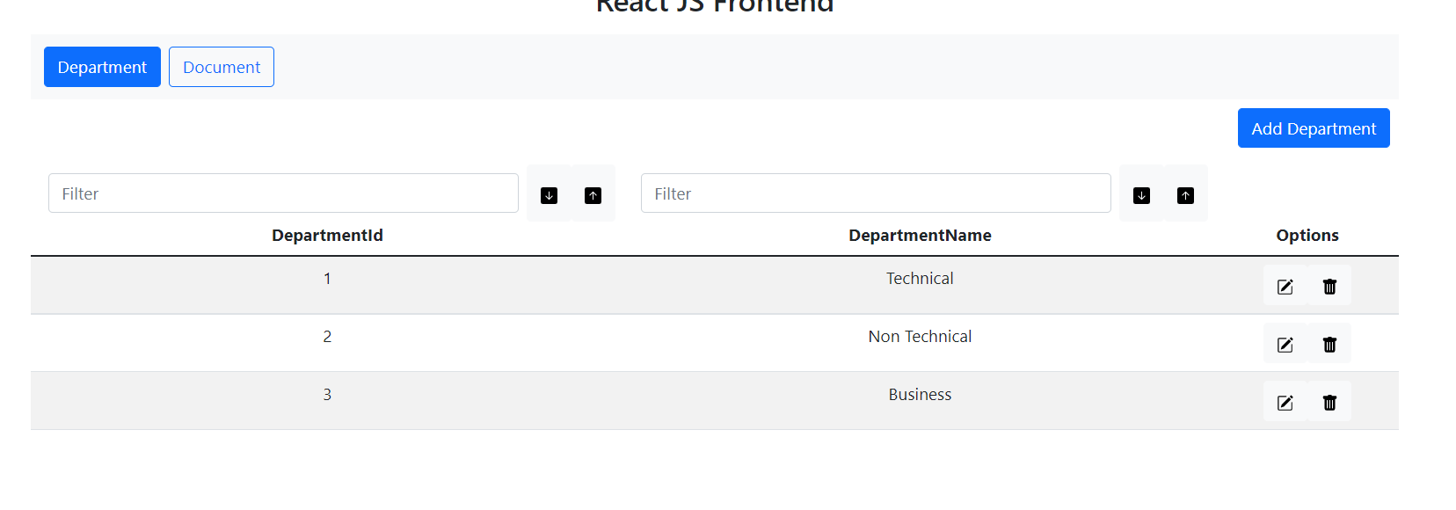

After insert document in web portal user can list the uploaded document.

User can perform filtering/search on data based on Document Id or Document name.

User can sort the order of data by click on arrow symbol.

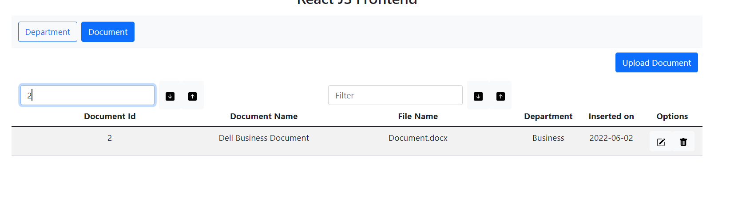

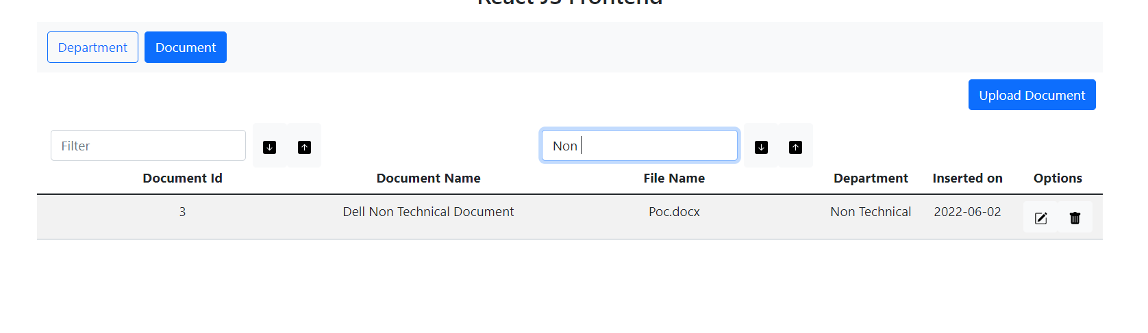

Thank you

Submitted on 02-06-2022