# Part A: Deep Convolutional Neural Network:

## Introduction:

Convolutional Neural Networks are deep, feed forward artificial neural networks used for analyzing visual imagery. The aim of this part of the assignment is to design a convolutional neural network to recognize the handwritten digits in the MNIST database. The MNIST database is separated into training and testing datasets. For this assignment, we have used the first 12000 records for training and the first 2000 records for testing.

## Task 1: Design a two-layer convolutional neural network

Specifications:

• An Input layer of 28x28 dimensions

• A convolution layer 𝐶1 of 15 feature maps and filters of window size 9x9. A max pooling layer 𝑆1with a pooling window of size 2x2.

• A convolution layer 𝐶2 of 20 feature maps and filters of window size 5x5. A max pooling layer 𝑆2with a pooling window of size 2x2.

• A fully connected layer 𝐹3 of size 100.

• A softmax layer 𝐹4 of size 10.

We trained the network using ReLu activation functions for neurons and mini batch gradient descent learning. We used the following parameters-

batch size 128, learning rate 𝛼 = 0.05 and decay parameter 𝛽 = 10^−4

### Test Accuracy against the number of epochs:

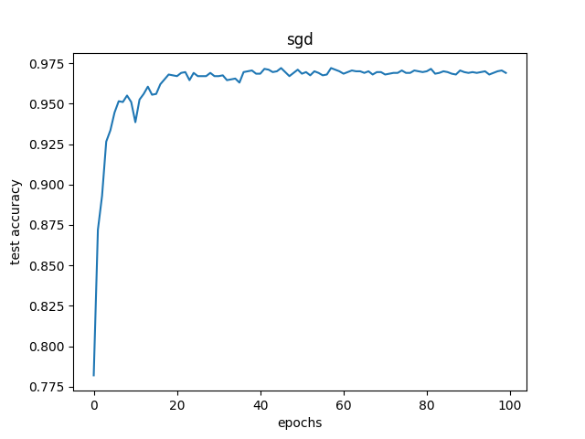

### Training error against the number of epochs:

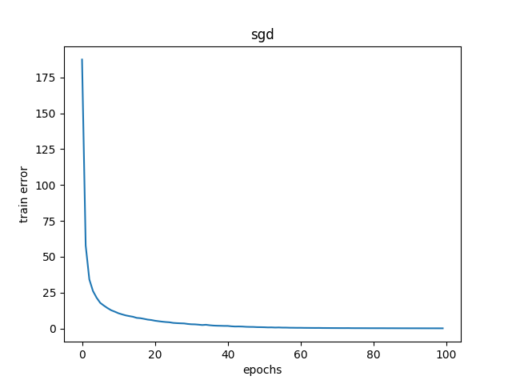

As we can see from the graphs, as the convolutional neural network was trained, the training cost decreased while the test accuracy increased against the number of iterations.

## Sample 1:

### Input Image:

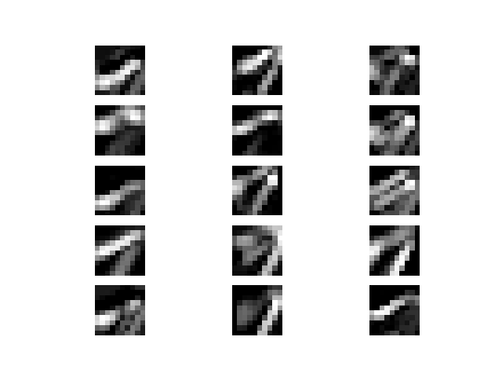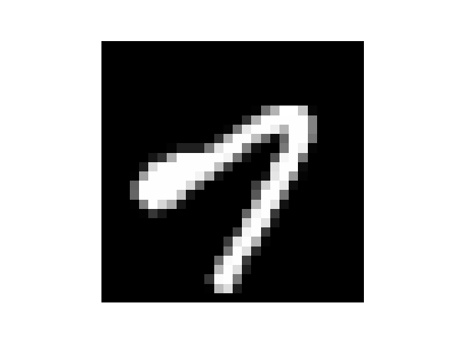

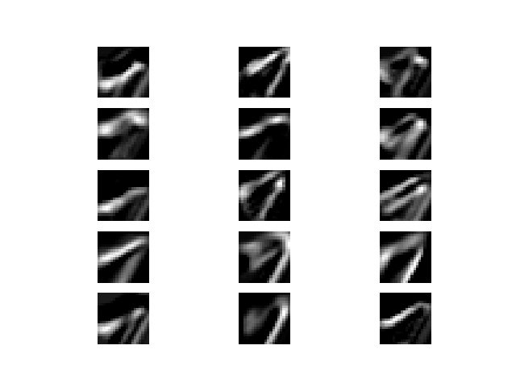

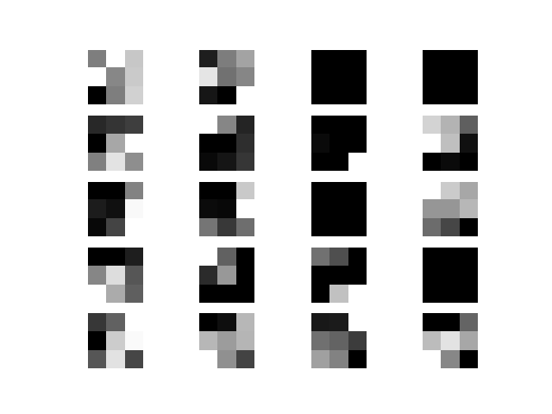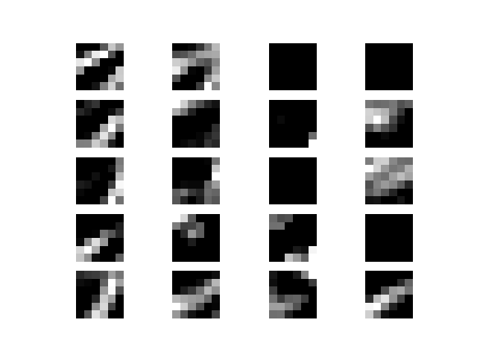

## Task 2: Repeat task 1 with momentum term:

Repeat part 1 by adding the momentum term to mini batch gradient descent learning with momentum parameter 𝛾 = 0.1

### Test Accuracy against the number of epochs:

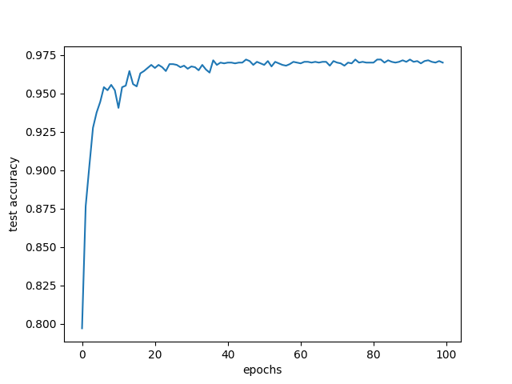

### Training error against the number of epochs:

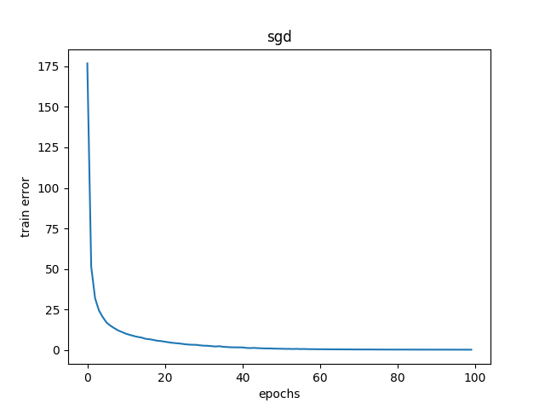

## Sample 1:



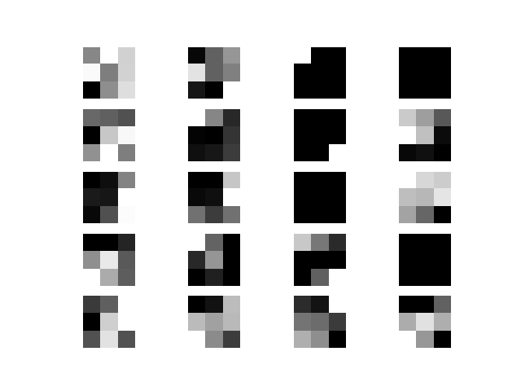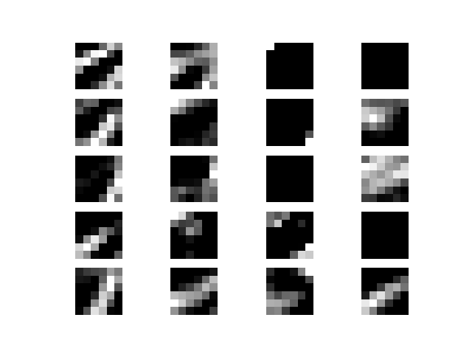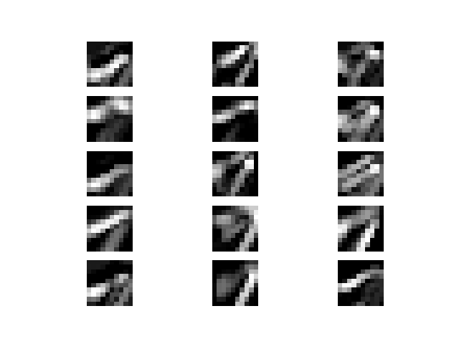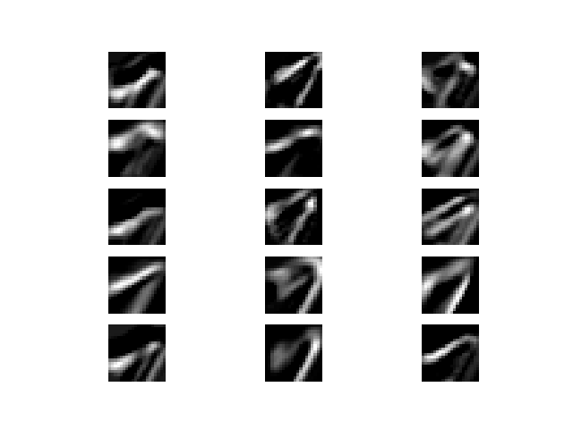

### Task 3: Repeat task 1 with RMSProp Algorithm:

Repeat part 1 by using RMSProp algorithm for learning. Use 𝛼 = 0.001, 𝛽 = 1𝑒 −4, 𝜌 = 0.9, and 𝜖 = 10−6 for RMSProp.

### Test Accuracy against the number of epochs:



### Training error against the number of epochs:



## Sample 1:

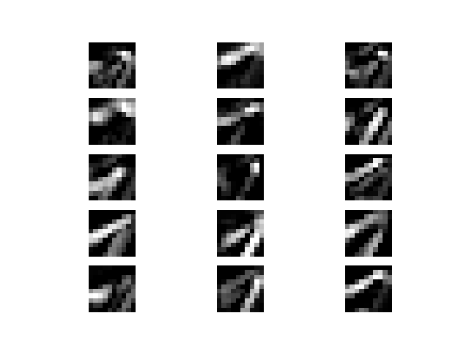

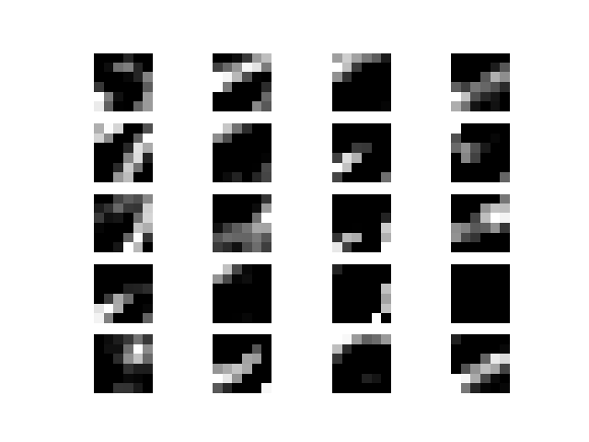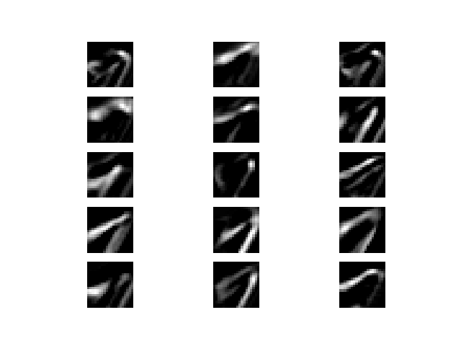

## Comparison of Algorithms:

As we can see in the diagrams below, that CNN with the RMSProp algorithm converges faster than the normal stochastic gradient algorithm and stochastic gradient with momentum.

The training errors of RMSProp also seem to decrease at a higher rate than the other two.

I think that RMSProp gives the best performance.

### Test Accuracy against epochs:

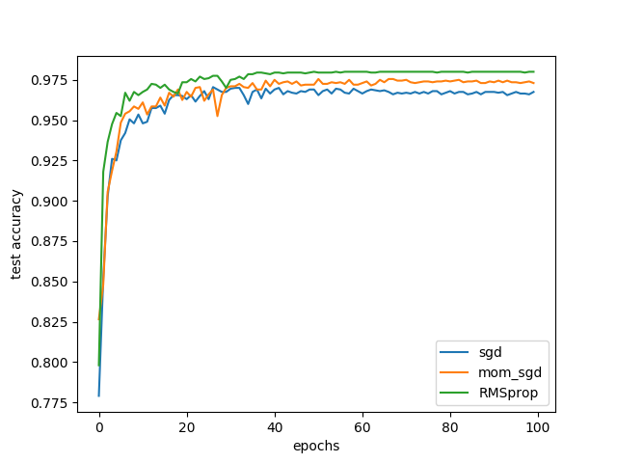

### Training Error against epochs:

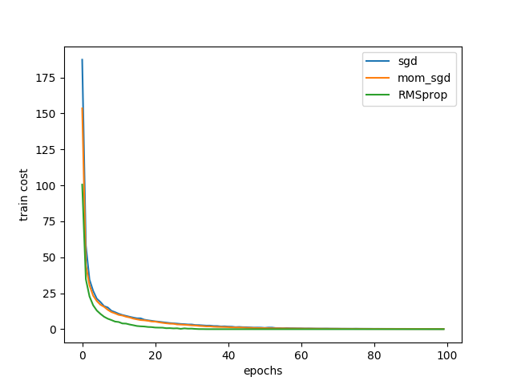

## Appendix A:

## Task 1: SGD

### Sample 2:

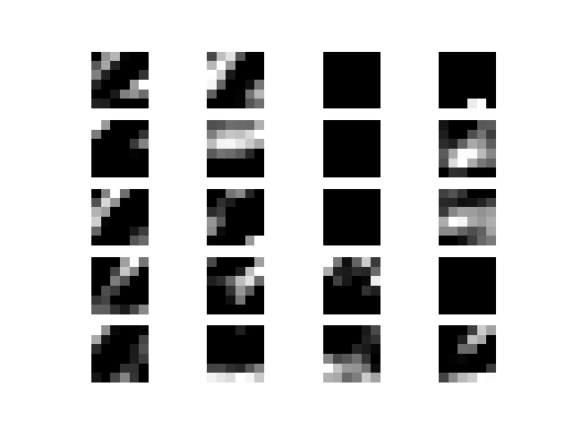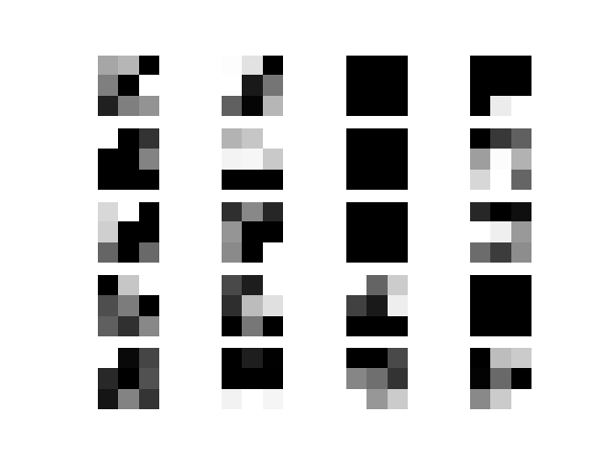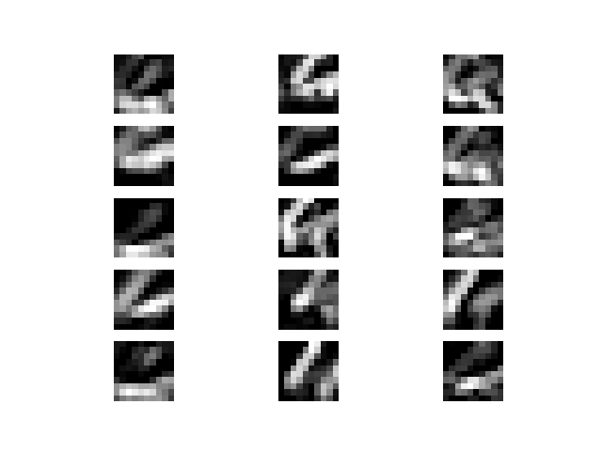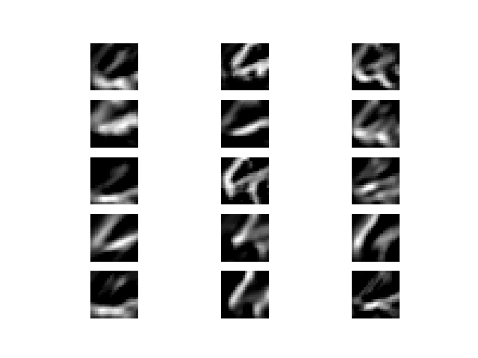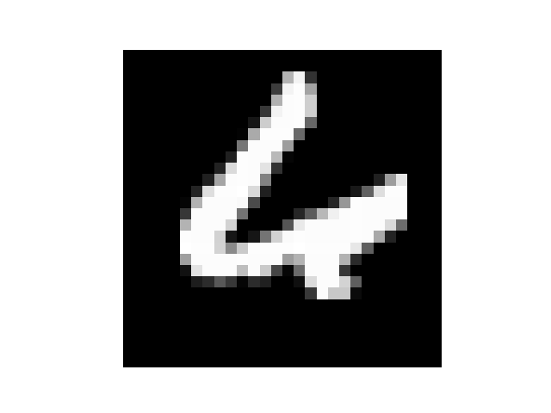

## Task 2: SGD with momentum

## Sample 2:



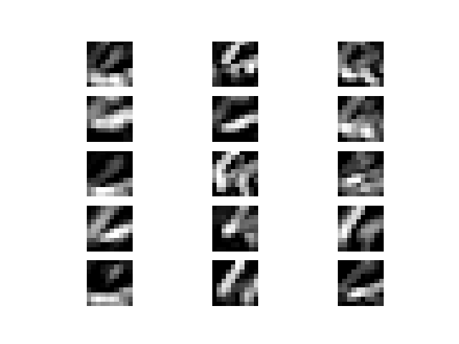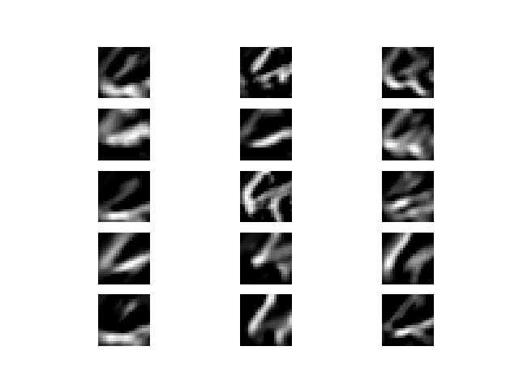

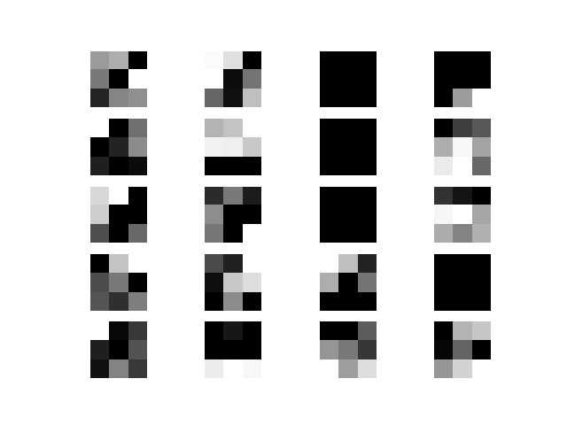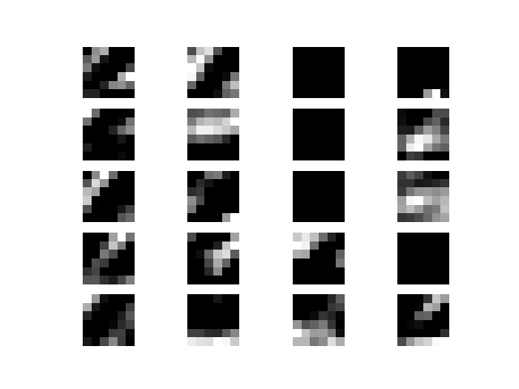

## Task 3: RMSProp

## Sample 2:

### 

