
NATIONAL INSTITUTE OF TRANSPORT
FACULTY OF INFORMATION TECHNOLOGY AND EDUCATION
DEPARTMEMT OF COMPUTING AND COMMUNICATION TECHNOLOGY

PROJECT PROPOSAL

Project Proposal Title: DEVELOPMENT OF LOGISTICS ANALYSIS TOOL FOR FUEL PRICES PREDICTION.
Project Type: DATA SCIENCE AND AI/ML PROJECT
Student Name: WENSESLAUS GREGORY KIDAKULE
Registration Number: NIT/BCS/2023/521
Program: BACHELOR’S DEGREE IN COMPUTER SCIENCE
Level: LEVEL 8
Supervisor Name: Miss. GLORY MALAMSHA.

PROJECT BACKGROUND
Fuel prices play a critical role in deciding the efficiency and sustainability of logistics operations globally, In Tanzania and across many developing economies, fluctuations in fuel costs directly influence transportation expenses, supply chain reliability and uncertainty in budgeting, there is a need for predicting upcoming fuel prices for effective planning.

PROBLEM STATEMENT
Currently, many fuel station operators and logistics companies rely on manual estimations to manage fuel-related costs. This lack of predictive capability leads to poor budgeting, inefficient route planning, and reduced competitiveness.

OBJECTIVES
Main Objective:
To Develop a web-based logistics analysis tool that uses fuel prices data to make analysis, data visualization and future fuel price prediction through machine learning models.
Specific Objectives:
Data collection and cleaning
Data analysis and visualization
Development of prediction model based on fuel prices
Design a user-friendly web-based interface.
Decision making insights according to prediction results.

LITERATURE REVIEW
1. Introduction
In Tanzania, several researches have been done on prediction of petrol and diesel prices by using different machine learning models especially ARIMA model, globally systems have been made to implement the prediction process through secondary data.
This literature review discusses existing researches and systems related to the project and identifies gaps that this project aims to address.
2. Review of Existing Studies and Systems
Ntare p.c(2023) conducted a scientific research on developing fuel prices prediction model where by his findings concluded that ARIMA(p,d,q) was the best model in prediction by using secondary data(2012-2022) due its accuracy.
Gasper Laban and Mbwambo Haika(2023) also conducted a research on determining the problem of predicting crude oil prices in a situation of unusual circumstances, where they concluded that the model must be updated to accurately predict the prices in exceptional circumstances
Also Swoyam Siddharth Nayak(2023) developed the oil and gas prices prediction system in US dollars, The project focused on creating models to predict the closing prices of these fuels based on their opening, highest, and lowest prices then designed a html pages for user interaction to the system.
3. Identified gaps in existing researches and systems;
From the local reviewed literature, it shows that in Tanzania there are only prediction models but no complete systems have been officially published.
All prediction models based on ARIMA model which is less flexible for irregular or missing data.
Secondary data used are not recently (2022)
From The global reviewed literature, the systems have already been made but price prediction bases on USD currency.
4. Relation to the proposed project;
The proposed logistics data analysis tool aims to address the identified gaps by providing;
User friendly system based in Tanzania with easy-to-use features.
Secondary data that are updated (2015 - 2025)
Prediction model based on Prophet Time-series forecasting Model which is more accurate for business forecasting.
Price prediction in Tanzania Shillings (Tsh)
5. Conclusion
By applying these additional features to my project, the logistics analysis system will be improved in terms of price prediction accuracy, user friendly interface, reusability, and local based price predictions.

SIGNIFICANCE OF THE PROJECT
- Provides operational efficiency in fuel and logistics companies
- Enables Risk mitigation by preparing users for fuel prices fluctuation
- Enhance data driven decision making
- Helps in sustainability and resources optimization
- Facilitates technological advancement

SCOPE OF THE PROJECT
This project will focus on fuel price analysis and prediction, and accurate predictions will be from short to medium terms, (one month to four months) only.
It will not deal with other logistics functions such as routes and it will not cover long term predictions like semi-annually or annually.

SYSTEM ARCHITECTURE DIAGRAM
The following architecture diagram aims to visually represent a system’s structure, components, and relationships. It contains Date flow, model training, deployment structure, and system components.

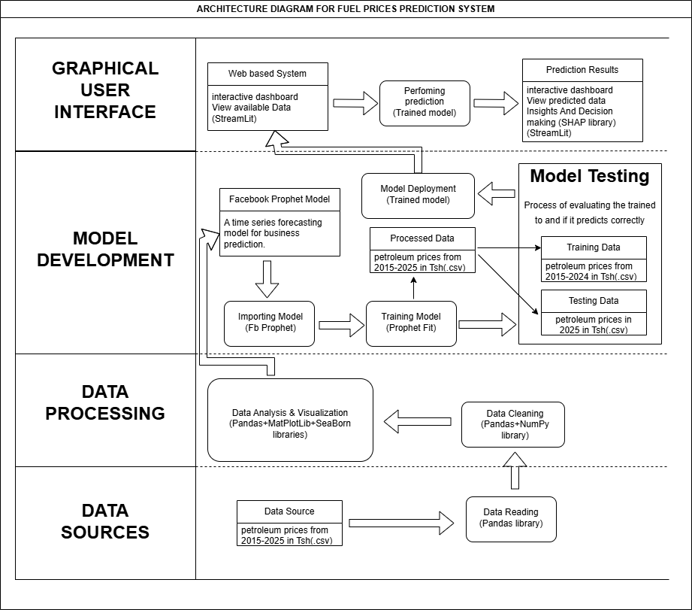
KEY;
Component
Layers
Relationship
Flow
Process
From the Architecture Diagram above;
It is designed to integrate data sources, processing procedures, forecasting models, and user interface into a single unit. It consists of five major layers.
1. Graphical User Interface (GUI)
The system provides a web-based interactive dashboard built with Streamlit.
Users can view available historical data, perform predictions using the trained model, and visualize prediction results.
Insights are enhanced with the SHAP library, which explains model outputs and supports decision-making.
2. Model Development
The forecasting engine is based on the Facebook Prophet model, a strong time series prediction framework.
The model is imported, trained on historical petroleum price data, and deployed for real-time use.
This ensures accurate forecasting of future fuel prices.
3. Model Testing
The trained model is evaluated using separate datasets to validate its accuracy.
Training data includes petroleum prices from 2015–2024, while testing data focuses on 2025.
This split allows the system to measure how well the model generalizes to unseen data.
4. Data Processing
Raw data undergoes cleaning and transformation using Pandas and NumPy libraries.
Visualization and analysis are performed with MatPlotLib and Seaborn, enabling better understanding of trends and anomalies in fuel prices.
This step ensures the model receives high-quality, structured input.
5. Data Sources
The system relies on historical petroleum price datasets (2015–2025) stored in .csv format.
Data is ingested using Pandas, forming the foundation for training, testing, and prediction.
USE CASE DIAGRAM.
The bellow use case diagram aims to show graphical depiction of all system users’ interaction with a system and their roles, on other side it shows what functions the system will provide.
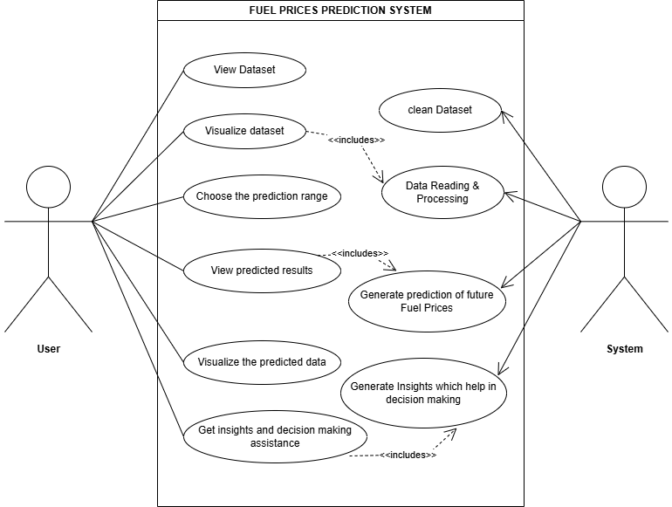
KEY;

Explanation of the Use Case Diagram;
Direct Relationship
Relationship
Action
Actor
This use case diagram illustrates the interaction between the User and the Fuel Prices Prediction System, highlighting the system’s core functionalities and how they support decision-making.
1. User Interactions
The user is the primary actor who engages with the system through several key actions:
- View Dataset: Access historical petroleum price data.
- Visualize Dataset: Explore data trends and patterns through graphical representations.
- Choose Prediction Range: Select the time frame for forecasting future fuel prices.
- View Predicted Results: Obtain forecasted fuel prices generated by the system.
- Visualize Predicted Data: Interpret predictions through charts and graphs for clarity.
- Get Insights and Decision-Making Assistance: Receive analytical insights that guide strategic decisions.
2. System Responsibilities
The system automates and supports the user’s actions by performing backend processes:
- Clean Dataset: Ensure data quality by removing inconsistencies and errors.
- Data Reading & Processing: Load and prepare raw datasets for analysis.
- Generate Prediction of Future Fuel Prices: Apply forecasting models to predict upcoming trends.
- Generate Insights for Decision Making: Provide explanations and actionable intelligence to support user decisions.
3. Relationships Between Actions
The diagram also shows dependencies using “<<includes>>” relationships:
- Visualizing datasets requires data reading and processing.
- Viewing predicted results depends on the generation of predictions.
- Insights for decision-making are derived from both predicted data and system analysis.

REFERENCES
Gasper, L., & Mbwambo, H. (2023). Forecasting crude oil prices by using ARIMA model: Evidence from Tanzania. Journal of Accounting, Finance and Auditing Studies, 9(2), 158–175.
Swoyam, S. N. (2023). Oil and Gas Price Analysis and Prediction
P. C. Ntare. (2023). Prediction of Petrol and Diesel Prices in Dar Es Salaam using ARIMA models.
Energy and Water Utilities Regulatory Authority (EWURA). (n.d.). Petroleum price publications. https://www.ewura.go.tz/publications/petroleum-price.

