(Large block quote? Something that immediately draws attention)

How can we help create a society that allows disabled people not only to **participate** but to **flourish**?

As I was diving into sources on the topic of disability, this is the question I began to ask myself. What is modern society getting right? What are we getting wrong? How should we improve? What does that look like practically?

Over the past few weeks, I have been building a research archive of several sources that provide some amazing insight into these questions:

(Clickable cards with an image, truncated description, read more – opens embedded scrollable window)

* Theoretical Framework (why should I care)
* Research Process
* Action Plan

Theoretical Framework:

The fundamental framework of my research is the idea that we as a society should be inclusive towards those with disabilities. My goal is to promote ways in which the theory of inclusivity collides with practice; in other words, what would a truly inclusive society look like?

**Two Models of Disability**

**1) The Medical Model**

Throughout my research, I found again and again this overarching fear and uncertainty around disability. Everyone is afraid of what becoming disabled would do to them, whether that is losing their job, being unable to get around, or a whole host of other things.

These fears stem from what is known as the Medical Model: The idea that a disabled person is disabled because there is something wrong with them that keeps them from being “normal.” This idea, while widely prevalent, is fundamentally discriminatory.

*[Source: TEDx Talks, 2020]*

It may be confusing at first; why would it be discriminatory to point out the truth that disabled people have something physically or mentally limiting about their bodies? That idea alone is not discriminatory, but it becomes so when it leads to a shift in blame fully onto the disabled person.

The truth is, even the most able-bodied/minded person has physical and mental limitations, and humans have been collectively advancing our abilities far beyond those of our bodies for thousands of years. Why then do we so readily resign ourselves to the notion that disabled people cannot be a functional part of society? That seems unfair, doesn’t it?

When brought under a critical eye, it becomes apparent that something more than bodily ability is at play in the process of making someone disabled; there is a societal component as well.

**2) The Social Model**

As I branched out into different sources on this topic, I came upon one common thread: the Social Model.

This model brings into question the ideas stated by the Medical Model and instead offers up the idea that the way society is built is responsible for disabling people, not their impairments.

*[Source: TEDx Talks, 2020]*

This model provides an interesting standpoint, because instead of placing all the blame on the individual, it shifts it onto society. It takes the dialogue from “we’re sorry for you” to “what can we change to accommodate you?”

For example, everyone would consider someone who can’t walk disabled. The Medical Model firmly backs this, saying that they have a problem that needs to be fixed. The Social Model, on the other hand, asks why they should be prevented from accessing certain buildings because of their impairment. The Medical Model calls their method of transportation (a wheelchair) broken, where the Social Model just calls it different. A person sitting on a wheelchair

*[Source: Shutterstock]*

Imagine we had a society that was fully wheelchair accessible. Imagine we built technologies meant to accommodate and extend the capabilities of those in wheelchairs. Would they even be impaired anymore? They would still have a physical limitation, but what does it matter if they can do everything just as well as everyone else?

This shift in perspective has become the foundation of my research. Where the Medical Model sees barriers, the Social Model sees opportunities for growth and inclusivity. If I am going to compile practical ways in which to include disabled people, the Social Model must be the framework through which I do so.

And let’s be real: does anybody actually want disabled people to remain disabled? Maybe instead of struggling against their bodies, we should change how our society prevents those bodies from participating in daily life. We can make a change, and the Social Model shows us how.

Research Process

Due to the topic at hand, my research process quickly deviated from my typical pattern. Normally, I seek out primarily peer-reviewed, academic sources as well as professional sources such as encyclopedias and respected news websites.

Throughout my research on this topic, though, it became apparent that lived experiences and the voices of individuals would be even more crucial to answering my question than academic and professional works.

I thus chose to search in a wide variety of places, including news sites, ted talks, blogs, academia, and even forum posts. I was searching for common elements between all these sources and was surprised by how quickly I found them.

Through academic and public sources alike I found a common theme that aligned almost perfectly with the Social (or Affirmative) Model of disability. Even people who seemingly had no knowledge of this model were arguing in favor of it.

Once I discovered this connection, I began to branch out in both public and academic circles, finding commonalities and ideas as to what my next steps should be. I ended up with many dozens of possible sources, only a few of which are curated and annotated here. I will definitely be adding to these as my project progresses.

Action Plan

Moving forwards, I want to be able to provide the public with a set of helpful resources in understanding the challenges that disabled people face in modern society, and some succinct and achievable ways in which they can lighten that burden and make the world a more accessible place.

My first idea in this regard was to create a webpage, because they are nearly universally understood and (if done correctly) accessible to a huge number of people. I quickly realized though that most people, especially those unaffected by societal discrimination against disabled people, are not interested in reading through a web text, essay, or blog on the topic.

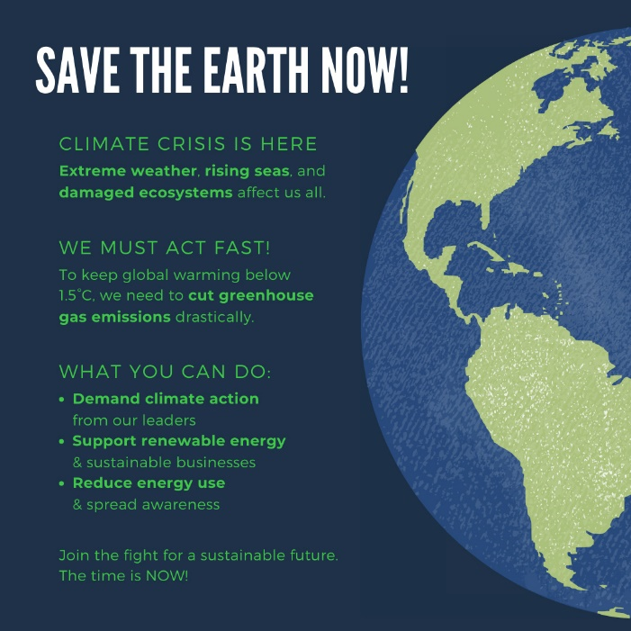Consider the following two example images:

*[Source: ChatGPT]*

Which one grabs your attention and makes a bigger impact on you? Most likely, the one that is condensed, visual, and isn’t packed with text you have to pore over.

If I want to make an impact, I need to lean into at-a-glance information, not long-form academic writing. Since the most important audience to reach with this material is those who are able-bodied and may not have even given thought to how their actions could be discriminatory, I am leaning towards producing a variety of more condensed communication forms such as pamphlets, flyers, or even advertisements.

I want to compile all of these into a media bundle and then create a website that they link to which elaborates further on the topic. I feel this provides the best of both worlds: in-depth information for people who are interested, and at-a-glance information that can plant the idea in the casual onlooker of “hmm, maybe I should do something about that.”