weekly-Exercise - 02

## ICS 365-01 Metropolitan State University/MN

## Week 2 Due 11:59pm, Sunday, Sept. 4, 2022 Fall 2022

## Name:____________Pong Lee________________ Score: __________________

## Please complete both Parts I and II and then upload the results to D2L under the dropbox for Weekly Exercise 02 before the deadline (total 20 points).

## Part I: Based on the discussion in Lecture 2 and Chapter 2, please either bold or highlight your answers below, only one answer per question. (1 point each, total 10 points)

1. Which of the following was not one of the goals in designing a programming language proposed by ACM and GAMM in 1958?

A) Must be translatable to machine code

B) Close to mathematical notation

C) Easy to read and write

D) Good for describing algorithms

2. Based on the discussion on the textbook, *IF ... THEN ... ELSE ... ENDIF* statement was introduced in which version of FORTRAN compilers?

A) FORTRAN I in 1957

B) FORTRAN II in 1958

C) FORTRAN VI in 1962

D) FORTRAN 77 in 1978

3. Based on the discussion in Chapter 2, Which of the following is NOT one of the reasons for the failure of ALGOL 60?

A) The input and output statements are implementation-dependent

B) A full endorsement from IBM (International Business Machines Corporation), which was a dominated computer company in the 60s

C) Associated with the BNF (Backus-Naur Form), ALGOL's syntax was considered too complicated in the early 60s

D) Lack of support from many FORTRAN programmers

4. According to the discussion in Chapter 2, which of the following statements is not true regarding COBOL programming language?

A) One of the design goals of COBOL was easy to use, even if that means it would be less powerful

B) Although COBOL is still the most widely used business application language, it was the first language required by the Department of Defense

C) One of the early contributions of COBOL is the inclusion of nested selection statements

D) The first design meeting for COBOL was held at the headquarters of IBM in New York

5. Based on the discussion on the minimal hardware programming for pseudocodes, which of the following is considered as a machine deficiency?

A) Expression coding was tedious

B) Poor modifiability

C) No floating point

D) Poor readability

6. Based on the discussion in Chapter 2, which of the following programming languages is not a script language?

A) Python

B) PHP

C) Perl

D) Pascal

7. Which of the following is not one of the new features introduced by ALGOL 60

A) Subprogram recursion

B) Two parameter passing methods

C) String handling

D) Block Structure (local scope)

8. All the following are true to ADA programming language except

A) It was named after Augusta Ada Byron (1815 to 1852, an English mathematician and writer), the first programmer

B) Concurrency, through the tasking model, was one of its main contributions

C) It included all that was then known about software engineering and language design

D) The first really usable compiler came right after the language design was completed

9. Based on the discussion in Chapter 2, which of the following is not true to programming language C?

A) It was created by Dennis Richie at Bell Labs B) it has been exclusively used for system programming but not for any application areasC) It was initially spread through UNIX operating systemD) It was designed for systems programming

10. Which of the following statements is not true to LISP ?

A) In LISP, the assignment statements and the variables are not necessary

B) It was designed as a functional programming language

C) Since it was developed in late 1950s and early 1960s, it is no longer useful for AI applications

D) It processes data in lists, rather than arrays

**Part II: Please study the handout for the programming assignment 1, practice the shell script examples provided in the handout, and then complete the following tasks: (total 10 points)**

1. Please provide the screenshots for the following script examples provided in the handouts:

1. Please provide the screenshot of the execution of script “*number4*” provided on page 6 of the handout below (2 points):

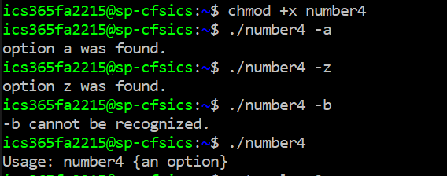

1. Please provide the screenshot of the execution of script “*loop2*” provided on page 7 of the handout below (2 points):

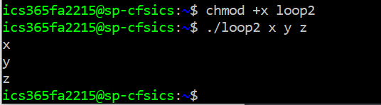

2. Please combine the technique provided in two script examples above and then come up with a single script called “*wk02p2*” that displays the following output: (6 points)

|  |  |  |
| --- | --- | --- |
|  |  |  |

1. Please provide the screenshot of your script below (2 points):

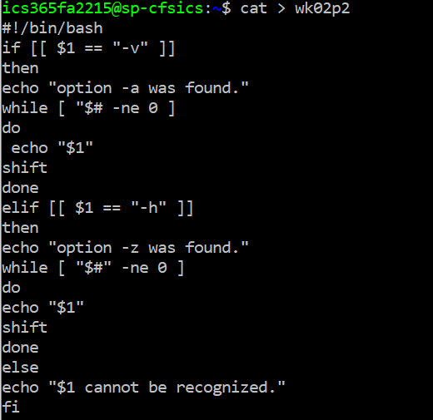

1. Please provide the screenshot(s) of the executions of your script below (4 points):

