IT Service and Asset Management System (ITSaAMS)
Appendix: Function Screenshots by Role
This appendix shows every function and screen available to each user role (Admin, Operator, Viewer) as captured from the running system. Each function has its route, a short explanation of how it works, and a full-window screenshot. Start with Login (common to all roles), then jump to your role section.
How to read this appendix: headings give the screen name and route (e.g. /assets), the paragraph below explains the workflow step by step, and the centered figure shows exactly what the user sees.

Getting Started - Login (all roles)

Login (/login)
How it works: Type Username or Email plus Password, optionally tick Remember me (secure HttpOnly cookie), then Sign In. Server checks bcrypt hash with rate-limiting and CSRF protection, then lands Admins on Dashboard and Operators on IT Concerns.
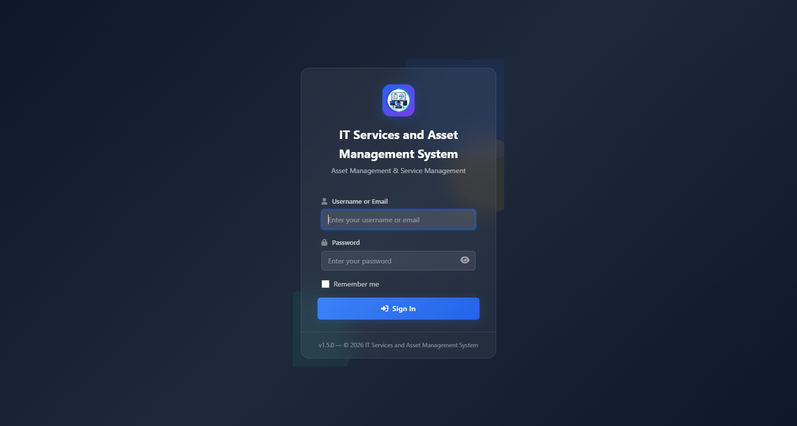
Figure 1 - Login (/login)

Admin Role - full access (21 screens incl. Login)
Admins manage assets, licenses, disposals, departments, users, settings, topology and the full ticket queue.
- Dashboard (/dashboard)
- Asset Ledger (/assets)
- Add New Asset (/assets/create)
- Retired Assets (/assets/retired)
- Departments (/departments)
- Asset Disposals (/disposals)
- Audit Log and History (/history)
- Software Licenses (/licenses)
- Add New License (/licenses/create)
- Messages (Messenger) (/messages)
- My Profile (/profile)
- System Settings (/settings)
- Tickets Analytics (/tickets/analytics)
- Tickets Backups (/tickets/backup)
- Tickets History and Remarks (/tickets/history)
- Tickets Instructions (/tickets/instructions)
- Tickets Manage Active (/tickets/manage)
- Network Diagram (Topology) (/topology)
- User Management (/users)
- Add New User (/users/create)
Screenshots follow - one block per function.

Dashboard (/dashboard)
How it works: At-a-glance overview. Stat cards show Total, Active, In Maintenance, Retired; charts break assets by type, status, department and monthly additions; Recent Activity streams last 10 audit entries.
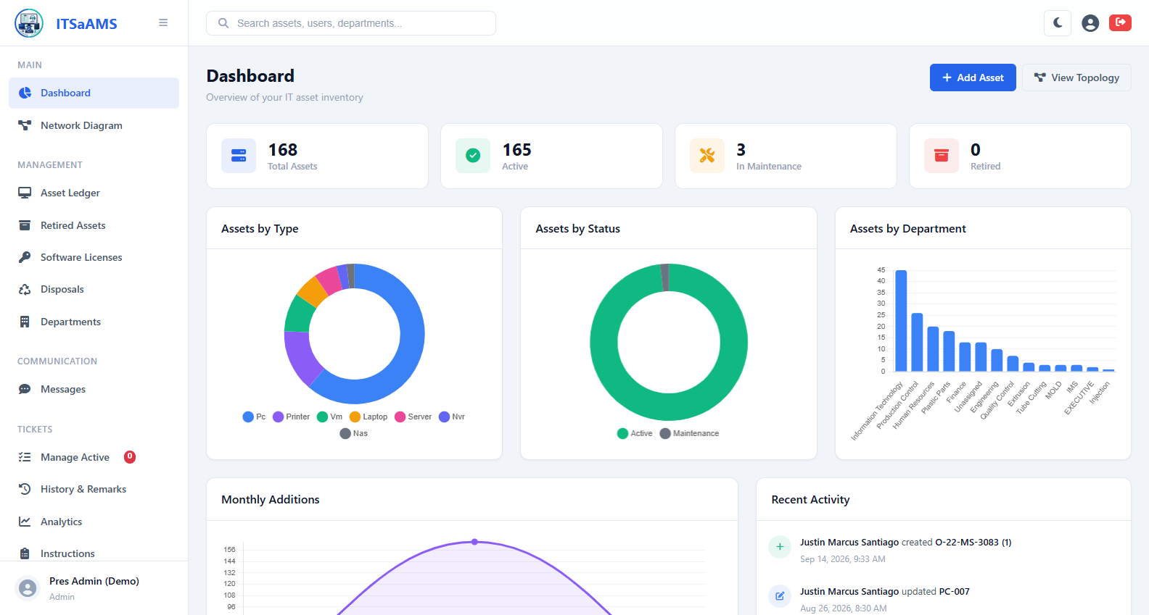
Figure 2 - Dashboard (/dashboard)

Asset Ledger (/assets)
How it works: Master table of all IT assets. Type keyword (tag, hostname, IP, serial) plus Type, Status, Department filters then Search. Export downloads CSV. Click tag or eye for detail; pencil and trash edit or delete (hidden for Viewers).
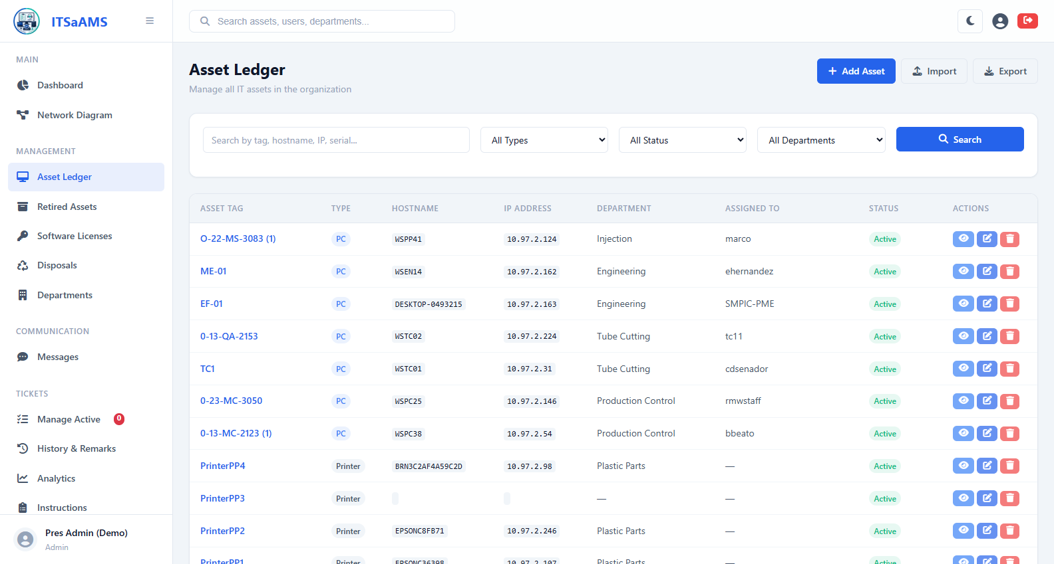
Figure 3 - Asset Ledger (/assets)

Add New Asset (/assets/create)
How it works: Creates one asset with auto tag per type (PC-001, LAP-001, SRV-001). Fill Hostname, Type, IP, MAC, vendor, model, serial, OS, CPU, RAM, storage, location, department and Assigned-User name (auto-resolves to user ID), then Save.
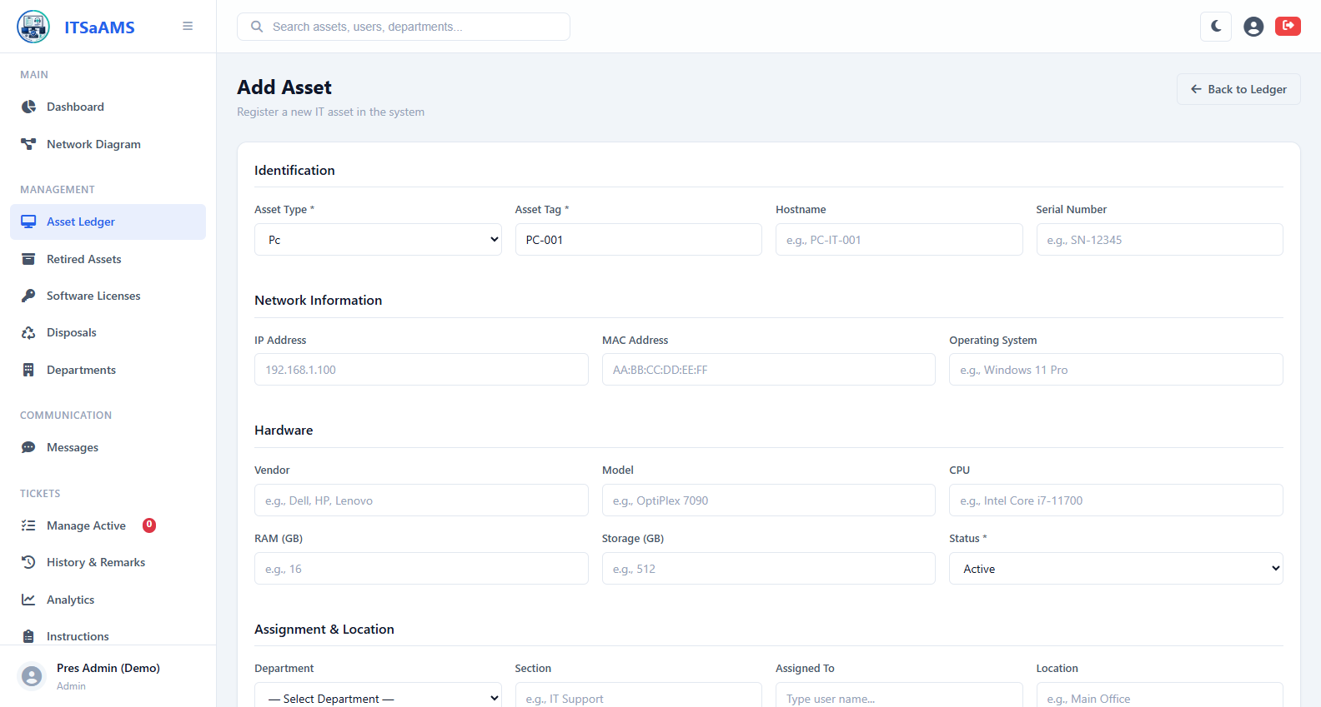
Figure 4 - Add New Asset (/assets/create)

Retired Assets (/assets/retired)
How it works: Holding area for end-of-life assets. Lists only Status Retired items. Start disposal from Disposals module or click Return to Service to flip back to Active.
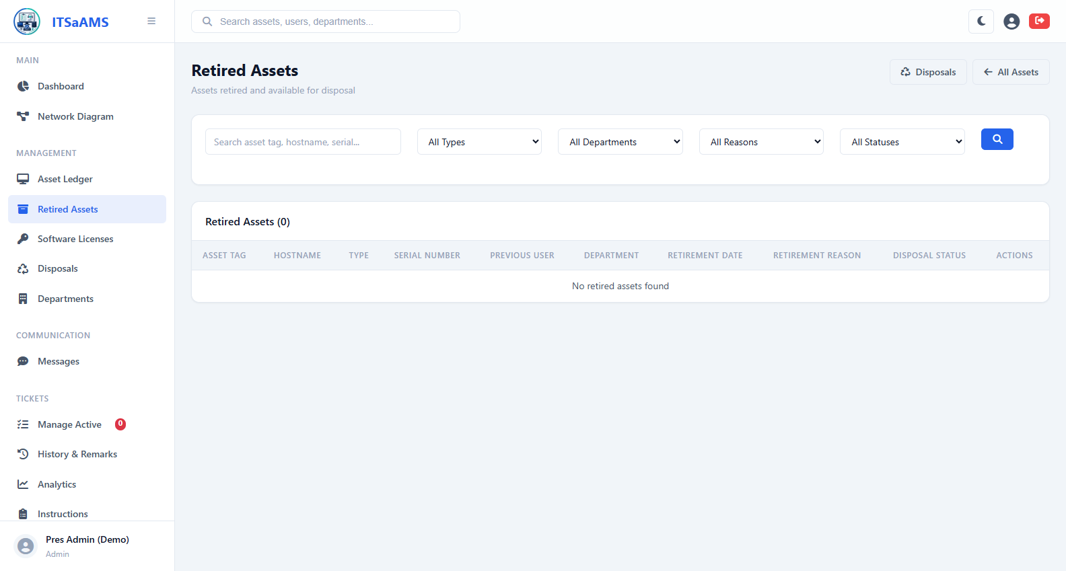
Figure 5 - Retired Assets (/assets/retired)

Departments (/departments)
How it works: Org units with Section that assets and tickets belong to. List shows name, section and asset count. Admins and operators add, rename or remove departments.
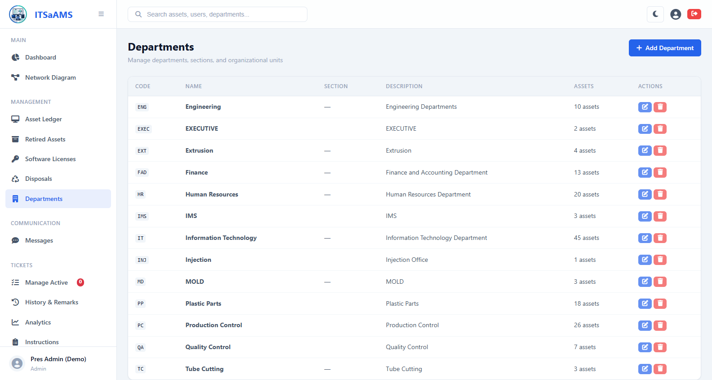
Figure 6 - Departments (/departments)

Asset Disposals (/disposals)
How it works: Retirement pipeline Pending, Awaiting Approval, Scheduled, Disposed. Create disposal from retired asset, submit for approval, set date and method, then confirm. Click row for detail with printable certificate.
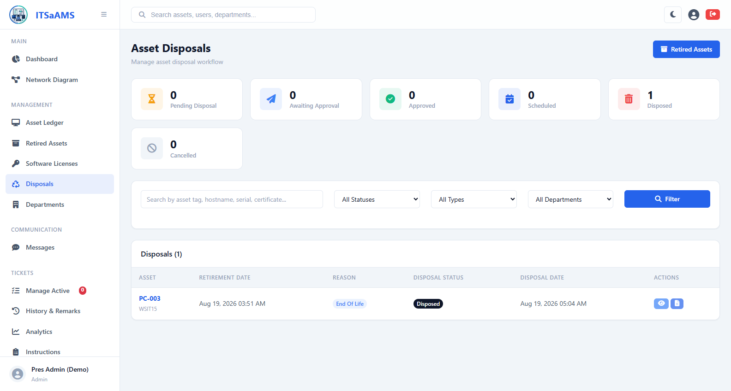
Figure 7 - Asset Disposals (/disposals)

Audit Log and History (/history)
How it works: Trail of every create, update, delete, login and ticket action. Rows show timestamp, user, action and record. Filter by date, user or action. Not editable; source of truth.
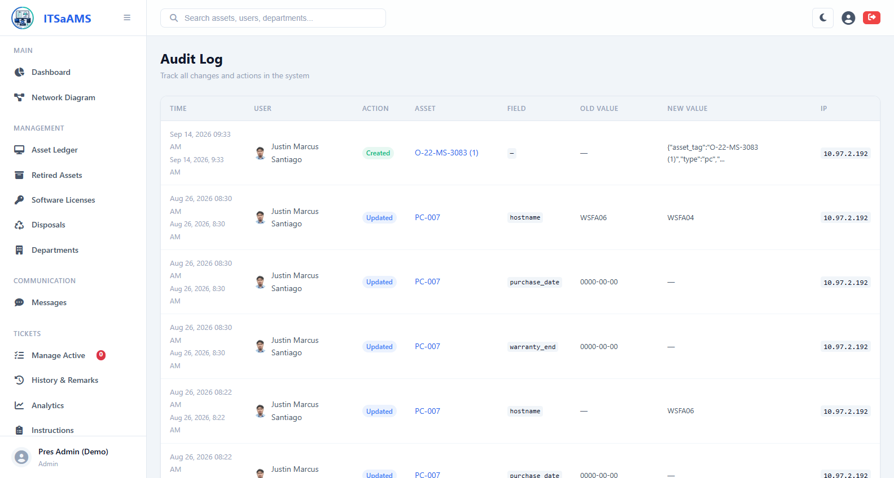
Figure 8 - Audit Log and History (/history)

Software Licenses (/licenses)
How it works: Library of entitlements with seat tracking. Each row shows total vs used seats, expiry and badges for Expiring within 30 days or Over Capacity. Search by product, vendor or key.
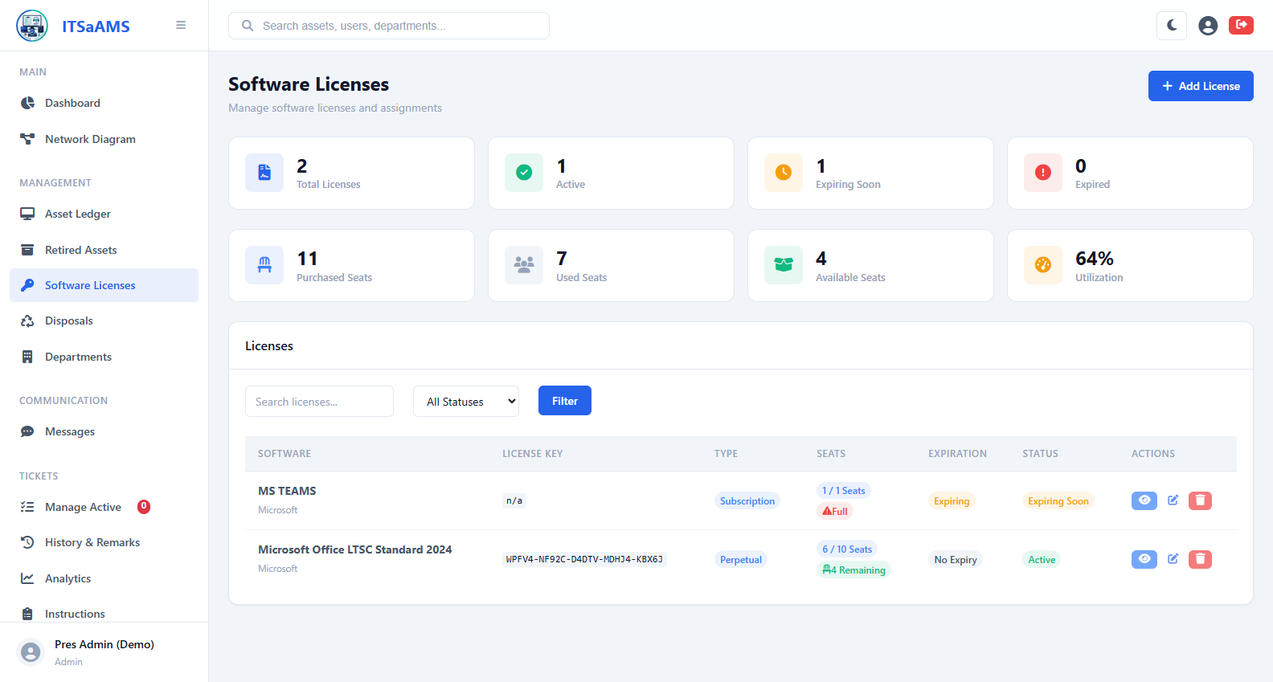
Figure 9 - Software Licenses (/licenses)

Add New License (/licenses/create)
How it works: Registers new software purchase. Enter product, vendor, license key, total seats, purchase and expiry dates and notes, then Save. Seats can then be assigned from detail page.
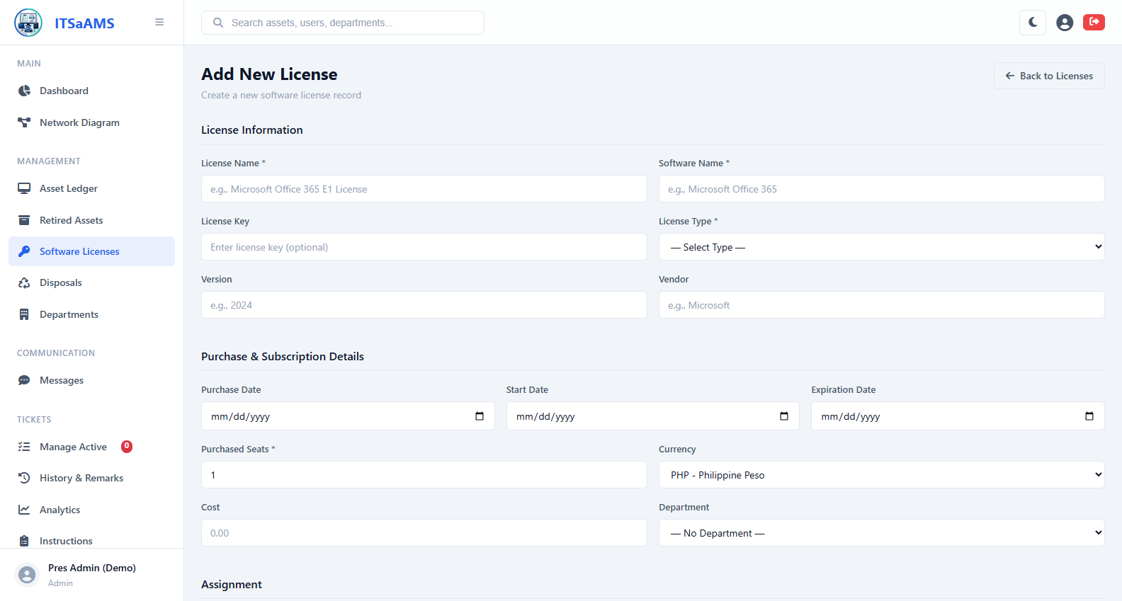
Figure 10 - Add New License (/licenses/create)

Messages (Messenger future plan) -still under developing (/messages)
How it works: Internal chat. Left pane lists conversations (unread highlighted), right pane shows thread. Pick conversation or start new one by choosing user, type message and Send.
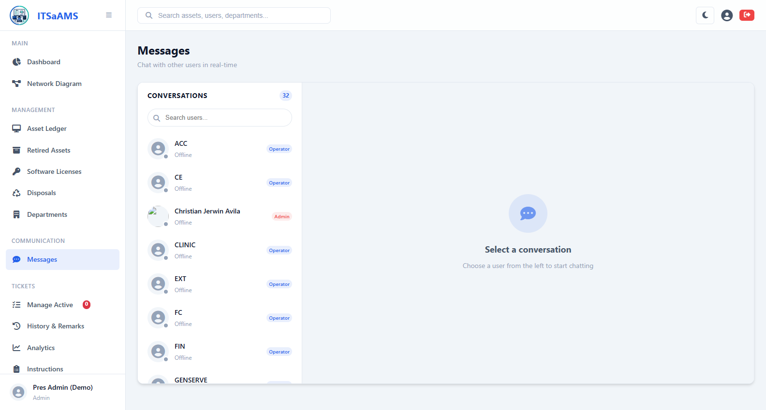
Figure 11 - Messages (Messenger) (/messages)

My Profile (/profile)
How it works: Self-service account page. View name, username, email, role, department and avatar; edit contact details, upload avatar, or change password. Save applies immediately.
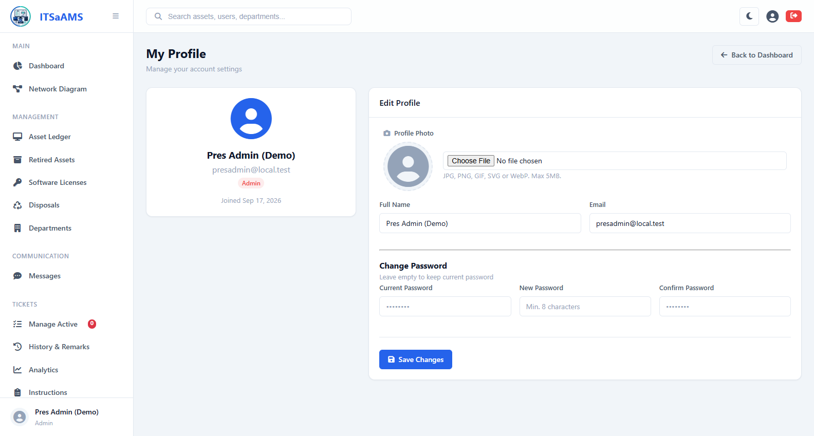
Figure 12 - My Profile (/profile)

System Settings (/settings)
How it works: Admin-only global config. Edit app name, mail and SMTP options, backup retention and toggles on one form, then Update. Applies instantly to all users.
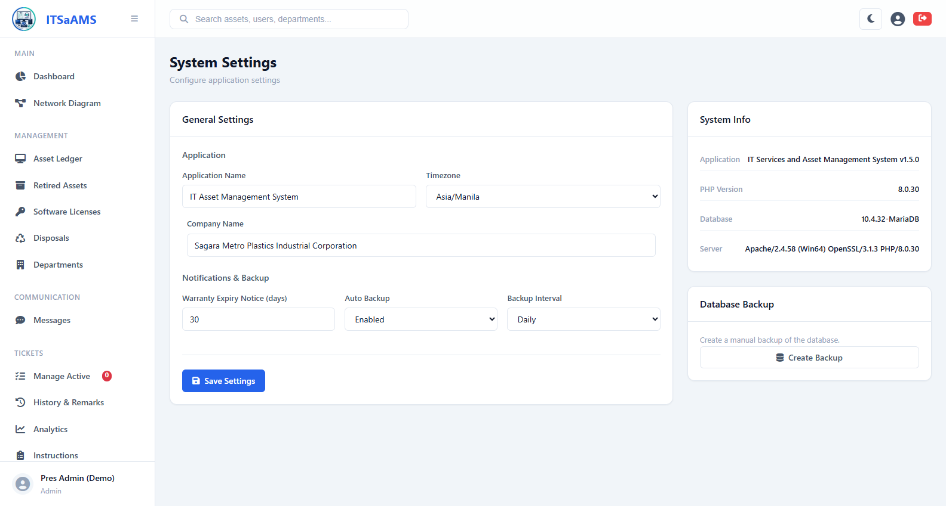
Figure 13 - System Settings (/settings)

Tickets Analytics (/tickets/analytics)
How it works: Charts for ticket performance by status (pending, accepted, repaired, canceled), priority and department, plus completed-today count and average repair time.
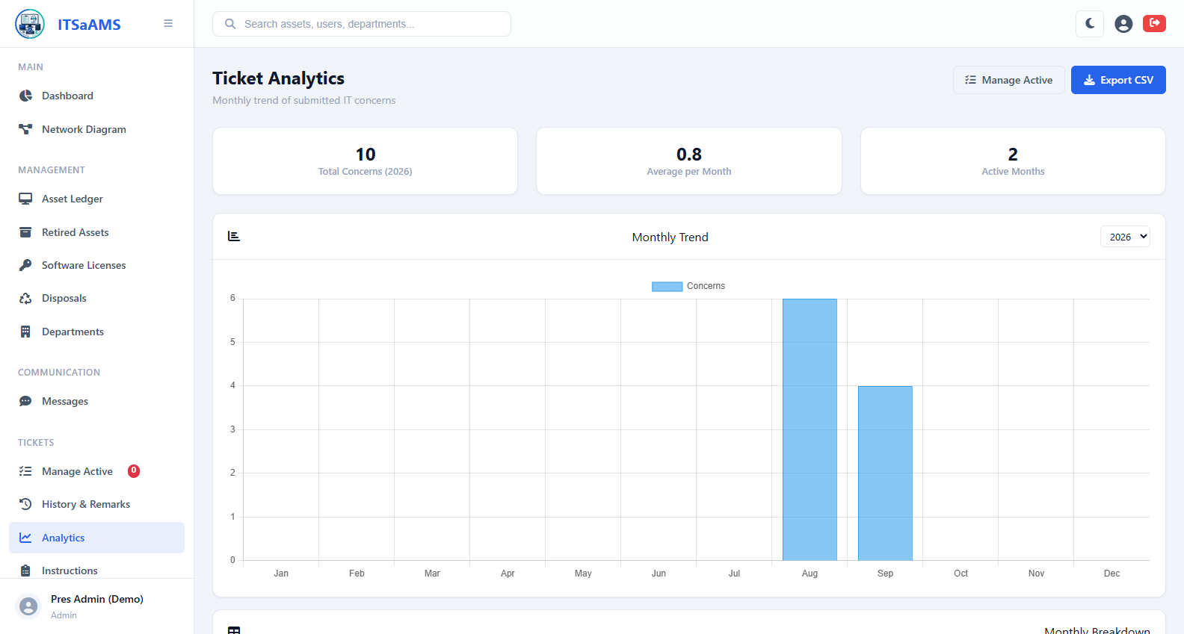
Figure 14 - Tickets Analytics (/tickets/analytics)

Tickets Backups (/tickets/backup)
How it works: Incremental backup of ticket data. Run Backup snapshots only records changed since last run (storage/backups), then Download the file.
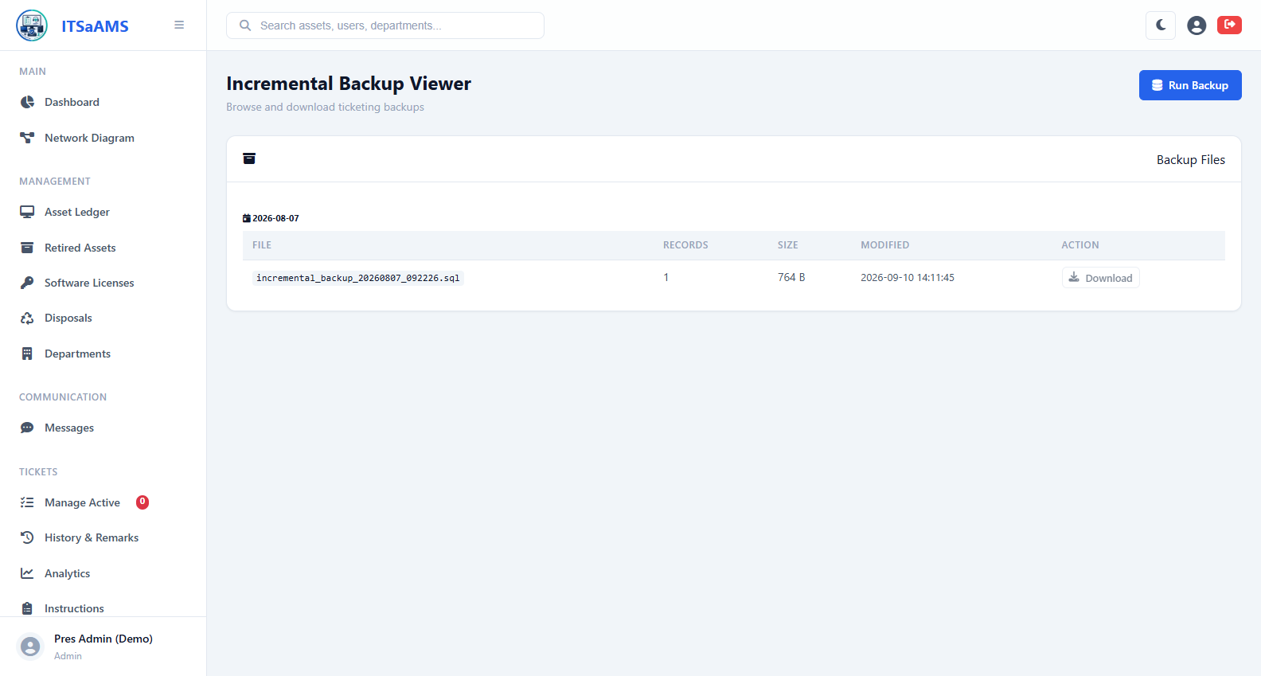
Figure 15 - Tickets Backups (/tickets/backup)

Tickets History and Remarks (/tickets/history)
How it works: Archive of finished tickets (admin). Every repaired or canceled ticket lands here with full remark thread, who accepted and repaired it and measured duration.
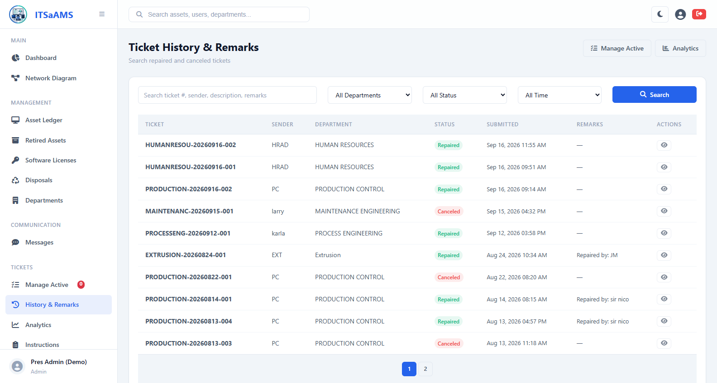
Figure 16 - Tickets History and Remarks (/tickets/history)

Tickets Instructions (/tickets/instructions)
How it works: Admin-editable guide shown to submitters. Admins edit rich text (what to include, photo tips, SLA notes) and Save; users see updated guide on Submit page.
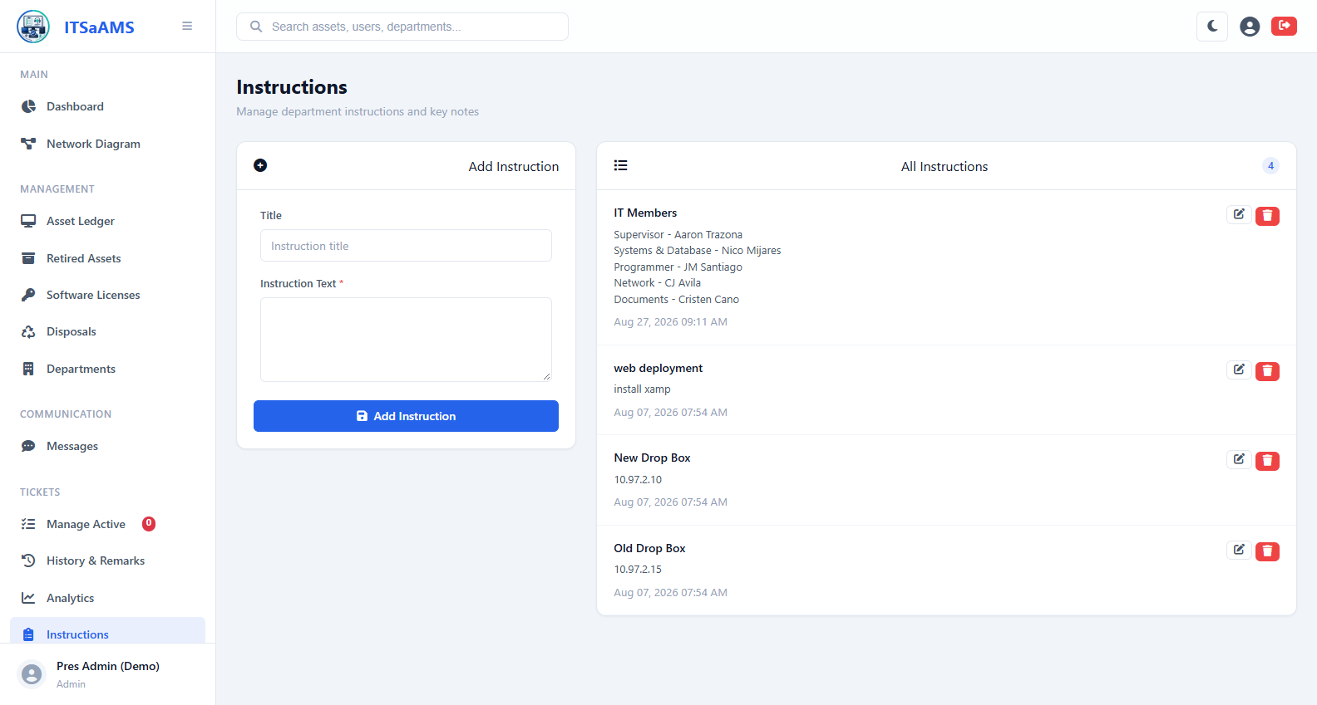
Figure 17 - Tickets Instructions (/tickets/instructions)

Tickets Manage Active (/tickets/manage)
How it works: Admin queue for live tickets. Filter by department, then Accept pending ticket (stamps accepted_at, starts live HH:MM:SS timer anchored to server clock), Mark as Repaired when done, or Cancel with mandatory reason.
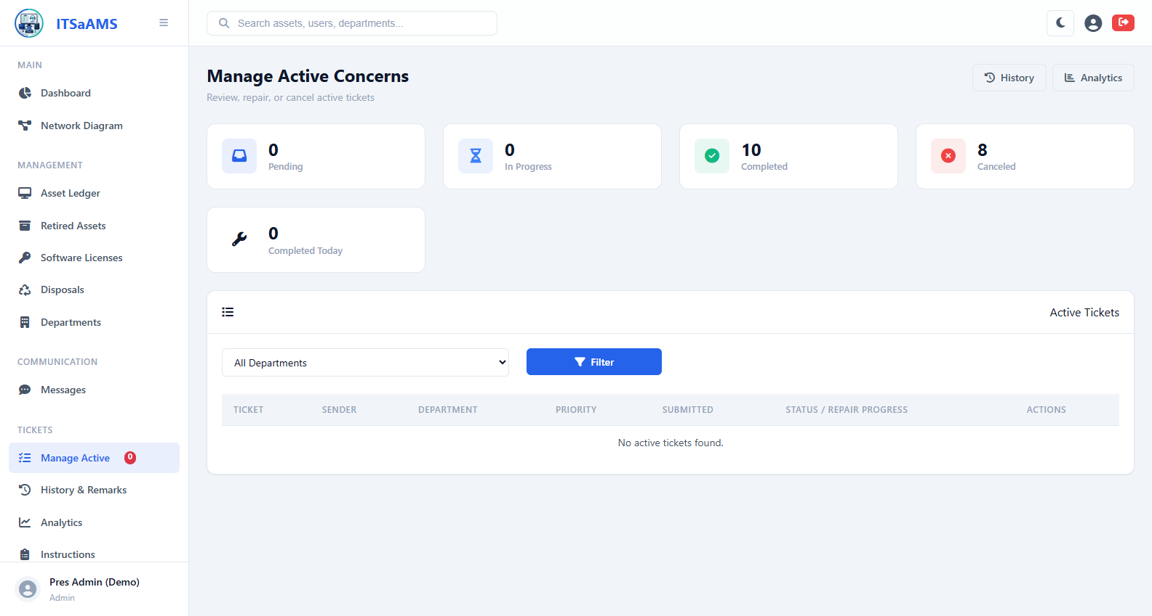
Figure 18 - Tickets Manage Active (/tickets/manage)

Network Diagram (Topology) (/topology)
How it works: Interactive canvas map of devices and links. Drag nodes, scroll to zoom, drag empty space to pan, Fit or Auto-layout. Filters dim others; search finds hostname, IP or type. Connect mode draws links, Disconnect removes them. Save persists positions, Export PNG for reports.
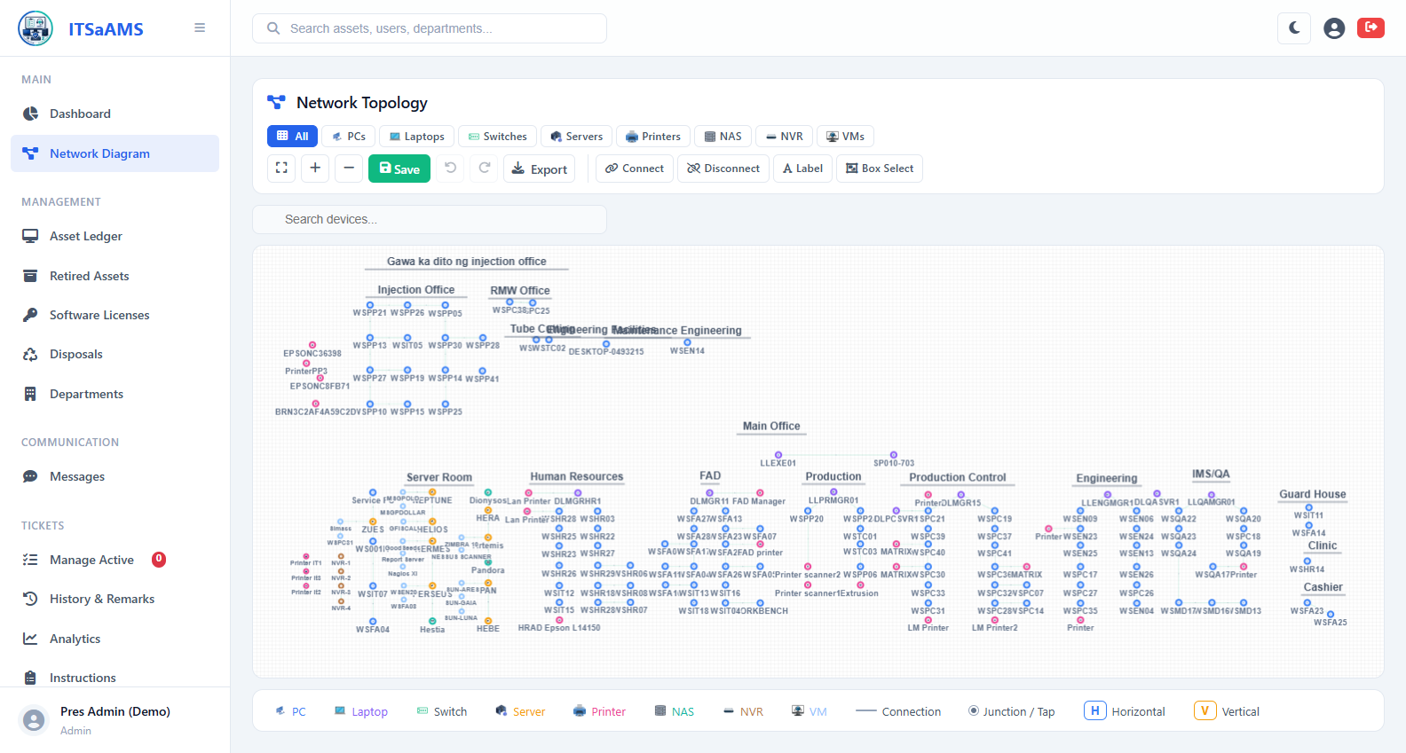
Figure 19 - Network Diagram (Topology) (/topology)

User Management (/users)
How it works: Admin-only staff directory. Table shows name, username, email, role (Admin, Users, Viewer) and department. Search, New User to add, row icons to edit or deactivate.
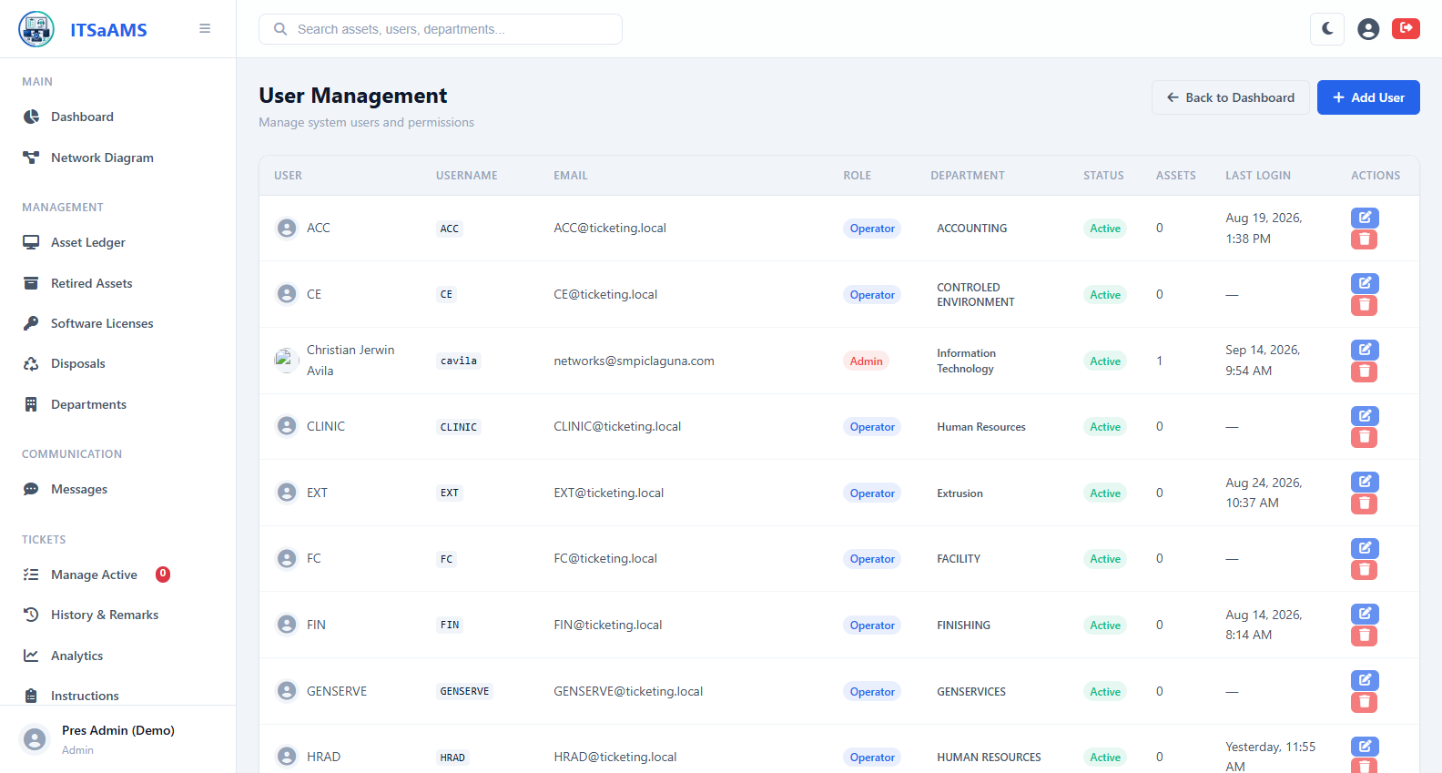
Figure 20 - User Management (/users)

Add New User (/users/create)
How it works: Provisions one login. Enter full name, username, email, temporary password, role (Admin full access, Operator assets plus own tickets, Viewer read-only) and department, then Save.
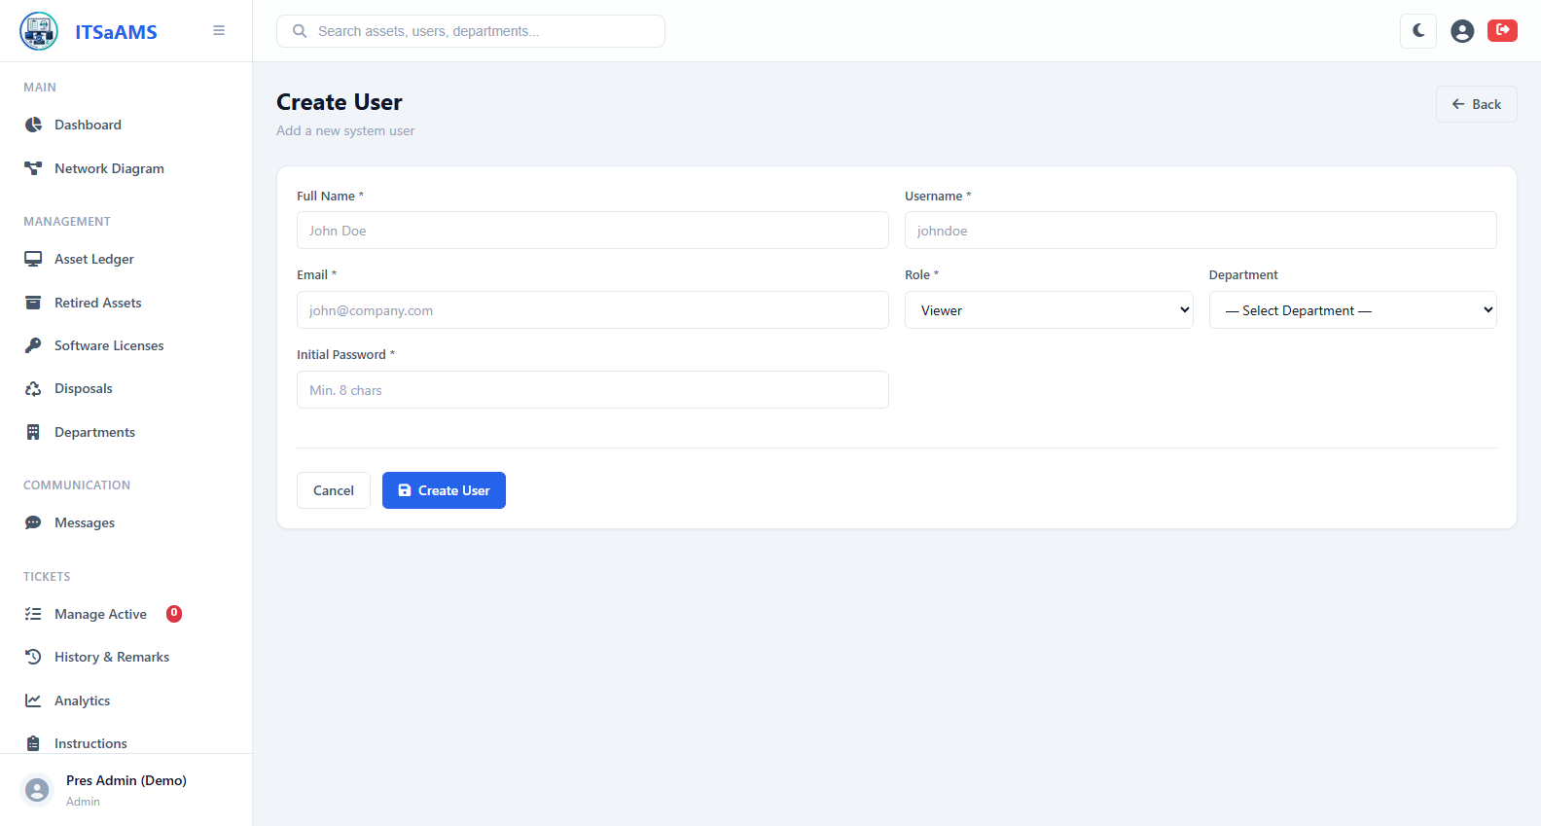
Figure 21 - Add New User (/users/create)

User Role - submit and track concerns (4 screens)
User’s submit IT concerns, follow live status, review own history, message IT staff and maintain profile.
- Messages (Messenger) (/messages)
- My Profile (/profile)
- IT Concerns Submit and Track Tickets (/tickets)
- My Ticket History (/tickets/my-history)
Screenshots follow - one block per function.

Messages (Messenger future plan) -still under developing (/messages)
How it works: Internal chat. Left pane lists conversations (unread highlighted), right pane shows thread. Pick conversation or start new one by choosing user, type message and Send.
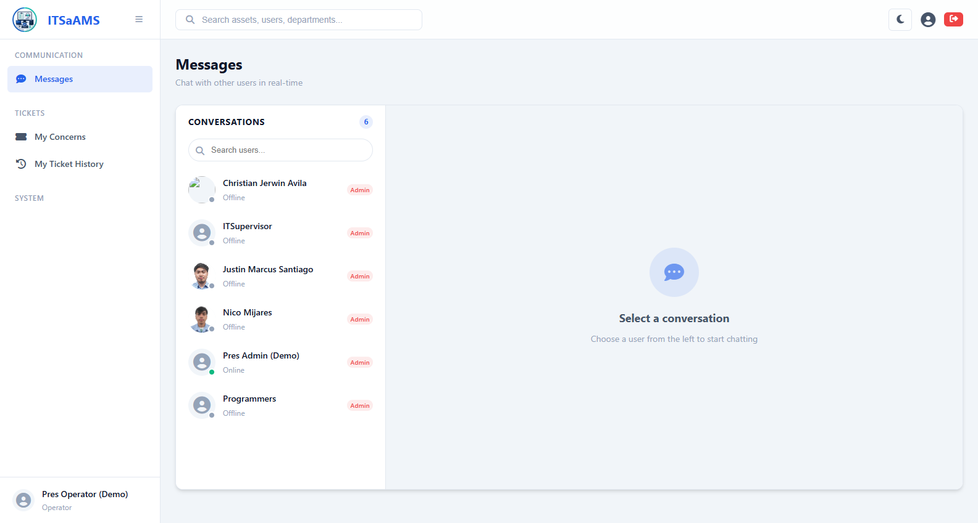
Figure 22 - Messages (Messenger) (/messages)

My Profile (/profile)
How it works: Self-service account page. View name, username, email, role, department and avatar; edit contact details, upload avatar, or change password. Save applies immediately.
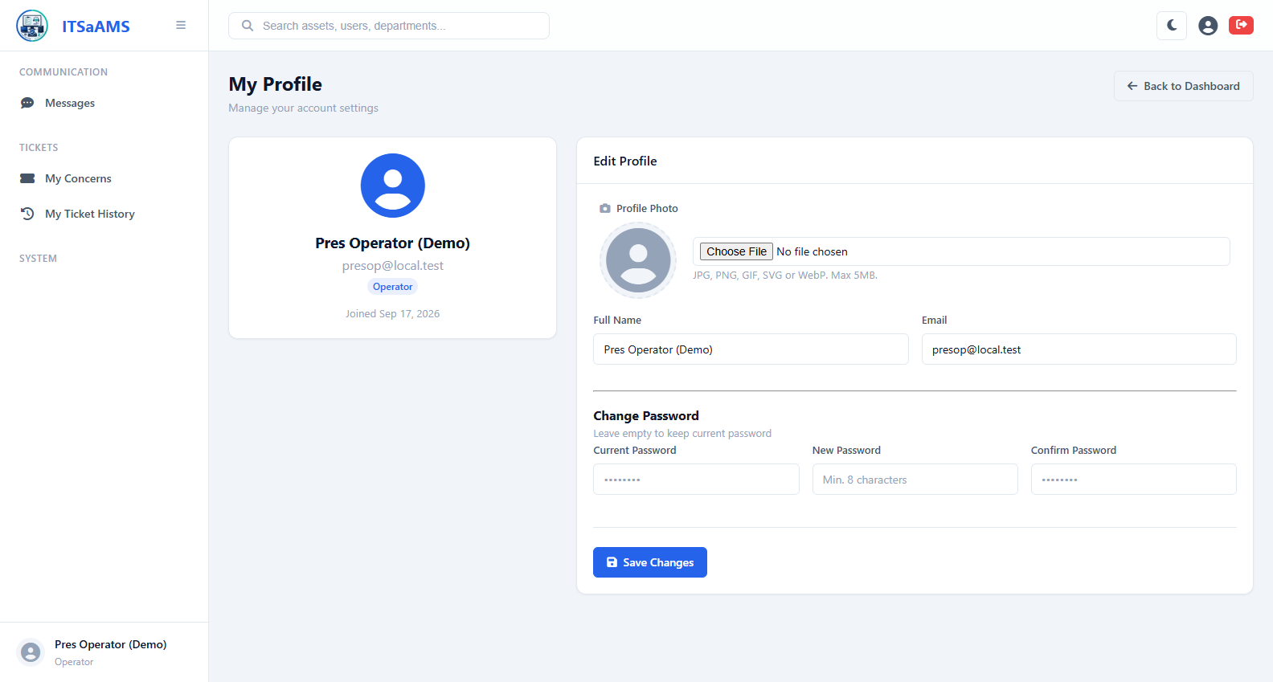
Figure 23 - My Profile (/profile)

IT Concerns Submit and Track Tickets (/tickets)
How it works: Operator landing page. Left card is submit form: sender pre-filled, department auto-filled, pick Priority, describe issue, optionally attach photo, then Submit to create PENDING ticket. Right table tracks live status.
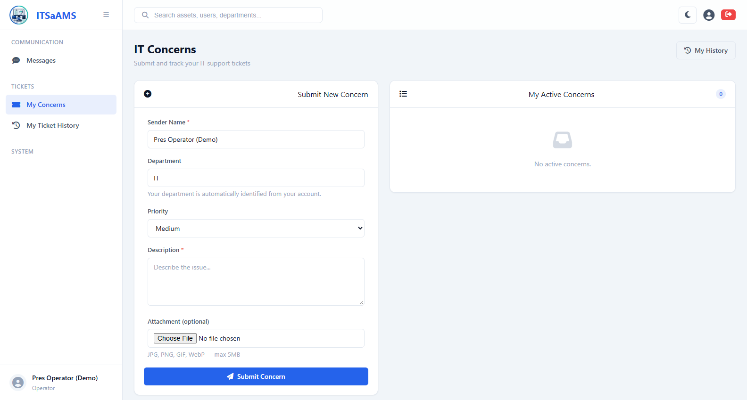
Figure 24 - IT Concerns Submit and Track Tickets (/tickets)

My Ticket History (/tickets/my-history)
How it works: Personal archive of finished concerns. After admin repairs or cancels ticket it moves here with number, final status, remarks and timestamps.
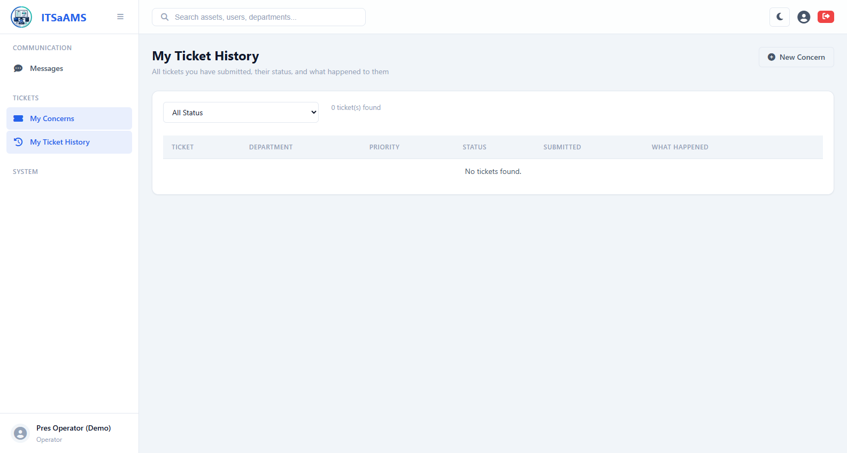
Figure 25 - My Ticket History (/tickets/my-history)

Viewer Role - read-only access (9 screens)
Viewers inspect dashboards, ledgers, disposals, licenses, history, messages, profile and topology but all create, edit and delete controls are hidden.
- Dashboard (/dashboard)
- Asset Ledger (/assets)
- Retired Assets (/assets/retired)
- Asset Disposals (/disposals)
- Audit Log and History (/history)
- Software Licenses (/licenses)
- Messages (Messenger) (/messages)
- My Profile (/profile)
- Network Diagram (Topology) (/topology)
Screenshots follow - one block per function.

Dashboard (/dashboard)
How it works: At-a-glance overview. Stat cards show Total, Active, In Maintenance, Retired; charts break assets by type, status, department and monthly additions; Recent Activity streams last 10 audit entries.
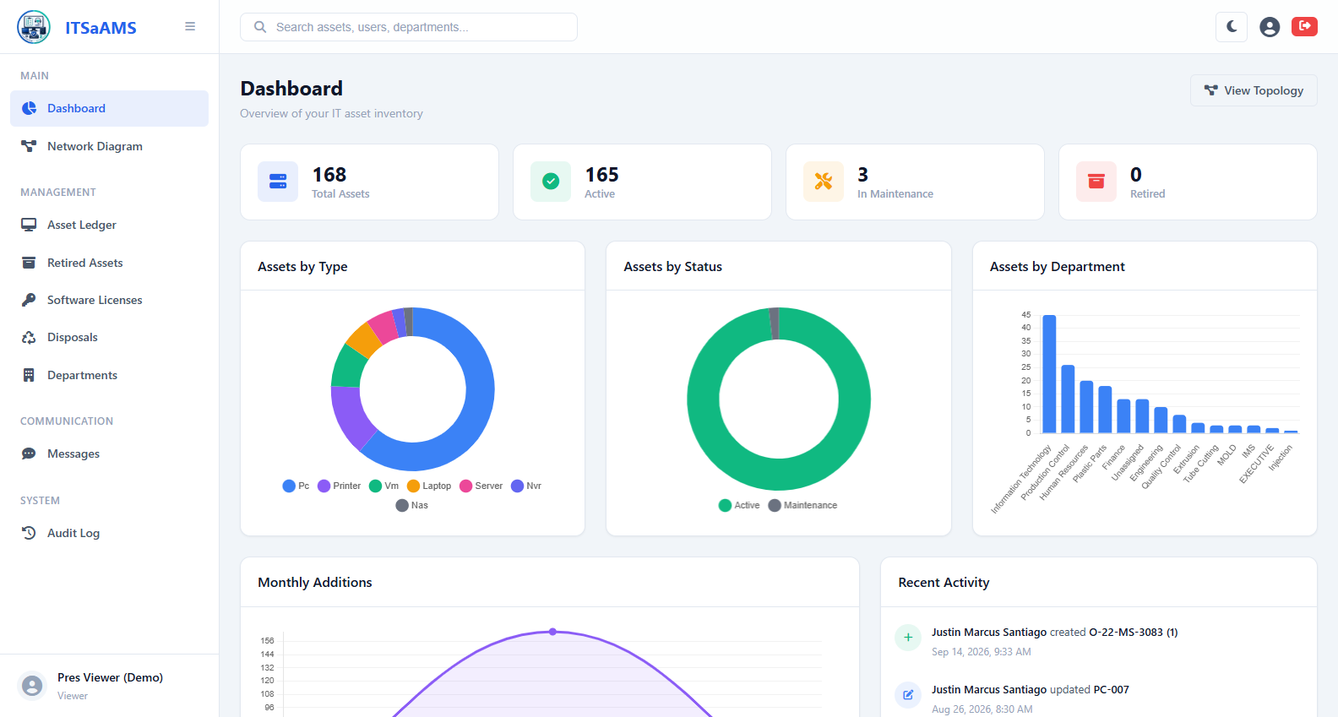
Figure 26 - Dashboard (/dashboard)

Asset Ledger (/assets)
How it works: Master table of all IT assets. Type keyword (tag, hostname, IP, serial) plus Type, Status, Department filters then Search. Export downloads CSV. Click tag or eye for detail; pencil and trash edit or delete (hidden for Viewers). But this account can only view
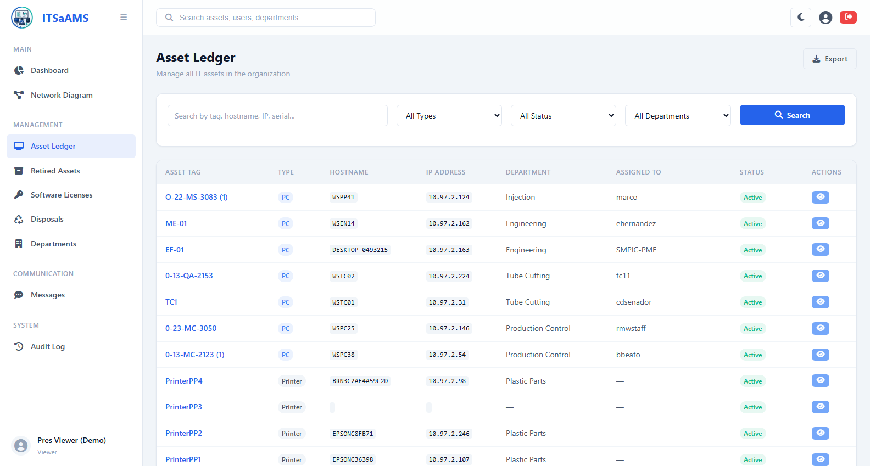
Figure 27 - Asset Ledger (/assets)

Retired Assets (/assets/retired)
How it works: Holding area for end-of-life assets. Lists only Status Retired items. Start disposal from Disposals module or click Return to Service to flip back to Active. But this account can only view
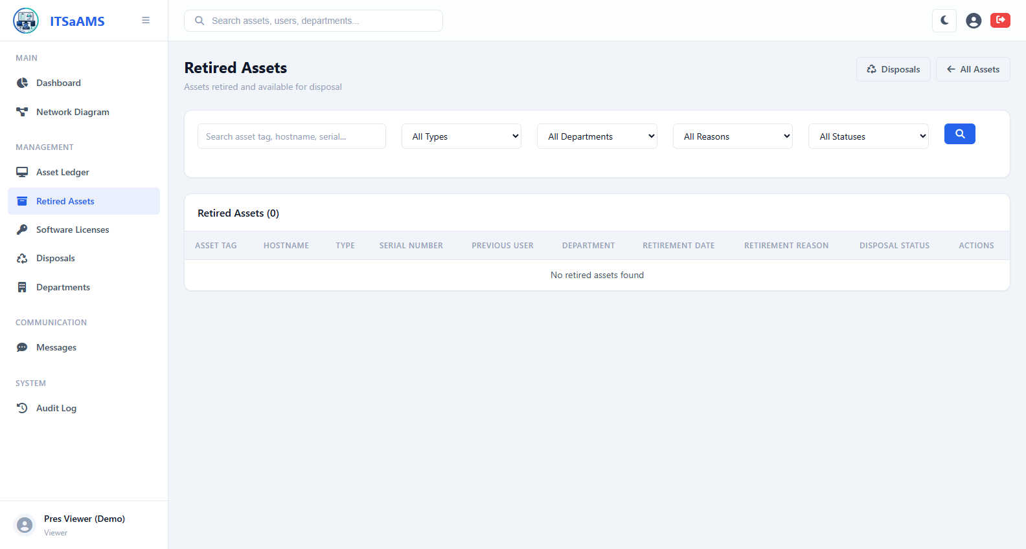
Figure 28 - Retired Assets (/assets/retired)

Asset Disposals (/disposals)
How it works: Retirement pipeline Pending, Awaiting Approval, Scheduled, Disposed. Create disposal from retired asset, submit for approval, set date and method, then confirm. Click row for detail with printable certificate. But this account can only view
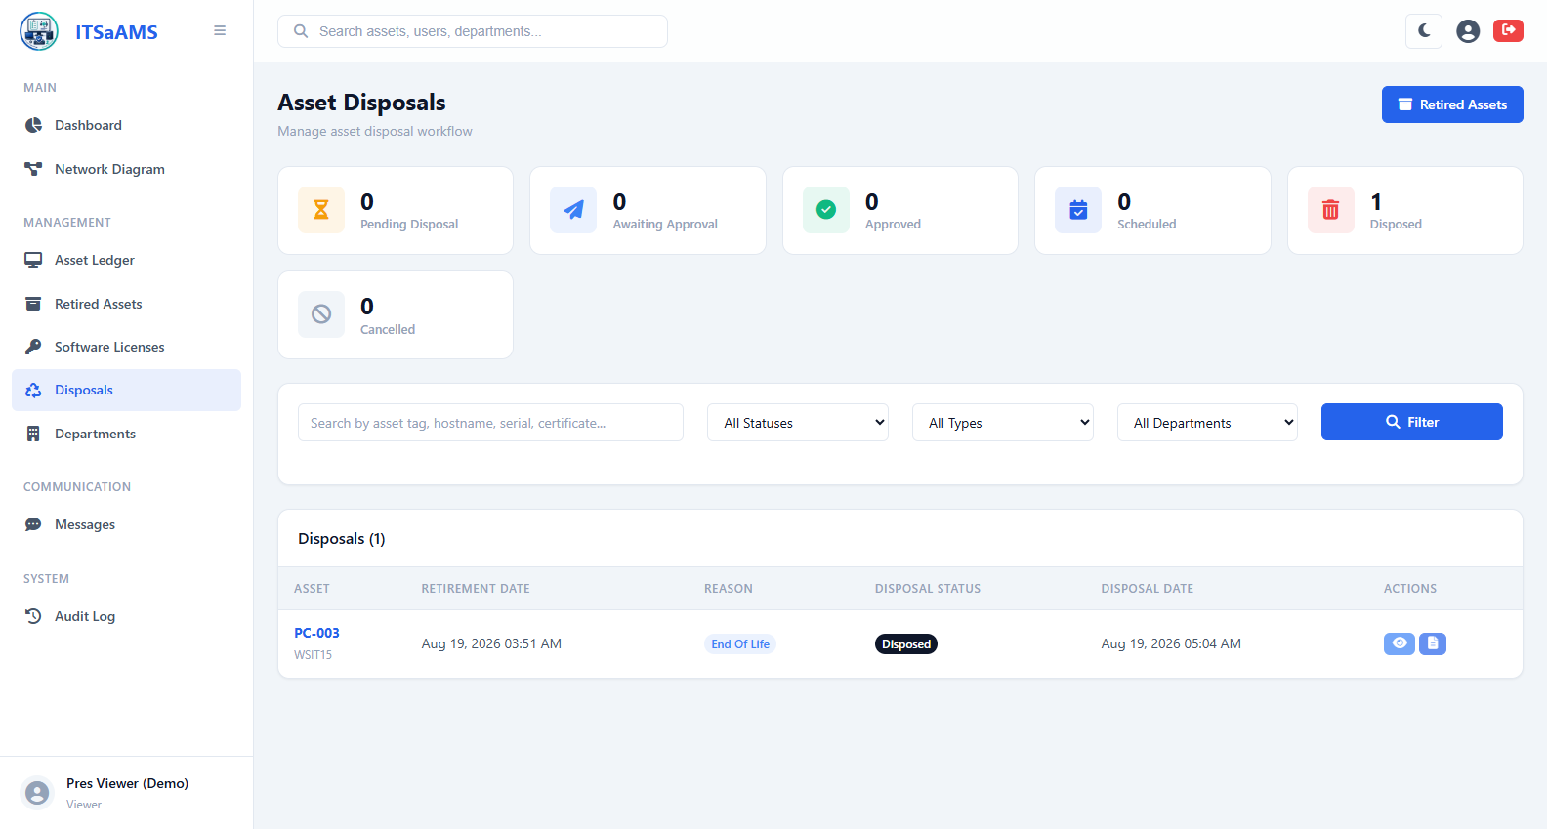
Figure 29 - Asset Disposals (/disposals)

Audit Log and History (/history)
How it works: Trail of every create, update, delete, login and ticket action. Rows show timestamp, user, action and record. Filter by date, user or action. Not editable; source of truth.
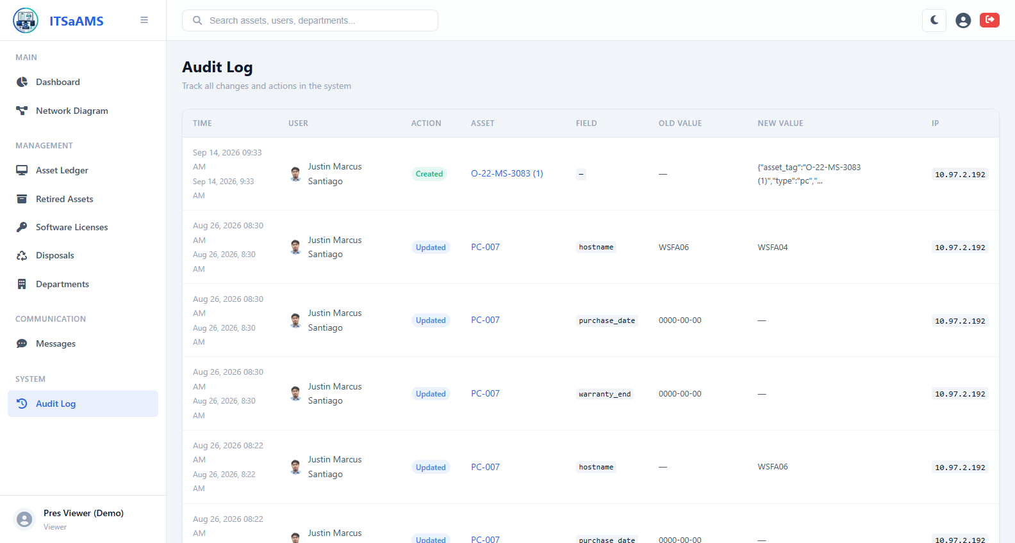
Figure 30 - Audit Log and History (/history)

Software Licenses (/licenses)
How it works: Library of entitlements with seat tracking. Each row shows total vs used seats, expiry and badges for Expiring within 30 days or Over Capacity. Search by product, vendor or key. But this account can only view
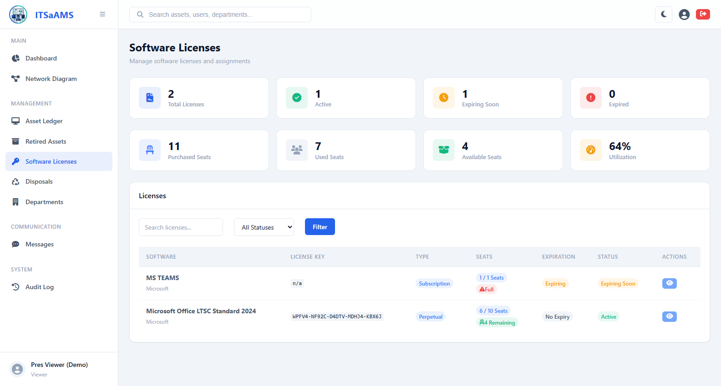
Figure 31 - Software Licenses (/licenses)

Messages (Messenger future plan) -still under developing (/messages)
How it works: Internal chat. Left pane lists conversations (unread highlighted), right pane shows thread. Pick conversation or start new one by choosing user, type message and Send.
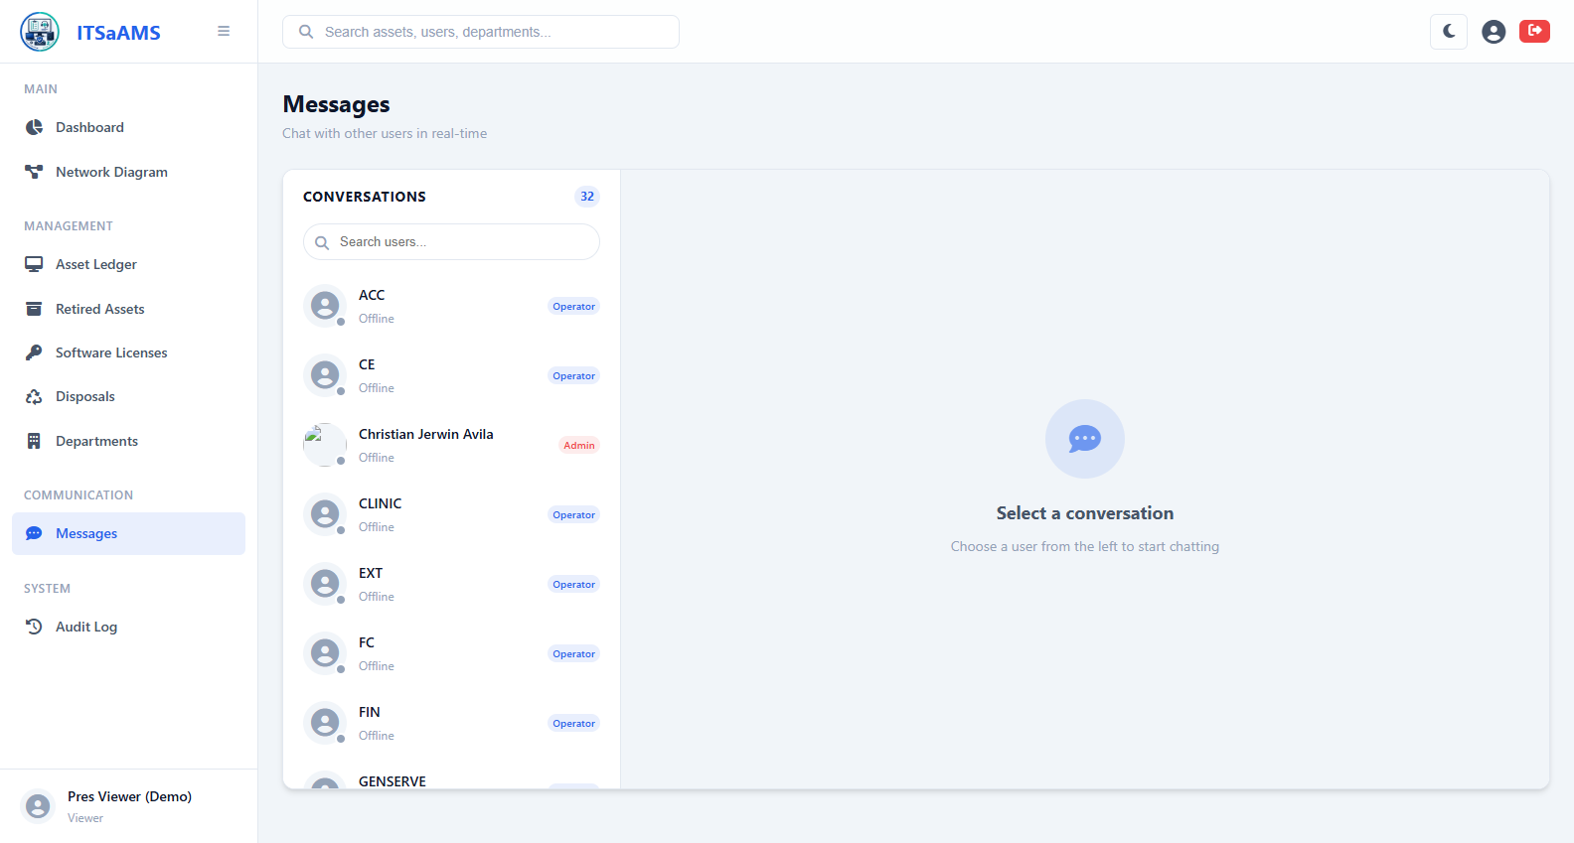
Figure 32 - Messages (Messenger) (/messages)

My Profile (/profile)
How it works: Self-service account page. View name, username, email, role, department and avatar; edit contact details, upload avatar, or change password. Save applies immediately.
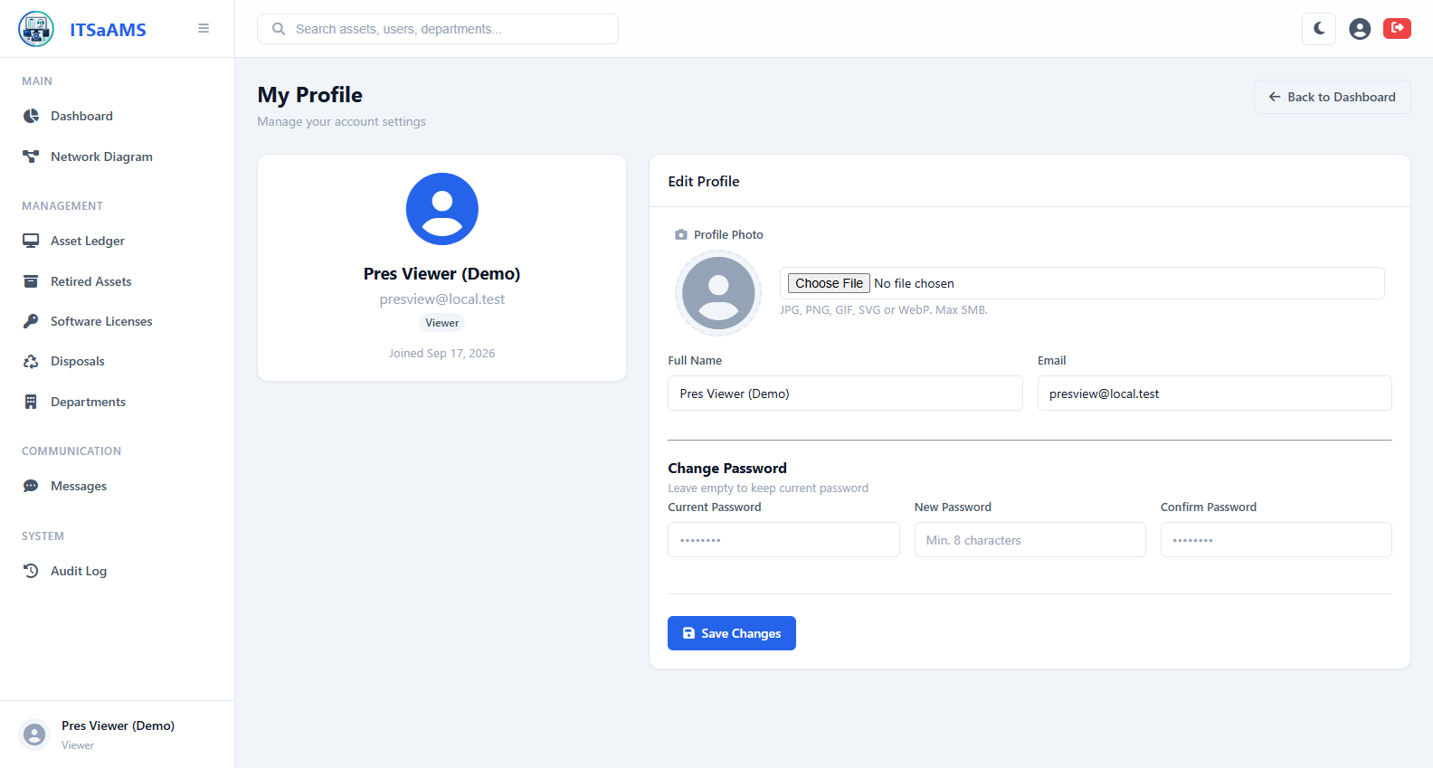
Figure 33 - My Profile (/profile)

Network Diagram (Topology) (/topology)
How it works: Interactive canvas map of devices and links. Drag nodes, scroll to zoom, drag empty space to pan, Fit or Auto-layout. Filters dim others; search finds hostname, IP or type. Connect mode draws links, Disconnect removes them. Save persists positions, Export PNG for reports. But this account can only view
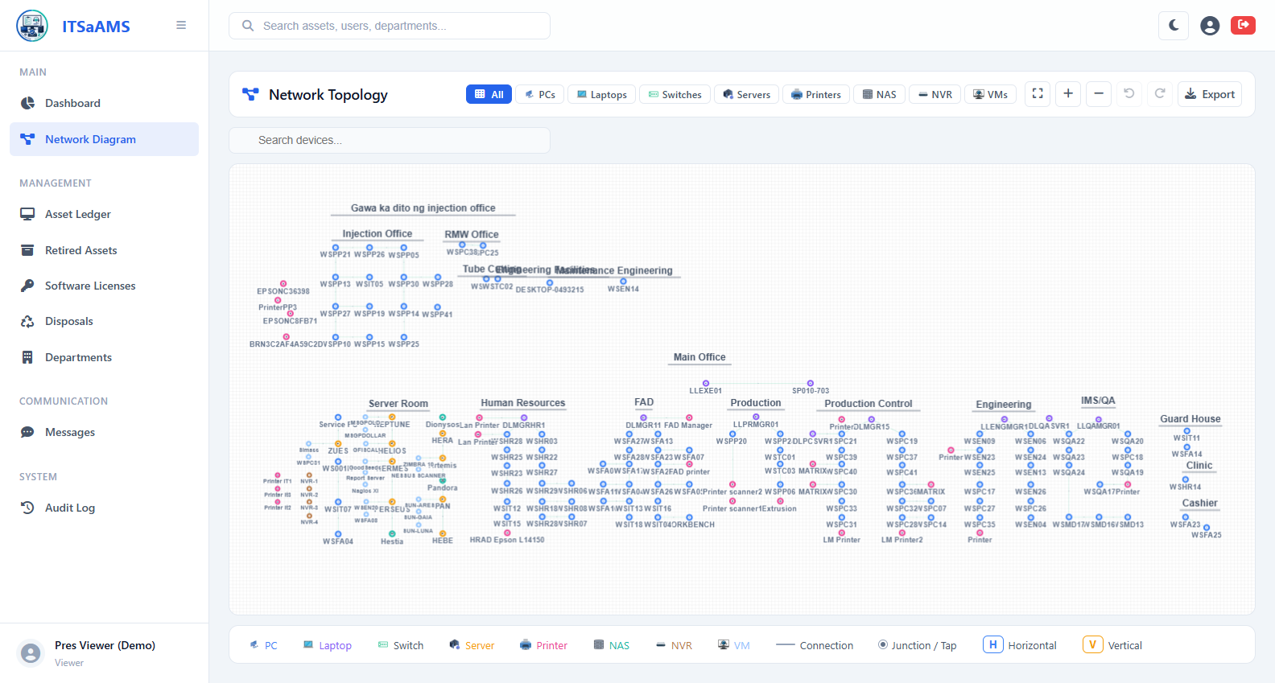
Figure 34 - Network Diagram (Topology) (/topology)

