Appendix: Function Screenshots by Role
The following screenshots show every function/screen available to each user role (Admin, User/Operator, Viewer) as captured from the running system.

Admin Role
Asset Ledger (/assets)
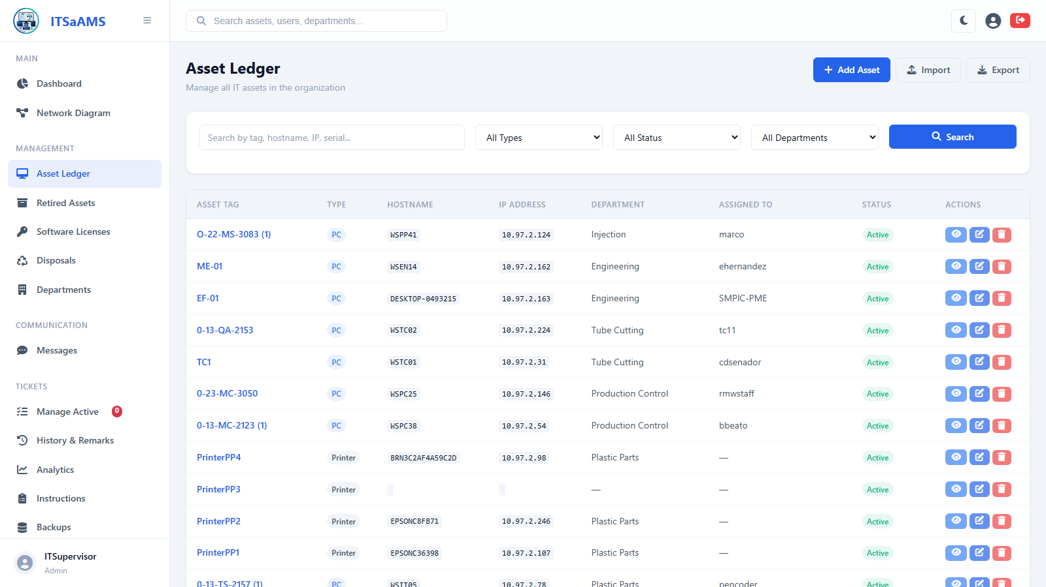

Add New Asset (/assets/create)
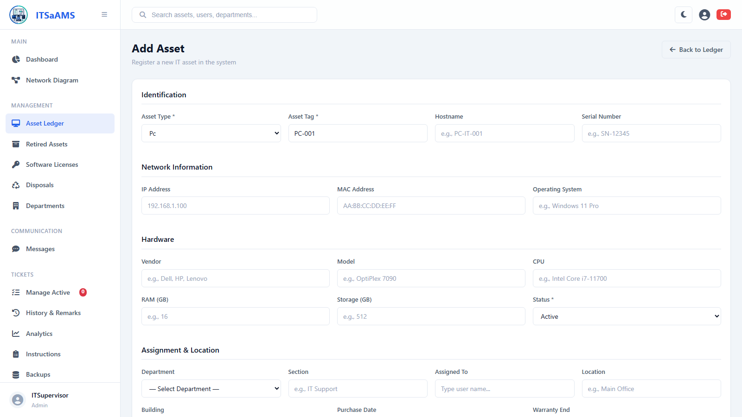

Retired Assets (/assets/retired)
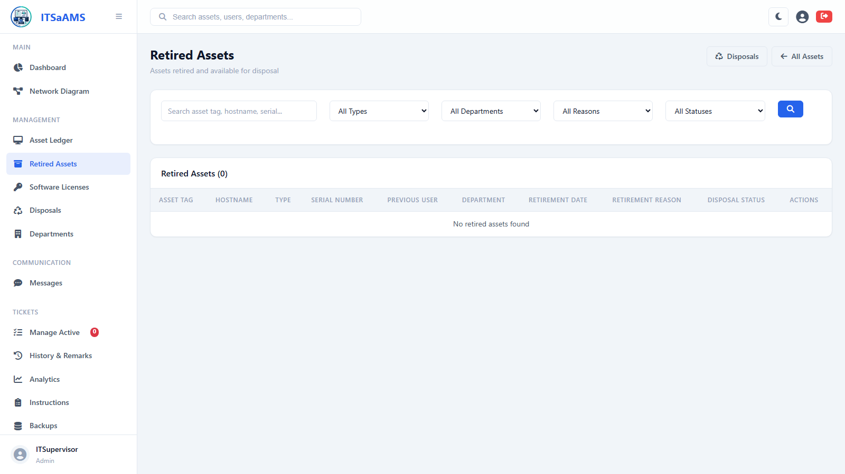

Dashboard (/dashboard)
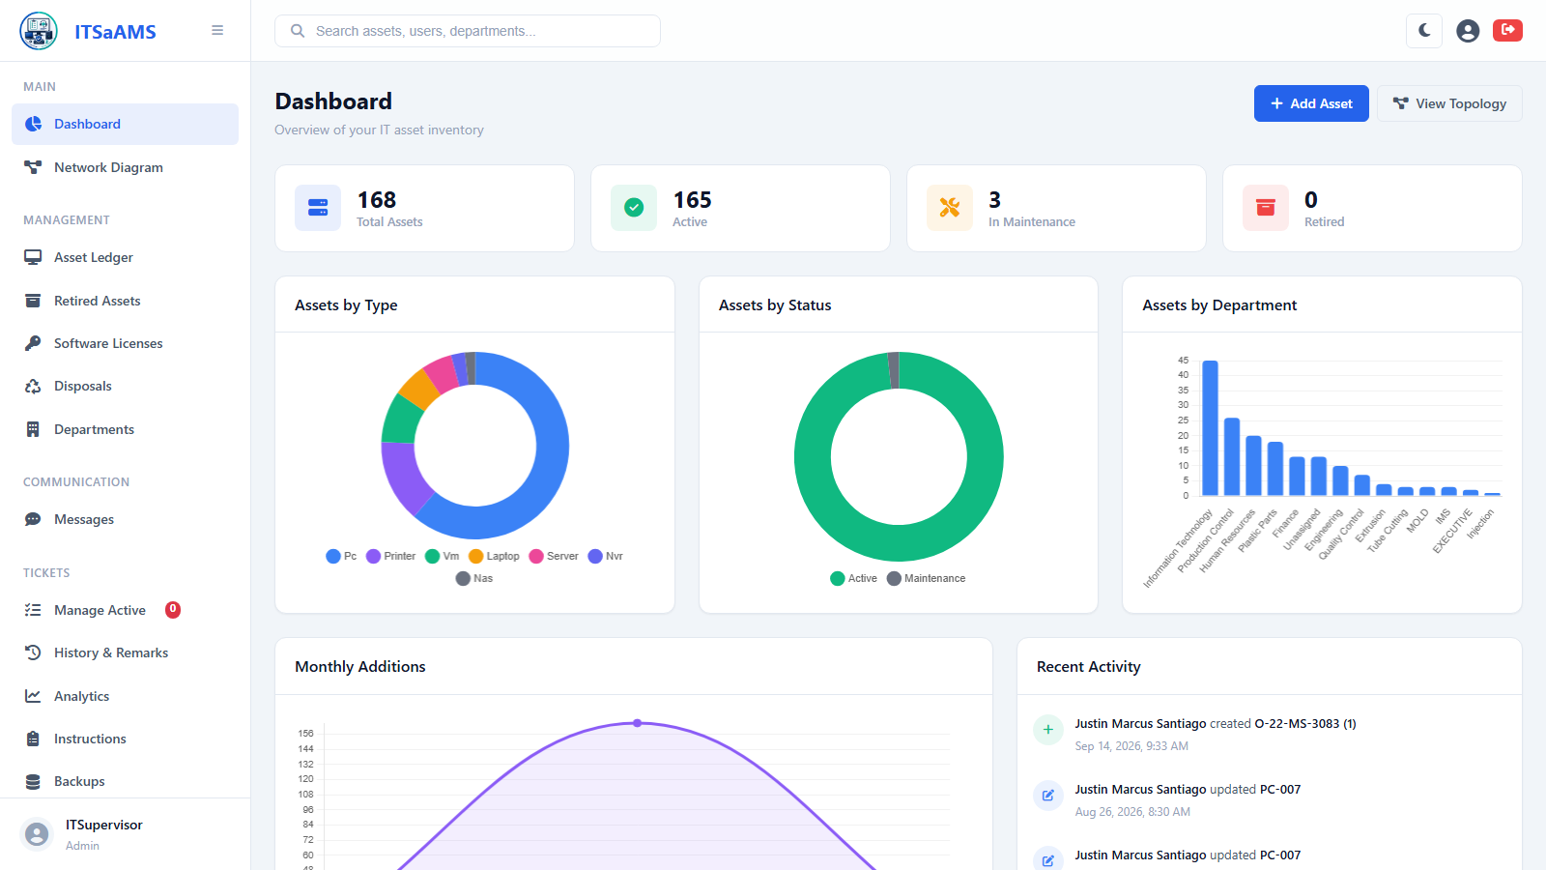

Departments (/departments)
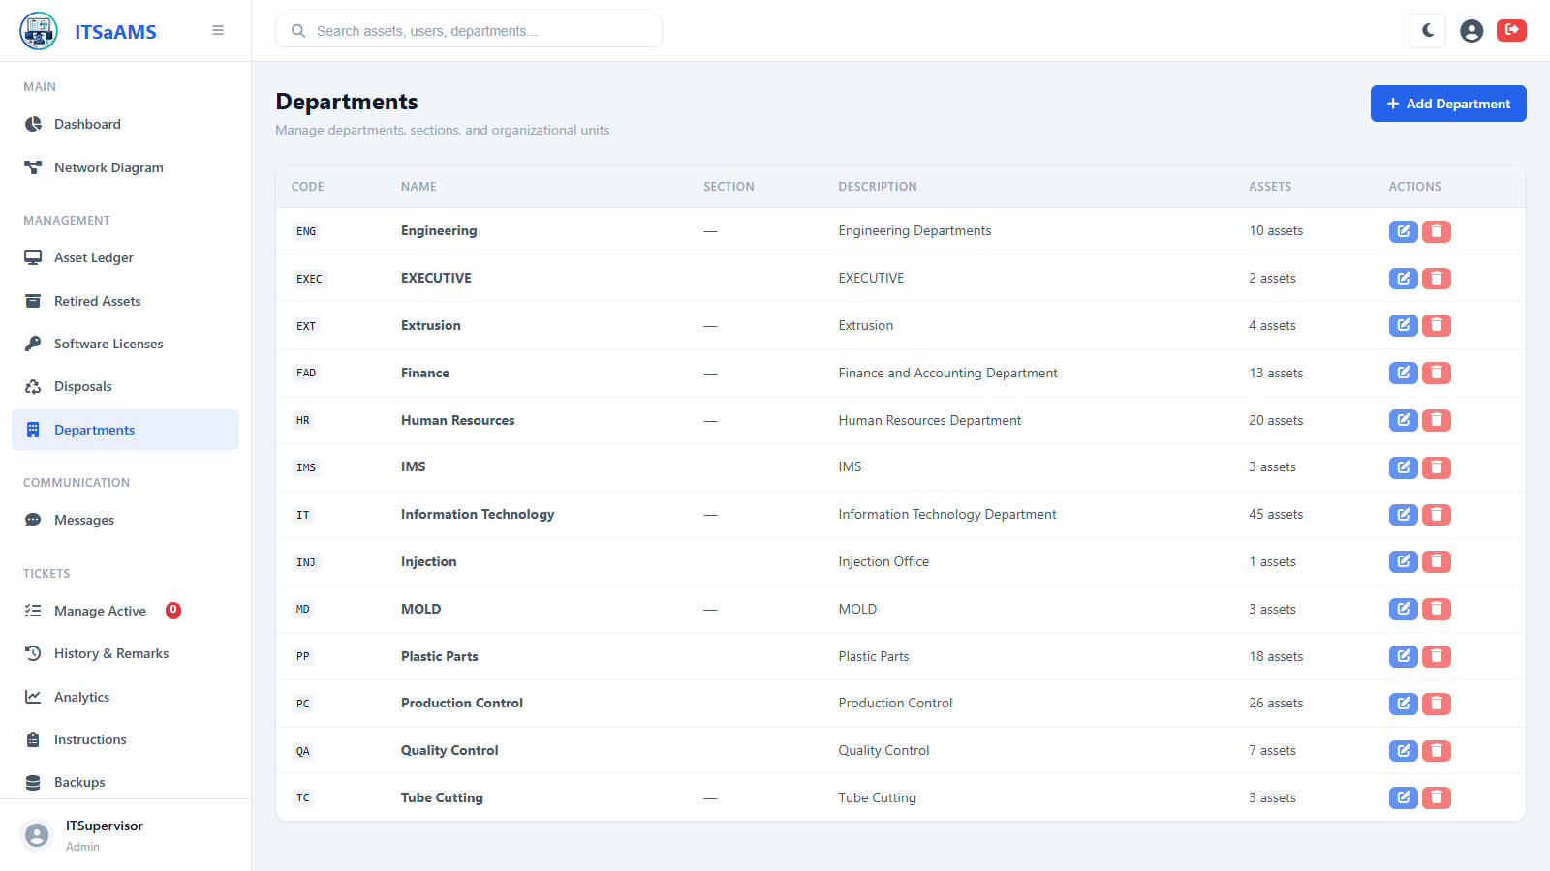

Asset Disposals (/disposals)
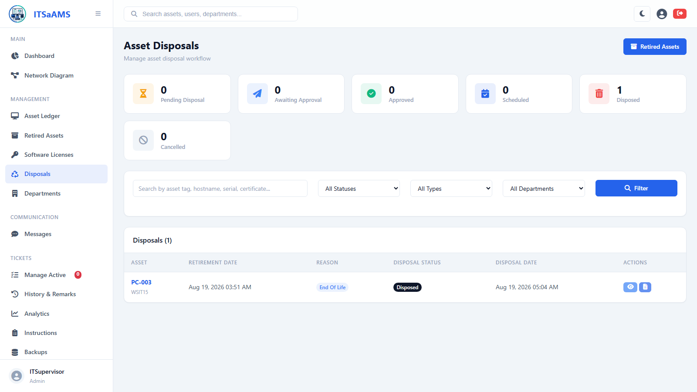

Audit Log / History (/history)
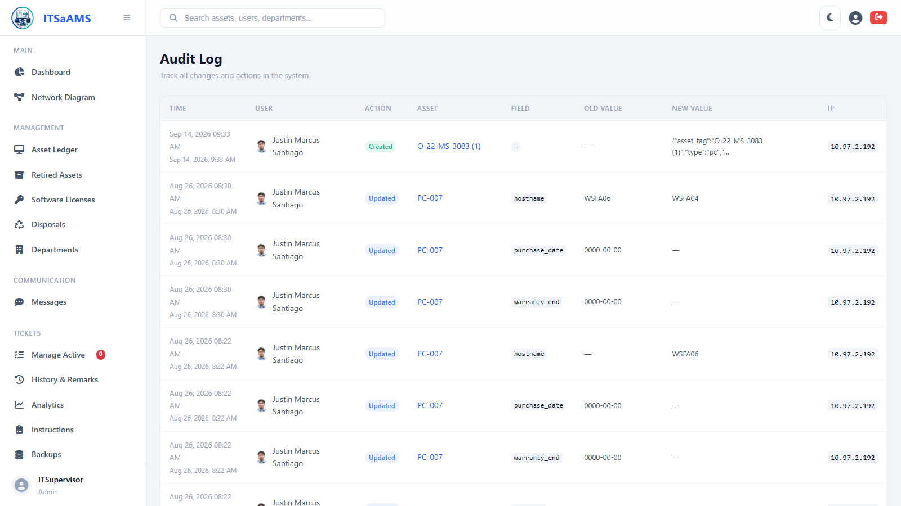

Software Licenses (/licenses)
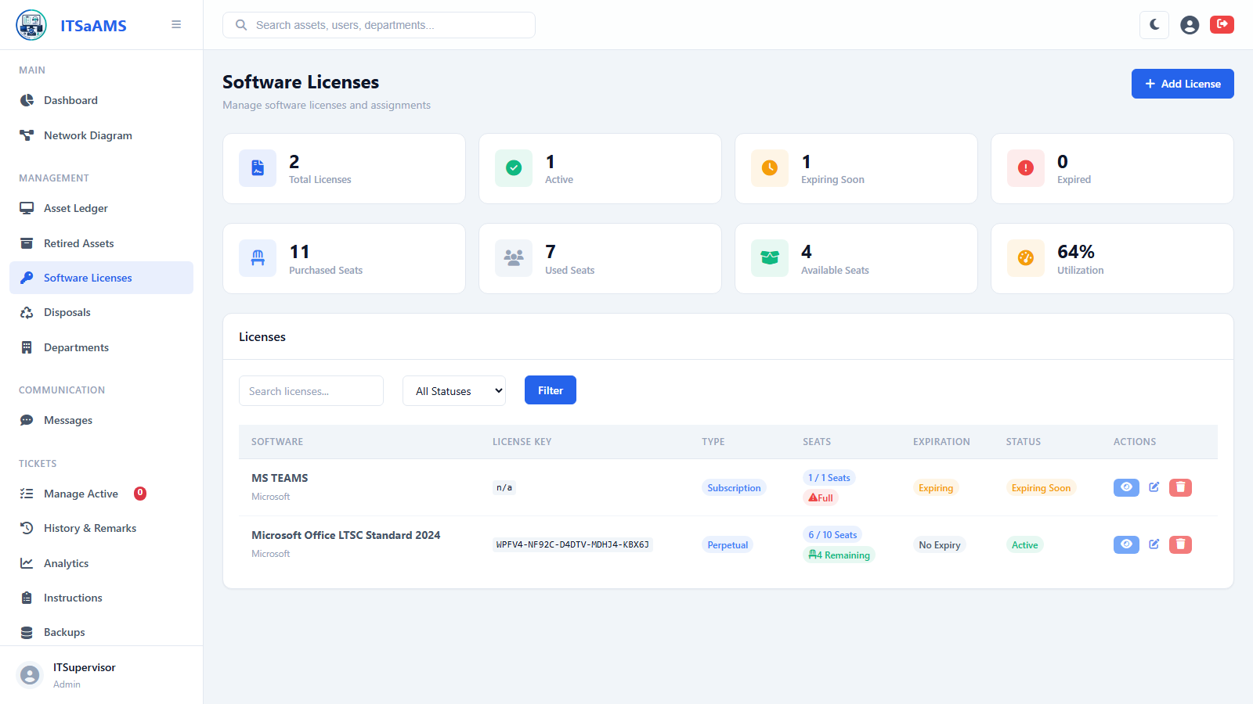

Add New License (/licenses/create)
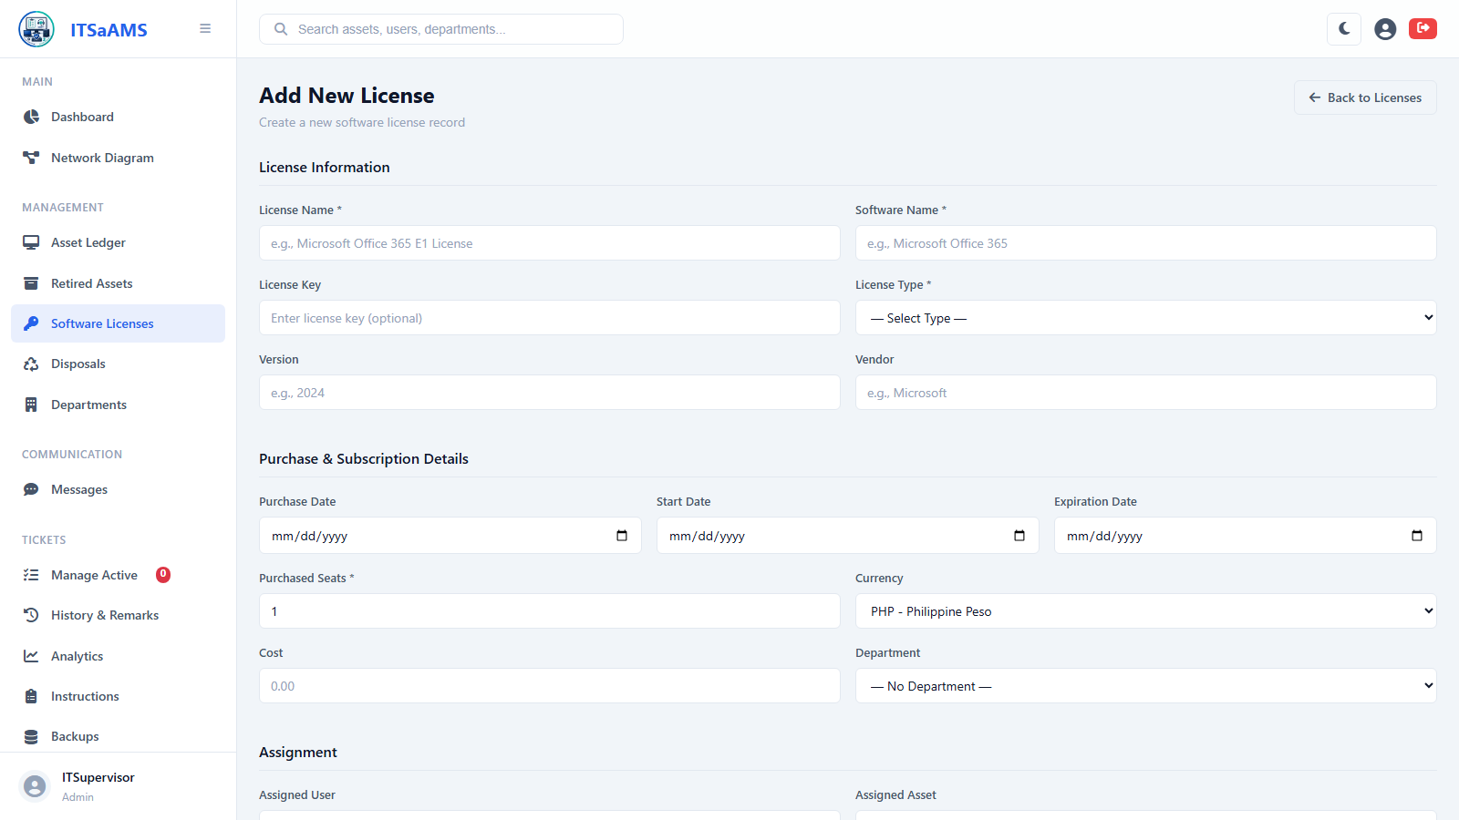

Messages (Messenger) (/messages)
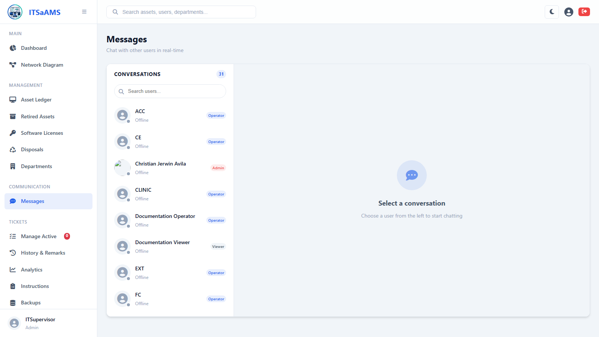

My Profile (/profile)
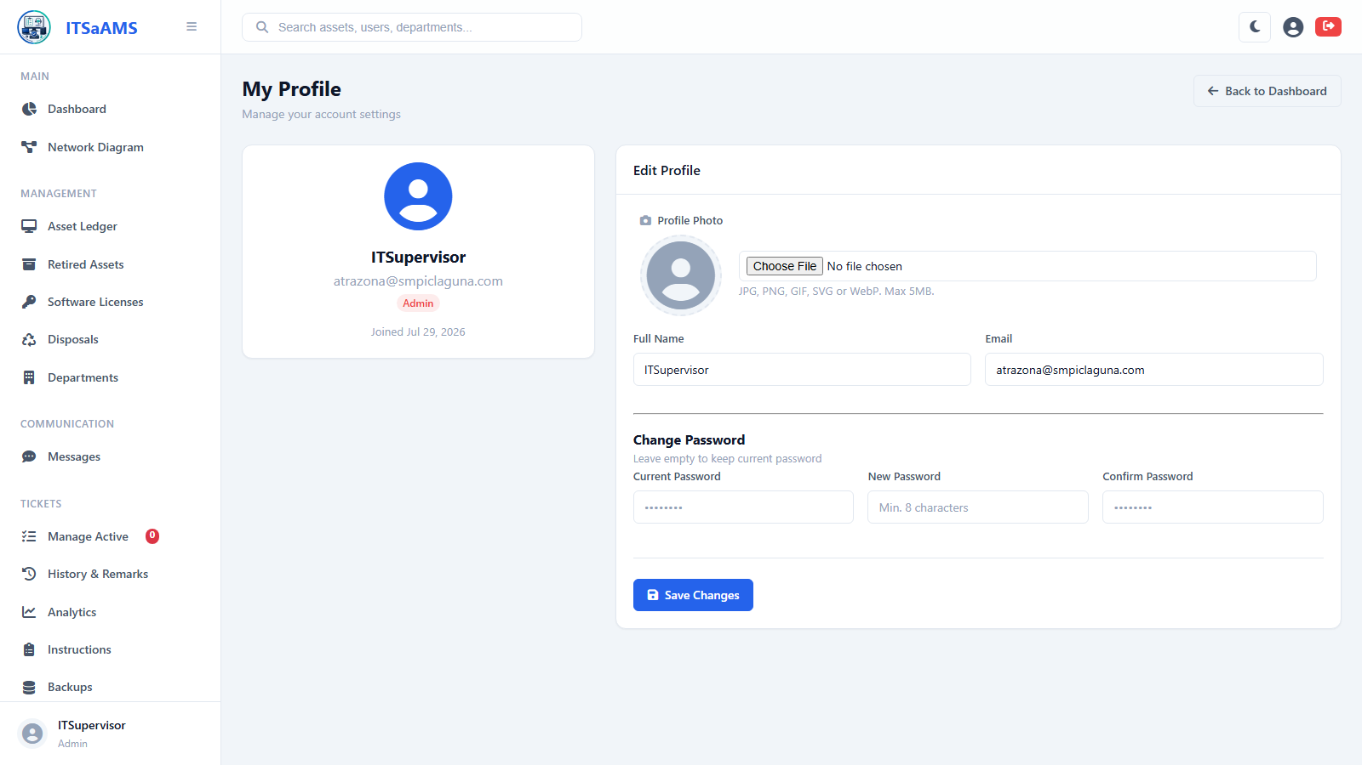

System Settings (/settings)
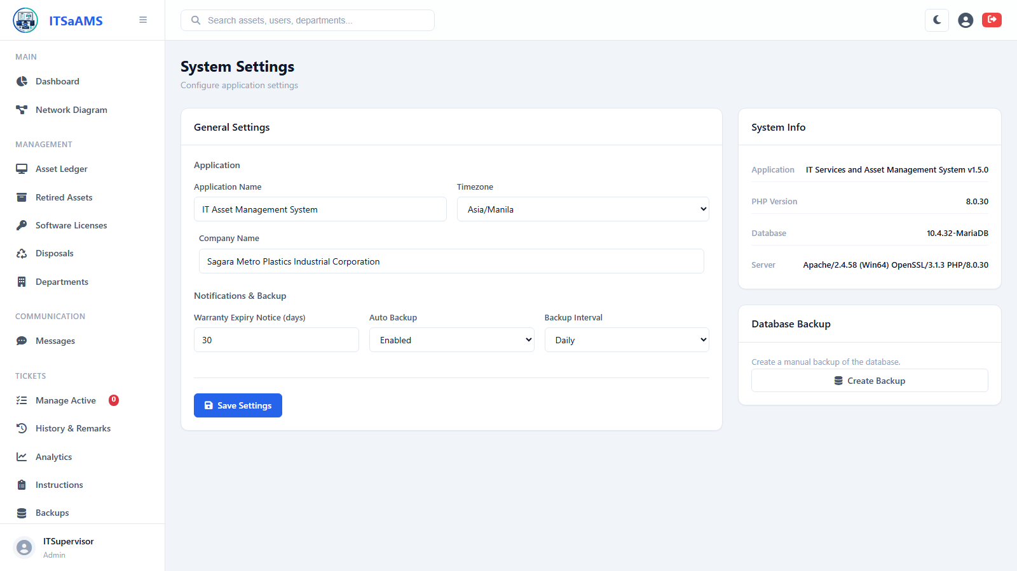

Tickets – Analytics (/tickets/analytics)
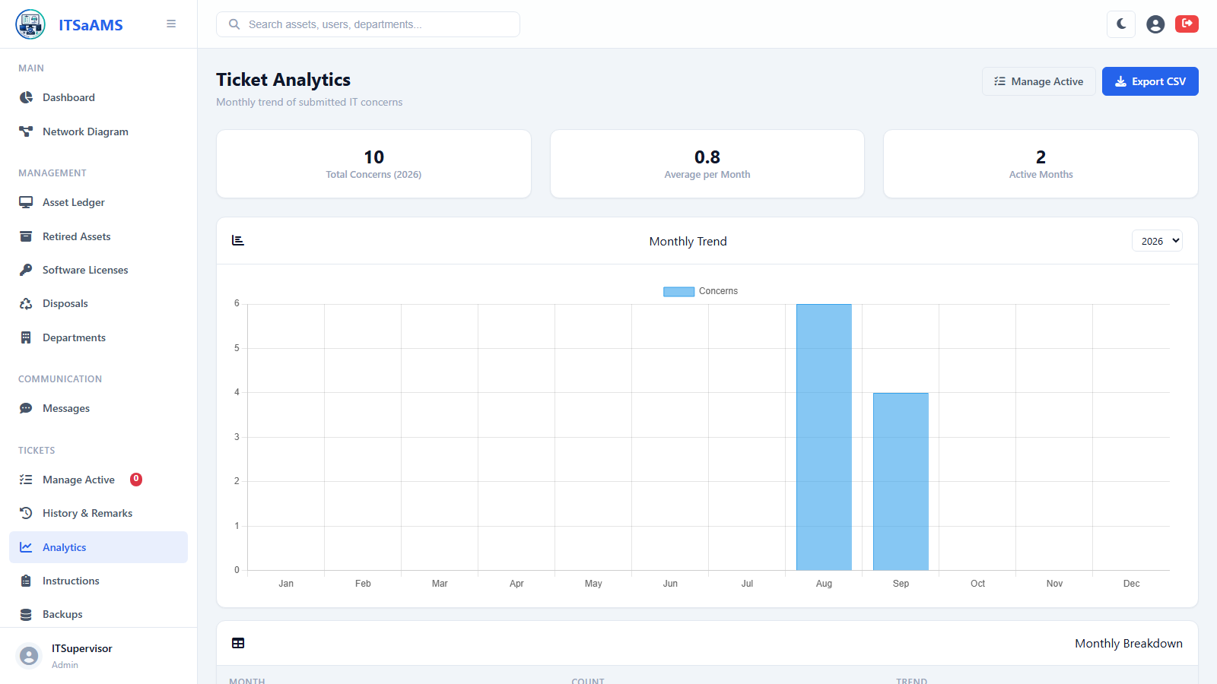

Tickets – Backups (/tickets/backup)
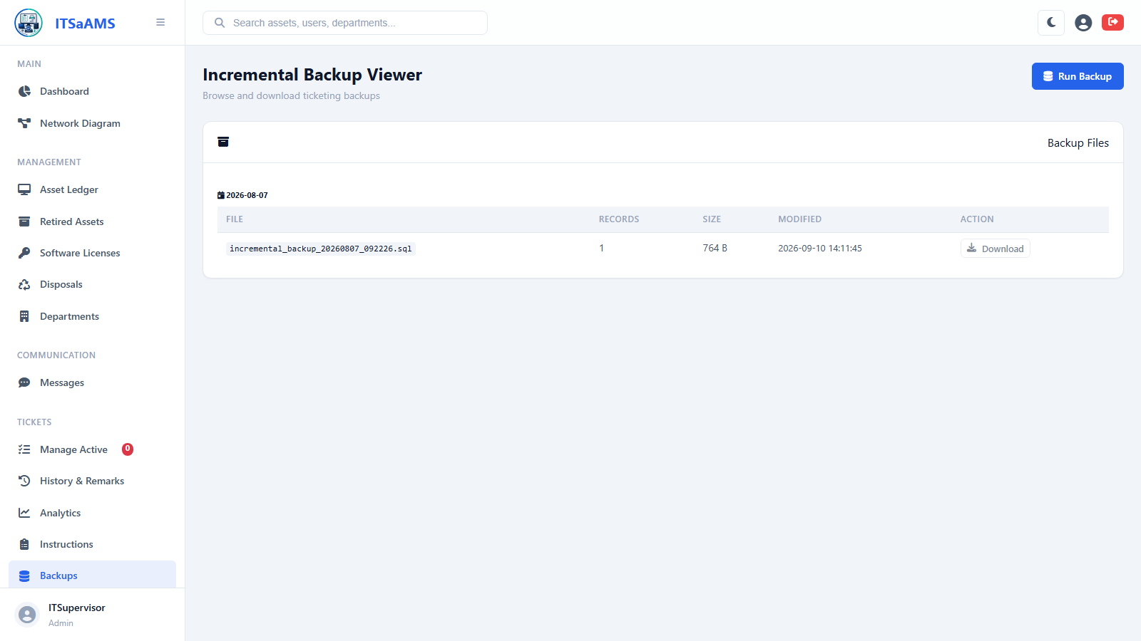

Tickets – History & Remarks (/tickets/history)
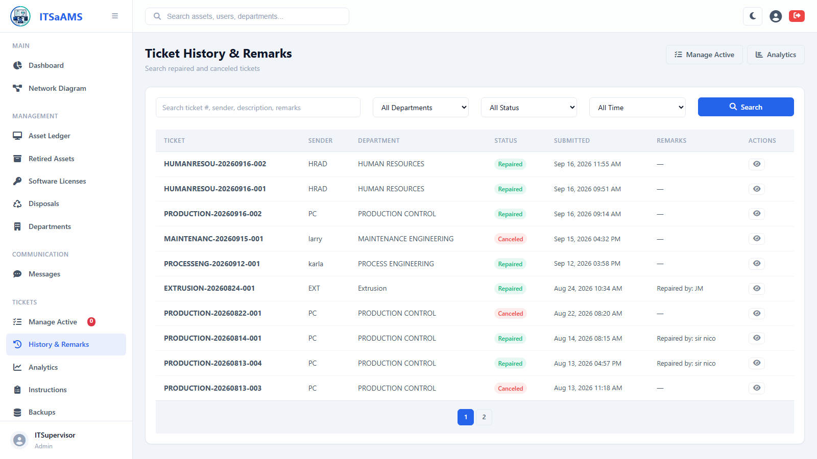

Tickets – Instructions (/tickets/instructions)
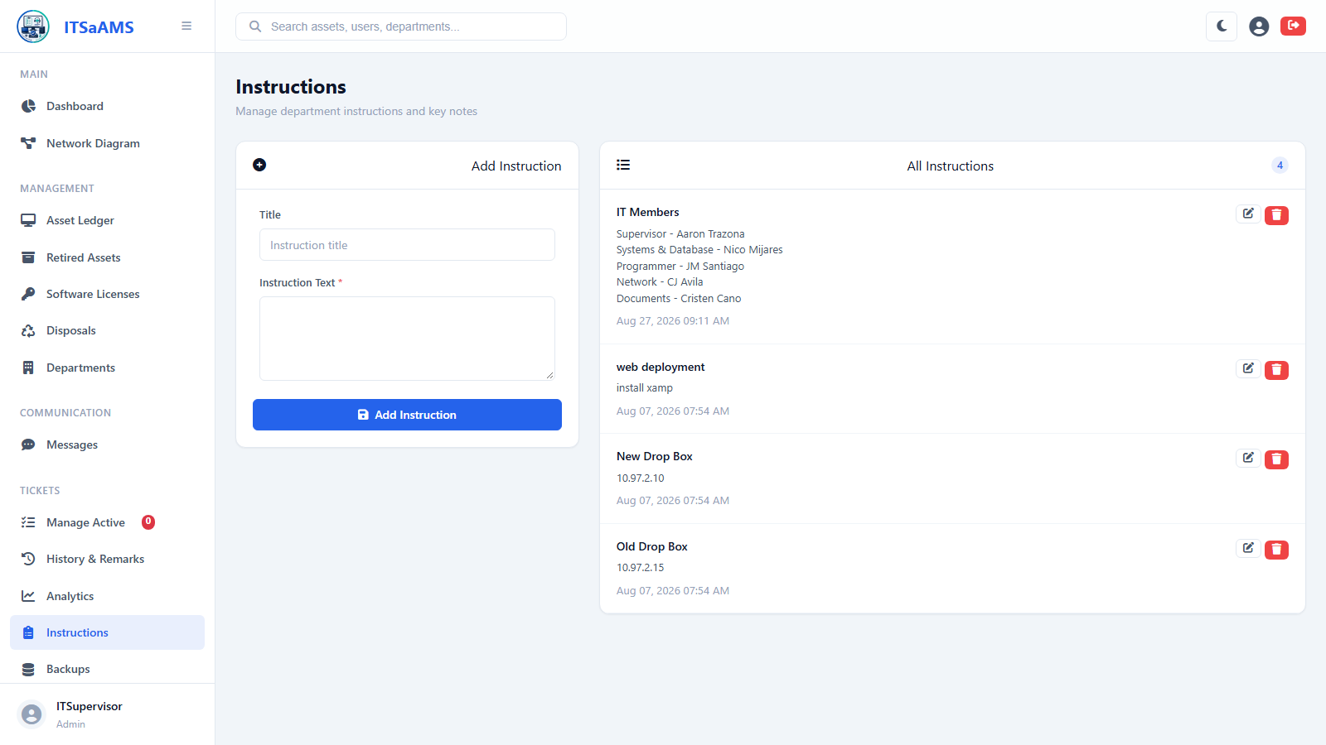

Tickets – Manage Active (/tickets/manage)
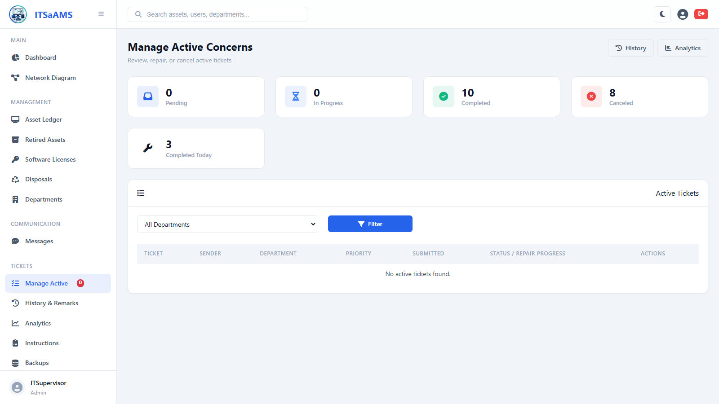

Network Diagram (Topology) (/topology)
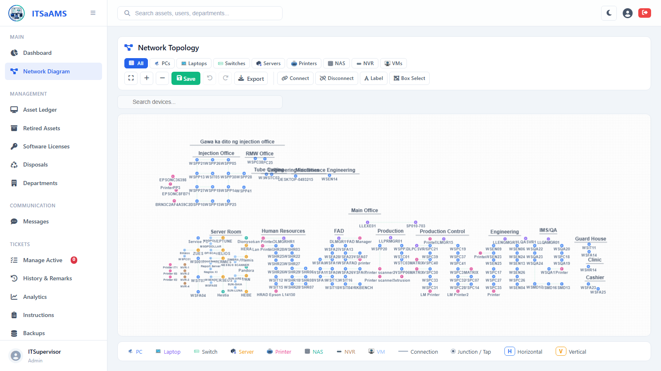

User Management (/users)
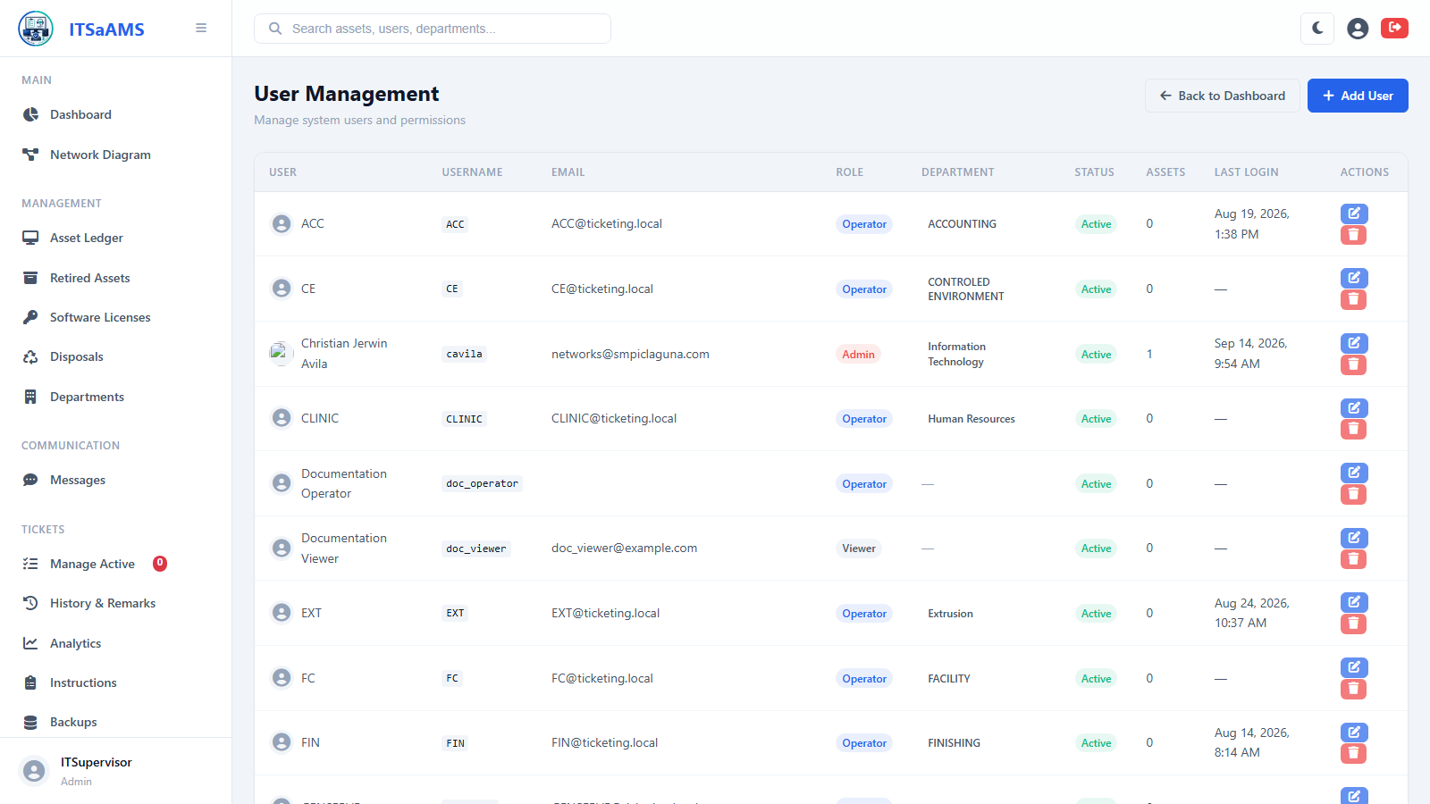

Add New User (/users/create)
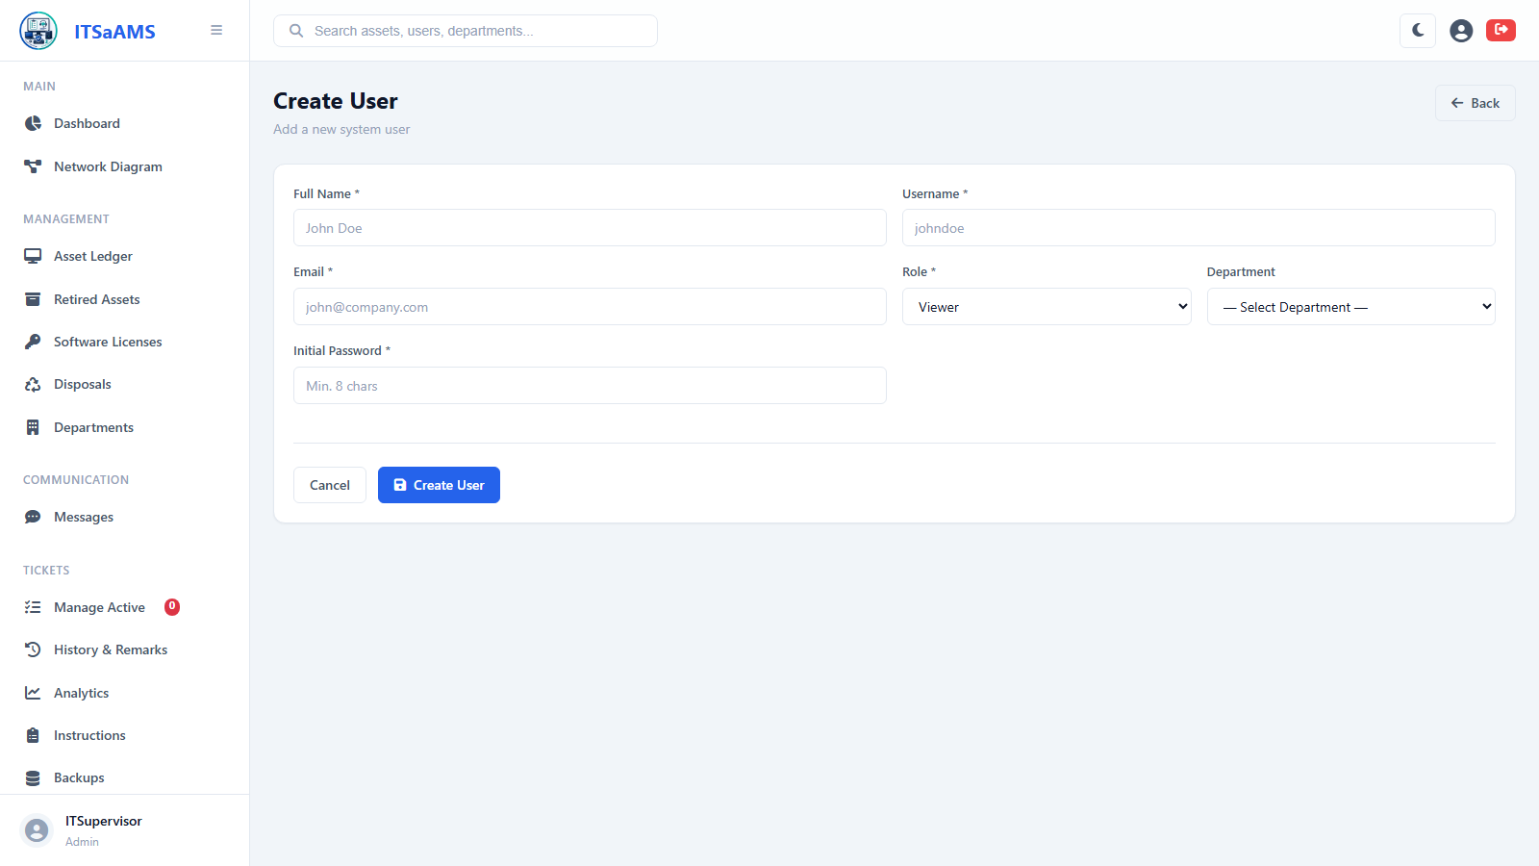

User (Operator) Role
Messages (Messenger) (/messages)
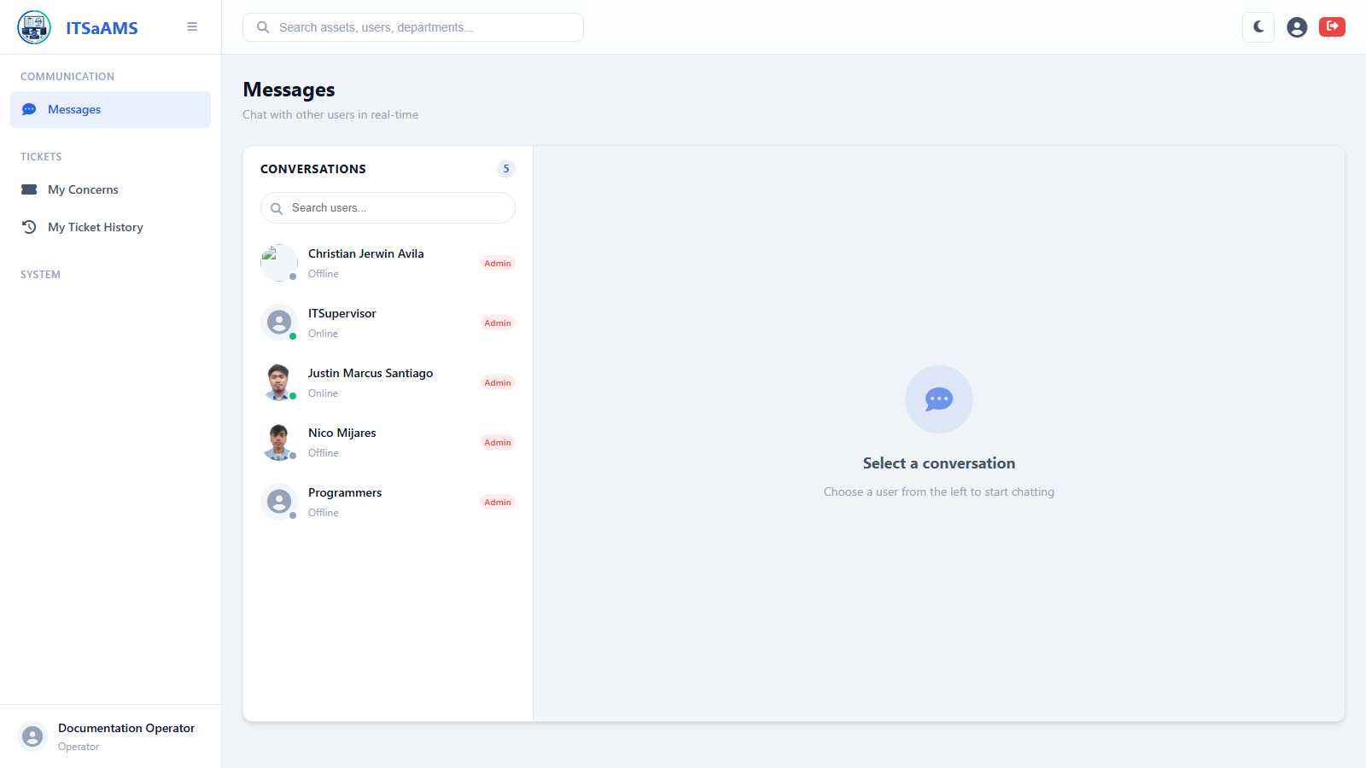

My Profile (/profile)
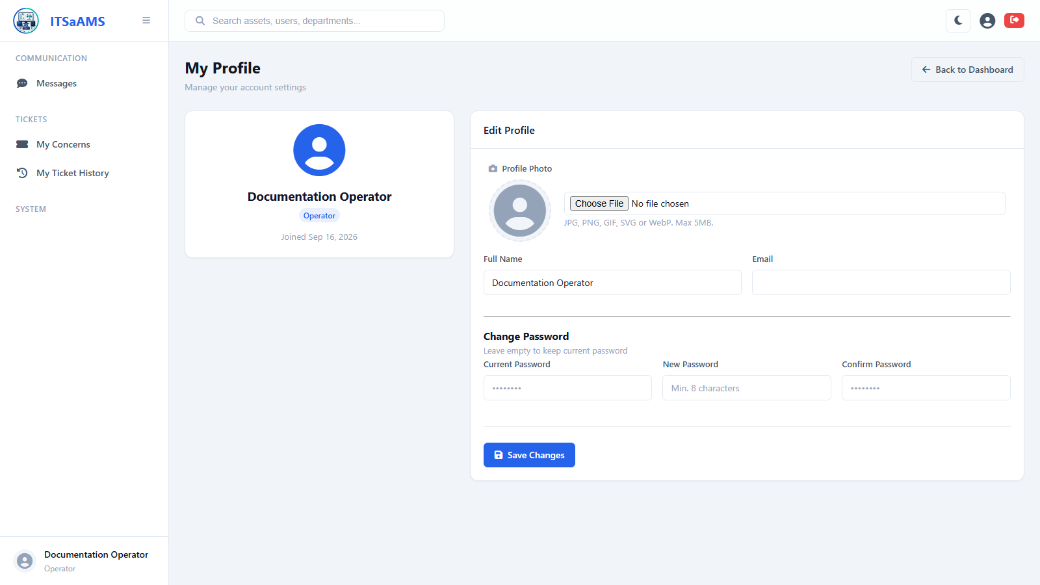

IT Concerns – Submit & Track Tickets (/tickets)
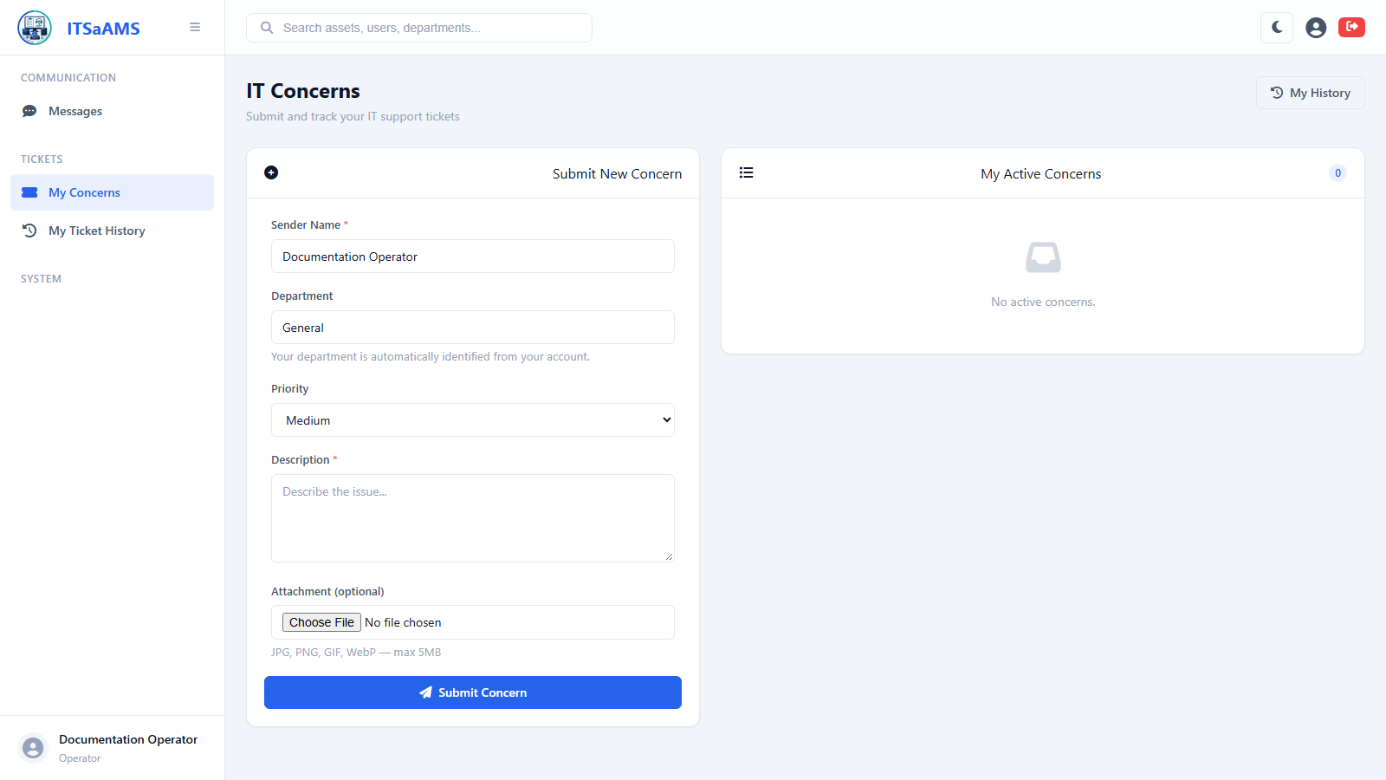

My Ticket History (/tickets/my-history)
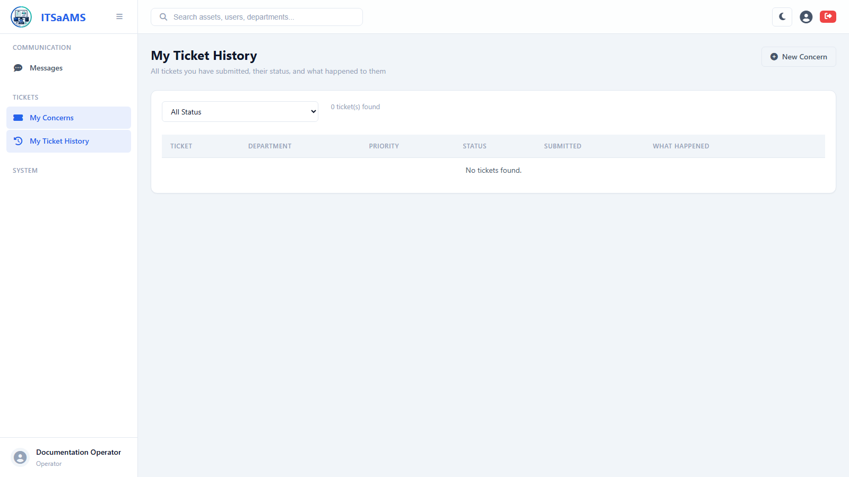

Viewer Role
Asset Ledger (/assets)
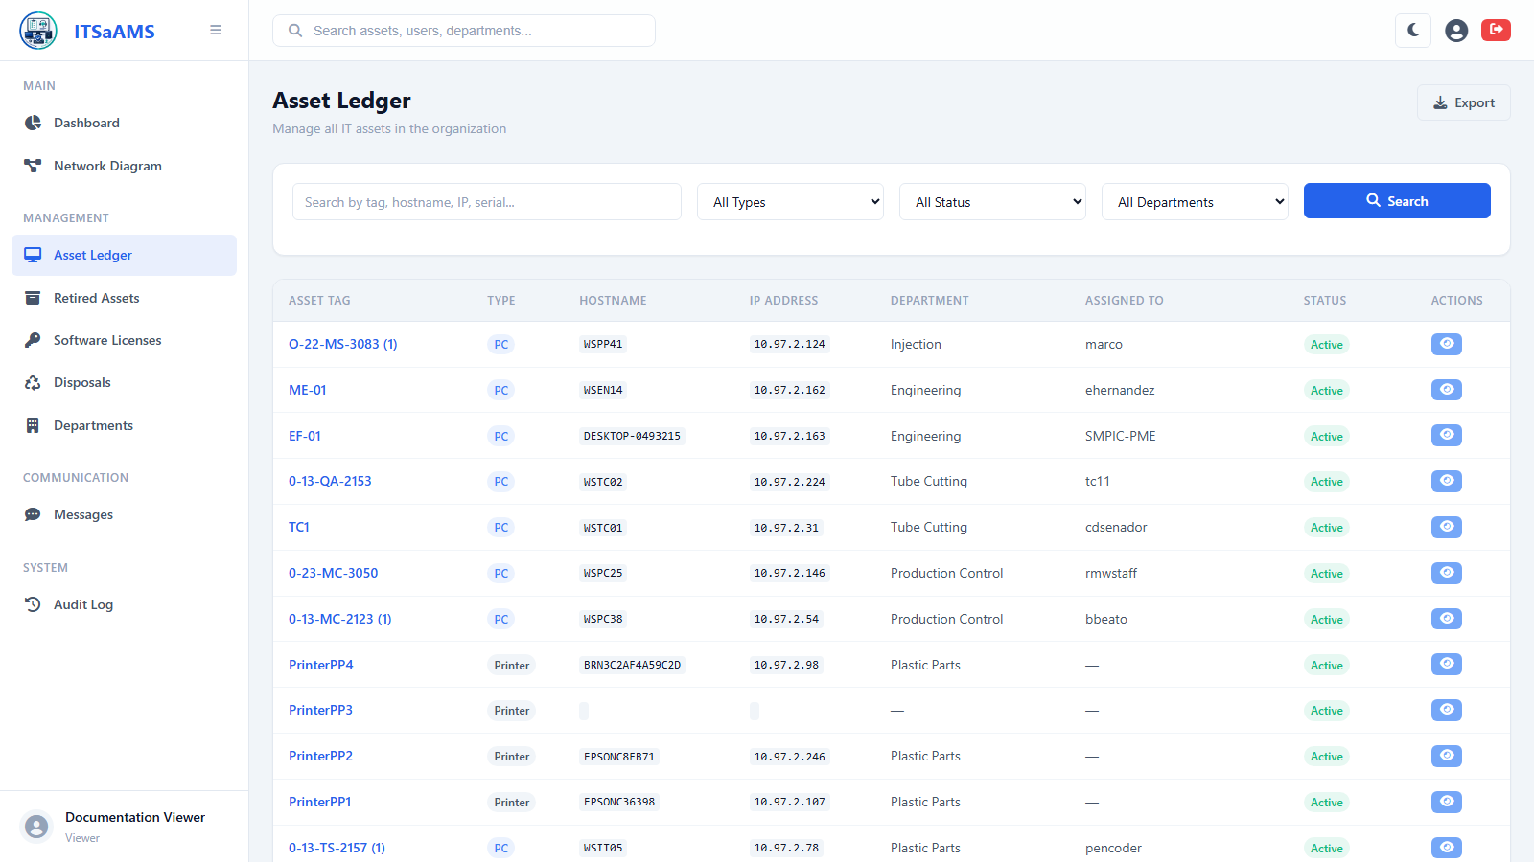

Retired Assets (/assets/retired)
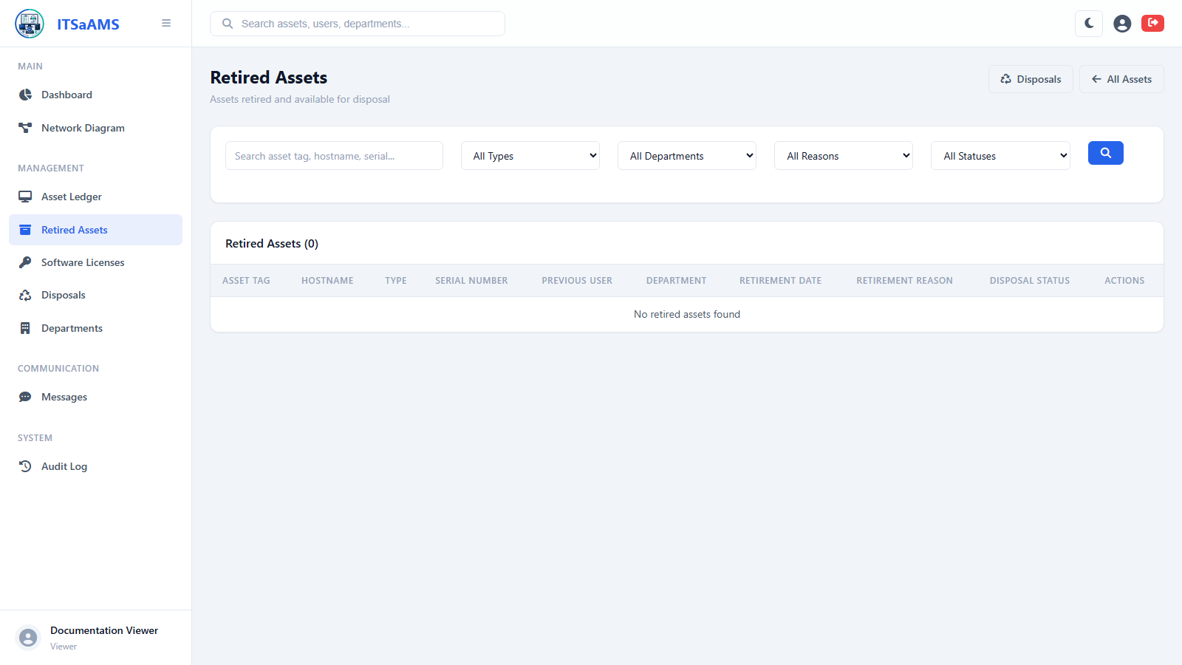

Dashboard (/dashboard)
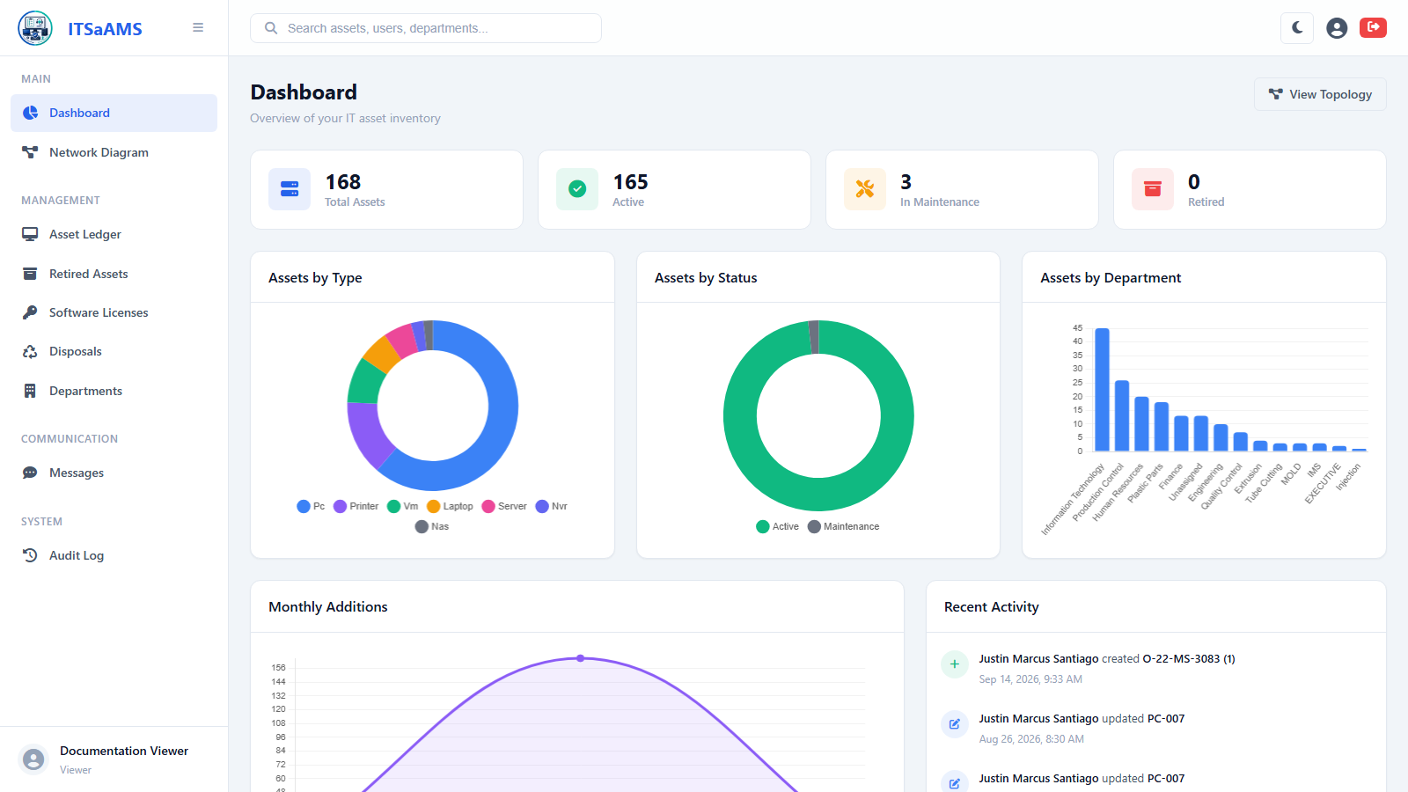

Asset Disposals (/disposals)
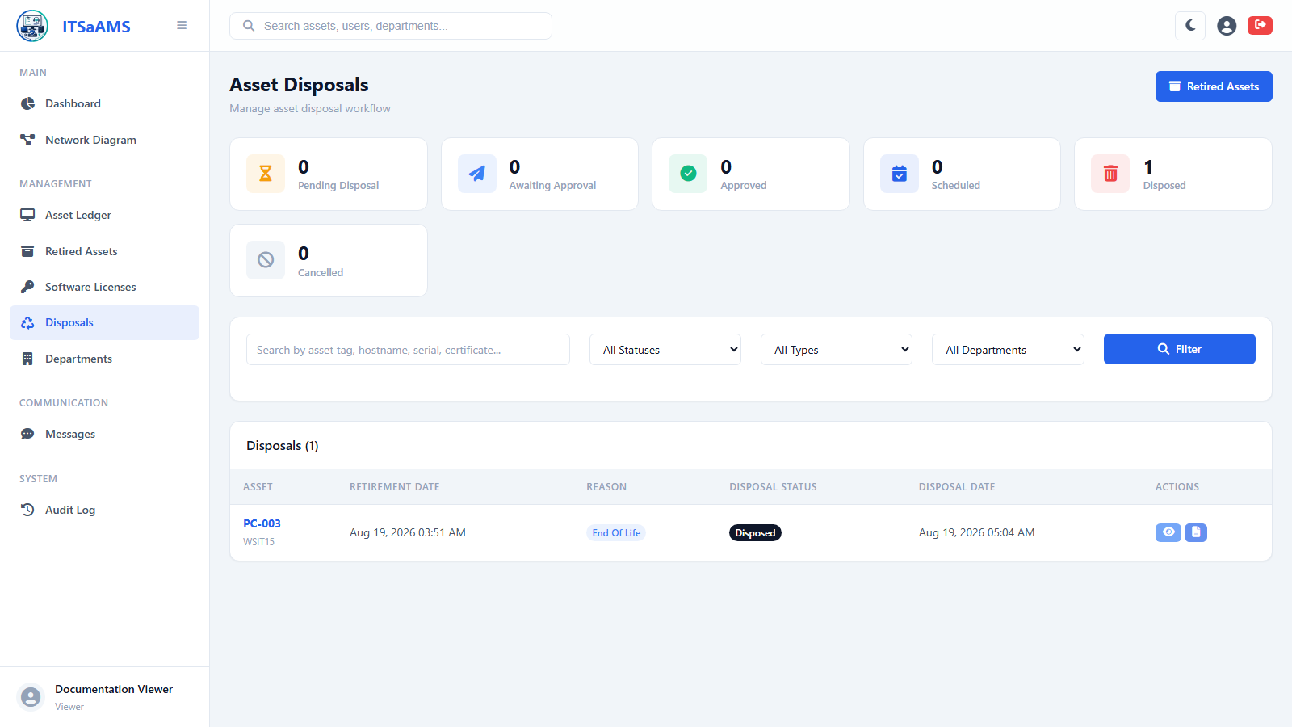

Audit Log / History (/history)
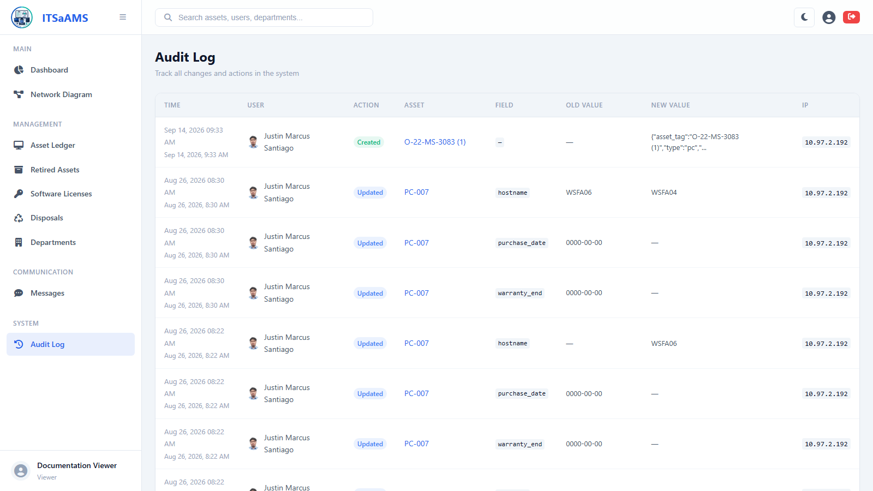

Software Licenses (/licenses)
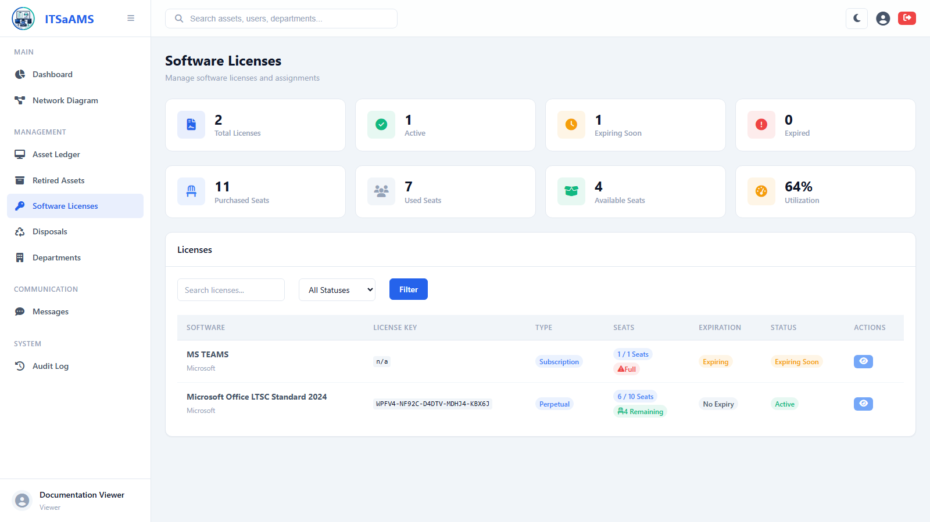

Messages (Messenger) (/messages)
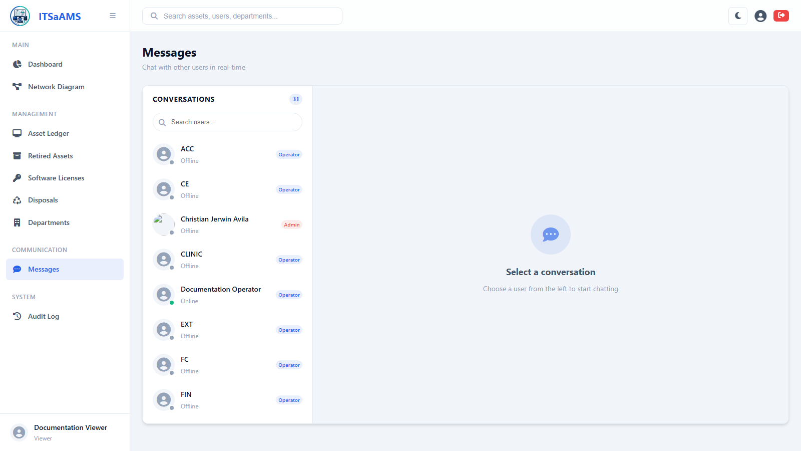

My Profile (/profile)
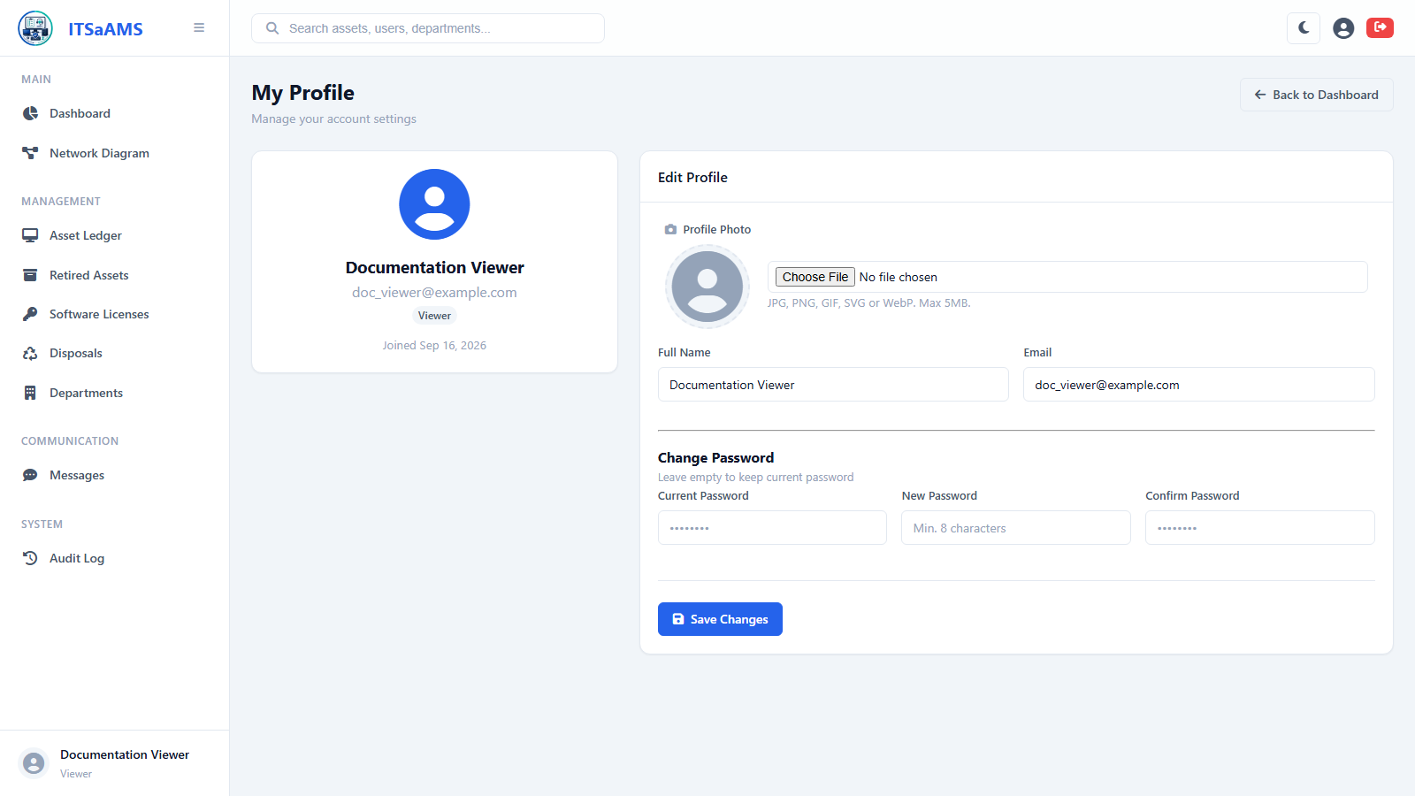

Network Diagram (Topology) (/topology)
