

National College of Ireland

Project Submission Sheet

Student Name: | ………………………Mingxuan Cai………………………………………………………………………………………
Student ID: | ……………22186565…………………………………………………………………………………………………
Programme: | ……………webde………………………………………………… | Year: | ………2023………………
Module: | …………Web Design and Client Side Scripting……………………………………………………………………………………………………
Lecturer: | ……………………………Eugene McLaughlin…………………………………………………………………………………
Submission Due Date: | 12/10/2023  ………………………………………………………………………………………………………………
Project Title: | …………………Chinese Tourism……………………………………………………………………………………………
Word Count: | ………………………………………………………………………………………………………………

I hereby certify that the information contained in this (my submission) is information pertaining to research I conducted for this project. All information other than my own contribution will be fully referenced and listed in the relevant bibliography section at the rear of the project.
ALL internet material must be referenced in the references section. Students are encouraged to use the Harvard Referencing Standard supplied by the Library. To use other author's written or electronic work is illegal (plagiarism) and may result in disciplinary action. Students may be required to undergo a viva (oral examination) if there is suspicion about the validity of their submitted work.

Signature: | 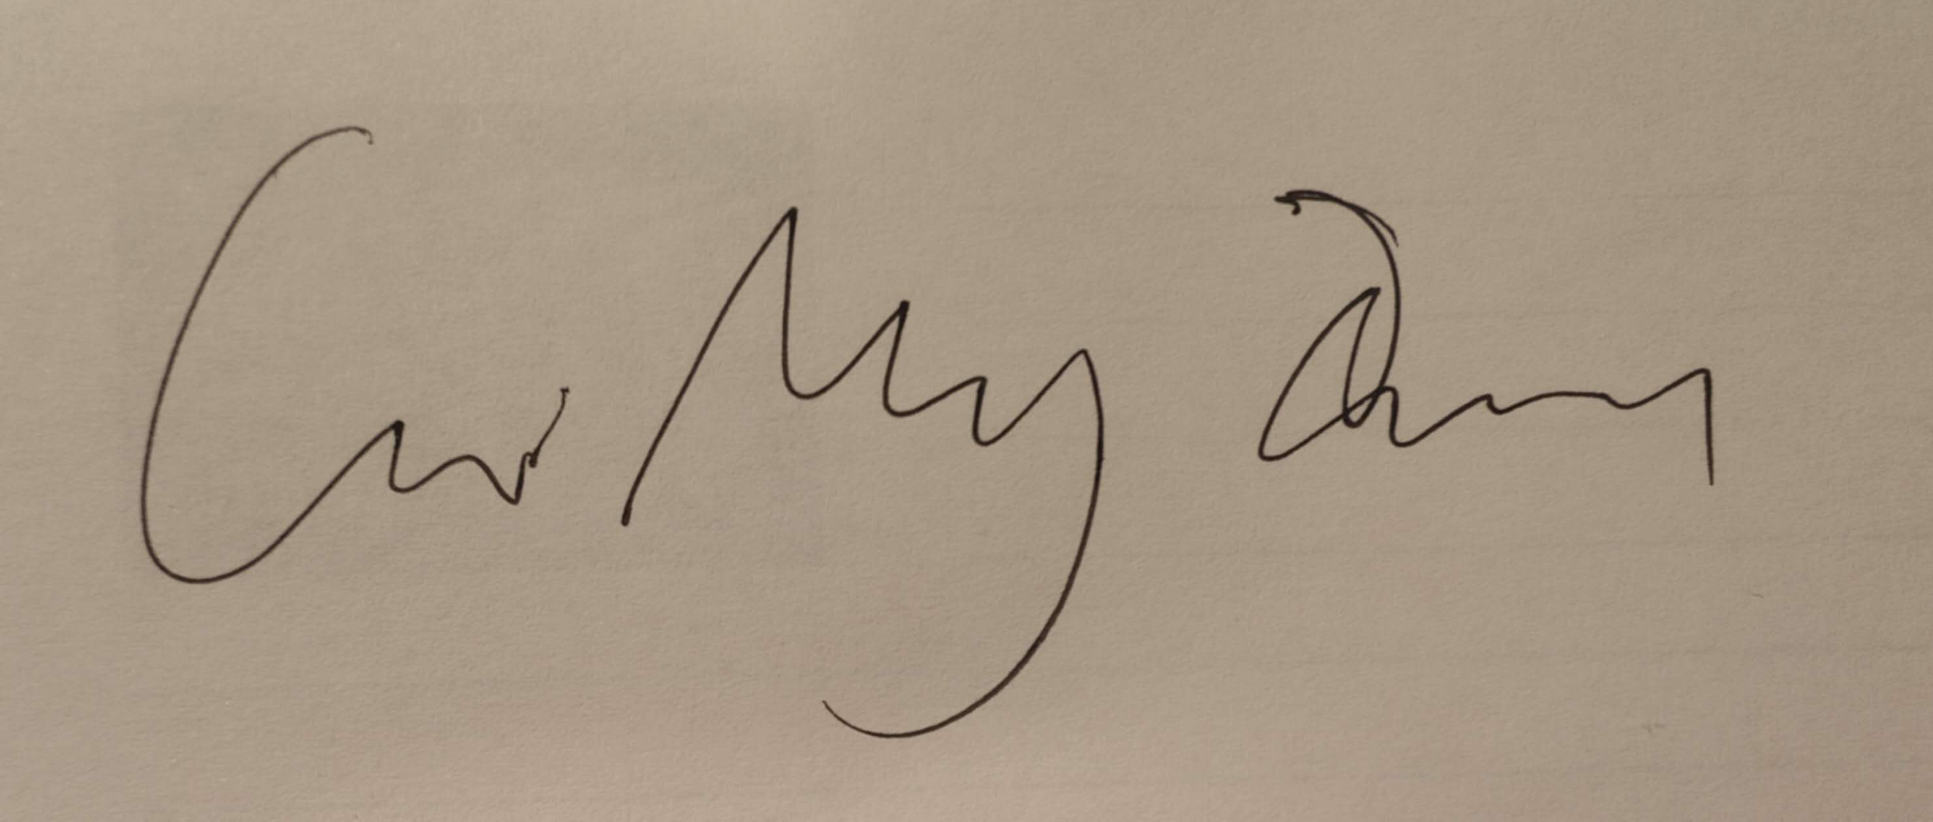……………………………………………………………………………………………………
Date: | ……12/10/2023  …………………………………………………………………………………………………………

PLEASE READ THE FOLLOWING INSTRUCTIONS:

1. Please attach a completed copy of this sheet to each project (including multiple copies).
2. Projects should be submitted to your Programme Coordinator.
3. You must ensure that you retain a HARD COPY of ALL projects, both for your own reference and in case a project is lost or mislaid. It is not sufficient to keep a copy on computer. Please do not bind projects or place in covers unless specifically requested.
4. You must ensure that all projects are submitted to your Programme Coordinator on or before the required submission date. Late submissions will incur penalties.
5. All projects must be submitted and passed in order to successfully complete the year. Any project/assignment not submitted will be marked as a fail.

Office Use Only
Signature:
Date: | 12/10/2023
Penalty Applied (if applicable):

AI Acknowledgement Supplement

[Insert Module Name]

[Insert Title of your assignment]

Your Name/Student Number | Course | Date
Mingxuan Cai | Web Design and Client Side Scripting | Web Design and Client Side Scripting

This section is a supplement to the main assignment, to be used if AI was used in any capacity in the creation of your assignment; if you have queries about how to do this, please contact your lecturer. For an example of how to fill these sections out, please click here.

AI Acknowledgment
This section acknowledges the AI tools that were utilized in the process of completing this assignment.
Tool Name | Brief Description | Link to tool
New bing | Similar to chatgpt | Bing AI - 搜索

Description of AI Usage
This section provides a more detailed description of how the AI tools were used in the assignment. It includes information about the prompts given to the AI tool, the responses received, and how these responses were utilized or modified in the assignment. One table should be used for each tool used.
[Insert Tool Name]
[Insert Description of use] Design 10 questions of the game. Optimizing the code of project to make it cleaner. Inquiring some functions of jQuery.
[Insert Sample prompt] | var questions = [  { question: "What is the capital of China?", choices: ["Beijing", "Shanghai", "Guangzhou", "Shenzhen"], answer: "Beijing" },  { question: "During which dynasty was the Great Wall of China built?", choices: ["Qin", "Han", "Tang", "Ming"], answer: "Qin" },  { question: "What is the national flower of China?", choices: ["Peony", "Chrysanthemum", "Plum Blossom", "Orchid"], answer: "Peony" },  { question: "What is the largest city in China?", choices: ["Beijing", "Shanghai", "Guangzhou", "Chongqing"], answer: "Shanghai" },  { question: "What is the longest river in China?", choices: ["Yangtze River", "Yellow River", "Pearl River", "Heilongjiang River"], answer: "Yangtze River" },  { question: "What is the highest mountain in China?", choices: ["Mount Everest", "K2", "Kangchenjunga", "Lhotse"], answer: "Mount Everest" },  { question: "What is the most populated province in China?", choices: ["Guangdong", "Shandong", "Henan", "Sichuan"], answer: "Guangdong" },  { question: "What is the official language of China?", choices: ["Cantonese", "English", "Mandarin", "Shanghainese"], answer: "Mandarin" },  { question: "What animal is a symbol of China?", choices: ["Dragon", "Panda", "Tiger", "Phoenix"], answer: "Dragon" },  { question: "What is the traditional Chinese New Year also known as?", choices: ["Mid-Autumn Festival", "Dragon Boat Festival", "Qingming Festival", "Spring Festival"], answer: "Spring Festival" }  ];

Evidence of AI Usage

1.Designing 10 questions of game.

var questions = [

{ question: "What is the capital of China?", choices: ["Beijing", "Shanghai", "Guangzhou", "Shenzhen"], answer: "Beijing" },

{ question: "During which dynasty was the Great Wall of China built?", choices: ["Qin", "Han", "Tang", "Ming"], answer: "Qin" },

{ question: "What is the national flower of China?", choices: ["Peony", "Chrysanthemum", "Plum Blossom", "Orchid"], answer: "Peony" },

{ question: "What is the largest city in China?", choices: ["Beijing", "Shanghai", "Guangzhou", "Chongqing"], answer: "Shanghai" },

{ question: "What is the longest river in China?", choices: ["Yangtze River", "Yellow River", "Pearl River", "Heilongjiang River"], answer: "Yangtze River" },

{ question: "What is the highest mountain in China?", choices: ["Mount Everest", "K2", "Kangchenjunga", "Lhotse"], answer: "Mount Everest" },

{ question: "What is the most populated province in China?", choices: ["Guangdong", "Shandong", "Henan", "Sichuan"], answer: "Guangdong" },

{ question: "What is the official language of China?", choices: ["Cantonese", "English", "Mandarin", "Shanghainese"], answer: "Mandarin" },

{ question: "What animal is a symbol of China?", choices: ["Dragon", "Panda", "Tiger", "Phoenix"], answer: "Dragon" },

{ question: "What is the traditional Chinese New Year also known as?", choices: ["Mid-Autumn Festival", "Dragon Boat Festival", "Qingming Festival", "Spring Festival"], answer: "Spring Festival" }

];

2.Optimizing the code of project to make it cleaner.

3. Inquiring some functions of jQuery. For example, I did not know how to add random elements to my game. I did not know how to change the sequence of the questions in each round of game. So I asked AI for that.

// shuffle the questions

function shuffleQuestions() {

questions.sort(function() { return 0.5 - Math.random(); });

}
// start the game
$('#start-game').click(function () {
shuffleQuestions();
$('#start-screen').hide();
$('#game-screen').show();
displayNextQuestion();
});
});
// restart the game when the "Restart Game" button is clicked
$('#restart-game').click(function () {
shuffleQuestions();
questionIndex = -1;
correctCount = 0;
$('#next-question').show();
$('#restart-game').hide();
displayNextQuestion();
});

