SVM, ANN, Machine Learning Theory
Support Vector Machines separate groups based on input. For example, a simple linear SVM in one dimension, say, distance d, would be ad + const > 0, separating two parts of a line.

For two dimensions, two inputs, a line ax+by +constant> 0 is a line, the a and b which generate minimal error would be the best weights for the decision boundary line. For example, say inputs are detection of something BIG or SMALL, something SOFT or HARD, in front of a car – When might precollision braking happen? We can find points that would be ok (pebbles or cardboard on the road), and other cases in this hypothetical problem are marked B for Brake immediately! With some number of examples of braking conditions, and go conditions, one could find a boundary line that fits best:
small
LARGE
soft
HARD
Go
B
B
B
B
B
– Decision boundary somewhere here –
Go
Go

For 3 inputs, constant + ax + by + cz > 0 separates part of a 3-dimensional space with a plane.
(Imagine a paper separator.)
This can be extended to any number of inputs, describe an n-dimensional plane with:
w1*x1 + w2*x2 + w3*x3 + w4*x4 …. > 0
and in general, find the wi values for which the x values plugged in from examples, minimizes error.

There's a problem though: what about separating a two-dimensional space (for example), where you can't with a line? What if inputs are length and height of car, and we want to train a computer to know what combinations are safe? (cars <.5m high are unsafe, as are 10m tall vehicles):
Height 0.4m
Height 10m
1m length
40m length
Vehicles within this range are
Safe and legal!
As you can see, this, and any other area of square/circular/ellipse shape area can't be segregated into two linear areas!

Thankfully we have a workaround for this: a “kernel” function transforms it to something separable.

Kernel Trick
When a case like this is not separable by an n-dimensional line/plane, you can change the function – for example, if you turn ax + bx = 0 to a²x² + b²x² = 0 you get a goblet shaped squared chart in each direction:

So now in the third dimension, you can split bad and good with a linear cut in the third dimension:
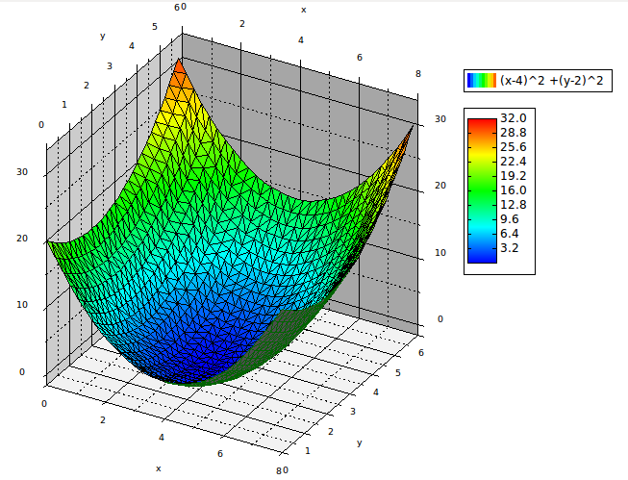

Squaring is a degree two polynomial function that often works well (accoring to Matthew Kirk in Thoughtful Machine Learning).

According to Davis King's paper, Max-Margin Object Detection, Dlib uses a trade-off between Matching all the given examples of objects to detect, and getting a large margin from erroneous predictions. Since HOG (histogram of oriented gradients) calculates differences in pixels from a few pixels to larger groups of pixels, extracting the slopes of rigid objects, it is great at extracting numbers that roughly estimate a face ( or other object ):
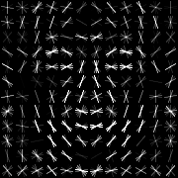
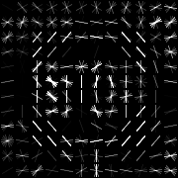

A face and a stop sign – this is what the software looks for (Demo images from http://blog.dlib.net/2014/02/dlib-186-released-make-your-own-object.html)

Artificial Neural Networks
Some research suggests we can do detection similar to a brain with many levels of “cells” which are functions which change values during training. Some companies have had good success with software like Caffe, detecting images and rejecting inappropriate content for example. This technique died out until recently, when high-end CPUs (and especially GPUs) enabled running many simple computations massively parallel.
A SVM is basically a neural network with one level – though researchers are finding ways to make this not so “shallow” (http://www.ai.rug.nl/~mwiering/GROUP/ARTICLES/Multi-Layer-SVM.pdf)

