**Start with these makeover tips.**

**Perfect your skin.** When it comes to makeup, keep in mind that "less is more." "Many women make the mistake of trying to cover up fine lines with layers of makeup; in effect, this actually makes them look older," notes New York City makeup ace Mel Rau. Instead, look for a new breed of skin-perfecting products with photo-optic technology, which brightens, resurfaces and improves your skin's clarity. One favorite: Estee Lauder Prime FX Color Neutralizing Primer ($25; esteelauder.com).

**Choose professional eyebrow shaping.** A skilled eyebrow shaping can totally transform your face. (Prices range from about $30-$60; call your local salon.) "The entire eye area can appear 'lifted' and more open, helping women look younger and much more polished," explains New York City-based celebrity makeup artist Ramy Gafni. Maintenance simply involves "cleaning up" brows underneath and removing only the strays on top.

**Eyebrow coloring: keep the color close to your hair color** (one shade darker than your locks). Since eyebrow coloring at home can easily go wrong (you don't want to take any chances working that close to your eyes), experiment with makeup pencils and powders. Women with very dark hair can try brown, while a taupe color works for blondes or most brunettes, according to Giselle, a colorist at Pierre Michel Salon in New York City, who suggests lightly feathering it into brows. (We like Revlon Brow Fantasy in Dark Blonde, Brunette and Dark Brown, $7.50; at drugstores.)

Beauty treatments[[edit](https://en.wikipedia.org/w/index.php?title=Beauty_salon&action=edit&section=1" \o "Edit section: Beauty treatments)]

[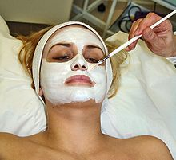](https://en.wikipedia.org/wiki/File:Facial_mask.jpg)

Facials may include the use of a [facial mask](https://en.wikipedia.org/wiki/Facial_mask).

[Massage](https://en.wikipedia.org/wiki/Massage) for the body is a popular beauty treatment, with various techniques offering benefits to the skin (including the application of beauty products) and for increasing mental well-being. [Hair removal](https://en.wikipedia.org/wiki/Hair_removal) is offered at some beauty salons through treatments such as [waxing](https://en.wikipedia.org/wiki/Waxing) and [threading](https://en.wikipedia.org/wiki/Threading_(epilation)). Some beauty salons style hair instead of going to a separate hair salon, and some also offer [sun tanning](https://en.wikipedia.org/wiki/Sun_tanning). Other treatments of the face are known as [facials](https://en.wikipedia.org/wiki/Facial). Specialized beauty salons known as [nail salons](https://en.wikipedia.org/wiki/Nail_salon) offer treatments such as [manicures](https://en.wikipedia.org/wiki/Manicure) and [pedicures](https://en.wikipedia.org/wiki/Pedicure) for the [nails](https://en.wikipedia.org/wiki/Nail_(anatomy)). A manicure is a treatment for the hands, incorporating the fingernails and cuticles and often involving the application of [nail polish](https://en.wikipedia.org/wiki/Nail_polish), while a pedicure involves treatment of the feet, incorporating the toenails and the softening or removal of [calluses](https://en.wikipedia.org/wiki/Calluses).

**Floral Ringlet Bun**

[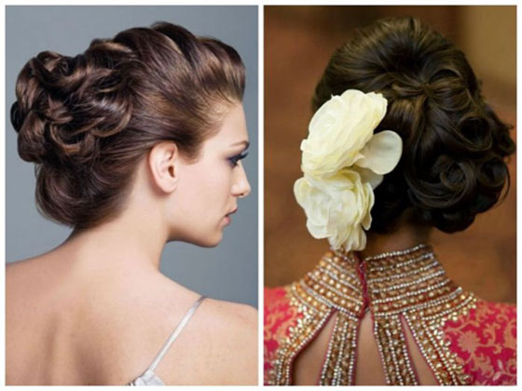](http://www.stylecraze.com/articles/10-best-indian-hairstyles/)

[**Save**](https://www.pinterest.com/pin/create/button/?guid=nUtgDzARssK6-26&url=http%3A%2F%2Fwww.stylecraze.com%2Farticles%2F10-best-indian-hairstyles%2F&media=http%3A%2F%2Fwww.stylecraze.com%2Fwp-content%2Fuploads%2F2012%2F12%2F23-Floral-Ringlet-Bun.jpg&description=50%20Best%20Indian%20Hairstyles%20You%20Must%20Try%20In%202018)

*Image:*[*Source*](https://planetzuri.files.wordpress.com/2015/06/indian-bridal-hairstyles-98.jpg?w=700&h=&crop=1)

When it comes to fancy hair, you should either go big or go home. And this hairstyle definitely goes big with its elaborate ringlet bun and a big flower to add that oomph-factor that you are looking for.

**What You Need**

* Texturizing spray
* Thin hair elastics
* Bobby pins
* Strong hold hairspray
* A big flower

**How To Style**

1. Prep your washed, dried hair with some texturizing spray.  
2. Pick up half of your hair from the top and French braid it till you reach the top of your ears, then secure it with a hair elastic.  
3. Leaving aside the hair from your French braid, pick up the rest of your hair and tie a simple bun, making sure to place it off center.  
4. Pick up a 1 inch section of hair from the hair left under your French braid, roll it into a ringlet, and secure it onto the bun using bobby pins.  
5. Repeat the previous step until all the hair from the French braid has been pinned to the bun.  
6. Attach a big flower next to your bun using bobby pins.  
7. Finish off the look with a few spritzes of strong hold hairspray.

**Half Bun/Half Braid**

[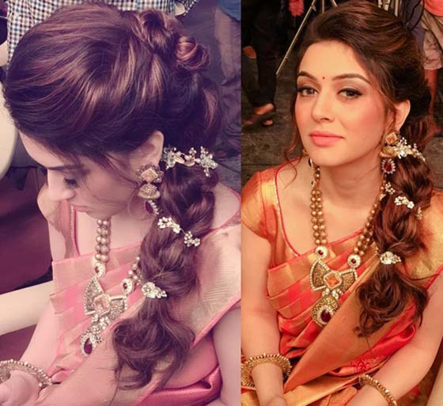](http://www.stylecraze.com/articles/10-best-indian-hairstyles/)

[**Save**](https://www.pinterest.com/pin/create/button/?guid=nUtgDzARssK6-51&url=http%3A%2F%2Fwww.stylecraze.com%2Farticles%2F10-best-indian-hairstyles%2F&media=http%3A%2F%2Fwww.stylecraze.com%2Fwp-content%2Fuploads%2F2012%2F12%2F48-Half-Bun-Half-Braid.jpg&description=50%20Best%20Indian%20Hairstyles%20You%20Must%20Try%20In%202018)

*Image: [Instagram](https://www.instagram.com/p/BJPrt5_BVdF/?taken-by=ritikahairstylist" \t "_blank)*

Now this look is quite innovative as it combines two hairstyles. The half bun provides a beautiful sweeping effect to your hair while the braid wrapped in Baby’s breath looks absolutely gorgeous.

**What You Need**

* Texturizing spray
* Bobby pins
* Hair elastics
* Baby’s breath flowers
* Light hold hairspray

**How To Style**

1. Prep your washed, dried hair with some texturizing spray.  
2. Starting from around your ears, pick up half of your hair, twist it right till the end, and roll it into a bun.  
3. Secure this bun to the back of your head by pushing some bobby pins into the bun.  
4. With the rest of your hair, do a loose messy braid and secure it at the end with a hair elastic.  
5. Pull out and loosen the braid with your fingers to give it a more relaxed look.  
6. Wrap some stems of Baby’s breath around the braid to finish the look.

**Floral Mixed Braid**

[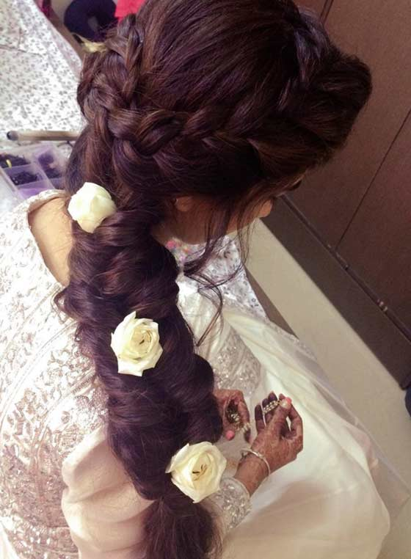](http://www.stylecraze.com/articles/10-best-indian-hairstyles/)

[**Save**](https://www.pinterest.com/pin/create/button/?guid=nUtgDzARssK6-52&url=http%3A%2F%2Fwww.stylecraze.com%2Farticles%2F10-best-indian-hairstyles%2F&media=http%3A%2F%2Fwww.stylecraze.com%2Fwp-content%2Fuploads%2F2012%2F12%2F49-Floral-Mixed-Braid.jpg&description=50%20Best%20Indian%20Hairstyles%20You%20Must%20Try%20In%202018)

*Image: [Instagram](https://www.instagram.com/p/BFoXRCDhwYq/?taken-by=ritikahairstylist" \t "_blank)*

I’m pretty sure this is not the newest idea in the book but that does not mean that it does not look cute. The combined effect of two French braids swooping into a fishtail braid is gorgeous by itself. But adding roses to the look just takes it to a whole new level.

**What You Need**

* Texturizing spray
* Bobby pins
* Hair elastics
* 3 roses (with 2 inch long stems)
* Light hold spray

**How To Style**

1. Prep your washed, dried hair with some texturizing spray.  
2. Part your hair down the middle.  
3. From right next to the right side of your parting, pick up a 3 inch section of hair and start French braiding.  
4. Once you reach the back of your head, bobby pin the French braid in place.  
5. Repeat steps 3 and 4 on the other side.  
6. Now gather all your hair at the back and start fishtail braiding.  
7. To do so, divide all your hair into 2 parts.  
8. Pick up a thin section of hair from the outer side of the right section and add it to the inner side of the left section.  
9. Next, pick up a thin section of hair from the outer side of the left section and add it to the inner side of the right section.  
10. Repeat steps 8 and 9 alternately until you reach the end of your hair and tie it with a hair elastic.  
11. Gently pull out the fishtail braid from the center to make it look wider and to give it a messy look.  
12. Finish off by inserting the 3 roses into the braid and a few spritzes of light hold hairspray.

Facial

People get facials for different reasons: some people want those horrible blackheads out! Others start taking care of their skin in their 20s to preserve a youthful look. Older people want some help with anti-again regimens. And then there are the people who just want to relax and be pampered.

These are all fine reasons to get facials. But often the facial itself is a bit mysterious. What does the steam do?

Why do they keep putting creams on and taking them off? Why get facials regularly?

A facial is essentially a multi-step skin treatment that is one of the best ways to take care of your skin. A facial cleanses, exfoliates, and nourishes the skin, promoting a clear, well-hydrated complexion and can help your skin look younger. You also receive advice on the best way to take care of *your* skin. A facial works best when it is part of an on-going program of skin care.

It is best to find an experienced, knowledgeable licensed [esthetician](https://www.tripsavvy.com/what-is-an-esthetician-3089928) who has special training in skin care and is knowledgeable, fastidious, and passionate about her work. Legally, a cosmetologist is allowed to give facials, but their primary training is in hair, so they might not be the best choice. There is also a trend toward dual-licensed therapists, where the person is licensed to give both massage and facials. Be on the lookout for this in a resort setting, especially if you'd rather go to someone who gives facials all the time.

A facial is the second most popular [spa treatment](https://www.tripsavvy.com/what-is-a-spa-treatment-3085951) after a [massage](https://www.tripsavvy.com/what-is-massage-therapy-3085918).

The Basic Steps of a Facial

* **Consultation.** A facial should begin with a consultation. You might fill out a form with questions about your skin concerns, your diet, how much water you drink, which drugs and supplements you take, and products you are currently using. Retin-A and other drugs can affect your skin and what kind of treatments the esthetician recommends. More commonly, the esthetician will simply ask about your skin concerns and if you are using Retin-A.
* **Preparations.**Usually, the esthetician offers a wrap that goes around your body and underneath your arms, then closes with velcro. She leaves the room so you can put it on in privacy. Some people remove all their clothes before putting on the wrap, some leave their pants on, and some even leave their bra on and put the straps underneath their arms. And at some spas, you are invited to take off some or all of your clothes and get between the sheets. Don't worry too much ------ the esthetician will let you know the protocol where you are.
* **Cleansing.**  Usually, the esthetician starts by wrapping your hair with a  towel or headband to keep product off of it. The first step is thorough cleansing, using cotton pads, esthetician wipes or sponges. Most professional facials do a double-cleanse.
* [**Skin Analysis**](https://www.tripsavvy.com/what-is-skin-analysis-3089933)**and Cleansing.**Depending on whether you have make-up on, the esthetician might look at your skin under a bright lamp first, or covers your eyes and looks at your skin through a brightly lit magnifying lamp. She is determining your basic skin type (dry, oily, combination, sensitive or normal) and skin conditions (acne, blackheads, whiteheads, aging, sun-damage, dehydration, etc.). The esthetician then chooses the appropriate products and treatments and consults with you about what he or she sees and recommends.
* **Steam**. Most facials use a machine that directs a thin vapor of warm steam to your face. This is relaxing and helps softens up any blackheads and whiteheads to be extracted. If you have very sensitive skin, the esthetician may not use steam.
* [**Exfoliation**](https://www.tripsavvy.com/why-is-exfoliation-important-3090271) using a mechanical or chemical exfoliant. Mechanical exfoliants have a gritty texture that rubs away the surface dead skin cells. This type of exfoliation usually happens during the steam. Chemical exfoliation uses enzymes and acids to loosen the bond between skin cells. A gentle enzyme treatment can be done during the steam. Stronger [chemical peels](https://www.tripsavvy.com/chemical-peels-3089919), which vary in intensity, can be a stand-alone treatment or part of the facial. It is not generally an "upgrade" and done in a series. It is not done with steam.
* [**Extractions**](https://www.tripsavvy.com/extractions-3089929)**.** This is the removal of blackheads or whiteheads if you want it and need it. People have different pain tolerance for extractions. They can be uncomfortable, especially on thin or ruddy skin. Extractions can cause broken capillaries and discoloration if done improperly.
* **Facial massage** using classic strokes like [effleurage](https://www.tripsavvy.com/effleurage-common-massage-stroke-3090212) to both relax you and stimulate your skin and facial muscles.
* [**Facial mask**](https://www.tripsavvy.com/what-are-facial-masks-3089921) targeted to your skin type (dry, oily, combination, sensitive, mature) and condition. During the facial, the esthetician should stay in the room and give you a scalp massage or some other service. If they leave the room to let you "relax," don't go back.
* **Final application**of toner, serums, moisturizer, and sunscreen if it's daytime.
* [**Advice on home skin care**](https://www.tripsavvy.com/nine-ways-to-beautiful-skin-3089927)**.** The esthetician will tell you how she thinks you can take better care of your skin and recommend products. Some people feel uncomfortable with this step because it involves product recommendations, but it is part of her job. You aren't obligated to buy anything, and he or she shouldn't be too pushy or make you feel bad about your skin.

At a minimum, a facial usually starts around $80 at a [day spa](https://www.tripsavvy.com/what-is-a-day-spa-3089867) and can go much higher at [destination spas](https://www.tripsavvy.com/how-to-pick-a-destination-spa-3085815), [resort](https://www.tripsavvy.com/what-is-a-resort-spa-3090113),  and hotel spas. Special masks and serums also make the price higher.

1. [Microdermabrasion with crystals: face treatment](http://uptownlaser.ca/services/facials/microdermabrasion-derma-pod-crystals/)

Skin resurfacing and micro currents combined in one treatment for a complete facial rejuvenation package:

* Deep exfoliation
* Delivers safe and even abrasion and can even be used on sensitive areas such as dark circles under the eyes
* Treatments adapted to all skin types
* Superior, longer lasting results that control and, in some cases, reversing the aging process
* Refines pores
* Softens coarse and granular skin
* Reduces uneven pigmentation
* Smooths superficial scars and blemishes

1. [Hydrafacial MD](http://uptownlaser.ca/services/facials/hydrafacial-md/)

HydraFacial MD® is a non-invasive, multistep treatment that combines the benefits of next-level hydradermabrasion, a chemical peel, automated painless extractions (no pinching!) and a special delivery of Antioxidants, Hyaluronic Acid and Peptides.

* No downtime or irritation
* Great for all skin types
* Improves overall skin health
* Reduces fine lines and wrinkles
* Improves elasticity, firmness, & overall texture
* Promotes skin tone evenness & vibrancy Skin Tone Evenness &
* Corrects hyperpigmentation/photo damage & advanced signs of aging
* Ameliorates oily/congested skin & reduces enlarged pores

1. [Microdermabrasion with Hyaluronic Acid Infusion](http://uptownlaser.ca/services/facials/microdermabrasion-with-hyaluronic-acid-infusion/)

Millions of people around the world have turned to microdermabrasion as an effective method of rejuvenating the skin and maintaining a youthful appearance.

* Facilitates the growth of new, healthy skin
* Painless, non-invasive, and non-surgical
* Shows immediate results with an improved smoothness, softness and glowing of the skin
* Reduces the appearance of age spots, acne scars, and fine wrinkles

If you are an Indian bride who plans to wear a traditional Sari or Lehenga of red, maroon, gold or green colors, you may also want to consider wearing Indian bridal makeup. Traditionally, Indian bridal makeup takes in the whole person and consists of 16 items including the dress. These items are known as the Solah Shringar of the bride.

Traditional Indian Bridal Makeup

The Solah Shringar holds many symbolic aspects for the Indian bride. Tikka bindi are traditionally a red dot worn at the center of the forehead dropping to the center of the brow. This is a symbol of femininity and marriage and represents good omens and purity. [Bridal bindi](http://www.indianbindi.com/fancy_bindi.asp?type=Bridal_Bindi) are available in a variety of shapes and sizes. These ornamental bindi can be decorated with mirror, rings, bells, beads and more.

Kajal (Kohl) is makeup applied along the edge of the eyes. This cosmetic has been [used by Indian women](http://makeup.lovetoknow.com/Slideshow:Indian_Beauties) since ancient times when it was believed to ward off bad luck. Back then it was made at home, but today it is easily purchased. Good kajal sticks provide a dreamy accent for your eyes, and even though this is an ancient tradition, today wearing Kajal is an urban fashion trend in India.

Other items that make up the Solah Shringar include bridal jewelry:

* Nose ring: The nose ring known as a Nath is a traditional piece of bridal jewelry.
* Jhumka: Earings
* Mangalsutra: A necklace worn by a married woman designed with a combination of black and gold beads.
* Payal: A fine chain worn around the ankle and decorated with ornamental, small bells.
* Bichua: A toe ring worn on the second toe.
* Choodi: Bangles worn on the wrist as a sign of marriage.
* Kamarband: A bridal waist ornament that holds the bridal sari in place.
* Pocha's: A bridal hand ornament.
* Angouti: The ring-just like in Western cultures is the symbol of love and commitment.
* Bazubandh: An ornament worn on the upper arm.

**Flowers**

Flowers are also a significant part of the traditional Indian bridal look. They symbolize life and happiness.

**Mehendi Designs**

Mehendi designs decorate the hands and feet of the traditional Indian bride with henna. This is an ancient art form and these decorations represent prosperity and play a big role in the shringar.

Contemporary but Traditional Bridal Makeup

While these traditional touches add to the beauty and sentiment for the Indian bride, you can add these elements to today's cosmetics to give you a fresh but traditional look. To make sure you get the exact look you want, practice applying your makeup before the big day. When you choose colors, it's important that they complement your gown and accessories. Apply makeup a few times as a trial run. This is the time to experiment with everything from foundation to [eyeshadow](http://makeup.lovetoknow.com/Eye_Shadow" \o "Basic Eye Shadow Overview).

**Moisturize**

On your wedding day, you'll want a flawless complexion. Make sure to allow yourself time to moisturize your face about 20 minutes before applying makeup. This is also the time to apply under-eye concealer. Choose an oil based concealer if you think you may become teary on this emotionally charged day.

**Foundation, Powder and Blush**

Apply a light-wearing foundation. If you practiced applying your makeup earlier, you'll know for sure you have the right color for your skin, dress and accessories. Set your makeup with a dusting of face powder and finish with a powder blush.

**Eyeshadow and Kajal**

To light up your eyes use a neutral eyeshadow shade. For brides who would rather not use a shadow, you can use face powder for a uniform effect. Kajal is applied along the edges of your eye. If you want to brighten your eyes, you can also apply an off-white pencil along the inside of the lower lid. Finish with a coat of waterproof mascara, let it dry and apply a second coat.

**Lips**

Perfect lips start with moisturized lips. In the days before you're wedding be sure to use lip balm to keep your lips hydrated and to avoid dried, cracked lips. On your wedding day, start with a coat of lip balm followed by a lip liner to outline your lips. Apply a matte color designed for long-lasting wear so you don't have to worry about re-applying in the middle of festivities. To finish the look, add a coat of gloss. This will give your lip-color even longer life.

A brush that's the perfect shape for shading and highlighting cheeks and face with blush.

FULL DESCRIPTION

Chiseled on both sides, this brush is the perfect shape for shading and highlighting the cheeks and face with blush. The bristles are soft and form a full, rounded shape. M·A·C professional brushes are hand-sculpted and assembled using the finest quality materials. Our 100% synthetic brushes incorporate the latest innovations in fibre technology for superior performance and improved longevity.