**Please Me MAC Matte Lipstick**

[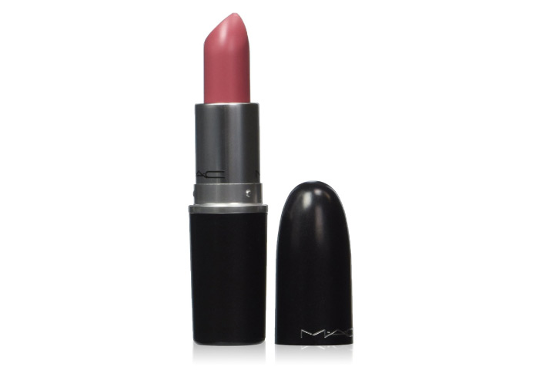](http://www.stylecraze.com/articles/best-mac-matte-lipstick-shades/)

[**Save**](https://www.pinterest.com/pin/create/button/?guid=zDfXLPVt98kw-12&url=http%3A%2F%2Fwww.stylecraze.com%2Farticles%2Fbest-mac-matte-lipstick-shades%2F&media=http%3A%2F%2Fwww.stylecraze.com%2Fwp-content%2Fuploads%2F2014%2F01%2FPlease-Me-MAC-Matte-Lipstick-1.jpg&description=Best%20MAC%20Matte%20Lipstick%20Shades%20%E2%80%93%20Our%20Top%2010%20Picks)

This one is a cool toned pink lipstick that gives a gorgeous smooth pink color to your lips. It lasts for up to four to five hours and provides a fresh and flirty look. People with medium to dark skin tones can pair this up with a dark pink lip pencil in order to avoid making the lips look pale.

**Diva MAC Matte Lipstick**

[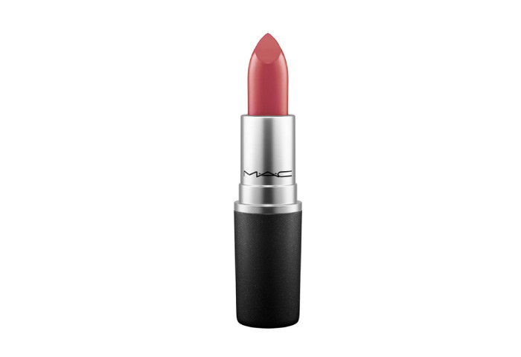](http://www.stylecraze.com/articles/best-mac-matte-lipstick-shades/)

[**Save**](https://www.pinterest.com/pin/create/button/?guid=zDfXLPVt98kw-9&url=http%3A%2F%2Fwww.stylecraze.com%2Farticles%2Fbest-mac-matte-lipstick-shades%2F&media=http%3A%2F%2Fwww.stylecraze.com%2Fwp-content%2Fuploads%2F2014%2F01%2FDiva-MAC-Matte-Lipstick-1.jpg&description=Best%20MAC%20Matte%20Lipstick%20Shades%20%E2%80%93%20Our%20Top%2010%20Picks)

This beautiful deep burgundy shade is perfect for evening parties, especially for brides-to-be. Its deep color and texture allow it to glide smoothly on your lips. It stays on for nearly four to five hours.

**. Russian Red MAC Matte Lipstick**

[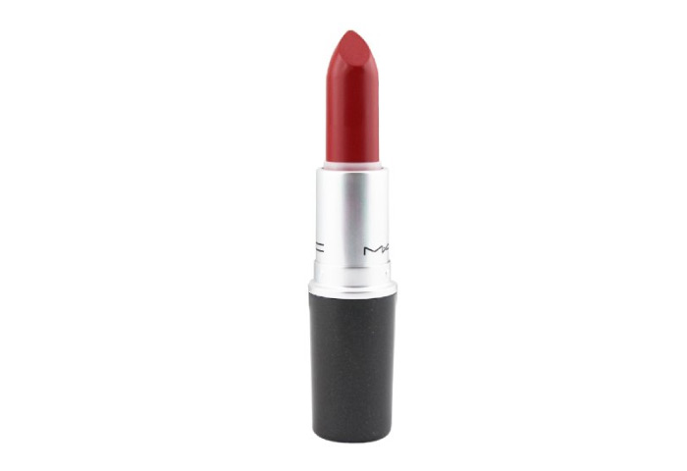](http://www.stylecraze.com/articles/best-mac-matte-lipstick-shades/)

[**Save**](https://www.pinterest.com/pin/create/button/?guid=S_LUgqXVPnRB-8&url=http%3A%2F%2Fwww.stylecraze.com%2Farticles%2Fbest-mac-matte-lipstick-shades%2F&media=http%3A%2F%2Fwww.stylecraze.com%2Fwp-content%2Fuploads%2F2014%2F01%2FRussian-Red-MAC-Matte-Lipstick-1.jpg&description=Best%20MAC%20Matte%20Lipstick%20Shades%20%E2%80%93%20Our%20Top%2010%20Picks)

‘Red’ never goes out of trend. The Russian Red matte finish lipstick gives an intense, deep red color and is a standard retro shade. It is also really long lasting and stays on up to four to five hours. For a smoother look, pair it with a lip conditioner or lip balm.

A brush that the perfect shape for shading and highlighting cheeks and face with blush.

Description:

Chiseled on both sides. This brush is the perfect shape for shading and highlighting the cheeks and face with blush. The bristles are soft and form a full. Rouded shape. MAC professional brushes are hand-sculpted and assembled using the finest quality materials. Our 100% synthetic brushes incorporate the latest innovations in fibre technology for superior performance and improved longevity.