**A**

**Project Report On**

**“MATRIX”**

**Submitted To**

**Shivaji University, Kolhapur.**

In partial fulfilment of the r

**Bachelor of Computer Application**

**(SEM-IV)**

By

**Mss. Bhakti Bharat Belwadikar**

**Mss. Harshada Lahu Shinde**

**Mss. Komal Tanaji Sawant**

**Under the guidance of**

**Asst. Prof. Mr. V. Pundikar**



**Department of Commerce and Management**

**SHRI SHAHAJI CHHATRAPATI MAHAVIDYALAYA, KOLHAPUR**

**2020-2021**

**CERTIFICATE**

This is to certify that Miss. Bhakti Bharat Belwadikar, Miss. Harshada Lahu Shinde, Mss. Komal Tanaji Sawant second year students has prepared a project report entitled “MATRIX” to Shivaji University as a partial fulfillment of Bachelor of Computer Application for the academic year 2020-21.

Place: Kolhapur.

Date: 17/08/2021

Dr. R. K. Shanediwan

Principal

**CERTIFICATE**

This is to certify that Miss. Bhakti Bharat Belwadikar, Miss, Harshada Lahu Shinde, Mss. Komal Tanaji Sawant has worked under my guidance and satisfactorily completed the project work in partial fulfillment of the requirement of the award of Bachelor of Computer Application. The work is based on original observation and efforts its being submitted under the title of “MATRIX”.

These conclusions and recommendations are based on the information collected by his during his project work.

To the best of my knowledge and belief the presented in this an original work and has not been submitted earlier to any other institution or university.

Place: Kolhapur.

Date: 17/08/2021

Mr.V. Pundikar Mr. S. H. Kamble

Guide HOD

**DECLARATION**

We here with declare that the project entitle is “MATRIX” completed & written by us under the guidance of Mr. V. Pundikar.

We further submit that the project work has been done by us & It has formed the basis of the partial fulfillment of Bachelor of Computer Application degree of Shivaji University, Kolhapur.

The empirical finding in this report based on work carried out by us during the course of the project work.

Miss. Bhakti Bharat Belwadikar,

Miss, Harshada Lahu Shinde,

Mss. Komal Tanaji Sawant,

Place: Kolhapur.

Date: 17/08/2021

**ACKNOWLEDGMENT**

We wish to express our deep sense of guidance to Dr. R. K. Shanediwan, Principal, Shri Shahaji Chhatrapati Mahavidalaya, Kolhapur having permitted us to carry out this project for BCA-II sem-IV in academic year 2020-21.

We take immense pleasure in thinking our guide Mr. V. Pundikar for her able guidance and useful suggestion, which helped us in completing the project.

Words are inadequate in offering our thanks to the staff of Department pf Commerce & Management, Shri Shhaji Chhatrapati Mahavidalaya, Kolhapur for their encouragement & co-operating in carrying our project work.

Finally, yet importantly, we would like to express our heartfelt thanks to our parents for their blessing, our friends and classmates for their help & wishes for the successful completion of this project.

Miss. Bhakti Bharat Belwadikar,

Miss, Harshada Lahu Shinde,

Mss. Komal Tanaji Sawant,

Place: Kolhapur.

Date: 17/08/2021

**INDEX**

|  |  |  |
| --- | --- | --- |
| Sr. No. | Title | Page No. |
| 1 | Introduction to Project | 7 |
| 2 | System Design | 9 |
| 3 | Conclusion | 13 |
| 4 | Reference |  |

**INTRODUCTION**

**INTRODUCTION**

The entire project has been developed keeping in view of the distributed client server computing technology, in mind. The user Interfaces are browser specific to give distributed accessibility for the overall system. In this project we don’t use any database.

The MATRIX project is an implementation of a general Matrix Calculation website, which helps the visitors to find product, division, addition, Substraction.

**System Design**

**System Desgin**

1] Use Bootstrap Framework

In this project we use Bootstrap (V4.5.2) framework for designing the webpages.

Bootstrap CDN:

<link rel="stylesheet" href="https://maxcdn.bootstrapcdn.com/bootstrap/4.5.2/css/bootstrap.min.css">

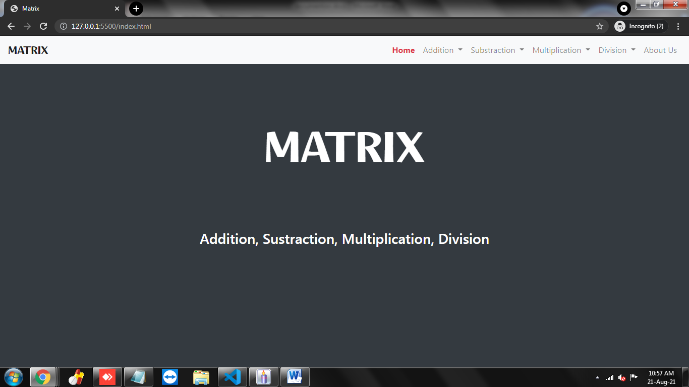

2] Use math.js

We use the math.js (v9.3.2) library to calculate addition, subtraction, multiplication and division of 2x2 and 3x3 matrix.

Math.js CDN:

<script src="https://maxcdn.bootstrapcdn.com/bootstrap/4.5.2/js/bootstrap.min.js">

</script>

CODE:

2X2 Matrix Addition

const mA = math.matrix([[matrix_1__row_1__column_1, matrix_1__row_1__column_2], [matrix_1__row_2__column_1, matrix_1__row_2__column_2]]);

const mB = math.matrix([[matrix_2__row_1__column_1, matrix_2__row_1__column_2], [matrix_2__row_2__column_1, matrix_2__row_2__column_2]]);

// Matrix Addition

const matrixAdd = math.add(mA, mB);

3X3 Matrix Addition

const mA = math.matrix([

[matrix_1__row_1__column_1, matrix_1__row_1__column_2, matrix_1__row_1__column_3],

[matrix_1__row_2__column_1, matrix_1__row_2__column_2, matrix_1__row_2__column_3],

[matrix_1__row_3__column_1, matrix_1__row_3__column_2, matrix_1__row_3__column_3]

]);

const mB = math.matrix([

[matrix_2__row_1__column_1, matrix_2__row_1__column_2, matrix_2__row_1__column_3],

[matrix_2__row_2__column_1, matrix_2__row_2__column_2, matrix_2__row_2__column_3],

[matrix_2__row_3__column_1, matrix_2__row_3__column_2, matrix_2__row_3__column_3]

]);

// Matrix Addition

const matrixAdd = math.add(mA, mB);

**Conclusion**

**Conclusion**

* We perform math’s operation on Matrix Easily.
* It Support to all devices easily.
* It is fully operate on client side computer.

**References**

**Reference**

* [www.google.com](http://www.google.com)
* <https://shubhams1401.blogspot.com>
* <https://shubhams1401-sawant.github.io>
* [www.w3school.com](http://www.w3school.com)
* [www.javapoint.com](http://www.javapoint.com)