FleetRental - Premier Car Rental Application Design Document

Revision History
Date | Revision | Author | Description | Document Tracking
07.30.09 | 1.0 | Mike Prasad | Genesis

Contents
1 Introduction 4
1.1 Intent 4
1.2 High Level Requirements 4
1.2.1 Registration 4
1.2.2 Authentication 5
1.2.3 Profile 5
1.2.4 Product Selection 5
1.2.5 Payments 5
1.2.6 Checkout 5
1.2.7 Return Processing 6
1.2.8 Administration 6
1.2.9 Key Technology Standards 6
1.2.10 Future Enhancements 6
2 Fleetrental Use Cases 8
2.1 Intent 8
2.2 Customer Interacting Use Cases 8
2.2.1 Use Case Diagram 8
3 Fully Dressed Use Case 10
3.1 Intent 10
3.2 Authenticate Customer Use Case 10
4 Class diagram 12
4.1 Description 12
4.2 Domain Layer Class Diagram 12
5 Development Directory 13
5.1 Description 13
6 Summary 14

Introduction

Intent
This document details the requirements of the FleetRental application along with a fully dressed use cases. Document al also includes design details of the FleetRental Application.

 In your case, you’d maintain a weekly update to this design document as you progress through each layer.

High Level Requirements
FleetRental is a fictitious car rental business that caters to high-end clients interested in renting high-performance and exotic cars. Cars such as Dodge Viper, Ford GT50, Lotus Elise, 911 Porsche, and Mercedes M3 are some of the cars that are offered initially.

Based on marketing studies, only major U.S., cities will host this business, which includes New York, Chicago, Houston, Los Angeles, and Denver, the company HQ, will be first city where this is available as a pilot.

During the pilot phase of this application it will be built as a windows based fat-client used by customer support reps (CSRs). In this phase, all orders will be placed via CSRs. This implies that inventory browsing, rental rate info will only be conveyed by the CSR.

Future implementation will make the application web enabled.

Registration

Customers are required to register, be of a legal age, and hold a valid driver’s license along with insurance. Business plan calls for providing in-house insurance at a latter time.

Registration process will capture customer’s legal, first name, middle initial, last name, their home address, phone numbers (home, work and mobile), email address, userid and a password. Registration process is a minimum to reserve a car.

Customer is required to answer three security questions, which they can use when userid’s and/or passwords are forgotten.

Authentication

Customers are required to have a valid userid and password. Login process will provide the ability reset forgotten password

Profile

Application will provide a mechanism for the customer to change their profile information. This includes home address, phone numbers and email address.
Any update to the profile will trigger an email to the customer.

Product Selection

During the pilot phase, CSRs will guide the customer through the product selection. For the task of browsing the inventory, checking on rental rates and for weekly specials does not require customer registration.

When customer has selected the car to rent, he/she is required to pass their userid/password to the CSR. CSR will do hold the car for 24 hours by which time the customer has to complete the in-house check-out process.

Payments

Given the high-end nature of the product, at the time of rental, a $1000.00 charge will be held as a deposit against a valid credit card (Amex, Visa, and MasterCard). No other forms of payments will be accepted.

Checkout

Upon successful payments processing, customer is required to sign the final contract, which details the rental rate, rental start, and return date and late return fees. Checkout process involves thorough inspection of the car by both FleetRental Store Manager and customer. Any issues are identified in a different part of the contract and a final signature completes the checkout.

Checkout process should update system inventory.

Return Processing

An inspection by the FleetRental Store Manager and the customer finalizes the return process. Processing of damaged rentals is beyond the scope of this document.

Administration

An administrator who will update the product list on frequent bases will maintain our catalog of cars. A third party product catalog supplied by Kroingsegg Software, called KPC (stands for Kroingsegg Product Catalog) will hold all the cars and its information. APIs exposed by this software will be used to integrate into the FleetRental application.

HR(KHR) modules supplied by the same vendor will provide all human resources needs.

Key Technology Standards

The process of registering, login, and credit card transactions will be on a secured channel.

The system will follow PCI rules for recording customer’s credit card information in our databases.

OWASP (www.owasp.org) standards will be adhered to in the development of the application. It should be understood that this is applicable when this application is web-enabled.

Future Enhancements

Future phase will extend this model to support to the web, which will provide self-care features.

Given the clientele involved, this business will be highly active on the social networking sites such as Twitter, Facebook and Yammer. Software integration to these sites will be scheduled after the completion of the pilot phase.

Fleetrental Use Cases

Intent
This section lists the various uses cases pertained to customer interaction with the system.

Non-customer related use cases such as Inventory Management and Employee services are not the focus of this document.

Customer Interacting Use Cases

Following are the customer interacting use cases by priority:

Register Customer

Authenticate Customer

Manage Profile

Product Selection

Payment Processing

Checkout

Return Processing

Use Case Diagram

Following figure depicts the use case diagram associated with the customer as the main actor.

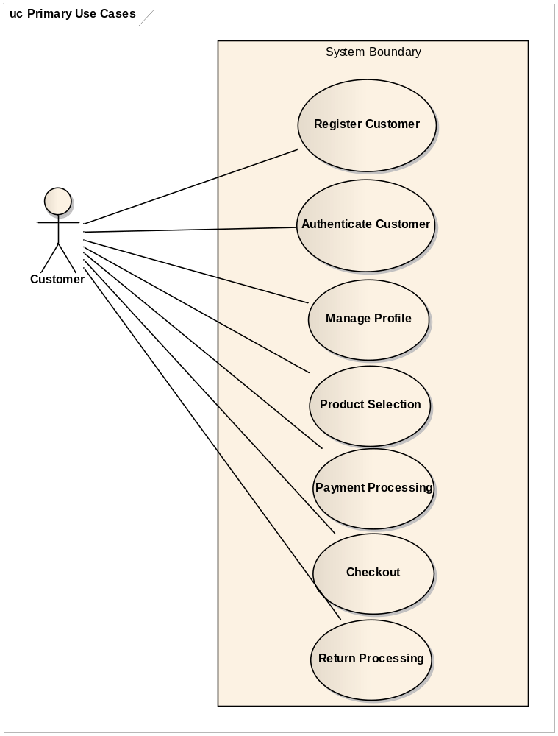
Figure 2-1 FleetRental Customer Interacting Use Cases

Fully Dressed Use Case

Intent
This section documents a fully dressed use case for authenticating the customer.

Students are expected to implement an use case that is rich in functionality. Authentication UC for example is not considered as such.

Authenticate Customer Use Case

Primary Actor: Customer

Assumptions:
- Customer already exists as an active FleetRental customer

Stakeholders:
- FleetRental wants to ensure a registered customer is accessing the application

Pre-conditions:
- The customer has registered with FleetRental

Post-conditions (Success Guarantee):
- Customer is successfully logged into the application (In the windows based application, this is performed by the CSR).

Flow of Events:
- Customer is prompted to either enter their userid and password to gain access to the FleetRental application functions or to become a member (During pilot phase, CSR logs in on behalf of the customer).

ALT FLOW 1.A1 Customer has not registered yet
  - See Register Customer UC for steps to register new customer

- Application checks all entered fields for format validity. (See requirements below.)
System/UI Requirements
  - Userids should begin with a letter, and use only letters (a-z), numbers (0-9), and the underscore (_), but no spaces. Userids must be a minimum of 6 characters.
  - Passwords must be at least four (4) characters long, may contain numbers (0-9) and upper and lowercase letters (A-Z, a-z), but no spaces.
ALT FLOW 2.A1 Login ID/Password data format is invalid

- When the entered Userid/Password is rejected upon validation, the UI presents a message corresponding to the error:
Examples:
“Userid/Password is invalid, please try again”

- When userid and password are successfully validated, the submitted data is stored in the FleetRental database as a successful transaction
- UI presents the FleetRental Main Menu screen with the following text:
<Firstname>, welcome to the premier car rental site!

Class diagram

Description
This section illustrates the class diagram in each layer.

Domain Layer Class Diagram
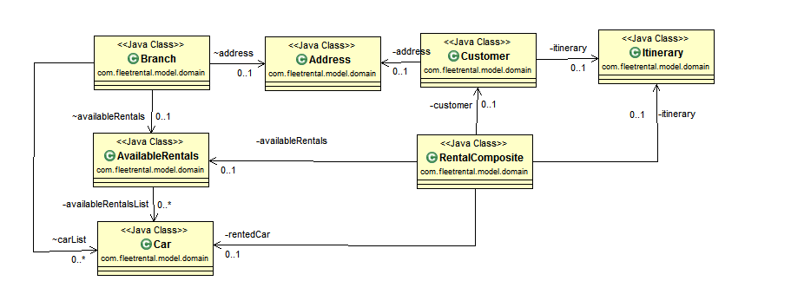
Figure 2-2 Domain Layer Class Diagram

Development Directory

Description
Figure 3-3 shows the directory structure of the source code located under the “src” folder and the corresponding test code under the “test” folder.
- For every source (Java) class there should be a corresponding unit test!
  - In my sample below I do not, however, you should! ☺

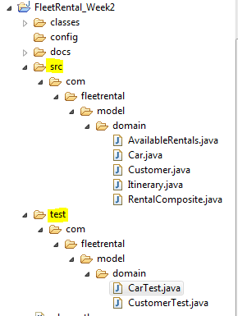

Figure 3-3 FleetRental Application Directory Structure

Summary

This document details the requirements, highlights use cases and flushes out a fully dressed use case and design details of the FleetRental application

- End -

