FleetRental Application Design Document

Revision History
Date | Revision | Author | Description | Document Tracking
07.30.09 | 1.0 | Mike Prasad | Initial Creation

Contents
1 Introduction 4
1.1 Intent 4
1.2 Issue 4
2 Class diagram 6
2.1 Description 6
2.2 View 6
2.3 Service Layer Class Diagram 9
2.4 Domain Layer Class Diagram 9
3 Development Directory 11
3.1 Description 11

Introduction

Intent
Document details the design of the FleetRental Application.

Issue

In this implementation, only one customer is saved in the file, which means we can register and authenticate only one customer.

To append multiple customers, would require us to use an overloaded FileOutputStream, for example:

new ObjectOutputStream (new FileOutputStream("RegisteredCustomer.out", true));

With this one can successfully add multiple objects.

The pseudo code to write (register customer use case) would look like

Write Scenario:
Open object stream to write/append
write object
close stream

We'd repeat the process to register next customer and so on.

Now, to read from this file that has multiple entries would require one to loop while reading each object.

The pseudo code to do this (login use case scenario) would look like:

Read Scenario:
Open Object stream to read
loop
read each object
exit on end of file
end loop

Issue

In the above case, where we are writing objects in one use case and reading them out in another use case, you will get this exception : java.io.StreamCorruptedException: invalid type code: AC

This can be produced in JDK 1.6.

This issue will not appear, if in the write scenario, all objects were written all at once, in which case the read scenario will work fine. However, writing all objects at once is not practical in the use case where customers are being registered at different times.

Summary

Just go with only one object (Customer) that gets saved in using object stream as in this sample code.

 Use case details to be added later.

Class diagram

Description
This section illustrates each layer.

View
Start off by running the com.fleetrental.view.ViewDriver, which creates a MainJFrameController passing in the MainJFrame. MainJFrame contains all the Swing view widgets, while MainJFrameController contains the callbacks.

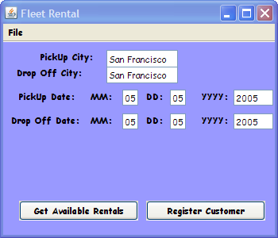

Only the Register Customer feature is implemented in this sample.

Upon clicking the Register Customer button, the registration screen will be displayed. On clicking the OK button, would invoke the com.fleetrental.controller. FleetRentalController,which in turn calls the FleetRentalManager.

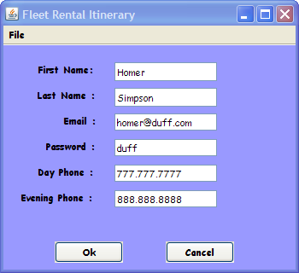

Make sure the VM Arguments are passed in when running the ViewDriver as shown below.
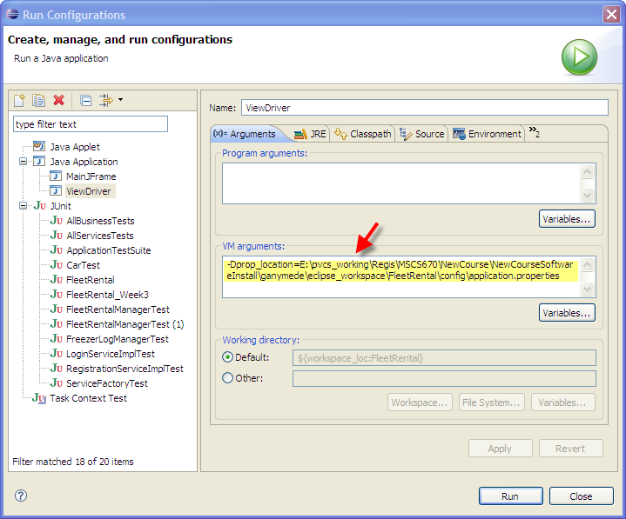

Service Layer Class Diagram

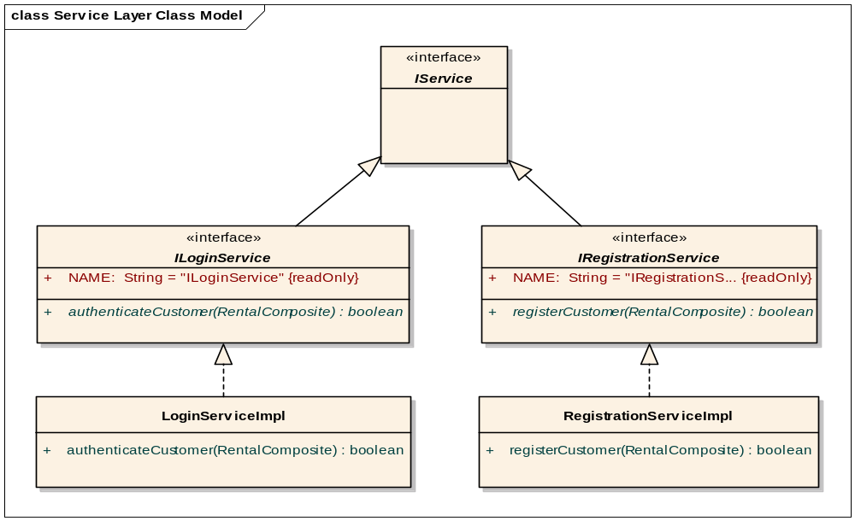
Figure 2-1 Service Layer Class Diagram

Domain Layer Class Diagram

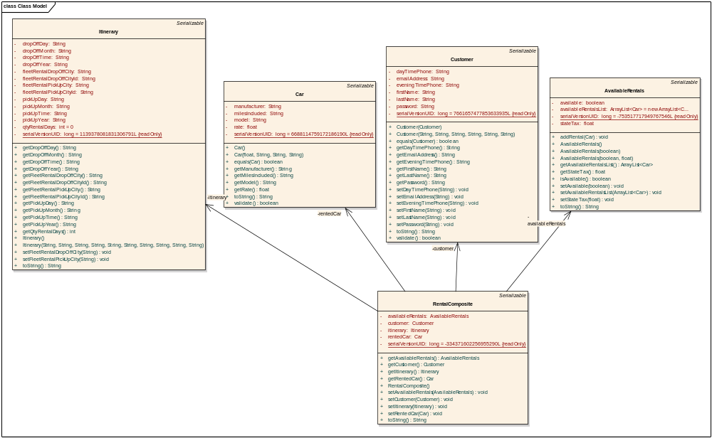
Figure 2-2 Domain Layer Class Diagram

Development Directory

Description
Figure 3-3 shows the directory structure of the source code located under the “src” folder and the corresponding test code under the “test” folder.
1. For every source (Java) class there is a corresponding unit test!

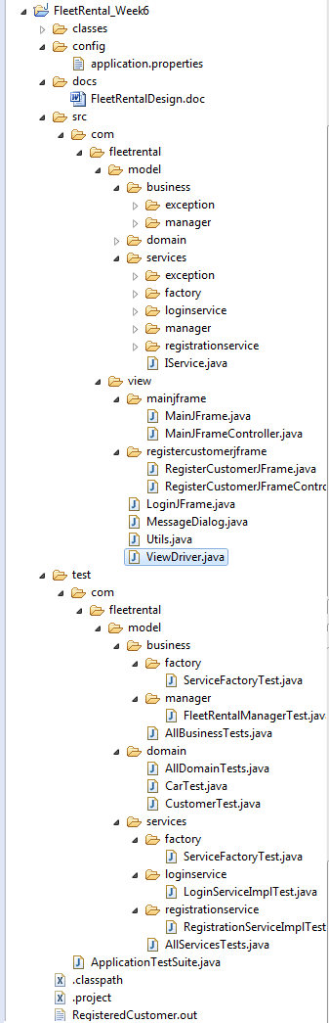

Figure 3-3 FleetRental Application Directory Structure

