MSSE670_Week5_Assignment

Thursday, September 1, 2022

3:57 PM

# Week 5 Assignment, Business layer

# Important Notes

* + This week, a project must run as viewed from both the perspective of the tests and the Driver Class to receive a passing grade. In your Driver class, you should instantiate and configure the Composite object, pass it to the services, and print returned output from the methods.
  + Be sure to include screen shots of sample runs and passed tests in your docs folder.

# Plan

* + Refer to the **Fleet Rental Sample Code** for details about how to program your **Flight Reservation Application**.
  + You will deliver the next iteration of your course project. This week, the Business Layer will be developed.
  + This week you will:
    - Develop the business layer logic that will use the services you previously developed. In previous assignments you developed at least two services in addition to the Login Service.
    - Implement design patterns discussed in the class material and refer to the sample code to understand how these are implemented.
    - The new design patterns include:
      * The Façade
      * Manager and Manager Supertype (Layer Supertype).
    - Previous design patterns include:
      * Marker Interface
      * Separated Interface
      * Plugin
      * Factory
      * Value Objects (Domain classes)
    - Implement exceptions for all services in your application and **ensure that exceptions are propagated to the business layer.**
    - As before, the application.properties file must be loaded at runtime using the following (spaces are important).

-Dprop_location=<pathname>

**Code View of Structure**

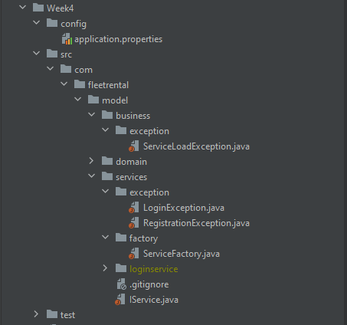

# What to turn in

You will implement your Business Layer following the details above. The should include:

* + Appropriate naming conventions and style (see sample code)
  + Packages in the Business Layer that implement a **Façade** design pattern.
  + **Manager** and **manager supertype**.
  + **PropertyManager** to allow loading of the properties file at application startup.
  + **Exceptions** in the Business Layer and Services Layer, ensuring that all exceptions are propagated to the Business Layer.
  + An **application.properties** file that is used to load the implementation of the services at runtime.
  + A **Driver Class** with a main method that runs the program. This week, this should be put in the Presentation Layer so that it is above the business layer.
  + Tests for the Business Layer including tests that handle exceptions.
  + A docs (see location in the Sample Code) folder with screen shots of completed runs using the Driver as well as successful test runs.
  + **Code uploaded to a source control repo and link submitted in Slack. Code for Week 5 must be clearly labeled in a folder or branch.**