Airline Flight Reservation

The airline flight system allows a customer to login and schedule a flight reservation based on their desired; time, airline, location, and date. The goal of this system will be to make reserving an airline flight as simple as possible. The first stage is for the customer to login, directed to the home page, the customer can select the city they are flying from and to. The system allows them to search for the flight based on airline and time. After the flight is selected the customer can make a payment with their credit card and verify the purchase. Lastly, a receipt and confirmation are sent to the customer.
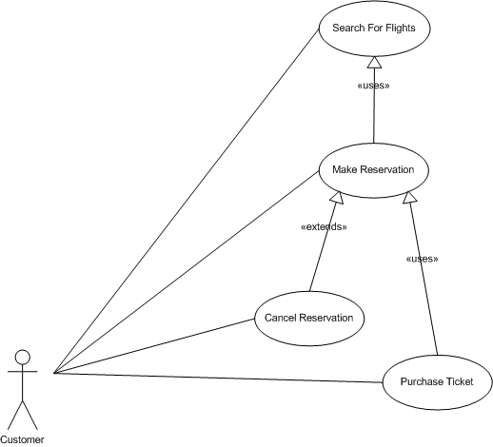
UseCaseID: Search for Flights
Goal: A customer desires to search for available flights between cities for specific dates chosen dates.
Scope: Flight Reservation System (FRS)
Pre-Condition: Actor has successfully navigated to the login and options screen.
Success End Condition: A list of flight matching the search criteria is presented.
Failed End Condition: A list of flight matching the search criteria is NOT presented.
Primary Actor: Customer
Trigger Event: Selects the "Search Flights" option.

Main Success Scenario
Step Actor Action Description
1 Customer Selects the "Search Flights" option.
2 FLS Displays a screen with input fields for source airport, destination airport, : type of ticket (one way or round trip) and the departure and arrival date based on the choice of ticket type. Two-way ticket will force an arrival date to be entered.
3 Customer Enters the all information and clicks the "Search" button.
4 FLS Displays a listing of all flights that match the customers input from step 3, each item in the list has an associated price and a "Book This Flight" link.

Scenario Extensions
Step Actor Action Description
3.a Customer Selects the "Cancel" option.
3.a.1 FLS Displays the main options screen.
3.b Customer Does not complete all the necessary fields.
3.b.1 FLS Redisplays the input fields from step 2 with the input data and a note stating that certain required data is missing.

Scenario Variations
Step Actor Action Description
None

UseCaseID: Make Reservation
Goal: A customer wishes to make a reservation.
Scope: Flight Reservation System (FRS)
Pre-Condition: Actor has successfully generated a list of flights as documented in the "Search for Flights" use case.
Success End Condition: A reservation has been made.
Failed End Condition: A reservation has NOT been made.
Primary Actor: Customer
Trigger Event: Selects the "Book This Flight" link from the list of flights presented.

Main Success Scenario
Step Actor Action Description
1 Customer Selects the "Book This Flight" link from the list of flights presented.
2 FLS Displays a screen with input fields for: a credit card number, cardholder name, and credit card expiration date.
3 Customer Enters a credit card number, the cardholder name and the credit card expiration date and clicks the "Submit" button.
4 FLS Displays the details of the reservation.
5 Customer Selects the "Complete Reservation" option.
6 FLS Displays the main options screen. The message "Reservation Successfully Made" is also displayed.

Scenario Extensions
Step Actor Action Description
3.a Customer Does not complete all the necessary fields.
3.a.1 FLS Redisplays the input fields from step 2 with the input data and a note stating that certain required data is missing or invalid.
3.b Customer Selects the "Cancel" option.
3.b.1 FLS Displays the main options screen.
5.a Customer Selects the "Cancel" option.
5.a.1 FLS Displays the main options screen.

Scenario Variations
Step Actor Action Description
None

