MSSE670_Week5_Assignment
Thursday, September 1, 2022
3:57 PM

Week 5 Assignment, Business layer

Important Notes
  - This week, a project must run as viewed from both the perspective of the tests and the Driver Class to receive a passing grade. In your Driver class, you should instantiate and configure the Composite object, pass it to the services, and print returned output from the methods.
  - Be sure to include screen shots of sample runs and passed tests in your docs folder.

Plan
  - Refer to the Fleet Rental Sample Code for details about how to program your Flight Reservation Application.
  - You will deliver the next iteration of your course project. This week, the Business Layer will be developed.
  - This week you will:
    - Develop the business layer logic that will use the services you previously developed. In previous assignments you developed at least two services in addition to the Login Service.
    - Implement design patterns discussed in the class material and refer to the sample code to understand how these are implemented.
    - The new design patterns include:
      - The Façade
      - Manager and Manager Supertype (Layer Supertype).
    - Previous design patterns include:
      - Marker Interface
      - Separated Interface
      - Plugin
      - Factory
      - Value Objects (Domain classes)
    - Implement exceptions for all services in your application and ensure that exceptions are propagated to the business layer.
    - As before, the application.properties file must be loaded at runtime using the following (spaces are important).
-Dprop_location=<pathname>

Code View of Structure

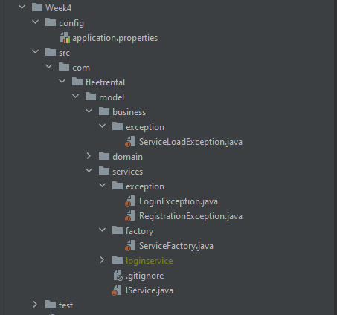

What to turn in
You will implement your Business Layer following the details above. The should include:
  - Appropriate naming conventions and style (see sample code)
  - Packages in the Business Layer that implement a Façade design pattern.
  - Manager and manager supertype.
  - PropertyManager to allow loading of the properties file at application startup.
  - Exceptions in the Business Layer and Services Layer, ensuring that all exceptions are propagated to the Business Layer.
  - An application.properties file that is used to load the implementation of the services at runtime.
  - A Driver Class with a main method that runs the program. This week, this should be put in the Presentation Layer so that it is above the business layer.
  - Tests for the Business Layer including tests that handle exceptions.
  - A docs (see location in the Sample Code) folder with screen shots of completed runs using the Driver as well as successful test runs.
  - Code uploaded to a source control repo and link submitted in Slack. Code for Week 5 must be clearly labeled in a folder or branch.

