FleetRental Application Design Document

Revision History
Date | Revision | Author | Description | Document Tracking
07.30.09 | 1.0 | Mike Prasad | Initial Creation

Contents
1 Introduction 4
1.1 Intent 4
1.2 Issue 4
2 Executable Jars 6
2.1 Building an Executable Jar File 6
2.1.1 manifest.txt 6
2.1.2 Property File Location 6
2.1.3 Creating Jar 7
3 Class diagram 10
3.1 Description 10
3.2 View 10
3.3 Service Layer Class Diagram 13
3.4 Domain Layer Class Diagram 13
4 Development Directory 15
4.1 Description 15
Appendix A – Setting path to jar and java 17

Introduction

Intent
Document details the design of the FleetRental Application.

Issue

In this implementation, only one customer is saved in the file, which means we can register and authenticate only one customer.

To append multiple customers, would require us to use an overloaded FileOutputStream, for example:

new ObjectOutputStream (new FileOutputStream("RegisteredCustomer.out", true));

With this one can successfully add multiple objects.

The pseudo code to write (register customer use case) would look like

Write Scenario:
Open object stream to write/append
write object
close stream

We'd repeat the process to register next customer and so on.

Now, to read from this file that has multiple entries would require one to loop while reading each object.

The pseudo code to do this (login use case scenario) would look like:

Read Scenario:
Open Object stream to read
loop
read each object
exit on end of file
end loop

Issue

In the above case, where we are writing objects in one use case and reading them out in another use case, you will get this exception : java.io.StreamCorruptedException: invalid type code: AC

This can be produced in JDK 1.6.

This issue will not appear, if in the write scenario, all objects were written all at once, in which case the read scenario will work fine. However, writing all objects at once is not practical in the use case where customers are being registered at different times.

Summary

Just go with only one object (Customer) that gets saved in using object stream as in this sample code.

 Use case details to be added later.

Executable Jars

Building an Executable Jar File
Follow the instructions in the slide for creating the manifest.txt and copying it and the config folder into the location where the .class files are located.

In the slides, the .class files are assumed to be in the ‘bin’ folder. However, in the fleetrental sample, the .class files are in the classes folder.

This section below points out to the changes made to the FleetRental code in supporting what is mentioned in the slides.

Read Appendix A on how to set path to run the ‘java’ and ‘jar’ commands.

manifest.txt
In the FleetRental sample, the main class is the ViewDriver, hence the manifest.txt file contains this entry:

Main-Class: com.fleetrental.view.ViewDriver

Property File Location

Since the ‘config’ is now located in the ‘classes’ folder, as mentioned in the slides, image below shows the changes I had to do in the ManagerSuperType.java

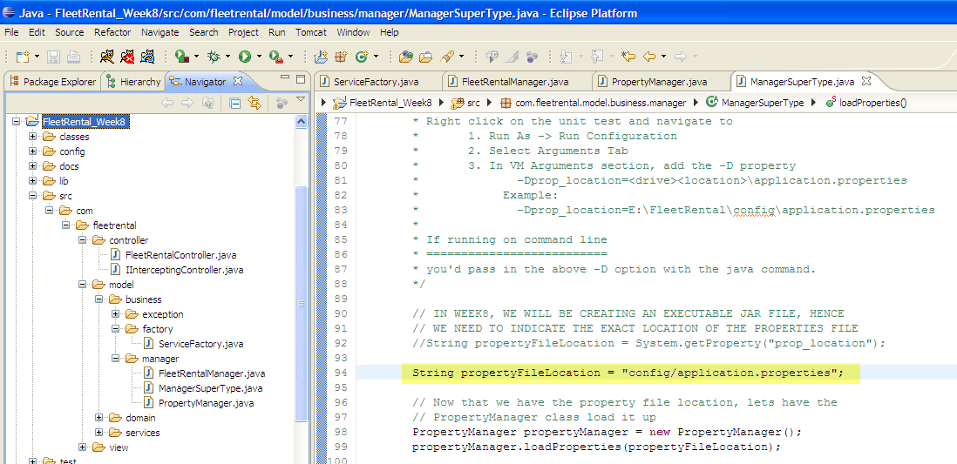

Creating Jar
This sections details two ways to create a Jar – Command Window and Ant

Command Window Approach

‘Jar’ Command on Command Window

Since FleetRental sample uses a nested package approach, the command to run the jar would be as follows.

jar -cvmf manifest.txt FleetRental.jar config com\fleetrental\view com\fleetrental\controller com\fleetrental\model\business\exception com\fleetrental\model\business\factory com\fleetrental\model\business\manager com\fleetrental\model\services com\fleetrental\model\domain

Note that entire command above would be executed in the command window in one straight line (meaning no new lines as it might appear by looking at the command above).

Executing the jar

In a command window (see Appendix A for setting path for ‘java’ command) change directory to FleetRental_Week8\classes folder and run the following command:

java -jar FleetRental.jar

This should fire up the swing app

Ant Approach

Creating Build.xml

Create the build.xml file as detailed in the slides. FleetRental’s version is located under FleetRental_Week8\build.xml and is structured as shown below.

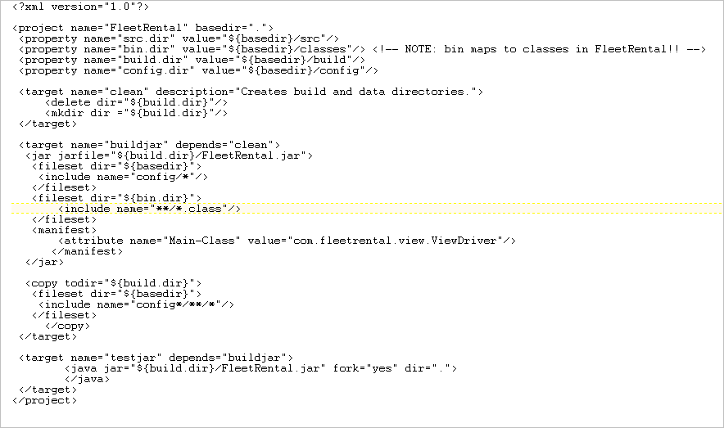

Running the build.xml
As discussed in the slides, one can run the Ant file either in the command window (which requires Ant to be installed and available in the path) Or via Eclipse.

Eclipse approach is what is shown below and again following the slides, changing the Eclipse View to Ant and importing the build.xml file (by clicking on the +Ant), the ant tasks are now visible in Ant window. Double clicking the task (say testjar) will cause it to be executed.

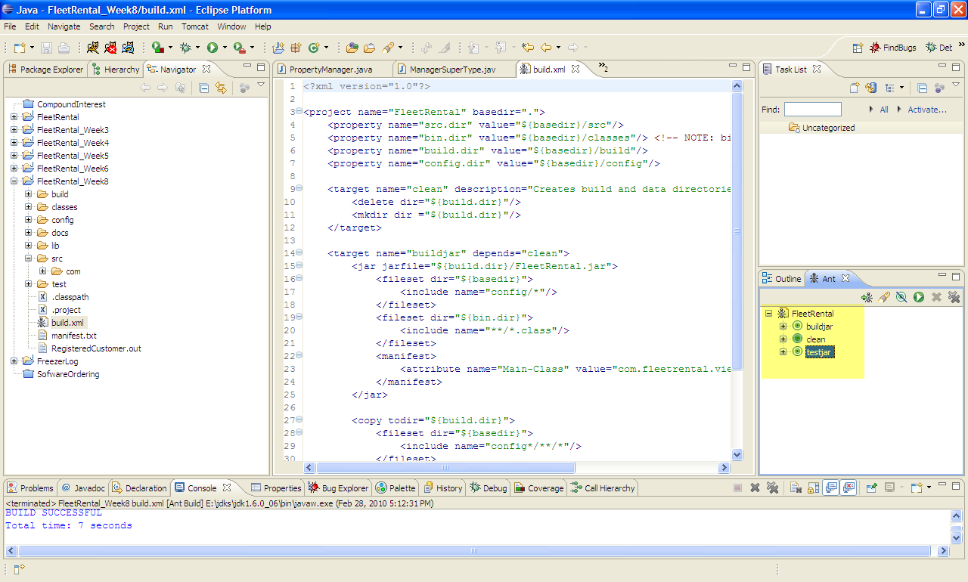

Class diagram

Description
This section illustrates each layer.

View
Start off by running the com.fleetrental.view.ViewDriver, which creates a MainJFrameController passing in the MainJFrame. MainJFrame contains all the Swing view widgets, while MainJFrameController contains the callbacks.

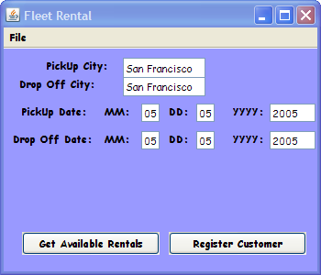

Only the Register Customer feature is implemented in this sample.

Upon clicking the Register Customer button, the registration screen will be displayed. On clicking the OK button, would invoke the com.fleetrental.controller. FleetRentalController,which in turn calls the FleetRentalManager.

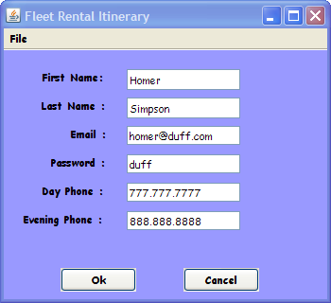

Make sure the VM Arguments are passed in when running the ViewDriver as shown below.
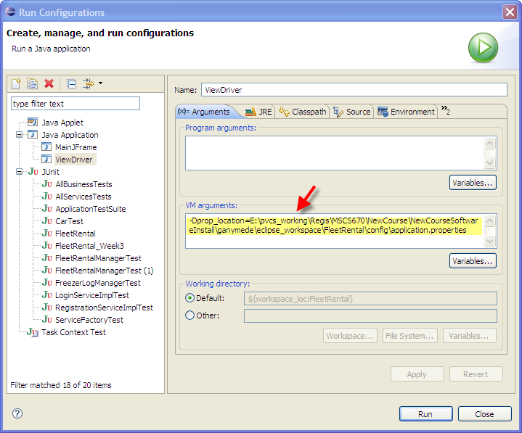

Service Layer Class Diagram

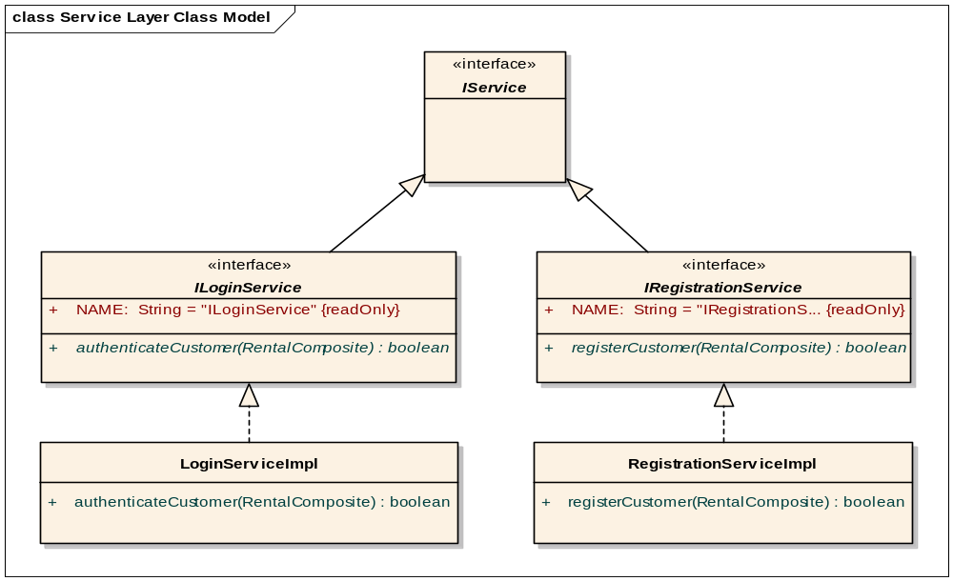
Figure 2-1 Service Layer Class Diagram

Domain Layer Class Diagram

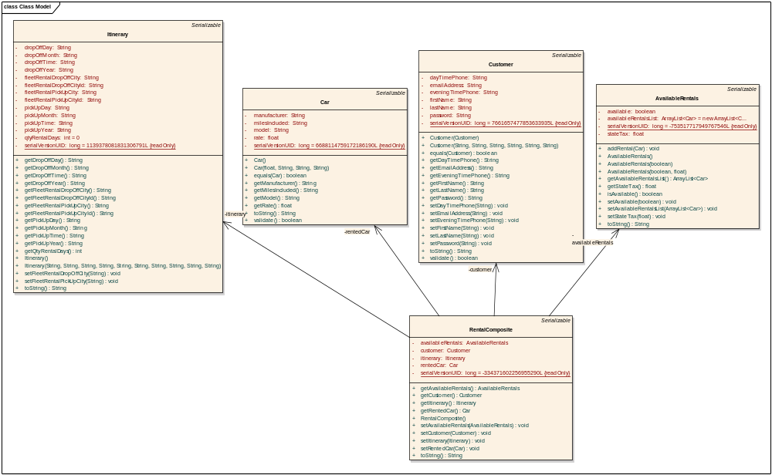
Figure 2-2 Domain Layer Class Diagram

Development Directory

Description
Figure 3-3 shows the directory structure of the source code located under the “src” folder and the corresponding test code under the “test” folder.
1. For every source (Java) class there is a corresponding unit test!
2. Exceptions will be covered in Week4.

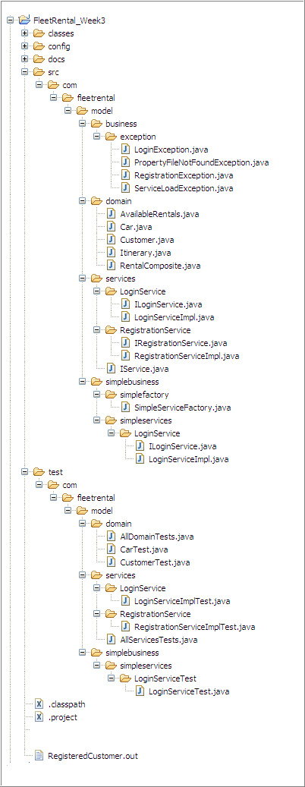

Figure 3-3 FleetRental Application Directory Structure

Appendix A – Setting path to jar and java

In Week8 HW, you will be required to run the “jar” and “java” commands on command line.

These commands reside in the JDK’s bin folder.

Hence, to run these commends, the “path” to the JDK’s bin folder needs to be set.

What happens if the “path” is not set?

You’ll see an error as shown below.

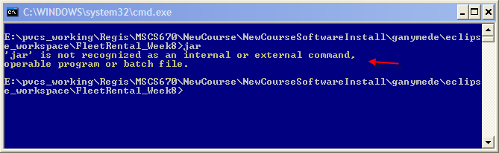

How do I set the path?

In my case, my JDK is installed in E:\jdks\jdk1.6.0_06. Follow screen below to set JAVA_HOME and PATH.

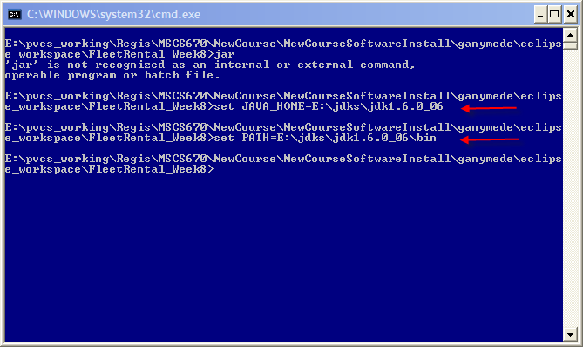

Now, when you type in the “jar” command, you’ll see the “Usage” or help for using “jar” command. This because this command along with “java” are in the path.

