A Comparative Study of Short-Term Load Forecasting Using Statistical, Decomposition and Neural Network Models
Arjun Maindarkar | AnshSingh | TamajeetBiswas
Department of Electrical Engineering Indian Institute of Technology Ropar, India

Abstract—Short-term load forecasting is important for efficient power system operation and planning. This study implements and evaluates univariate forecasting methods based on James
W. Taylor’s exponentially weighted techniques using half-hourly historical load data. The models capture intraday and intraweek seasonal patterns without using weather variables. After data preprocessing, forecast accuracy was evaluated using Mean Absolute Percentage Error (MAPE). The results show that these methods can provide accurate short-term forecasts and are useful when weather data is unavailable or unreliable.
Index Terms—Discount weighted regression, exponential smoothing, load forecasting, singular value decomposition, spline functions.

- Introduction
Short-term electrical load forecasting is an essential task in modern power system operation and energy management. Accurate prediction of future demand assists utilities in gen-eration scheduling, economic dispatch, reserve allocation, and maintaining grid reliability. With the growing complexity of power networks and varying consumer demand patterns, the development of reliable forecasting techniques has become increasingly important.
Load demand data generally contains trend, daily and weekly seasonality, and stochastic fluctuations. Therefore, forecasting models must be capable of representing both structured temporal patterns and irregular variations. Over the years, several statistical, decomposition-based, and machine learning methods have been proposed for this purpose.
In this work, a comparative study of six forecasting ap-proaches is presented: Intraday Cycle (IC), Holt-Winters-Taylor (HWT), Singular Value Decomposition (SVD), Dy-namic Weighted Regression (DWR), Artificial Neural Net-work (ANN), and AutoRegressive Moving Average (ARMA). These models were implemented and evaluated on half-hourly electrical load data using Mean Absolute Percentage Error (MAPE).
The objective of this paper is to benchmark the forecasting accuracy of classical and modern techniques under a common framework and identify suitable models for short-term load prediction.

- Load Series
The empirical analysis presented in this paper was carried out using real half-hourly electrical load demand data ob-tained from the official Berkswell, United Kingdom electricity
demand records. The dataset consists of continuous half-hour interval observations collected during the year 2022-23, resulting in 48 demand measurements per day and 336 measurements per week.
To improve numerical stability and maintain consistency with modern load forecasting practices, the raw demand values were transformed into logarithmic scale (Log MW) prior to model development. This transformation reduces heteroscedas-ticity, suppresses extreme variations, and improves the perfor-mance of statistical and machine learning forecasting models. Missing observations, if present, were handled using linear interpolation, while abnormal outlier values were corrected using local smoothing methods before training. The cleaned load series was then divided into training and testing subsets, where approximately 80% of the observations were used for model estimation and the remaining 20% were reserved for
out-of-sample forecast evaluation.
The dataset exhibits strong intraday and intraweek seasonal behavior. Repeating daily demand cycles corresponding to residential and commercial activity are clearly visible, along with broader weekly patterns caused by weekday and weekend consumption differences. These recurring structures motivate the use of seasonal and adaptive forecasting methods such as IC, HWT, DWR, and SVD.
Forecasting performance was evaluated for horizons up to 48 half-hour intervals ahead using Mean Absolute Percentage Error (MAPE).
- Methodology
The forecasting framework adopted in this work consists of data preprocessing, model implementation, multi-step fore-casting, and comparative performance evaluation. The dataset used in this study corresponds to half-hourly electrical load demand measurements from Berkswell, United Kingdom, ob-tained from the official publicly available source. The dataset contains real demand observations with strong daily and weekly seasonal characteristics, making it suitable for short-term load forecasting analysis. Missing values and abnormal data points were corrected using interpolation and smoothing techniques prior to model training.
A total of seven forecasting approaches were studied under identical experimental conditions:
- Intraday Cycle (IC): Exploits recurring daily load demand patterns with adaptive correction.
- Holt-Winters-Taylor (HWT): Models level, daily sea-sonality, and weekly seasonality using exponential

smoothing.
- Singular Value Decomposition (SVD): Extracts dom-inant load structures through low-rank matrix approxi-mation.
- DWR Trigonometric Model: Uses dynamic weighted regression with sinusoidal basis functions for periodic load behavior.
- DWR Spline Model: Uses spline basis functions with recursive coefficient updating for nonlinear trend esti-mation.
- Artificial Neural Network (ANN): Learns nonlinear temporal relationships using lagged historical demand samples.
- AutoRegressive Moving Average (ARMA): Represents linear dependencies through autoregressive and moving average components.
Each model was evaluated for forecasting horizons up to 48 half-hour intervals ahead. Performance comparison was carried out using Mean Absolute Percentage Error (MAPE), Mean Absolute Error (MAE), and Root Mean Square Error (RMSE).
- Results and Discussion
All forecasting models were evaluated using identical test conditions on the Berkswell half-hourly load demand dataset. Multi-step forecasting accuracy was analyzed for horizons up to 48 half-hour intervals ahead. The primary performance metric used for comparison was Mean Absolute Percentage Error (MAPE), along with Mean Absolute Error (MAE) and Root Mean Square Error (RMSE).
The obtained results indicate that models incorporating sea-sonal structure performed better than purely linear models. The Holt-Winters-Taylor (HWT) and Intraday Cycle (IC) methods showed strong performance due to their ability to capture recurring daily and weekly load demand patterns. The SVD-based approach provided competitive results by extracting dominant low-rank temporal components from historical data. Among the Dynamic Weighted Regression methods, the spline-based model demonstrated improved flexibility in rep-resenting nonlinear variations, while the trigonometric model effectively captured periodic demand behavior. The Artificial Neural Network (ANN) model showed competitive forecasting capability by learning nonlinear dependencies from lagged observations. The ARMA model served as a useful statistical baseline but showed reduced performance for larger forecast-
ing horizons due to limited nonlinear representation.
Overall, the comparative study confirms that hybrid seasonal and nonlinear approaches are more effective for short-term electrical load forecasting than basic linear stochastic models.
- Forecasting Models
- IC Exponential Smoothing Method
Intraday Cycle (IC) Exponential Smoothing is a univari-ate forecasting method used for short-term electricity load forecasting. It models repeating daily demand patterns while allowing these patterns to vary for different day types such as weekdays and weekends. Instead of using one common daily
seasonal profile, separate intraday seasonal effects are assigned to different categories of days, improving forecast accuracy. The forecasting equation used in this implementation is:

yˆt = lt − 1 + d_{j,c} (1)
where yˆt is the forecasted load at time t, lt − 1 is the level component, and d_{j,c} is the seasonal effect for half-hour interval j and day type c. Since the data is half-hourly, one day contains m = 48 observations.
In the MATLAB code, the seven days of the week were grouped into five day types: Monday, Tuesday, Wednesday–Friday, Saturday, and Sunday. This grouping helps capture similar load behavior across certain weekdays.
The smoothing parameters used were α = 0.2 for the level component and δ = 0.1 for the seasonal component. The recursive updating equations are:

e_{t} = y_{t} − yˆ_{t} (2)

l_{t} = l_{t−1} + αe_{t} (3)

d_{j,c} = d_{j,c} + δe_{t} (4)
where e_{t} is the forecast error. These equations update the base demand level and the relevant intraday seasonal factor using the latest observed value.
In this implementation, forecasts were generated using the complete load dataset, and Mean Absolute Percentage Error (MAPE) was evaluated for horizons up to 48 half-hour steps ahead.
Overall, the IC Exponential Smoothing method is simple and effective for short-term load forecasting, as it captures daily demand cycles, distinguishes different day types, and adapts to recent changes using exponential smoothing.
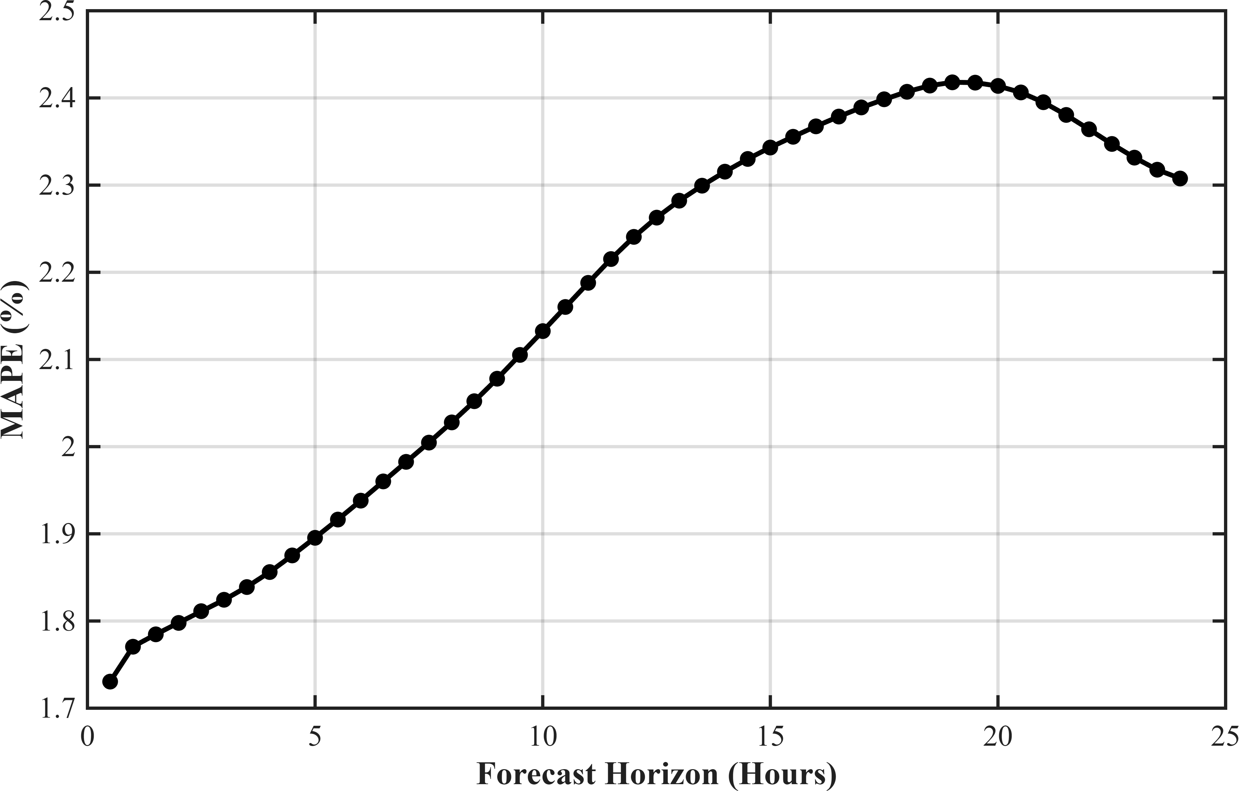
Fig. 1. MAPE versus forecasting horizon for the Intraday Cycle (IC) model.

In addition, the predicted load profile was compared with the actual observed demand to visually assess the tracking capability of the model.

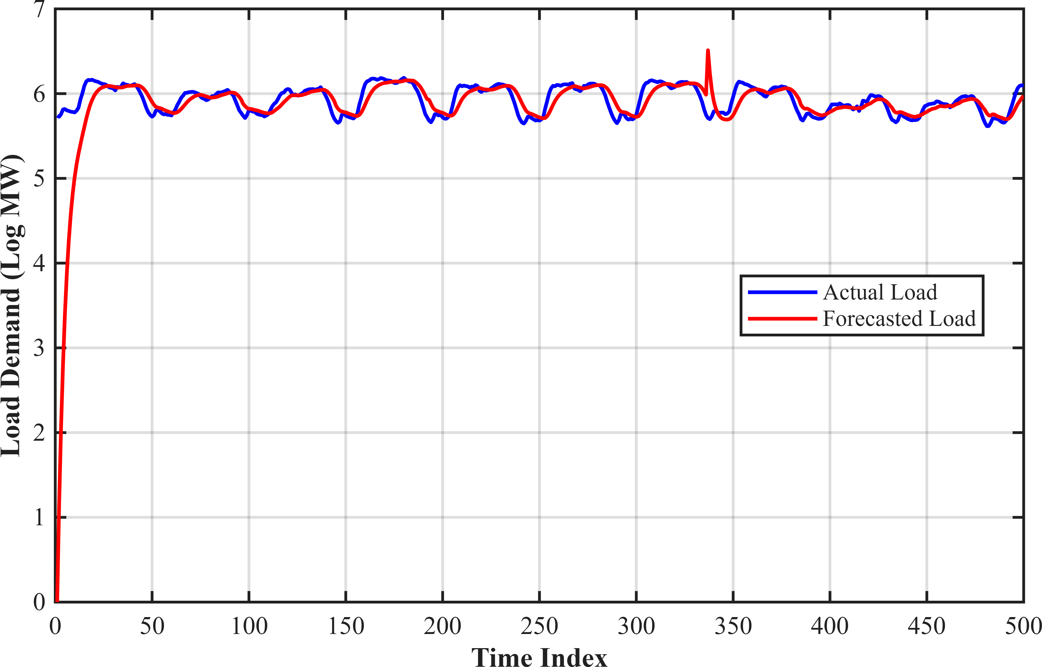
Fig. 2. Comparison of actual and forecasted load demand using the IC model.

- HWT Method
Holt-Winters-Taylor (HWT) is an exponentially weighted univariate forecasting method used for short-term electricity load forecasting. It is designed for load data having multiple seasonal patterns, mainly daily and weekly cycles. Since electricity demand changes with time of day, day of week, and recent usage trends, simple single-seasonal models are often insufficient. The HWT method extends exponential smooth-ing by simultaneously modeling level, daily seasonality, and weekly seasonality.
The forecasting equation used in this implementation is:
yˆt = lt−1 + dt−m1 + wt−m2 (5) where yˆ_{t} is the forecasted load, l_{t−1} is the level component,
d_{t−m}1 is the daily seasonal component, and w_{t−m}2 is the weekly seasonal component. For half-hourly data, the seasonal periods were taken as m₁ = 48 for one day and m₂ = 336 for one week.
The smoothing parameters used in the MATLAB code were α = 0.2, δ = 0.1, and ω = 0.05. Here, α updates the level component, δ updates daily seasonality, and ω updates weekly seasonality. A larger value allows faster adaptation, while a smaller value gives smoother and more stable updates.
The recursive updating equations are:

e_{t} = y_{t} − yˆ_{t} (6)

l_{t} = l_{t−1} + αe_{t} (7)

d_{t} = d_{t−m}1 + δe_{t} (8)
In this implementation, the complete load dataset was used to generate forecasts. Actual and predicted values were compared graphically, and Mean Absolute Percentage Error (MAPE) was evaluated for forecast horizons up to 48 half-hour steps ahead. This helped analyze how forecasting accuracy changes with increasing horizon.
Overall, the HWT method proved effective for short-term load forecasting by capturing both daily and weekly seasonal behavior while adapting to recent demand changes through exponential smoothing.
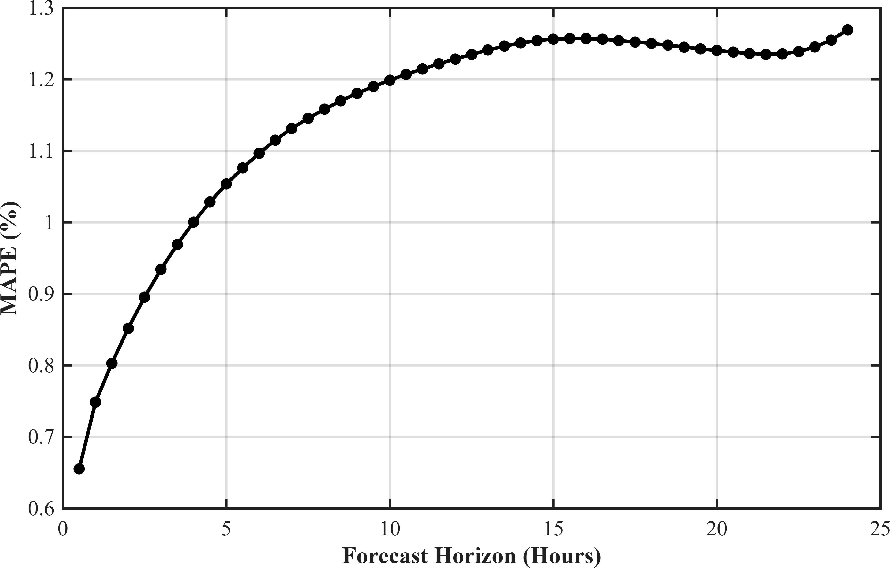
Fig. 3. MAPE versus forecasting horizon for the Holt-Winters-Taylor (HWT) model.
The predicted load demand was also compared with the actual observations to evaluate the tracking performance of the model over time.
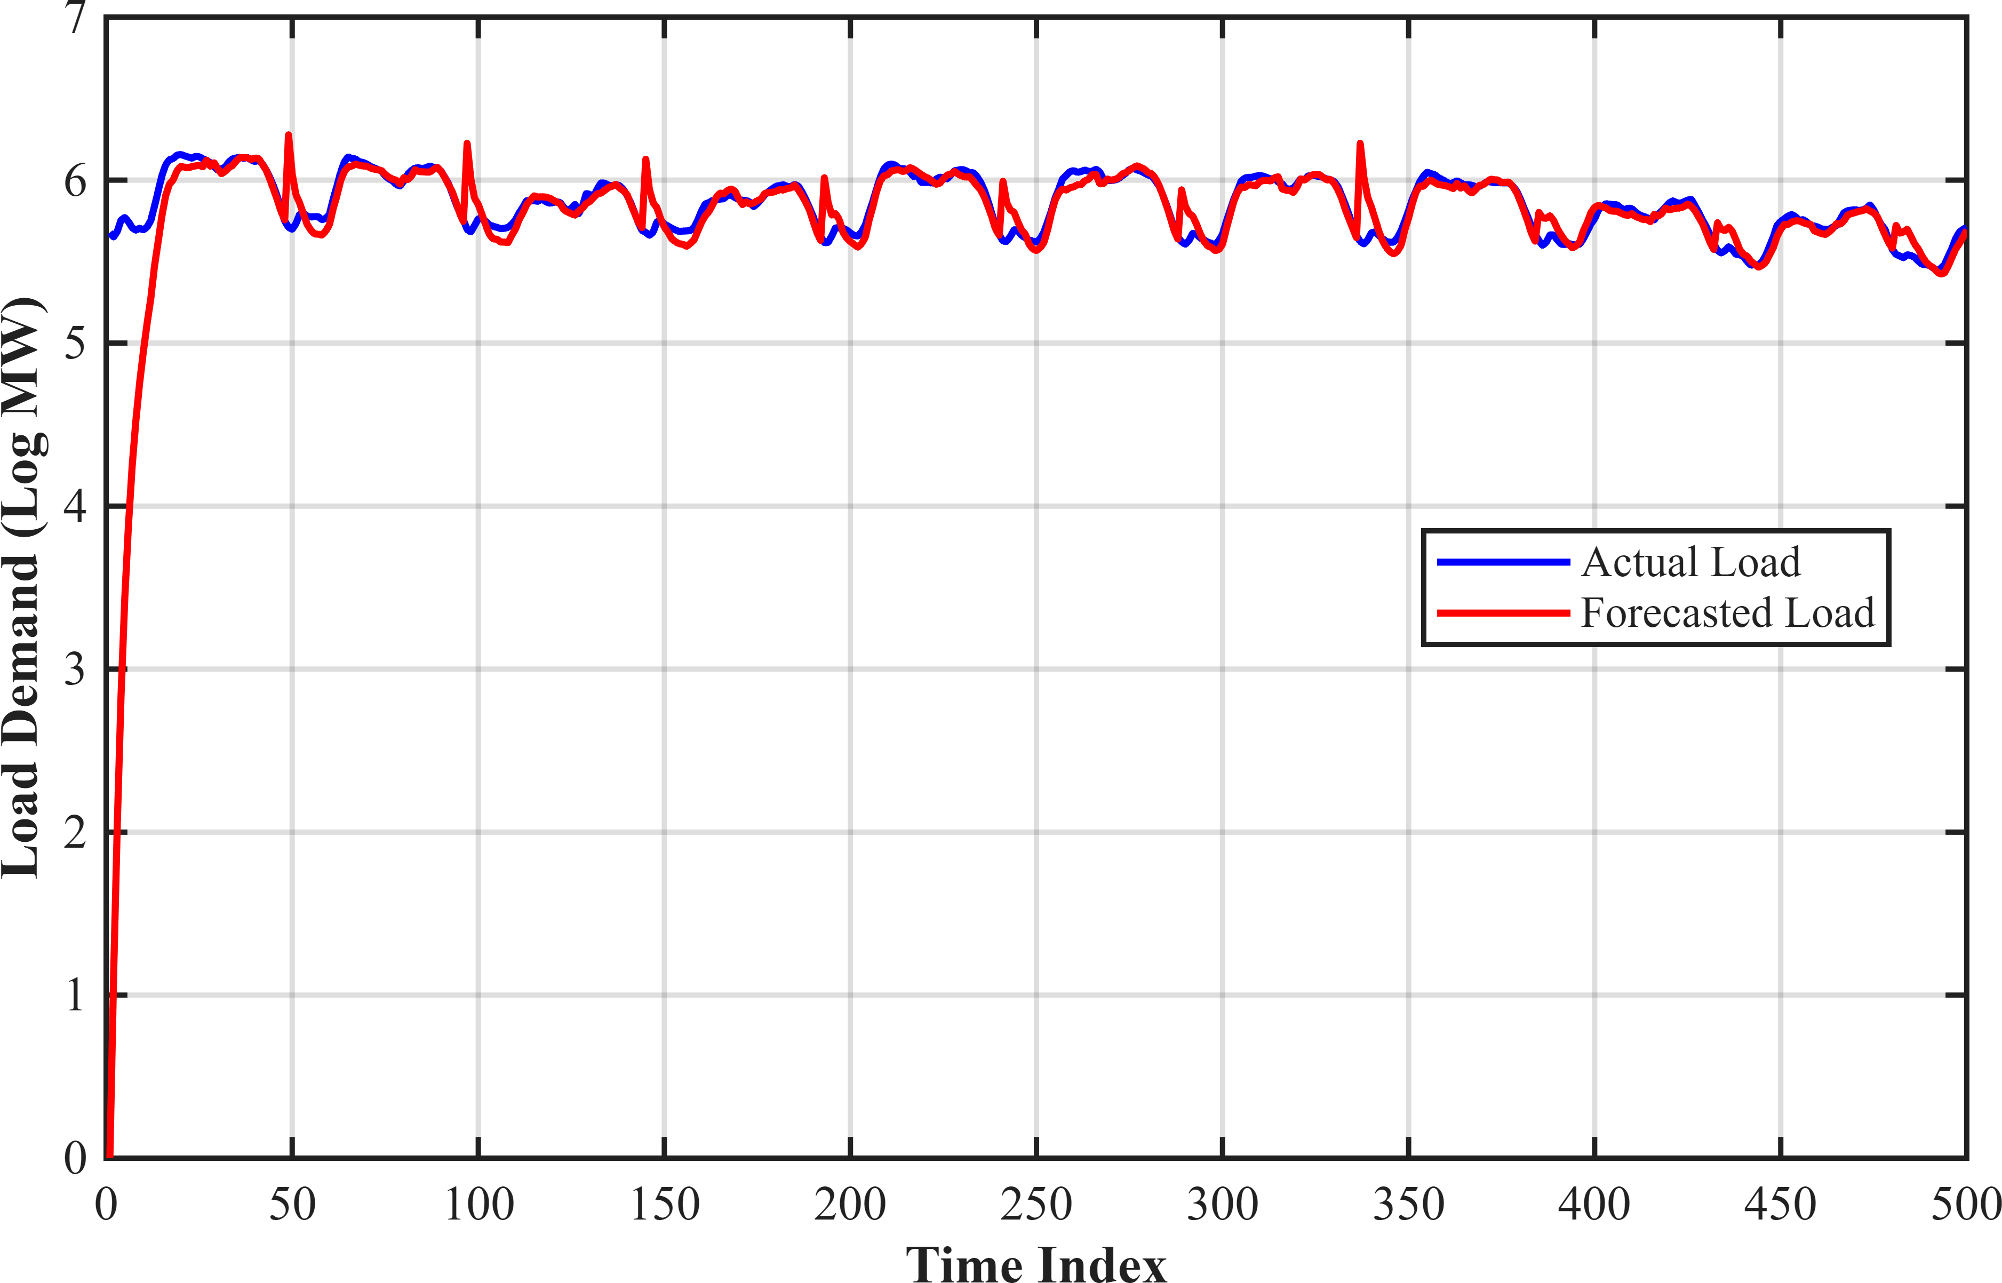
Fig. 4. Comparison of actual and forecasted load demand using the HWT model.

- DWR with Trigonometric Terms
Discount Weighted Regression (DWR) with Trigonometric

wt = wt−m2
+ ωe_{t} (9)
Terms is an adaptive forecasting method used for time series data having seasonal and cyclical patterns. In short-term load

where e_{t} is the forecast error at time t. These equations continuously adjust the model components using the latest observed error.
forecasting, electricity demand follows repeating daily and weekly cycles along with gradual changes in the overall de-mand level. A normal regression model with fixed coefficients

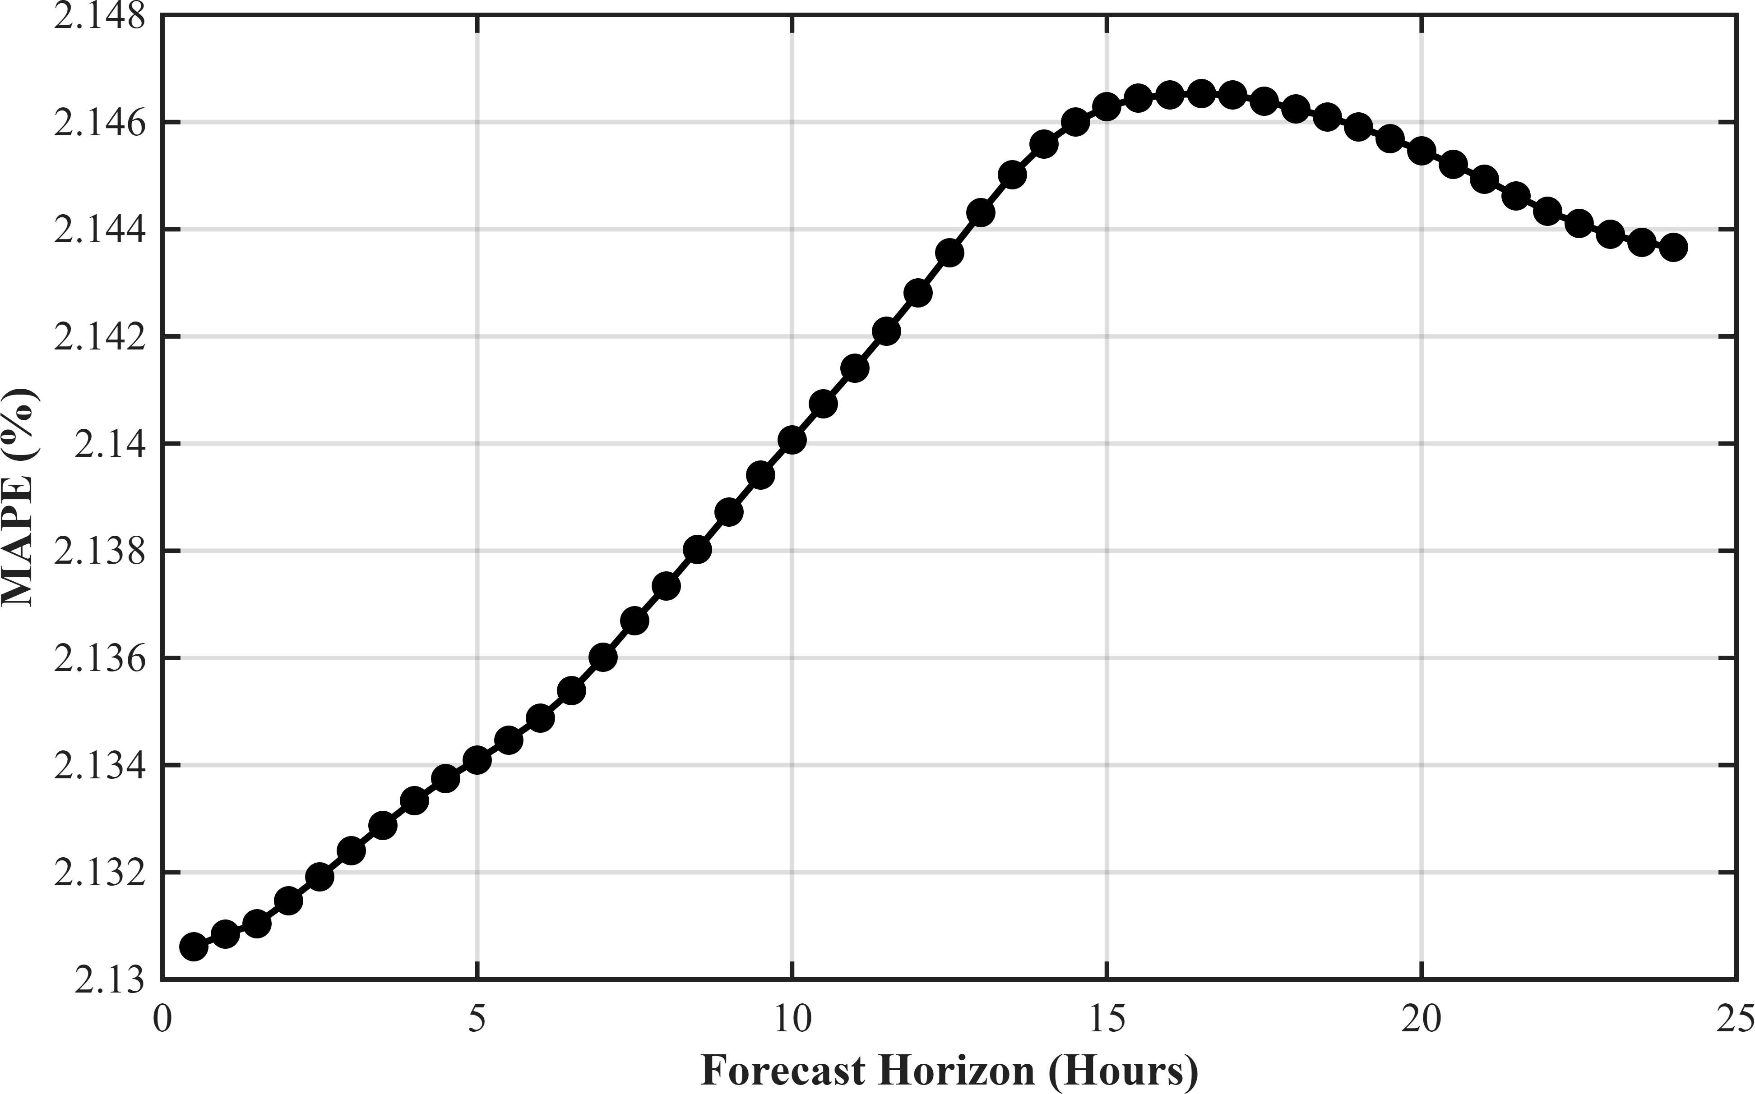
cannot capture these changing patterns effectively. Therefore, DWR is used because it allows model coefficients to vary with time while giving more importance to recent observations and less importance to older data.
The trigonometric regression model used in this implemen-tation is:

y_{t} = β_{0,t} +
K
kΣ=1

α_{k,t} cos
2πkt
S

+ β_{k,t} sin
2πkt
S

+ e_{t}
(10)

where y_{t} is the observed load at time t, β_{0,t} is the time-varying intercept representing the base load level, K is the number of harmonics, S is the seasonal period, α_{k,t} and β_{k,t} are coefficients of cosine and sine terms, and e_{t} is the random error term. These sine and cosine terms are used to model periodic electricity demand patterns.
According to the MATLAB code, two seasonal cycles were modeled. The daily seasonal period was taken as S₁ = 48 because the data is half-hourly and one day contains 48 ob-servations. The weekly seasonal period was taken as S₂ = 336 because one week contains 7 × 48 = 336 observations. The number of harmonics used were K₁ = 15 for the daily cycle and K₂ = 20 for the weekly cycle. Thus, 15 sine-cosine pairs modeled daily seasonality, while 20 sine-cosine pairs modeled weekly seasonality.
A major feature of DWR is the use of discount factors λ, which control how quickly parameters are updated. In this implementation, λ₀ = 0.994 was used for the intercept term, λ₁ = 0.999 for daily seasonal coefficients, and λ₂ = 0.999 for weekly seasonal coefficients. The smaller value of λ₀ allows the base load level to adapt faster, while the values close to 1 for seasonal terms ensure that daily and weekly patterns change gradually.
The model was trained using the training dataset through recursive coefficient updating. At each time step, the forecast error was calculated and the coefficients were adjusted ac-cordingly. After training, the final coefficients were used to forecast the testing dataset. Forecast accuracy was evaluated using Mean Absolute Percentage Error (MAPE), and the first 48 half-hour observations were also analyzed separately for one-day performance.
Overall, DWR with Trigonometric Terms proved to be an effective short-term load forecasting method. It successfully captured daily and weekly seasonality, adapted to recent demand changes, and produced accurate forecasts on unseen testing data.
- Dynamic Weighted Regression (DWR) Spline Model
The Dynamic Weighted Regression (DWR) Spline model uses spline basis functions to represent nonlinear and locally varying load demand behavior. Unlike sinusoidal functions, splines provide greater flexibility in tracking abrupt changes and irregular demand variations. Recursive parameter updating enables the model to continuously learn from incoming data and improve forecasting performance over time.

Fig. 5. MAPE versus forecasting horizon for the DWR Trigonometric model.
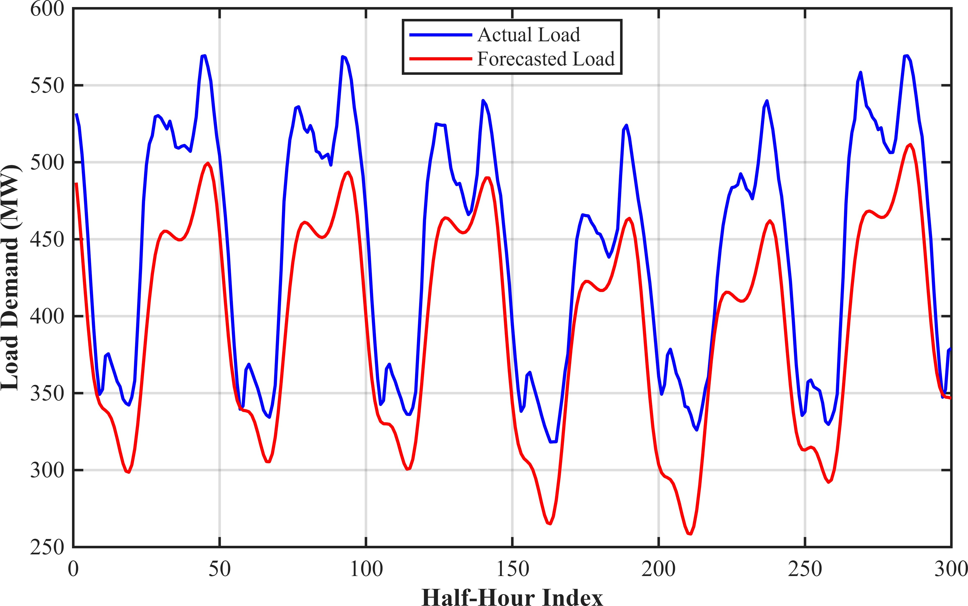
Fig. 6. Comparison of actual and forecasted load demand using the DWR Trigonometric model.

The forecasting capability of the DWR Spline model was analyzed for horizons up to 48 half-hour intervals ahead using Mean Absolute Percentage Error (MAPE).
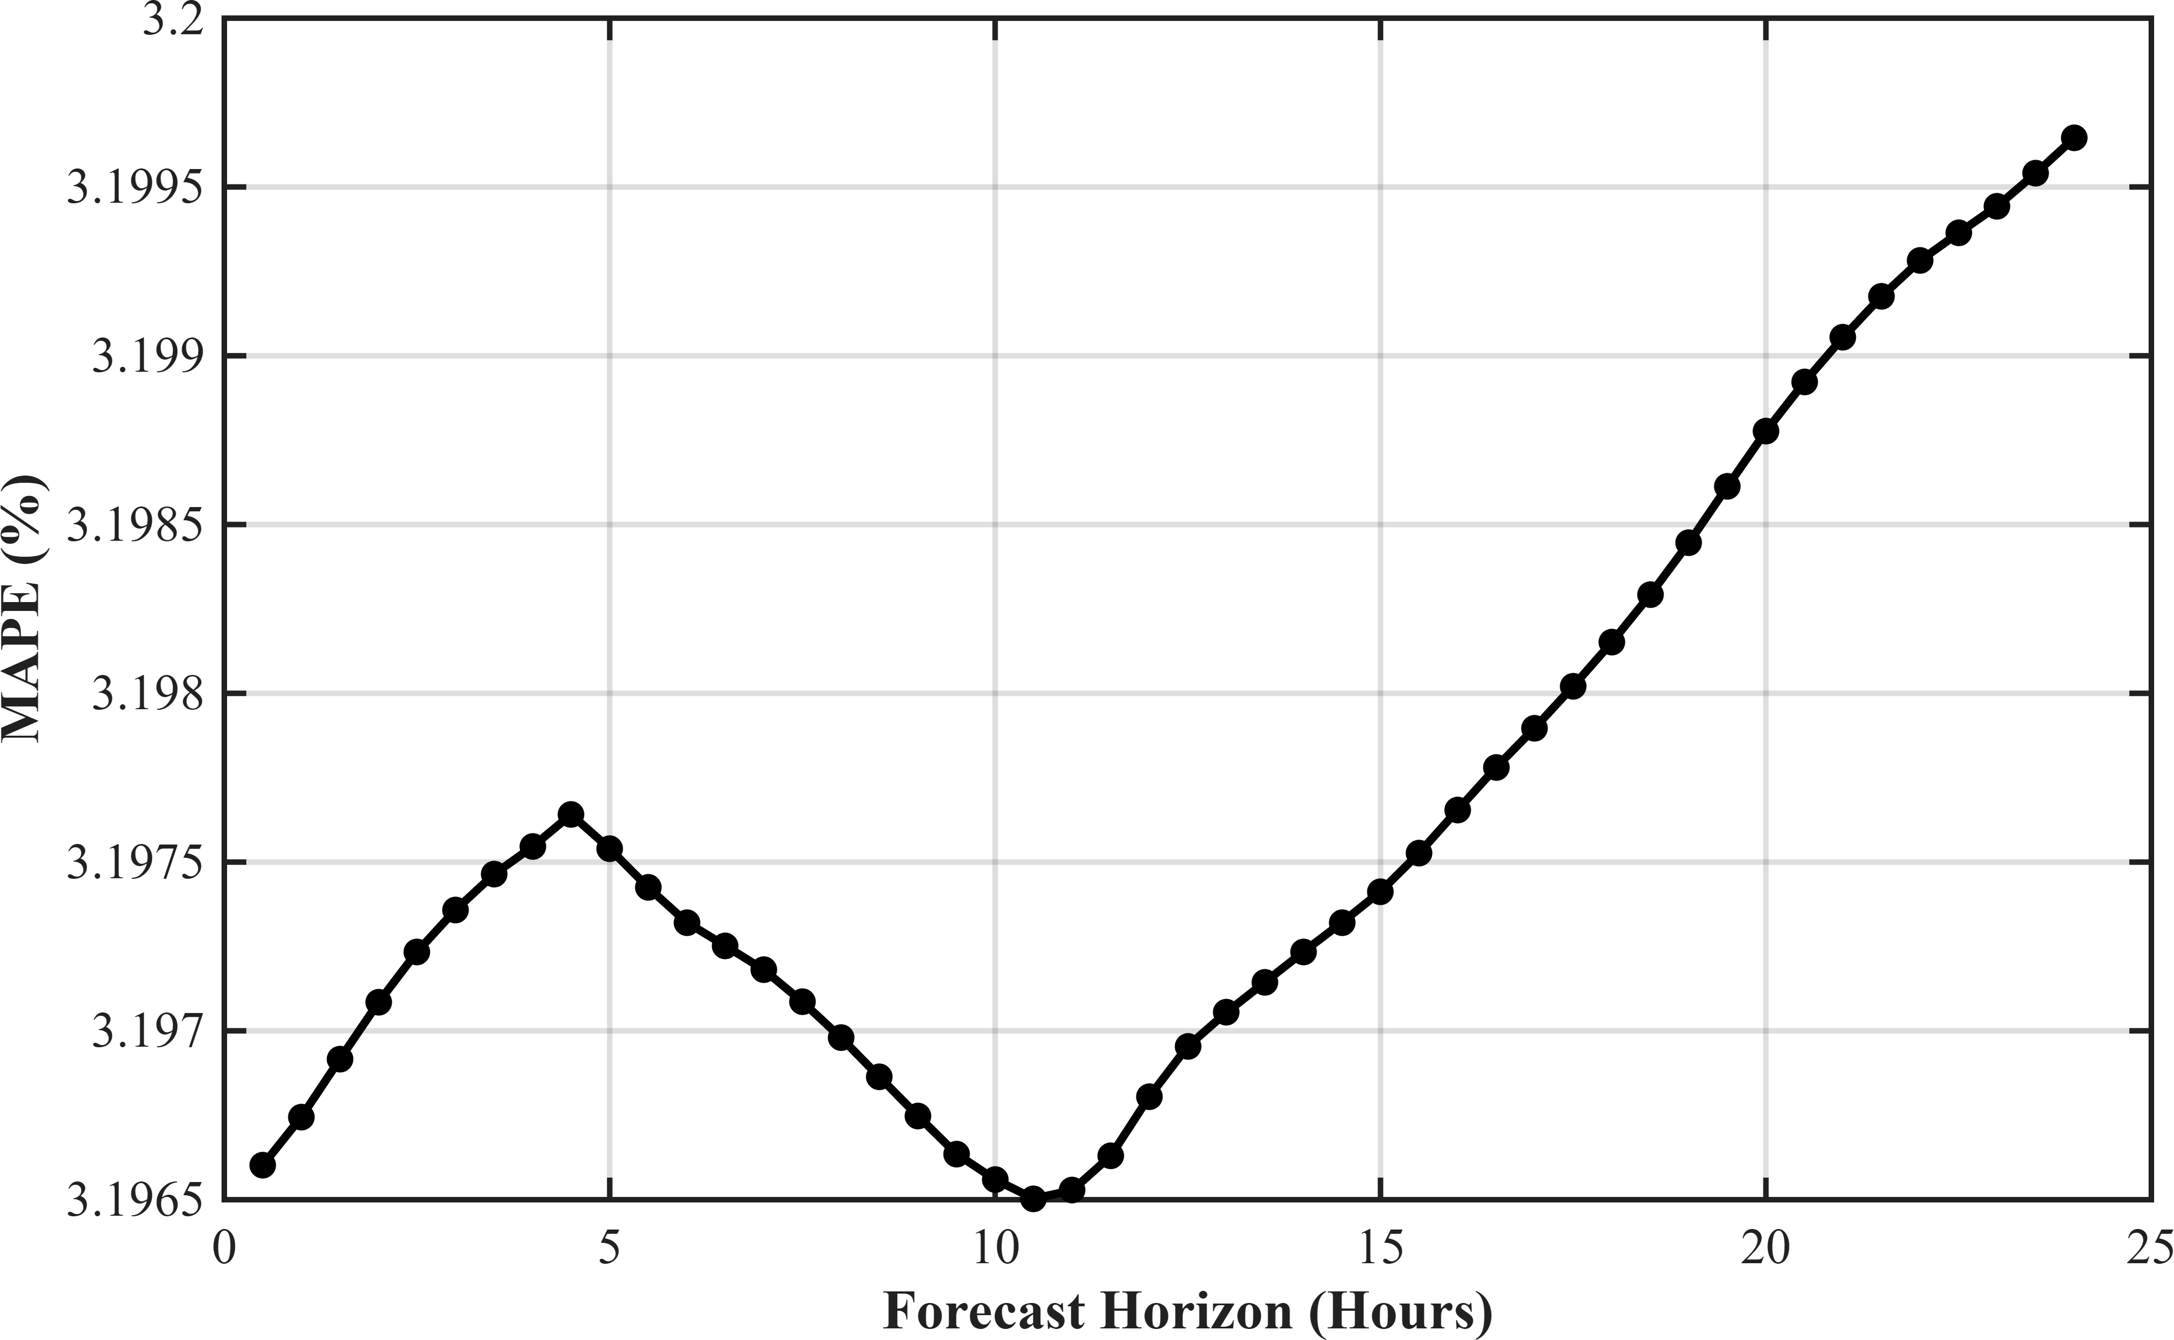

Fig. 7. MAPE versus forecasting horizon for the DWR Spline model.

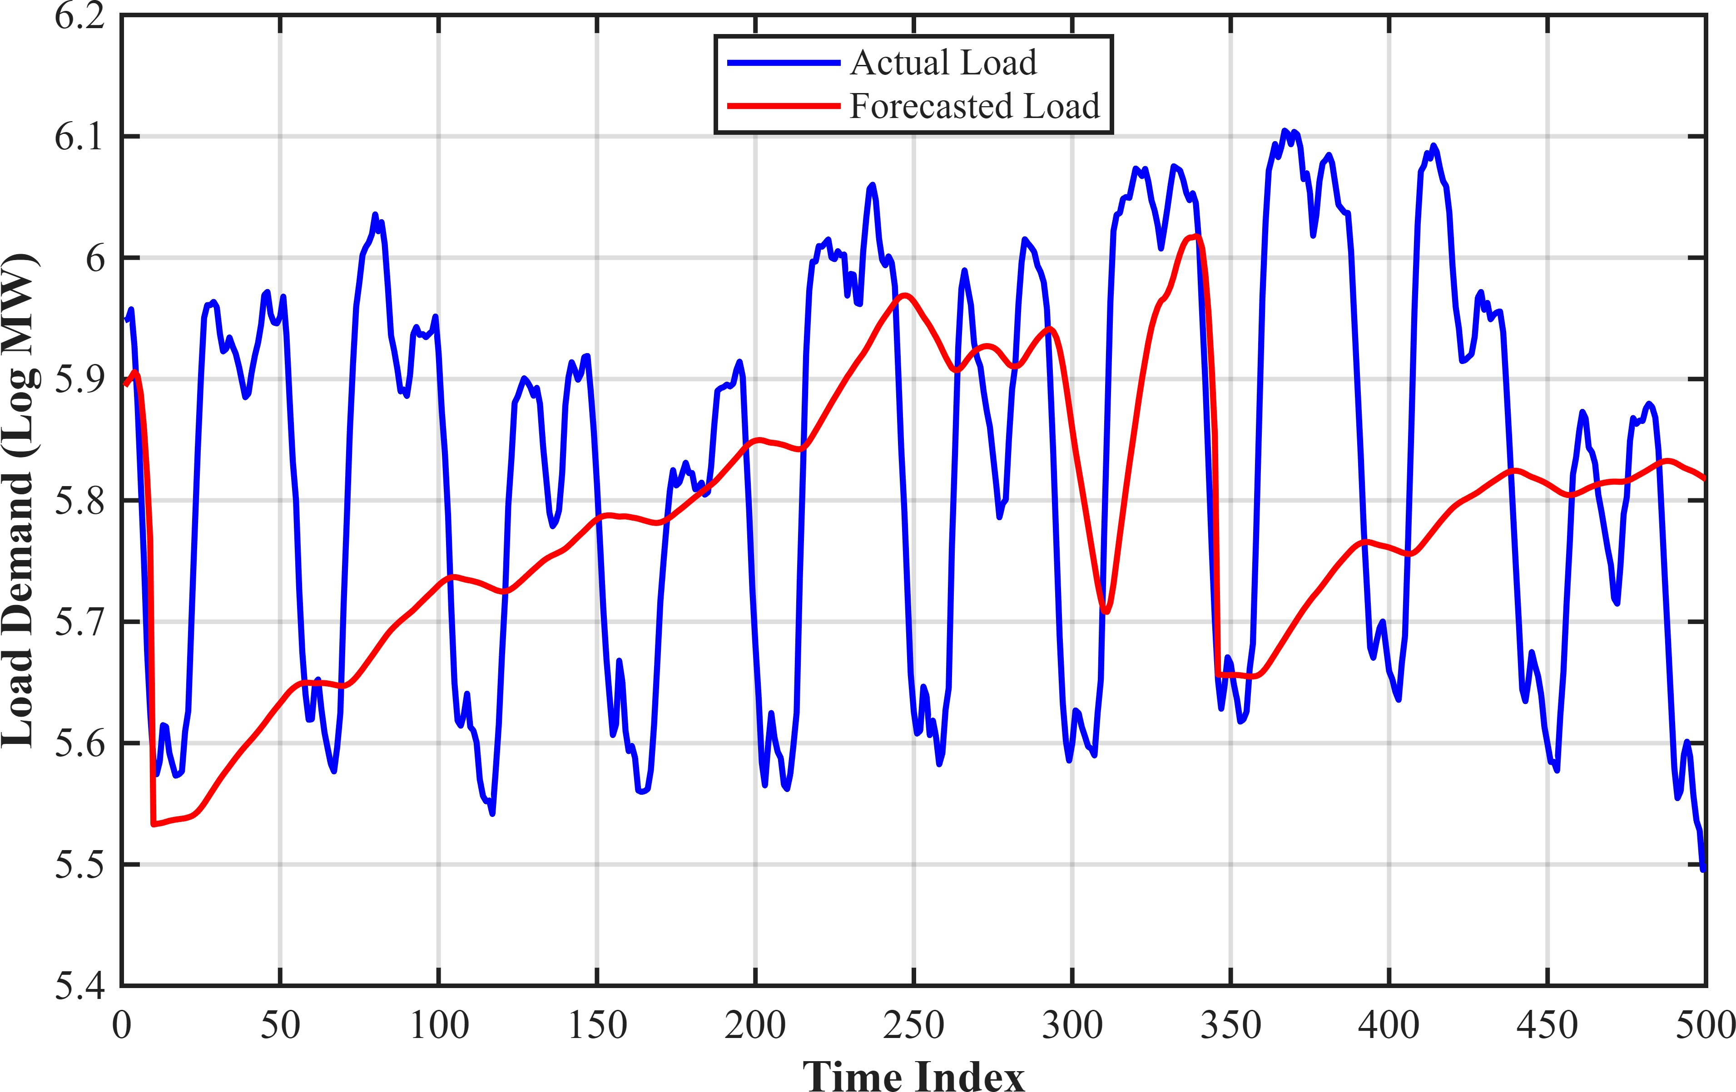
Fig. 8. Comparison of actual and forecasted load demand using the DWR Spline model.

- SVD-Based Exponential Smoothing Method
Singular Value Decomposition (SVD) is used to reduce the dimensionality of intraday load data by extracting dominant intraweek patterns. The historical load is arranged into a matrix Y, where each row represents a weekly load profile consisting of half-hour observations.
Applying SVD to this matrix yields:

Y = PV^{T} (11)
where V contains orthogonal intraweek feature vectors and P contains the corresponding interweek feature series. Dimensionality reduction is achieved by retaining only the first k dominant feature vectors associated with the largest singular values.
Forecasting is then performed on the reduced feature space using an exponential smoothing formulation. The model is defined by the following equations:

yt = pt−1v(t mod m2) + ϕet−1 + εt (12)

et = yt − pt−1v(t mod m2) (13)

7
Σ
pt = pt−1+α1et+δ v(t mod m2)+(j−1)m1 et+ωv(t mod m2)et
j=1
In this implementation, the number of retained features k is selected empirically to balance accuracy and complexity. Fore-casts are generated for horizons up to 48 half-hour intervals, and performance is evaluated using Mean Absolute Percentage Error (MAPE).
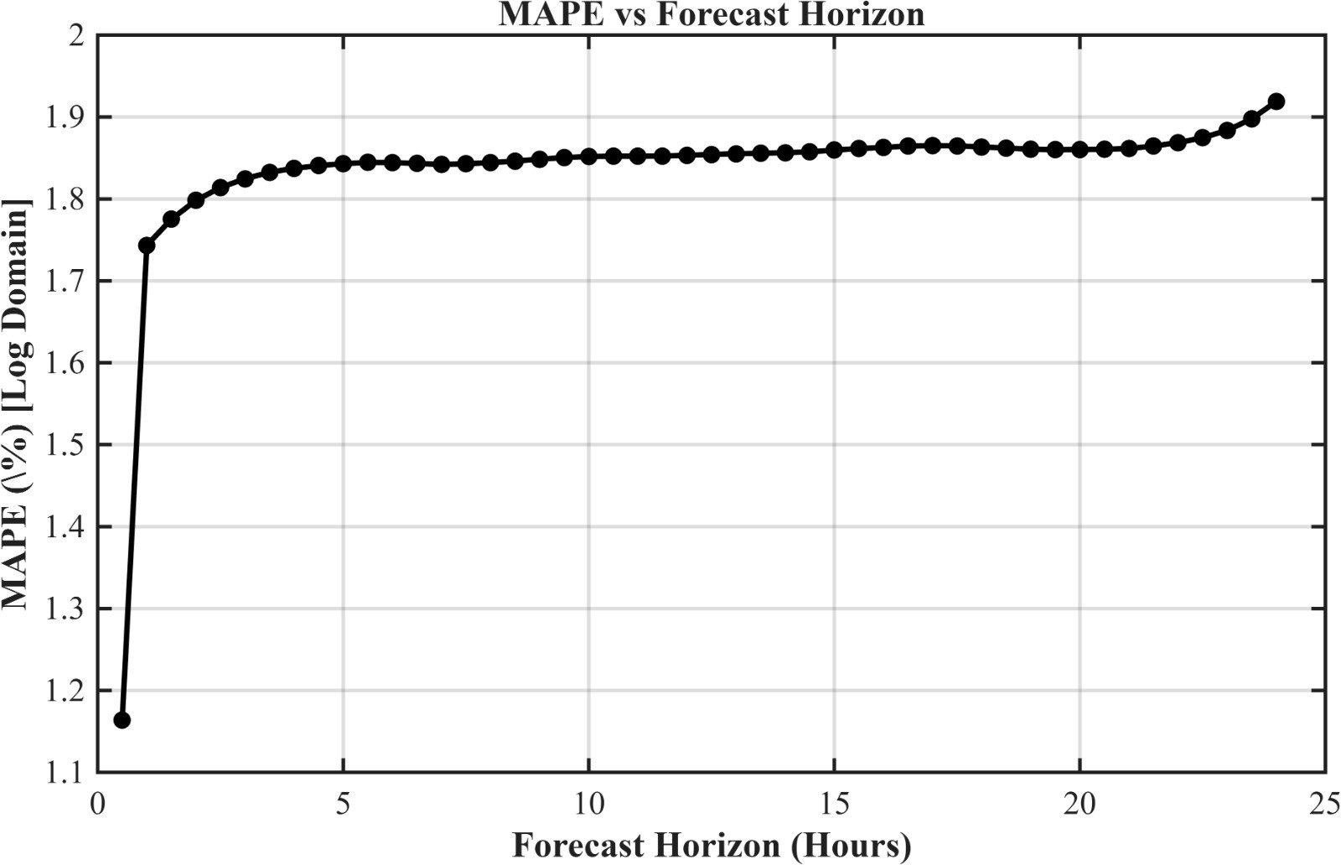
Fig. 9. MAPE versus forecasting horizon for the SVD-based exponential smoothing model.

Fig. 9 shows that the forecasting error increases gradually with horizon, reflecting the accumulation of uncertainty in multi-step prediction. The SVD-based model demonstrates strong performance for short-term horizons due to its ability to capture dominant temporal patterns efficiently.

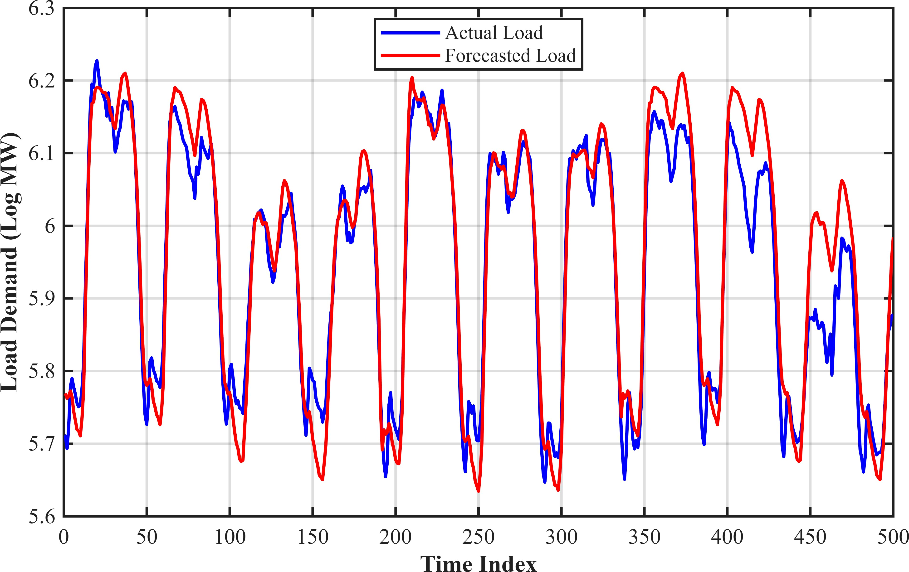

(14)
where y_{t} is the observed load (in log domain), p_{t} is the state vector representing the interweek feature series, and v denotes the intraweek feature vectors. The parameters α, δ, and ω are smoothing coefficients, while ϕ accounts for residual autocorrelation.
The first equation represents the forecast as a projection of the state vector onto the intraweek feature space. The second equation defines the forecast error, and the third equation updates the state vector using smoothing components that capture level, intraday, and intraweek effects.
Fig. 10. Comparison of actual and forecasted load demand using the SVD-based model.

Fig. 10 compares actual and predicted load values over a selected interval. The model closely follows the actual demand profile, capturing both periodic behavior and trend variations. Small deviations occur during abrupt load changes, which are difficult to represent using low-dimensional structures. Overall, the SVD-based exponential smoothing approach pro-vides an efficient and accurate framework for short-term load forecasting.

- Benchmark Methods: ARMA and ANN
To provide a broader comparative evaluation, two widely used benchmark forecasting approaches were also imple-mented: the AutoRegressive Moving Average (ARMA) model and the Artificial Neural Network (ANN) model. These meth-ods represent classical statistical forecasting and data-driven machine learning forecasting, respectively.
The ARMA model estimates future electrical demand using linear relationships between previous observations and past random disturbances. It is commonly used as a baseline time-series forecasting model due to its simplicity and effectiveness for short-horizon prediction. However, its capability to model nonlinear and multiple seasonal demand structures is limited. The ANN model uses interconnected neurons to learn nonlinear relationships directly from historical lagged load observations. Owing to its adaptive learning capability, ANN can capture complex temporal patterns that are difficult to
represent using conventional linear models.
Both benchmark methods were evaluated for forecasting horizons up to 48 half-hour intervals ahead using Mean Absolute Percentage Error (MAPE).

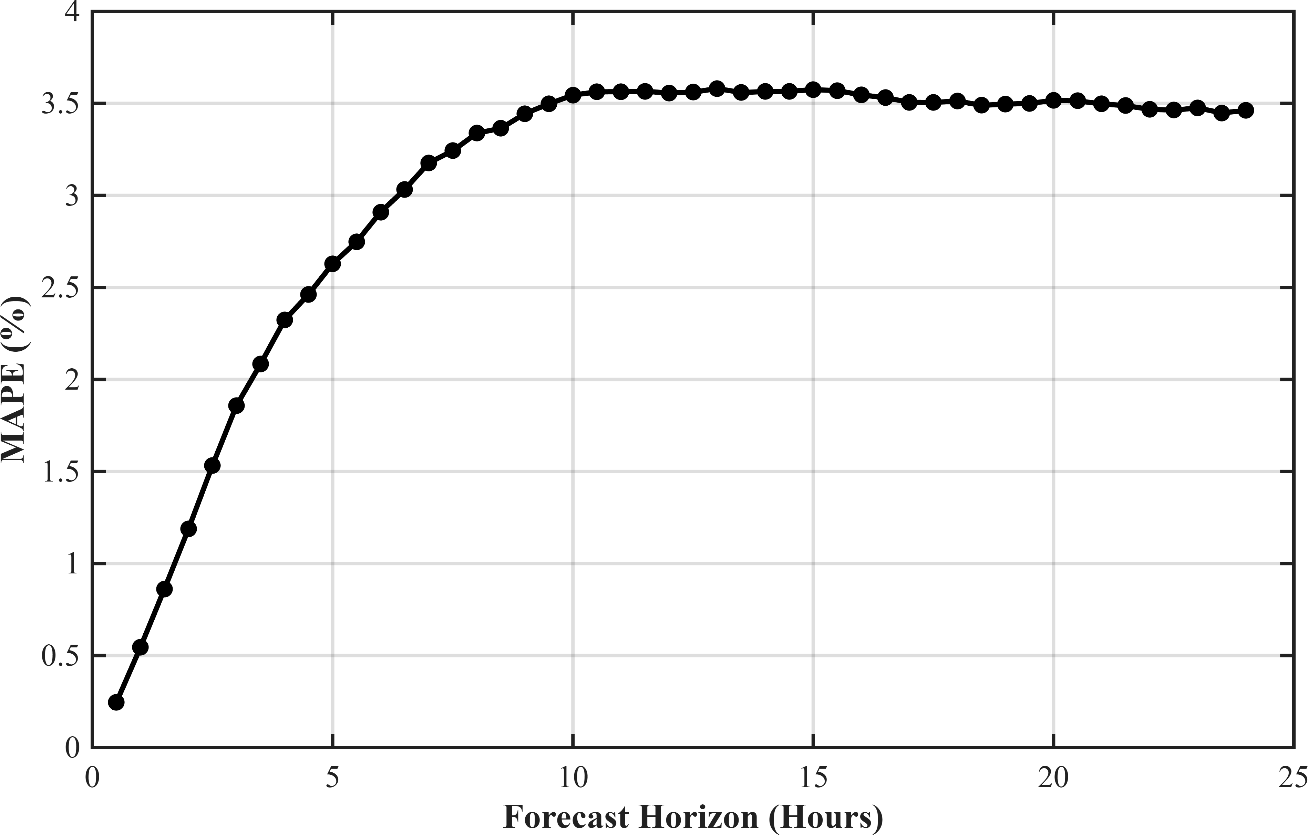
Fig. 11. MAPE versus forecasting horizon for the ARMA benchmark model.

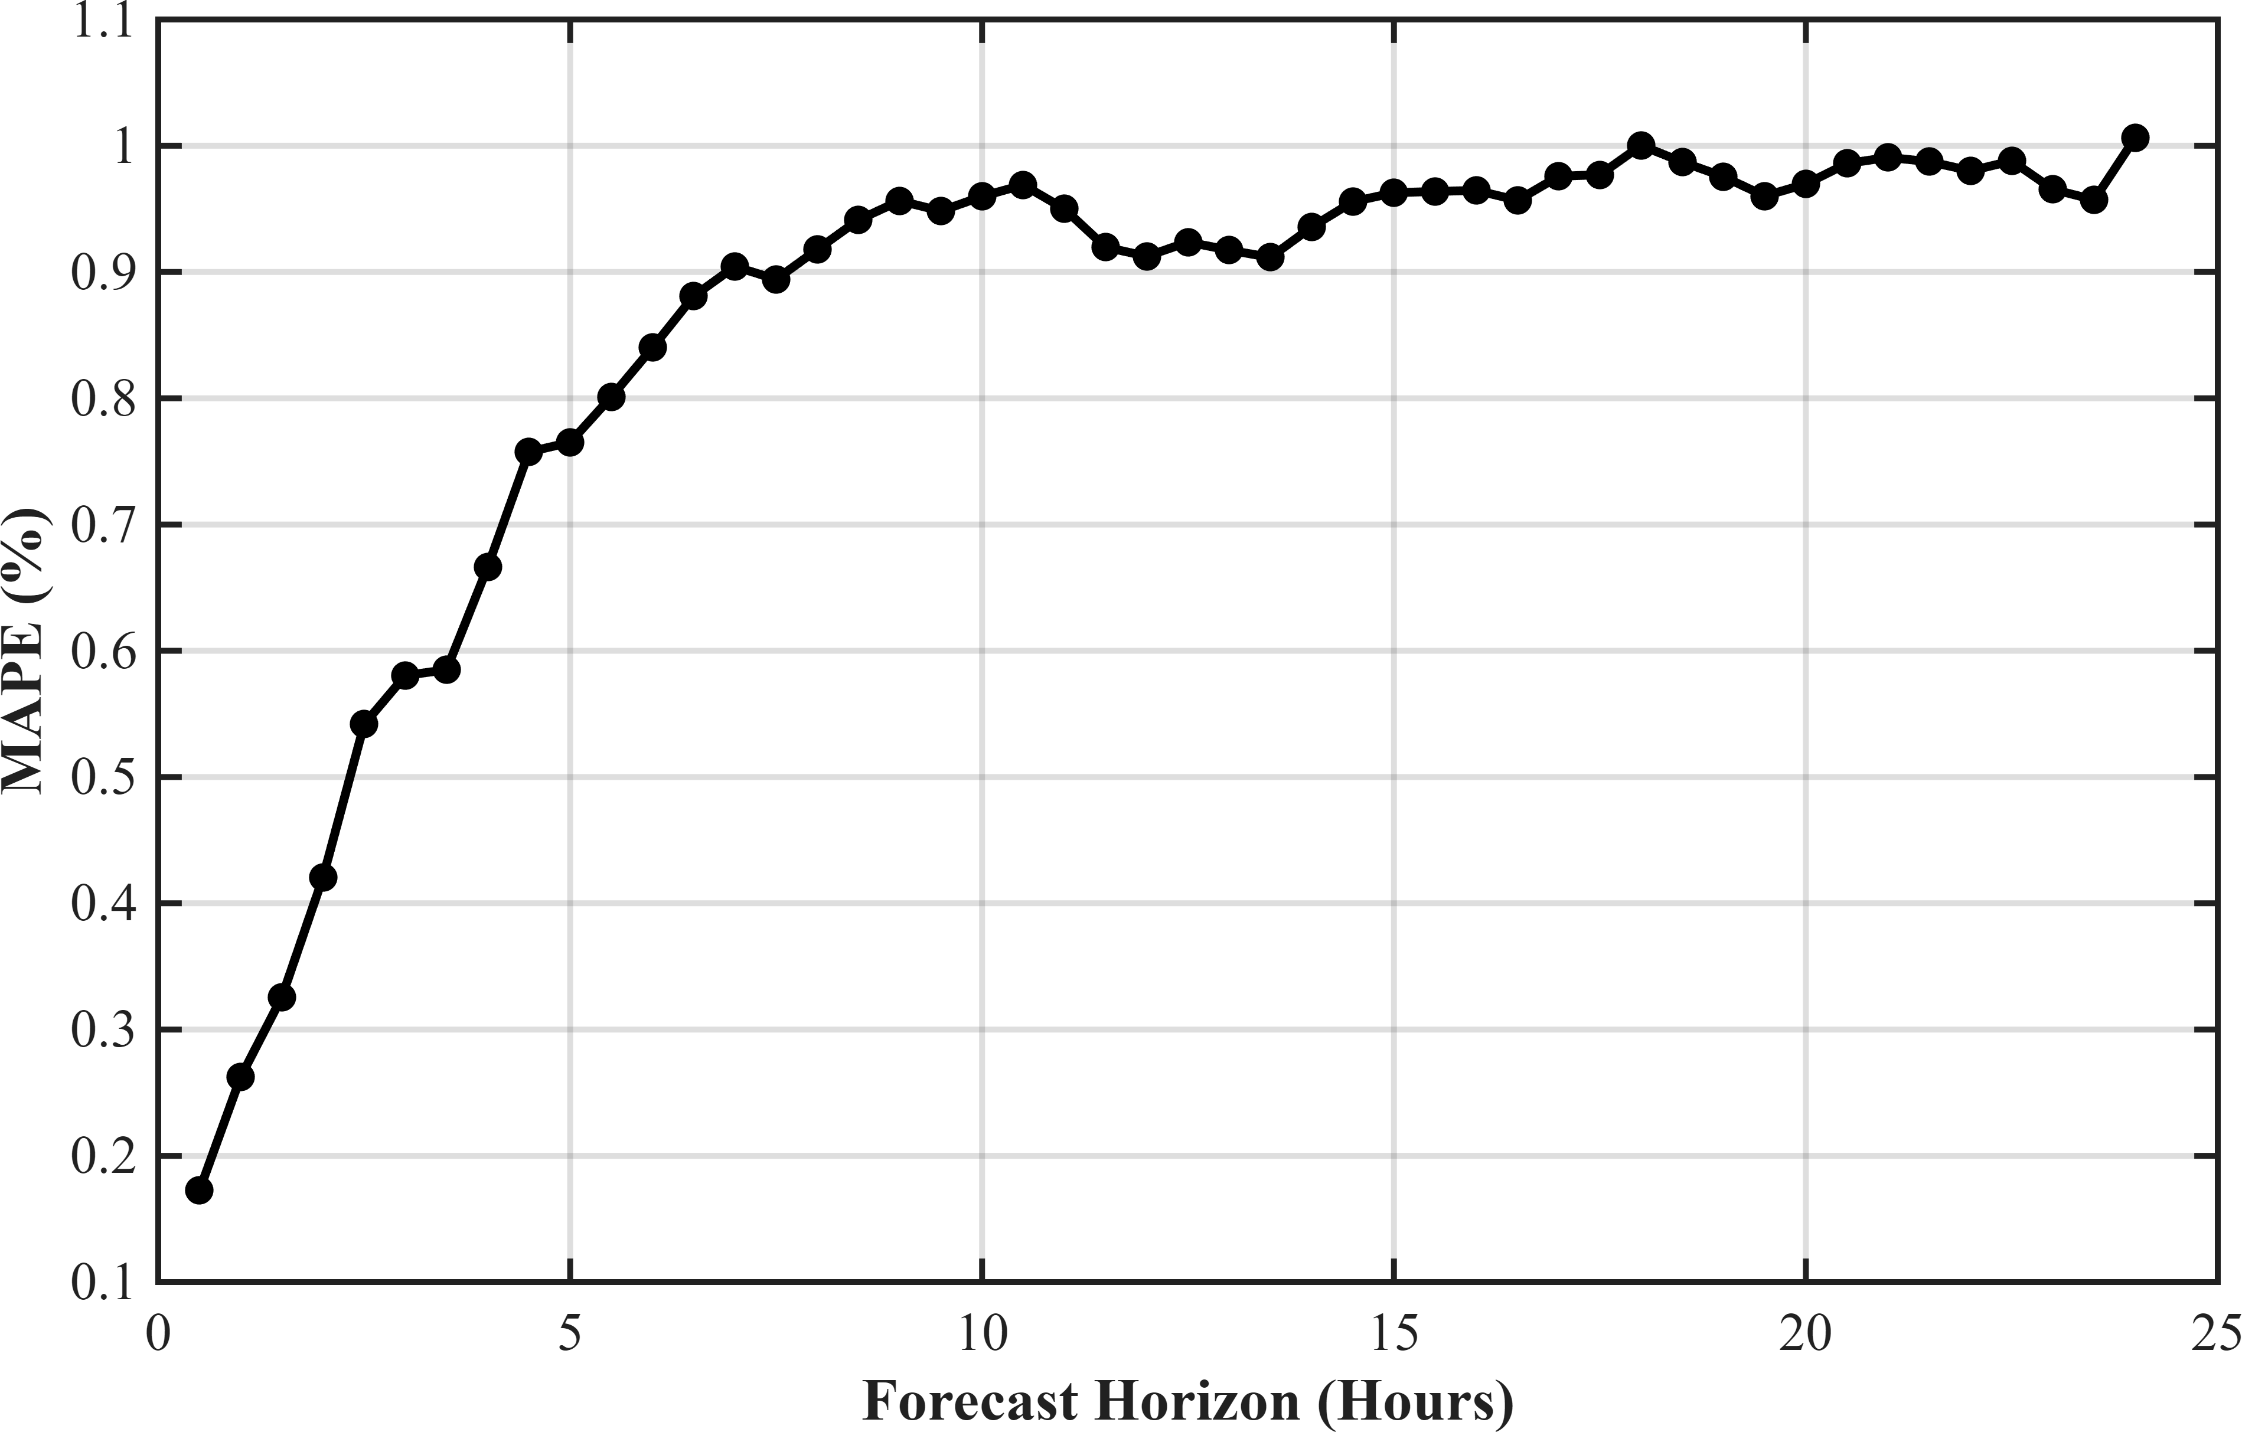
Fig. 12. MAPE versus forecasting horizon for the ANN benchmark model.
- Comparative Analysis
A comparative evaluation of all forecasting models was carried out using Mean Absolute Percentage Error (MAPE) over prediction horizons ranging from 1 to 48 half-hour intervals ahead. The objective of this analysis was to identify the most accurate and robust method for short-term electrical load forecasting under varying forecast lengths.
Among the classical exponential smoothing approaches, the Holt-Winters-Taylor (HWT) model demonstrated consistently strong forecasting performance due to its ability to simultane-ously model level, daily seasonality, and weekly seasonality. The Intraday Cycle (IC) model also produced competitive results, particularly for short forecast horizons where repetitive daily demand behavior dominates.
The Dynamic Weighted Regression (DWR) methods showed strong adaptive capability. Between the two variants, the spline-based implementation generally provided improved accuracy over the trigonometric version, as spline basis func-tions offer greater flexibility for capturing nonlinear and lo-calized variations in load demand.
The Singular Value Decomposition (SVD) model performed effectively by extracting dominant latent demand structures from the historical load matrix. Its forecasting performance remained stable across multiple horizons, demonstrating the usefulness of low-rank decomposition techniques for struc-tured load data.
Among the benchmark methods, the Artificial Neural Net-work (ANN) model achieved competitive forecasting accuracy due to its nonlinear learning capability and ability to capture complex temporal relationships. The AutoRegressive Moving Average (ARMA) model provided a useful statistical baseline, although its performance was relatively limited for longer horizons because of its linear structure and reduced ability to model multiple seasonal patterns.
Overall, models that explicitly captured both daily and weekly seasonality, while also adapting to changing load be-havior, produced the lowest forecasting errors. This highlights the importance of combining seasonal structure with adaptive learning mechanisms for accurate short-term load forecasting.
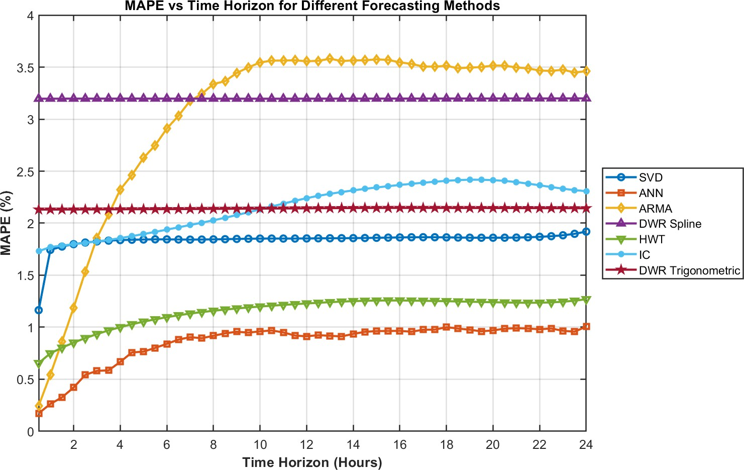

Fig. 13. Comparison of MAPE versus forecasting horizon for all implemented forecasting models.

- Weather-Based Forecasting Model
To further improve forecasting performance, a weather-based load forecasting model was also developed by com-bining historical electricity demand data with meteorological information. Electrical load demand is often influenced by environmental factors such as temperature, humidity, seasonal climate variation, and weather-dependent heating or cooling usage. Hence, incorporating weather variables can provide ad-ditional predictive information beyond historical load patterns alone.
The forecasting accuracy of the weather-based model was evaluated for the first 48 half-hour prediction horizons using Mean Absolute Percentage Error (MAPE). As illustrated in Fig. 14, the MAPE values remained low across all forecast horizons, varying approximately between 0.84% and 1.56%, which indicates strong and stable short-term forecasting capa-bility.
The same figure also presents the forecasted load profile for the first 500 test hours. It can be observed that the predicted demand closely follows the actual load series and successfully captures the major cyclical demand behavior, including peak and off-peak periods. Slight deviations occur during sudden abnormal drops in demand, which are comparatively difficult to forecast accurately.
Overall, the results confirm that weather-assisted forecasting provides competitive performance and can significantly im-prove short-term electrical load prediction when environmental conditions influence demand patterns.
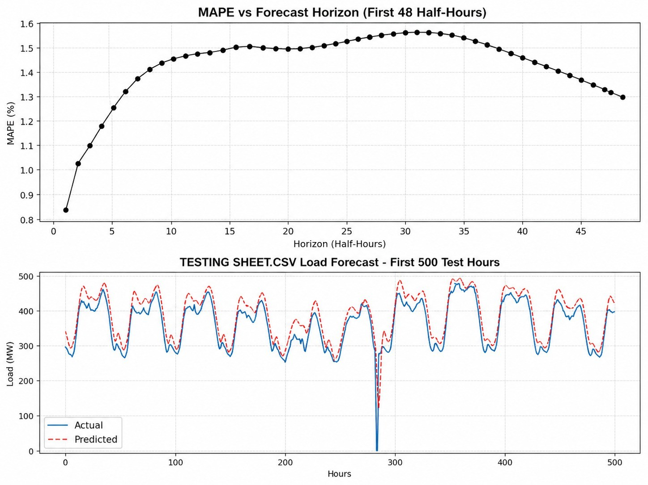

Fig. 14. Weather-based forecasting results showing MAPE versus forecasting horizon (top) and comparison of actual and predicted load demand for the first 500 test hours (bottom).

- Conclusion
This paper presented a comparative study of several short-term electrical load forecasting techniques using real half-hourly demand data from Berkswell, United Kingdom. The evaluated methods included Intraday Cycle (IC), Holt-Winters-Taylor (HWT), Singular Value Decomposition (SVD),
Dynamic Weighted Regression (DWR) with trigonometric and spline basis functions, AutoRegressive Moving Average (ARMA), and Artificial Neural Network (ANN) models.
The results demonstrated that forecasting accuracy strongly depends on the ability of a model to capture daily and weekly seasonality together with nonlinear demand variations. Among all evaluated approaches, the ANN model achieved the best overall forecasting performance, followed closely by the HWT model. The IC model provided satisfactory medium-range performance, while the DWR and SVD approaches showed competitive but comparatively moderate accuracy. The ARMA model yielded the highest forecasting errors, indicating the limitations of linear statistical models for complex load demand data.
The comparative analysis confirms that adaptive machine learning and multi-seasonal exponential smoothing techniques are highly effective for short-term load forecasting problems. Accurate demand forecasting can support improved generation scheduling, demand-side management, and efficient smart grid operation.
References
[1] J. W. Taylor and P. E. McSharry, “Short-Term Load Forecasting Methods: An Evaluation Based on European Data,” IEEE Transactions on Power Systems, vol. 22, no. 4, pp. 2213–2219, 2008.

