Implementation
app.py
from flask import Flask
from routes import main_bp
from database import init_db

app = Flask(__name__)
app.secret_key = 'oose_mini_project_secret'

app.register_blueprint(main_bp)

if __name__ == '__main__':
init_db()

app.run(debug=True, port=5000)

database.py
import sqlite3

def get_db_connection():
"""Establishes connection to SkillExchangeDB using sqlite3.Row [cite: 433, 434]"""
conn = sqlite3.connect('SkillExchangeDB.db')
conn.row_factory = sqlite3.Row
return conn

def init_db():
"""Initializes the relational database schema based on OOSE design [cite: 421]"""
conn = get_db_connection()

conn.execute('''
CREATE TABLE IF NOT EXISTS User (
userId INTEGER PRIMARY KEY AUTOINCREMENT,
name VARCHAR(100) NOT NULL,
email VARCHAR(100) UNIQUE NOT NULL,
passwordHash VARCHAR(255) NOT NULL,
bio TEXT,
createdAt TIMESTAMP DEFAULT CURRENT_TIMESTAMP
)
''')

conn.execute('''
CREATE TABLE IF NOT EXISTS Skill (
skillId INTEGER PRIMARY KEY AUTOINCREMENT,
skillName VARCHAR(100) NOT NULL,
category VARCHAR(100)
)
''')
conn.execute('''
CREATE TABLE IF NOT EXISTS UserOffer (
offerId INTEGER PRIMARY KEY AUTOINCREMENT,
userId INTEGER,
skillId INTEGER,
level VARCHAR(50),
available INTEGER DEFAULT 1,
FOREIGN KEY(userId) REFERENCES User(userId),
FOREIGN KEY(skillId) REFERENCES Skill(skillId)
)
''')

conn.execute('''
CREATE TABLE IF NOT EXISTS UserRequestPreference (
requestPrefId INTEGER PRIMARY KEY AUTOINCREMENT,
userId INTEGER,
skillId INTEGER,
levelNeeded VARCHAR(50),
FOREIGN KEY(userId) REFERENCES User(userId),
FOREIGN KEY(skillId) REFERENCES Skill(skillId)
)
''')
skills = [
('Python Programming', 'Programming'),
('Machine Learning', 'Data Science'),
('Web Development', 'Software Engineering'),
('UI/UX Design', 'Design'),
('Public Speaking', 'Communication'),
('Database Management', 'Systems')
]

existing = conn.execute('SELECT COUNT(*) FROM Skill').fetchone()[0]
if existing == 0:
conn.executemany('''
INSERT INTO Skill (skillName, category) VALUES (?, ?)
''', skills)

conn.execute('''
CREATE TABLE IF NOT EXISTS ExchangeRequest (
exchangeId INTEGER PRIMARY KEY AUTOINCREMENT,
senderId INTEGER NOT NULL,
receiverId INTEGER NOT NULL,
skillId INTEGER NOT NULL,
status TEXT DEFAULT 'Pending',
created_at TIMESTAMP DEFAULT CURRENT_TIMESTAMP,
FOREIGN KEY (senderId) REFERENCES User (userId),
FOREIGN KEY (receiverId) REFERENCES User (userId),
FOREIGN KEY (skillId) REFERENCES Skill (skillId)
)
''')

conn.commit()
conn.close()

models.py
from datetime import datetime

class User:
"""
Represents the central User entity.
This class serves as the base for both learners and mentors.
"""
def __init__(self, user_id, name, email, bio=None, password_hash=None):
self.user_id = user_id
self.name = name
self.email = email
self.password_hash = password_hash
self.bio = bio
self.created_at = datetime.now()

class Skill:
"""
Defines the available skills within the decentralized 'knowledge economy'.
"""
def __init__(self, skill_id, skill_name, category, description=None):
self.skill_id = skill_id
self.skill_name = skill_name
self.category = category
self.description = description

class UserOffer:
"""
Association entity representing skills a user is prepared to 'Teach'.
"""
def __init__(self, offer_id, user_id, skill_id, level, available=1):
self.offer_id = offer_id
self.user_id = user_id
self.skill_id = skill_id
self.level = level
self.available = available
class UserRequestPreference:
"""
Association entity representing skills a user wants to 'Learn'.
"""
def __init__(self, request_pref_id, user_id, skill_id, level_needed):
self.request_pref_id = request_pref_id
self.user_id = user_id
self.skill_id = skill_id
self.level_needed = level_needed

class ExchangeRequest:
"""
Tracks the lifecycle of a skill exchange as per the State Machine Diagram.
"""
def __init__(self, exchange_id, sender_id, receiver_id, skill_id, message=None, status='Pending'):
self.exchange_id = exchange_id
self.sender_id = sender_id
self.receiver_id = receiver_id
self.skill_id = skill_id
self.message = message
self.status = status # States: Pending, Accepted, Rejected, Cancelled, Completed
self.created_at = datetime.now()

class Session:
"""
Represents a scheduled learning interaction between a mentor and a learner.
"""
def __init__(self, session_id, exchange_id, scheduled_date, scheduled_time, mode, location_link=None):
self.session_id = session_id
self.exchange_id = exchange_id
self.scheduled_date = scheduled_date
self.scheduled_time = scheduled_time
self.mode = mode # e.g., Online, Offline
self.location_link = location_link
self.status = 'Scheduled'

routes.py
from flask import Blueprint, render_template, request, flash, redirect, url_for
from database import get_db_connection

main_bp = Blueprint('main', __name__)

@main_bp.route('/', methods=['GET', 'POST'])
def index():
if request.method == 'POST':
email = request.form.get('email')
password = request.form.get('password')

conn = get_db_connection()
user = conn.execute('SELECT * FROM User WHERE email = ? AND passwordHash = ?',
(email, password)).fetchone()
conn.close()

if user:

return redirect(url_for('main.dashboard', user_id=user['userId']))
else:
flash('Invalid email or password.')
return redirect(url_for('main.index'))

return render_template('index.html')

@main_bp.route('/dashboard/<int:user_id>')
def dashboard(user_id):
conn = get_db_connection()

user = conn.execute('SELECT * FROM User WHERE userId = ?', (user_id,)).fetchone()

learn_skills = conn.execute('''
SELECT skillId FROM UserRequestPreference WHERE userId = ?
''', (user_id,)).fetchall()

learn_ids = [s['skillId'] for s in learn_skills]
mentors = []

if learn_ids:
placeholders = ','.join(['?'] * len(learn_ids))
query = f'''
SELECT u.name, s.skillName, o.level, u.userId
FROM User u
JOIN UserOffer o ON u.userId = o.userId
JOIN Skill s ON o.skillId = s.skillId
WHERE o.skillId IN ({placeholders}) AND u.userId != ?
'''
mentors = conn.execute(query, (*learn_ids, user_id)).fetchall()

conn.close()
return render_template('dashboard.html', user=user, mentors=mentors)

@main_bp.route('/add_skill', methods=['POST'])
def add_skill():
"""Allows users to 'Push' new skill data into the database"""
user_id = request.form.get('user_id')
skill_id = request.form.get('skill_id')
level = request.form.get('level')

conn = get_db_connection()
conn.execute('''
INSERT INTO UserOffer (userId, skillId, level)
VALUES (?, ?, ?)
''', (user_id, skill_id, level))

conn.commit()
conn.close()
flash('Skill offered successfully!')
return redirect(url_for('main.dashboard', user_id=user_id))

@main_bp.route('/register', methods=['GET', 'POST'])
def register():
if request.method == 'POST':
name = request.form.get('name')
email = request.form.get('email')
password = request.form.get('password')
bio = request.form.get('bio')

conn = get_db_connection()
try:
conn.execute('''
INSERT INTO User (name, email, passwordHash, bio)
VALUES (?, ?, ?, ?)
''', (name, email, password, bio))
conn.commit()
flash('Registration successful! Please login.')
return redirect(url_for('main.index'))
except sqlite3.IntegrityError:
flash('Email already exists. Please use a different one.')
finally:
conn.close()

return render_template('register.html')
from flask import session

@main_bp.route('/logout')
def logout():
"""Handles the Sign Out use case"""
session.clear()
flash('You have been logged out.')
return redirect(url_for('main.index'))

@main_bp.route('/profile/<int:user_id>')
def profile(user_id):
conn = get_db_connection()
user = conn.execute('SELECT * FROM User WHERE userId = ?', (user_id,)).fetchone()

all_skills = conn.execute('SELECT * FROM Skill').fetchall()

user_offers = conn.execute('''
SELECT o.*, s.skillName FROM UserOffer o
JOIN Skill s ON o.skillId = s.skillId WHERE o.userId = ?
''', (user_id,)).fetchall()

learning_list = conn.execute('''
SELECT p.*, s.skillName FROM UserRequestPreference p
JOIN Skill s ON p.skillId = s.skillId WHERE p.userId = ?
''', (user_id,)).fetchall()

conn.close()

return render_template('profile.html',
user=user,
all_skills=all_skills,
user_offers=user_offers,
learning_list=learning_list)
@main_bp.route('/add_preference', methods=['POST'])
def add_preference():
user_id = request.form.get('user_id')
skill_id = request.form.get('skill_id')

conn = get_db_connection()
conn.execute('''
INSERT INTO UserRequestPreference (userId, skillId)
VALUES (?, ?)
''', (user_id, skill_id))

conn.commit()
conn.close()
return redirect(url_for('main.profile', user_id=user_id))
@main_bp.route('/update_profile', methods=['POST'])
def update_profile():
"""Handles the modification of user metadata such as bio."""
user_id = request.form.get('user_id')
new_name = request.form.get('name')
new_bio = request.form.get('bio')

conn = get_db_connection()

conn.execute('''
UPDATE User
SET name = ?, bio = ?
WHERE userId = ?
''', (new_name, new_bio, user_id))

conn.commit()
conn.close()

flash('Profile updated successfully!')
return redirect(url_for('main.profile', user_id=user_id))
@main_bp.route('/send_request/<int:mentor_id>/<string:skill_name>')
def send_request(mentor_id, skill_name):
"""
Implements the 'Send Exchange Request' use case.
Transitions the request to 'Pending' status.
"""
# Assuming the current logged-in user is '1'
learner_id = 1

conn = get_db_connection()

# 1. Verify the skill exists to maintain data integrity
skill = conn.execute('SELECT skillId FROM Skill WHERE skillName = ?', (skill_name,)).fetchone()

if skill:
# 2. INSERT the request into the ExchangeRequest table
conn.execute('''
INSERT INTO ExchangeRequest (senderId, receiverId, skillId, status)
VALUES (?, ?, ?, 'Pending')
''', (learner_id, mentor_id, skill['skillId']))

conn.commit()
flash(f'Request for {skill_name} sent to the mentor!')
else:
flash('Error: Skill not found.')

conn.close()
return redirect(url_for('main.dashboard', user_id=learner_id))
@main_bp.route('/sessions/<int:user_id>')
def view_sessions(user_id):
conn = get_db_connection()

# We join u1 (Mentor) and u2 (Learner) to get their specific details
sessions = conn.execute('''
SELECT r.exchangeId,
u1.name as mentorName,
u1.email as mentorEmail,
u2.name as learnerName,
u2.email as learnerEmail,
s.skillName,
r.status
FROM ExchangeRequest r
JOIN User u1 ON r.receiverId = u1.userId
JOIN User u2 ON r.senderId = u2.userId
JOIN Skill s ON r.skillId = s.skillId
WHERE (r.senderId = ? OR r.receiverId = ?) AND r.status = 'Accepted'
''', (user_id, user_id)).fetchall()

user = conn.execute('SELECT * FROM User WHERE userId = ?', (user_id,)).fetchone()
conn.close()
return render_template('sessions.html', user=user, sessions=sessions)
@main_bp.route('/manage_requests/<int:user_id>')
def manage_requests(user_id):
"""
Displays both Sent and Received requests.
Fulfills the 'Monitor Request Status' use case.
"""
conn = get_db_connection()
user = conn.execute('SELECT * FROM User WHERE userId = ?', (user_id,)).fetchone()

# 1. Received Requests (Mentor)
received = conn.execute('''
SELECT r.exchangeId, u.name as senderName, s.skillName, r.status
FROM ExchangeRequest r
JOIN User u ON r.senderId = u.userId
JOIN Skill s ON r.skillId = s.skillId
WHERE r.receiverId = ? AND r.status = 'Pending'
''', (user_id,)).fetchall()

# 2. Sent Requests (Learner)
sent = conn.execute('''
SELECT r.exchangeId, u.name as mentorName, s.skillName, r.status
FROM ExchangeRequest r
JOIN User u ON r.receiverId = u.userId
JOIN Skill s ON r.skillId = s.skillId
WHERE r.senderId = ?
''', (user_id,)).fetchall()

conn.close()
return render_template('manage_requests.html',
user=user,
received=received,
sent=sent)
@main_bp.route('/handle_request/<int:request_id>/<string:action>')
def handle_request(request_id, action):
"""Transitions the request state based on Mentor action"""
new_status = 'Accepted' if action == 'accept' else 'Rejected'

conn = get_db_connection()
conn.execute('UPDATE ExchangeRequest SET status = ? WHERE exchangeId = ?',
(new_status, request_id))

row = conn.execute('SELECT receiverId FROM ExchangeRequest WHERE exchangeId = ?',
(request_id,)).fetchone()
user_id = row['receiverId']

conn.commit()
conn.close()
flash(f'Request has been {new_status}.')
return redirect(url_for('main.manage_requests', user_id=user_id))
@main_bp.route('/contact_partner/<int:session_user_id>')
def contact_partner(session_user_id):
"""
Fetches contact details for a matched partner.
Fulfills the 'Initiate Communication' use case.
"""
conn = get_db_connection()
# Fetch the partner's email and bio
partner = conn.execute('SELECT name, email, bio FROM User WHERE userId = ?',
(session_user_id,)).fetchone()
conn.close()

if partner:
return {
"name": partner['name'],
"email": partner['email'],
"bio": partner['bio']
}
return {"error": "User not found"}, 404
@main_bp.route('/complete_session/<int:exchange_id>')
def complete_session(exchange_id):
"""
Transitions the session state to 'Completed'.
Fulfills the 'Finalize Exchange' use case.
"""
conn = get_db_connection()

# Update the status to Completed
conn.execute('''
UPDATE ExchangeRequest
SET status = 'Completed'
WHERE exchangeId = ?
''', (exchange_id,))

# Fetch user_id for redirection
row = conn.execute('SELECT senderId FROM ExchangeRequest WHERE exchangeId = ?', (exchange_id,)).fetchone()
user_id = row['senderId']

conn.commit()
conn.close()

flash('Congratulations! You have completed this skill exchange.')
return redirect(url_for('main.view_sessions', user_id=user_id))
Dashboard.html
{% extends "layout.html" %}

{% block content %}
<div class="row">
<div class="col-lg-8">
<div class="card border-0 shadow-sm mb-4 bg-white p-4">
<h2 class="fw-bold">Hello, {{ user.name }}!</h2>
<p class="text-muted">The matching engine has analyzed your learning preferences and found potential mentors.</p>
<div class="d-flex gap-2">
<span class="badge bg-success-subtle text-success px-3 py-2">System Status: Stable</span>
<span class="badge bg-primary-subtle text-primary px-3 py-2">Matches Found: {{ mentors|length }}</span>
</div>
</div>

<h4 class="mb-3 fw-bold">Recommended Partners</h4>
<div class="row">
{% if mentors %}
{% for mentor in mentors %}
<div class="col-md-6 mb-4">
<div class="card h-100 border-0 shadow-sm card-hover">
<div class="card-body">
<div class="d-flex justify-content-between align-items-start mb-3">
<div class="bg-light rounded p-2 text-primary">
<i class="bi bi-person-workspace fs-3"></i>
</div>
<span class="badge bg-success">Mutual Match</span>
</div>
<h5 class="card-title fw-bold mb-1">{{ mentor.name }}</h5>
<p class="text-primary small fw-bold mb-3">Expertise: {{ mentor.skillName }}</p>
<p class="card-text small text-muted">Available to teach at an <strong>{{ mentor.level }}</strong> level.</p>

<a href="{{ url_for('main.send_request', mentor_id=mentor.userId, skill_name=mentor.skillName) }}"
class="btn btn-primary w-100 btn-sm">
<i class="bi bi-send me-2"></i>Send Exchange Request
</a>
</div>
</div>
</div>
{% endfor %}
{% else %}
<div class="col-12">
<div class="card text-center border-0 shadow-sm p-5 bg-white">
<i class="bi bi-search fs-1 text-muted"></i>
<h5 class="mt-3">No matches found yet</h5>
<p class="text-muted">Try adding more skills to your "Learn" list to trigger the matching engine.</p>
<a href="{{ url_for('main.profile', user_id=user.userId) }}" class="btn btn-outline-primary btn-sm mx-auto">Update Learning Preferences</a>
</div>
</div>
{% endif %}
</div>
</div>

<div class="col-lg-4">
<div class="card border-0 shadow-sm mb-4">
<div class="card-header bg-white fw-bold py-3">Quick Navigation</div>
<div class="list-group list-group-flush">
<a href="{{ url_for('main.profile', user_id=user.userId) }}" class="list-group-item list-group-item-action py-3 sidebar-link">
<i class="bi bi-pencil-square me-2 text-primary"></i>Manage My Skills & Bio
</a>
<a href="{{ url_for('main.manage_requests', user_id=user.userId) }}" class="list-group-item list-group-item-action py-3 sidebar-link">
<i class="bi bi-envelope-paper me-2 text-warning"></i>Track Sent/Received Requests
</a>
<a href="{{ url_for('main.view_sessions', user_id=user.userId) }}" class="list-group-item list-group-item-action py-3 sidebar-link">
<i class="bi bi-calendar-check me-2 text-success"></i>Confirmed Sessions
</a>
<a href="{{ url_for('main.logout') }}" class="list-group-item list-group-item-action py-3 sidebar-link text-danger">
<i class="bi bi-box-arrow-right me-2"></i>Logout
</a>
</div>
</div>

<div class="card border-0 shadow-sm bg-primary text-white p-4">
<h5>Skill Tip</h5>
<p class="small mb-0">Users with a detailed bio and at least 3 teaching skills get matched 2x faster!</p>
</div>
</div>
</div>
{% endblock %}

Index.html
<!DOCTYPE html>
<html lang="en">
<head>
<meta charset="UTF-8">
<title>SkillSwap | Login</title>
<link href="https://cdn.jsdelivr.net/npm/bootstrap@5.3.0/dist/css/bootstrap.min.css" rel="stylesheet">
</head>
<body class="bg-primary text-white">
<div class="container vh-100 d-flex align-items-center justify-content-center">
<div class="card text-dark p-4 shadow-lg" style="width: 400px;">
<div class="text-center mb-4">
<h3>Skill Exchange System</h3>
<p class="text-muted">A Decentralized Knowledge Economy</p>
</div>

{% with messages = get_flashed_messages() %}
{% if messages %}
{% for message in messages %}
<div class="alert alert-info py-2">{{ message }}</div>
{% endfor %}
{% endif %}
{% endwith %}

<form action="{{ url_for('main.index') }}" method="POST">
<div class="mb-3">
<label class="form-label">Email Address</label>
<input type="email" name="email" class="form-control" placeholder="name@example.com" required>
</div>
<div class="mb-3">
<label class="form-label">Password</label>
<input type="password" name="password" class="form-control" required>
</div>
<button type="submit" class="btn btn-primary w-100">Login</button>
</form>

<div class="mt-3 text-center">
<small>Don't have an account? <a href="{{ url_for('main.register') }}" class="text-decoration-none">Register here</a></small>
</div>
</div>
</div>
</body>
</html>

Layout.html
<!DOCTYPE html>
<html lang="en">
<head>
<meta charset="UTF-8">
<meta name="viewport" content="width=device-width, initial-scale=1.0">
<title>SkillSwap | Knowledge Economy</title>
<link href="https://cdn.jsdelivr.net/npm/bootstrap@5.3.0/dist/css/bootstrap.min.css" rel="stylesheet">
<link rel="stylesheet" href="https://cdn.jsdelivr.net/npm/bootstrap-icons@1.11.1/font/bootstrap-icons.css">
<style>
:root { --primary-blue: #0d6efd; }
.sidebar-link { transition: 0.3s; border-radius: 8px; }
.sidebar-link:hover { background-color: #f8f9fa; transform: translateX(5px); }
</style>
</head>
<body class="bg-light">

<nav class="navbar navbar-expand-lg navbar-dark bg-dark sticky-top shadow-sm">
<div class="container">
<a class="navbar-brand fw-bold" href="{{ url_for('main.dashboard', user_id=user.userId) }}">
<i class="bi bi-arrow-left-right me-2 text-primary"></i>SkillSwap
</a>

<button class="navbar-toggler" type="button" data-bs-toggle="collapse" data-bs-target="#navbarNav">
<span class="navbar-toggler-icon"></span>
</button>

<div class="collapse navbar-collapse" id="navbarNav">
<ul class="navbar-nav me-auto">
<li class="nav-item">
<a class="nav-link" href="{{ url_for('main.dashboard', user_id=user.userId) }}">Dashboard</a>
</li>
<li class="nav-item">
<a class="nav-link" href="{{ url_for('main.manage_requests', user_id=user.userId) }}">Requests</a>
</li>
<li class="nav-item">
<a class="nav-link" href="{{ url_for('main.view_sessions', user_id=user.userId) }}">Sessions</a>
</li>
</ul>

<div class="dropdown">
<a href="#" class="d-flex align-items-center text-white text-decoration-none dropdown-toggle" data-bs-toggle="dropdown">
<div class="bg-primary rounded-circle d-flex align-items-center justify-content-center me-2" style="width: 32px; height: 32px;">
<i class="bi bi-person-fill"></i>
</div>
<span class="d-none d-md-inline">{{ user.name }}</span>
</a>
<ul class="dropdown-menu dropdown-menu-end dropdown-menu-dark shadow">
<li><a class="dropdown-item" href="{{ url_for('main.profile', user_id=user.userId) }}">My Profile</a></li>
<li><hr class="dropdown-divider"></li>
<li><a class="dropdown-item text-danger" href="{{ url_for('main.logout') }}">Sign Out</a></li>
</ul>
</div>
</div>
</div>
</nav>

<main class="py-4">
<div class="container">
{% with messages = get_flashed_messages() %}
{% if messages %}
{% for message in messages %}
<div class="alert alert-primary alert-dismissible fade show shadow-sm" role="alert">
<i class="bi bi-info-circle me-2"></i>{{ message }}
<button type="button" class="btn-close" data-bs-dismiss="alert"></button>
</div>
{% endfor %}
{% endif %}
{% endwith %}

{% block content %}{% endblock %}
</div>
</main>

<script src="https://cdn.jsdelivr.net/npm/bootstrap@5.3.0/dist/js/bootstrap.bundle.min.js"></script>
</body>
</html>

Managerequests.html
{% extends "layout.html" %}

{% block content %}
<div class="row mb-4">
<div class="col-md-12">
<h2 class="fw-bold"><i class="bi bi-arrow-left-right me-2"></i>Manage Requests</h2>
<p class="text-muted">Track the status of your knowledge exchange proposals.</p>
</div>
</div>

<ul class="nav nav-pills mb-4" id="requestTabs" role="tablist">
<li class="nav-item">
<button class="nav-link active" id="received-tab" data-bs-toggle="pill" data-bs-target="#received" type="button">
Received <span class="badge bg-light text-dark ms-1">{{ received|length }}</span>
</button>
</li>
<li class="nav-item">
<button class="nav-link" id="sent-tab" data-bs-toggle="pill" data-bs-target="#sent" type="button">
Sent <span class="badge bg-light text-dark ms-1">{{ sent|length }}</span>
</button>
</li>
</ul>

<div class="tab-content" id="requestTabsContent">
<div class="tab-pane fade show active" id="received">
{% if received %}
{% for req in received %}
<div class="card mb-2 border-0 shadow-sm">
<div class="card-body d-flex justify-content-between align-items-center">
<div>
<span class="fw-bold">{{ req.senderName }}</span> wants to learn <strong>{{ req.skillName }}</strong>
</div>
<div class="btn-group">
<a href="{{ url_for('main.handle_request', request_id=req.exchangeId, action='accept') }}"
class="btn btn-success btn-sm">Accept</a>
<a href="{{ url_for('main.handle_request', request_id=req.exchangeId, action='reject') }}" class="btn btn-danger btn-sm">Reject</a>
</div>
</div>
</div>
{% endfor %}
{% else %}
<div class="alert alert-light text-center">No incoming requests.</div>
{% endif %}
</div>

<div class="tab-pane fade" id="sent">
{% if sent %}
<div class="table-responsive bg-white rounded shadow-sm p-3">
<table class="table align-middle">
<thead>
<tr>
<th>Mentor</th>
<th>Skill</th>
<th>Status</th>
</tr>
</thead>
<tbody>
{% for req in sent %}
<tr>
<td>{{ req.mentorName }}</td>
<td>{{ req.skillName }}</td>
<td>
{% if req.status == 'Pending' %}
<span class="badge bg-warning text-dark">Pending</span>
{% elif req.status == 'Accepted' %}
<span class="badge bg-success">Accepted</span>
{% else %}
<span class="badge bg-danger">Rejected</span>
{% endif %}
</td>
</tr>
{% endfor %}
</tbody>
</table>
</div>
{% else %}
<div class="alert alert-light text-center">You haven't sent any requests yet.</div>
{% endif %}
</div>
</div>
{% endblock %}

Profile.html
{% extends "layout.html" %}

{% block content %}
<div class="row">
<div class="col-md-4 mb-4">
<div class="card border-0 shadow-sm p-4">
<form action="{{ url_for('main.update_profile') }}" method="POST">
<input type="hidden" name="user_id" value="{{ user.userId }}">

<div class="text-center mb-3">
<div class="bg-primary rounded-circle mx-auto d-flex align-items-center justify-content-center" style="width: 80px; height: 80px;">
<i class="bi bi-person-fill text-white fs-1"></i>
</div>
</div>

<div class="mb-3">
<label class="form-label small fw-bold">Full Name</label>
<input type="text" name="name" class="form-control form-control-sm" value="{{ user.name }}" required>
</div>

<div class="mb-3">
<label class="form-label small fw-bold">Bio</label>
<textarea name="bio" class="form-control form-control-sm" rows="4">{{ user.bio }}</textarea>
</div>

<button type="submit" class="btn btn-primary btn-sm w-100">
<i class="bi bi-check2-circle me-1"></i> Save Changes
</button>
</form>
</div>
</div>
</div>

<div class="col-md-8">
<div class="card border-0 shadow-sm mb-4">
<div class="card-body">
<h5 class="fw-bold mb-3">Skills I am Teaching</h5>
<form action="{{ url_for('main.add_skill') }}" method="POST" class="row g-2 mb-3">
<input type="hidden" name="user_id" value="{{ user.userId }}">
<div class="col-md-6">
<select name="skill_id" class="form-select" required>
<option value="" disabled selected>Select a Skill...</option>
{% for skill in all_skills %}
<option value="{{ skill.skillId }}">{{ skill.skillName }}</option>
{% endfor %}
</select>
</div>
<div class="col-md-4">
<select name="level" class="form-select">
<option value="Beginner">Beginner</option>
<option value="Intermediate">Intermediate</option>
<option value="Expert">Expert</option>
</select>
</div>
<div class="col-md-2">
<button type="submit" class="btn btn-success w-100">Add</button>
</div>
</form>

<ul class="list-group list-group-flush">
{% for offer in user_offers %}
<li class="list-group-item d-flex justify-content-between align-items-center">
{{ offer.skillName }}
<span class="badge bg-primary rounded-pill">{{ offer.level }}</span>
</li>
{% endfor %}
</ul>
</div>
</div>

<div class="card border-0 shadow-sm mt-4">
<div class="card-body">
<h5 class="fw-bold mb-3">Skills I Want to Learn</h5>

<form action="{{ url_for('main.add_preference') }}" method="POST" class="row g-2 mb-3">
<input type="hidden" name="user_id" value="{{ user.userId }}">
<div class="col-md-8">
<select name="skill_id" class="form-select" required>
<option value="" disabled selected>Select a skill you want to learn...</option>
{% for skill in all_skills %}
<option value="{{ skill.skillId }}">{{ skill.skillName }}</option>
{% endfor %}
</select>
</div>
<div class="col-md-4">
<button type="submit" class="btn btn-primary w-100">Add to Learning List</button>
</div>
</form>

<ul class="list-group list-group-flush">
{% if learning_list %}
{% for pref in learning_list %}
<li class="list-group-item d-flex justify-content-between align-items-center">
<i class="bi bi-book me-2"></i> {{ pref.skillName }}
<span class="badge bg-secondary rounded-pill">Interested</span>
</li>
{% endfor %}
{% else %}
<li class="list-group-item text-muted">No learning preferences added yet.</li>
{% endif %}
</ul>
</div>
</div>
</div>
</div>
{% endblock %}

Register.html
<!DOCTYPE html>
<html lang="en">
<head>
<meta charset="UTF-8">
<title>SkillSwap | Register</title>
<link href="https://cdn.jsdelivr.net/npm/bootstrap@5.3.0/dist/css/bootstrap.min.css" rel="stylesheet">
</head>
<body class="bg-primary text-white">
<div class="container vh-100 d-flex align-items-center justify-content-center">
<div class="card text-dark p-4 shadow-lg" style="max-width: 500px; width: 100%;">
<div class="text-center mb-4">
<h3>Create Account</h3>
<p class="text-muted">Join the Skill Exchange Community</p>
</div>

{% with messages = get_flashed_messages() %}
{% if messages %}
{% for message in messages %}
<div class="alert alert-warning py-2">{{ message }}</div>
{% endfor %}
{% endif %}
{% endwith %}

<form action="{{ url_for('main.register') }}" method="POST">
<div class="mb-3">
<label class="form-label">Full Name</label>
<input type="text" name="name" class="form-control" required>
</div>
<div class="mb-3">
<label class="form-label">Email Address</label>
<input type="email" name="email" class="form-control" required>
</div>
<div class="mb-3">
<label class="form-label">Password</label>
<input type="password" name="password" class="form-control" required>
</div>
<button type="submit" class="btn btn-primary w-100">Register</button>
</form>

<div class="mt-3 text-center">
<small>Already have an account? <a href="{{ url_for('main.index') }}" class="text-decoration-none">Login here</a></small>
</div>
</div>
</div>
</body>
</html>

Sessions.html
{% extends "layout.html" %}

{% block content %}
<div class="row mb-4">
<div class="col-md-12">
<div class="d-flex justify-content-between align-items-center bg-white p-4 rounded shadow-sm border-start border-4 border-success">
<div>
<h2 class="fw-bold mb-1"><i class="bi bi-calendar-check me-2 text-success"></i>My Scheduled Sessions</h2>
<p class="text-muted mb-0">Active partnerships where a skill exchange has been confirmed.</p>
</div>
<div class="text-end">
<span class="badge bg-success-subtle text-success px-3 py-2 rounded-pill">
{{ sessions|length }} Active Sessions
</span>
</div>
</div>
</div>
</div>

<div class="row">
<div class="col-md-12">
{% if sessions %}
<div class="table-responsive bg-white rounded shadow-sm p-3">
<table class="table table-hover align-middle">
<thead class="table-light">
<tr>
<th class="ps-3">Skill Exchange</th>
<th>Mentor</th>
<th>Learner</th>
<th>Status</th>
<th class="text-end pe-3">Actions</th>
</tr>
</thead>
<tbody>
{% for session in sessions %}
<tr>
<td class="ps-3">
<div class="d-flex align-items-center">
<div class="bg-primary-subtle text-primary rounded p-2 me-3">
<i class="bi bi-mortarboard-fill"></i>
</div>
<div>
<span class="fw-bold d-block">{{ session.skillName }}</span>
<small class="text-muted">ID: #EX-{{ session.exchangeId }}</small>
</div>
</div>
</td>
<td>
<span class="text-dark">{{ session.mentorName }}</span>
</td>
<td>
<span class="text-dark">{{ session.learnerName }}</span>
</td>
<td>
<span class="badge bg-success px-3">Confirmed</span>
</td>
<td class="text-end pe-3">
<button class="btn btn-sm btn-primary shadow-sm" data-bs-toggle="modal" data-bs-target="#contactModal{{ session.exchangeId }}">
<i class="bi bi-chat-dots me-1"></i> Contact Partner
</button>
</td>
<td class="text-end pe-3">
<div class="btn-group">
<button class="btn btn-sm btn-outline-primary" data-bs-toggle="modal" data-bs-target="#contactModal{{ session.exchangeId }}">
<i class="bi bi-chat-dots"></i>
</button>

<a href="{{ url_for('main.complete_session', exchange_id=session.exchangeId) }}"
class="btn btn-sm btn-success"
onclick="return confirm('Mark this session as completed?')">
<i class="bi bi-check-lg me-1"></i> Complete
</a>
</div>
</td>
</tr>

<div class="modal fade" id="contactModal{{ session.exchangeId }}" tabindex="-1" aria-labelledby="contactModalLabel{{ session.exchangeId }}" aria-hidden="true">
<div class="modal-dialog modal-dialog-centered">
<div class="modal-content border-0 shadow-lg">
<div class="modal-header bg-primary text-white border-0">
<h5 class="modal-title fw-bold" id="contactModalLabel{{ session.exchangeId }}">Exchange Details</h5>
<button type="button" class="btn-close btn-close-white" data-bs-dismiss="modal" aria-label="Close"></button>
</div>
<div class="modal-body text-center p-4">
<div class="bg-light rounded-circle mx-auto d-flex align-items-center justify-content-center mb-3" style="width: 70px; height: 70px;">
<i class="bi bi-person-check fs-2 text-primary"></i>
</div>
<h4 class="fw-bold mb-1">{{ session.mentorName }}</h4>
<p class="text-muted mb-4">Matched for: <strong>{{ session.skillName }}</strong></p>

<div class="card bg-light border-0 p-3 mb-4">
<div class="small text-uppercase fw-bold text-muted mb-1">Contact Email</div>
<div class="h5 mb-0 text-primary">{{ session.mentorEmail }}</div>
</div>

<div class="d-grid gap-2">
<a href="mailto:{{ session.mentorEmail }}?subject=SkillSwap Session: {{ session.skillName }}" class="btn btn-primary py-2">
<i class="bi bi-envelope-at-fill me-2"></i>Send Email
</a>
<button type="button" class="btn btn-link btn-sm text-decoration-none text-muted" data-bs-dismiss="modal">Close</button>
</div>
</div>
</div>
</div>
</div>
{% endfor %}
</tbody>
</table>
</div>
{% else %}
<div class="text-center py-5 bg-white rounded shadow-sm border">
<i class="bi bi-calendar2-x fs-1 text-muted opacity-50"></i>
<h5 class="mt-3 fw-bold">No Active Sessions</h5>
<p class="text-muted">You don't have any confirmed skill exchanges yet.</p>
<a href="{{ url_for('main.dashboard', user_id=user.userId) }}" class="btn btn-outline-primary btn-sm mt-2">
Discover Mentors
</a>
</div>
{% endif %}
</div>
</div>
{% endblock %}
Requirements.txt
blinker==1.9.0
click==8.3.3
colorama==0.4.6
Flask==3.1.3
Flask-SQLAlchemy==3.1.1
greenlet==3.4.0
itsdangerous==2.2.0
Jinja2==3.1.6
MarkupSafe==3.0.3
SQLAlchemy==2.0.49
typing_extensions==4.15.0
Werkzeug==3.1.8

1.Dashboard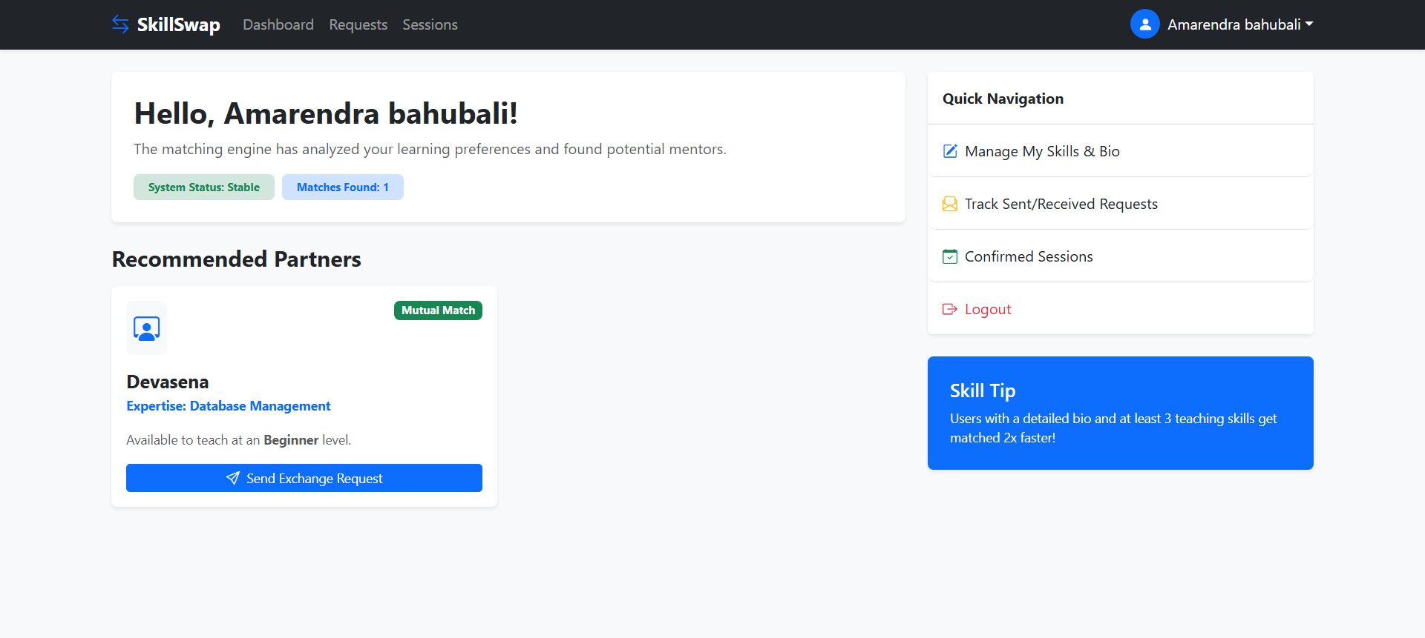
2.Requests page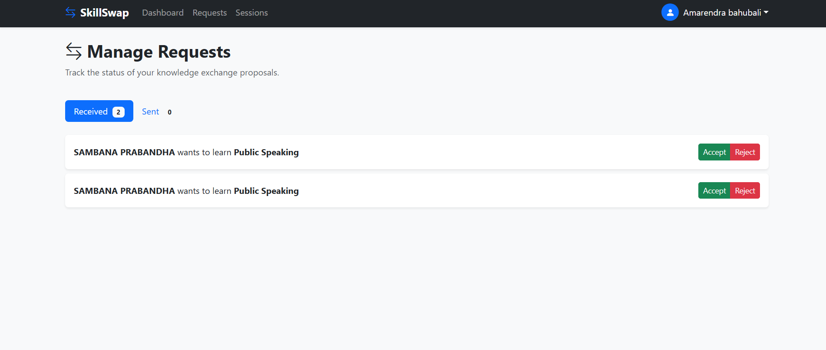

3.Profile page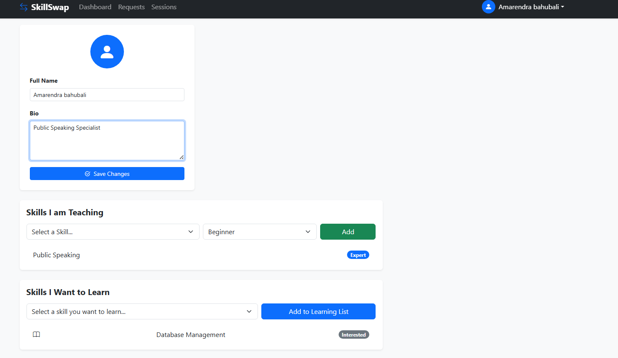
4.Sessions page
