Chappy App Co. Financial Reports



Assumptions…………………………………………………Page 2

Start-Up Costs……………………………………………….Page 3

Balance Sheet……………………………………………….Page 4

Income Statement…………………………………………..Page 5

Forecasting…………………………………………………..Page 6

Forecasting…Cont’d…………………..……………………Page 7

Assumptions

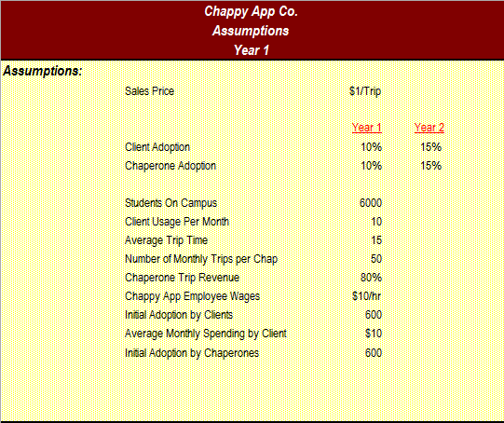

Start-Up Costs

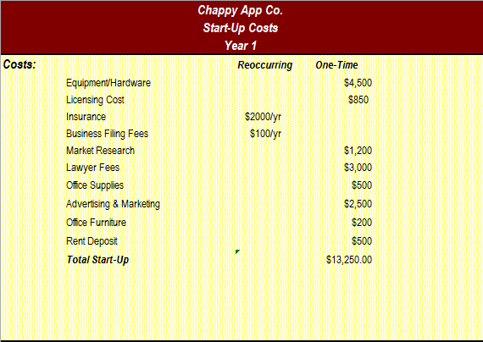

Balance Sheet

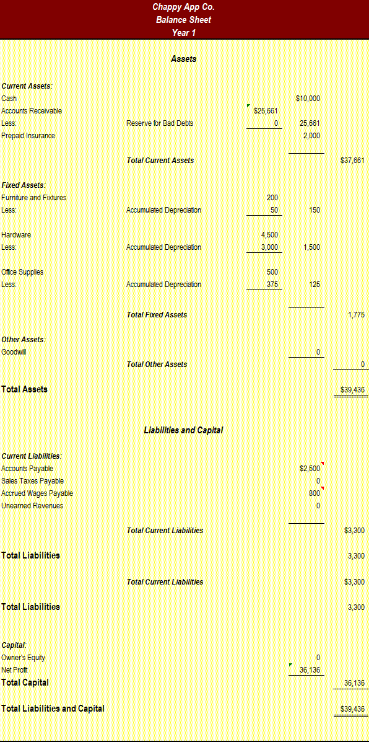

Income Statement

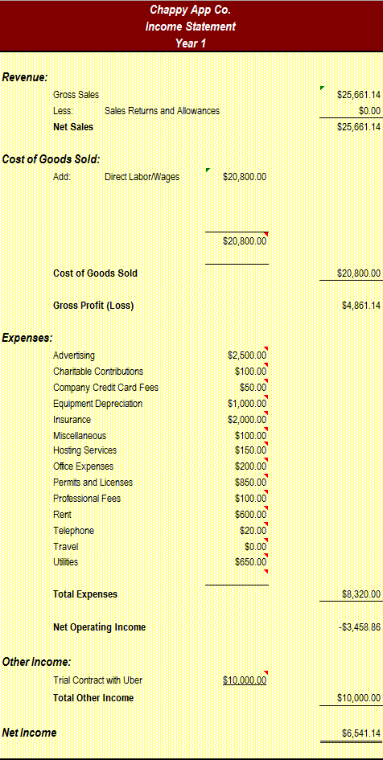

Forecasting

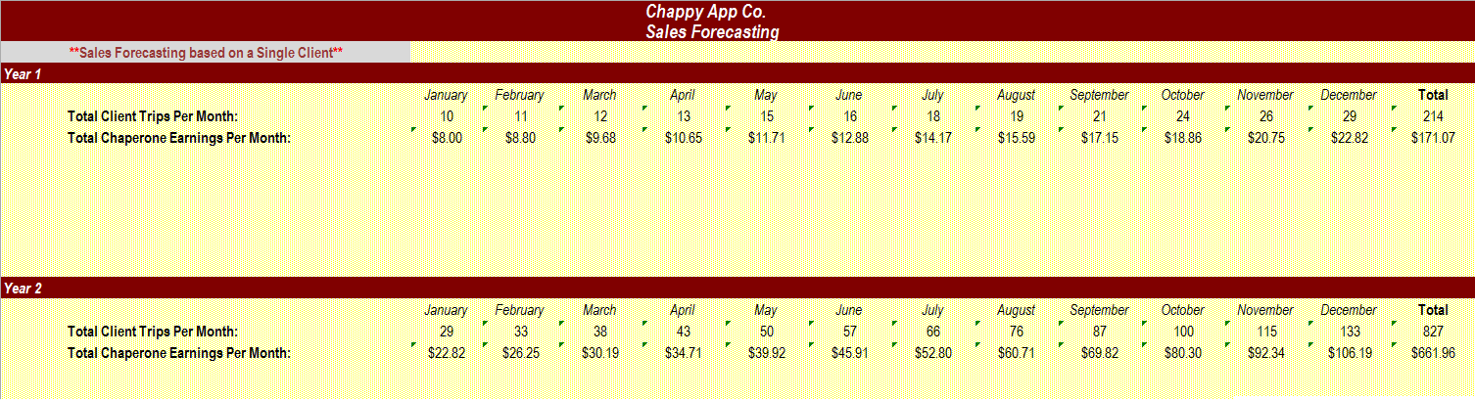

Forecasting…cont’d.

