Can AI Design Responsible Home-Care Robots? A Comparative Evaluation of ChatGPT, Gemini, Claude, and DeepSeek
November 5, 2026

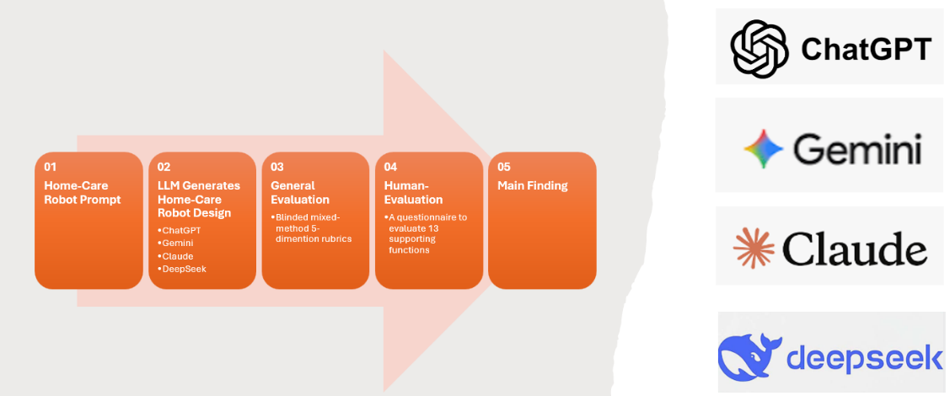
(Study workflow for evaluating home-care robot design)

I've always been fascinated by how technology can solve real-world problems. Whether I'm programming a robot to navigate a competition field, or exploring the capabilities of the machine learning models, I really enjoy the challenge of turning ideas into something tangible.
With the rapid development of AI, one question came to my mind: Could AI help design home-care robots for older adults to live safely and independently at home? As we know, many seniors need assistance with medication management, mobility, meal preparation, household tasks, and emergency response. At the same time, shortages of caregivers and rising healthcare costs make continuous human support increasingly difficult.
This question inspired my recent research project comparing four leading large language models (LLMs), ChatGPT, Claude, Gemini, and DeepSeek, to see how effectively they could design realistic home-care robots for older adults.

Why This Matters
Advances in LLMs have made it possible for models to generate detailed engineering concepts, system architectures, safety procedures, and product specifications from simple text prompts. While AI-generated designs often appear impressive, an important question remains: Are these designs safe, practical, affordable, and appropriate for vulnerable users?
In home-care robotics, mistakes can have serious consequences. A robot responsible for monitoring falls, supporting mobility, or managing medications must prioritize safety, privacy, dignity, and human oversight. For this reason, evaluating AI-generated designs requires much more than measuring technical sophistication.

The Challenge
I asked each AI model with a standardized prompt to design a “Technically realistic home-care robot for older adults living independently or semi-independently”.
The robot was expected to assist with responsibilities such as medication reminders, hydration tracking, scheduling support, grocery management, housekeeping, social engagement, emergency response, communication with caregivers. The models were also instructed to prioritize safety, accessibility, privacy, independence, user consent, and caregiver collaboration.
Most importantly, they were required to identify tasks that would still require human supervision and acknowledge limitations of current technology.

How the Study Worked
Each model developed robot designs for three different care scenarios:
- Basic Support: A lower-risk robot focused on reminders, companionship, wellness monitoring, and caregiver alerts.
- Mobility and Safety: A robot designed to assist users with reduced mobility and elevated fall risk.
- Comprehensive Home Care: A more advanced robot capable of supporting daily living activities while carefully managing high-risk tasks such as cooking and physical assistance.
In total, twelve AI-generated robot designs were evaluated. To compare the designs fairly, I developed a structured rubric containing five domains. Each domain was scored from 1 to 5, and then calculated a total score as weighted average, with a maximum total score of 25 for each design. A higher score indicated a stronger overall performance.
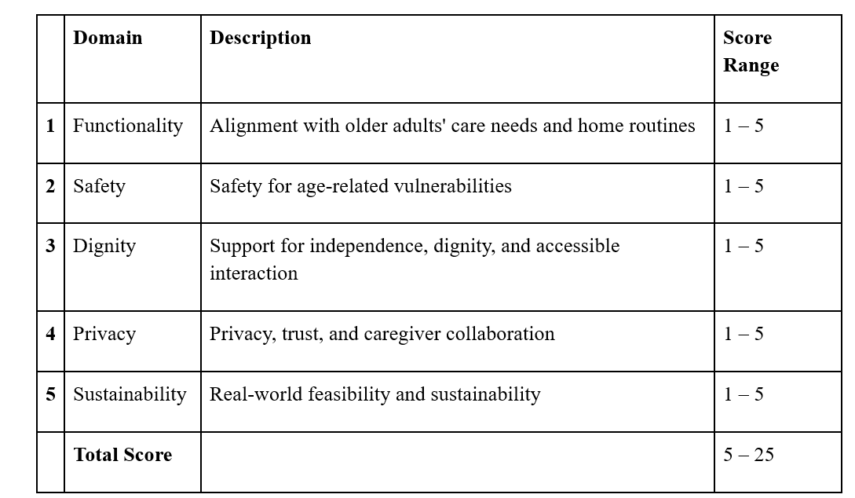

What the AI Models Designed
Although all four models recognized the importance of safety, fall detection, medication reminders, caregiver communication, and social engagement, their design approaches varied significantly.
- ChatGPT: The Practical Assistant
ChatGPT designed Harbor Lite, a mobile companion robot focused on practical daily support. It could perform wellness check-ins, deliver small items, facilitate video calls, and provide emergency alerts. The design emphasized clear safety boundaries and avoided replacing human caregivers.

- Claude: The Ethics Specialist
Claude produced the strongest privacy and ethics framework. Its design included detailed discussions of user consent, caregiver access controls, data protection, and maintaining user autonomy. Among all models, Claude placed the greatest emphasis on ethical decision-making.

- Gemini: The Balanced Care Partner
Gemini's CompanionGuard integrated health monitoring, social interaction, environmental awareness, navigation, and caregiver coordination into a single platform. Its design struck a strong balance between functionality and accessibility.
- DeepSeek: The Affordable Option
Unlike the others, DeepSeek proposed a stationary tabletop assistant rather than a mobile robot. While it lacked mobility and advanced features, it offered a simpler and potentially more affordable solution focused on reminders, communication, and monitoring.

Table 2 Key difference among four LLM-generated home-care robots.
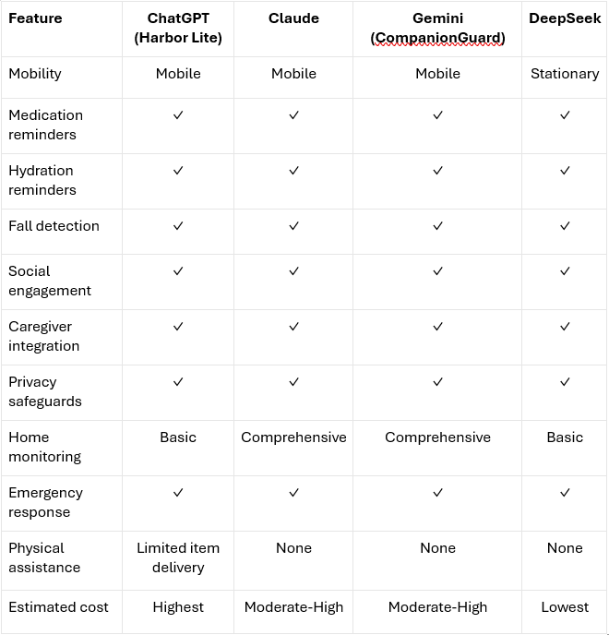

Results
Figure 1 compares the total score of the four LLM-generated home-care robot designs. Overall, ChatGPT demonstrated the strongest performance based on the 5-domain evaluation criteria, with Claude and Gemini showing comparable results. DeepSeek scored substantially lower than the other models.
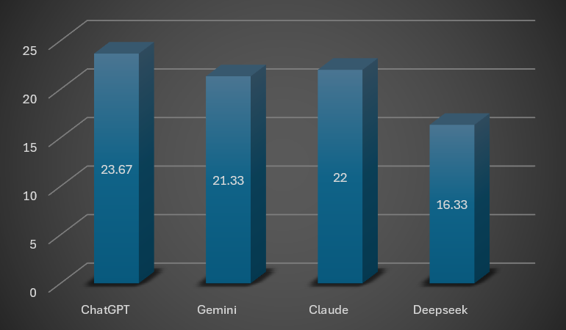
Figure 1. Comparison of Total Scores Across Four LLMs

Figure 2 presents the scores by three evaluation scenarios, including Basic Support, Comprehensive Care, and Mobility Safety, across the four LLM-generated robot designs. ChatGPT achieved the highest score in Basic Support and tied for the highest score in Mobility Safety (24 points each). Claude performed consistently across all three scenarios, receiving scores of 23, 21, and 22 for Basic Support, Comprehensive Care, and Mobility Safety, respectively. Gemini showed stronger performance in Mobility Safety (23) and Basic Support (22) than in Comprehensive Care (19). DeepSeek received the lowest scores across all scenarios, with scores of 17, 16, and 16 for Basic Support, Comprehensive Care, and Mobility Safety, respectively. In summary, the results indicate that ChatGPT, Claude, and Gemini performed similarly in Basic Support and Mobility Safety, whereas relatively larger differences were observed in Comprehensive Care, where ChatGPT achieved the highest score and Gemini and DeepSeek received lower ratings. In summary, the results indicate that ChatGPT, Claude, and Gemini performed similarly in Basic Support and Mobility Safety, whereas relatively larger differences were observed in Comprehensive Care, where ChatGPT achieved the highest score and Gemini and DeepSeek received lower ratings.
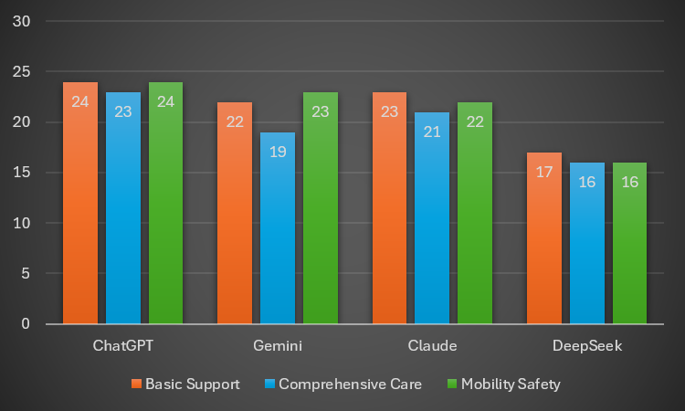
Figure 2. Comparison of Overall Evaluation Scores by Scenarios Across Four LLMs
It is worth mentioning that despite receiving lower evaluation scores, DeepSeek may represent a cost-effective alternative, as it is generally recognized as the most affordable model among the four LLMs evaluated.

Key Findings
Several interesting patterns emerged.
- AI Models Understand Core Care Needs
All four models identified the same fundamental priorities, suggesting that current AI systems have a surprisingly strong understanding of older adults' care requirements.
- Medication support
- Fall detection
- Emergency communication
- Caregiver coordination
- Independent living
- Different Models Have Different Design Philosophies
The models varied not only in quality but also in perspective, suggesting that choosing an AI tool for engineering design may depend as much on design philosophy as technical capability.
- ChatGPT emphasized functionality and day-to-day usefulness.
- Claude prioritized ethics, privacy, and consent.
- Gemini focused on balance and system integration.
- DeepSeek emphasized simplicity and affordability.
- AI Recognizes Its Own Limits
Perhaps the most encouraging finding was that none of the models attempted to replace caregivers, physicians, or emergency responders. Instead, every design treated the robot as a supportive assistant working alongside humans rather than replacing them.

Limitations
This study evaluated written design proposals rather than physical robots. As a result, it assessed conceptual quality rather than real-world performance. I also converted each AI-generated concept into a preliminary 3D CAD model using FreeCAD to examine how well the proposed designs could translate into physical systems. While these models were not manufacturing-ready, they provided an additional way to evaluate feasibility and component layout.

Final Thoughts
This project demonstrates that modern AI models can generate thoughtful and detailed concepts for home-care robots. More importantly, it shows that AI can serve as a valuable design partner during the early stages of engineering development.
However, the study also reinforces an important lesson: The best robotics solutions will not come from AI alone. Safe and effective home-care robots will require collaboration among engineers, healthcare professionals, caregivers, older adults, and AI systems. Generative AI can help generate ideas and explore possibilities, but human expertise remains essential to ensure those ideas are safe, practical, ethical, and truly beneficial.
As AI continues to advance, understanding both its strengths and its limitations will be critical in shaping the future of assistive technology.

Reference:
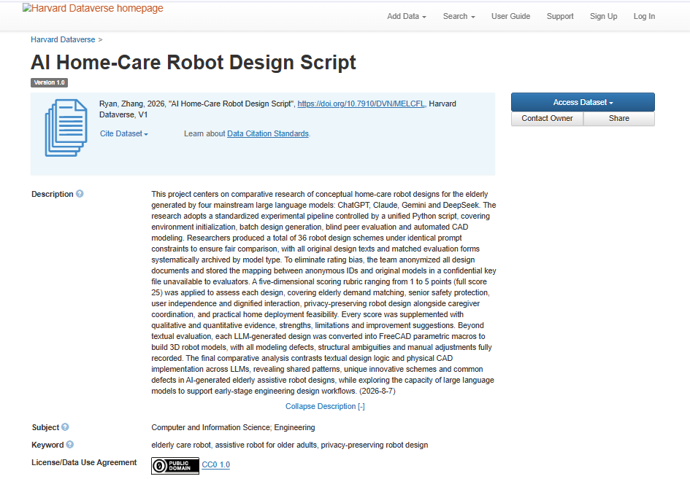
View data and code - Harvard University Dataverse, V1. Available from https://dataverse.harvard.edu/dataset.xhtml?persistentId=doi:10.7910/DVN/MELCFL

