**Readme for Project 2b**

**This program is simulation of shortest path algorithm (distant vector).**

**Note:- as this is a single machine communication there will be no different IP address, “File Name” will act as IP address, it will be helpful identify different routers.**

* Program will ask for file Name with extension ”.dat”, characters before this extension will be taken as router name (used in place of IP address).
* Content of File should be in this format

filename with extension(i.e. router name will be “a”)

“number of neighbour” and “port number” are separated using space

Information about Neighbours:

Every node will have different line and program will only read “number of neighbour” lines.

Each line has “name of neighbour”, “cost to that neighbour” and “port on which this neighbour will be listening”. (separated using space)

Port number on using which router will send and receiver packets

Number of neighbours

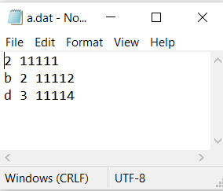

**Note:- its better to use port number between 10000 and 64000**

If you want to create below structure:

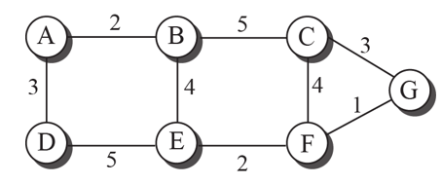

1. Create a new folder and past the provided program in it.

**Make sure you have python installed before running this program**

1. Choose a port no. for every node in image

(suggestion: as it is alphabets choose port range starting from 11111 and add +1 for next alphabet)

11113

11112

11117

11116

11115

11114

11111



1. Select a node and create file in same folder with its name and with content as follow :



**Note :- provide appropriate names of neighbour, cost to them and port number on which they are listening, as it will send and receive packets from neighbours.**

1. Do same for all other nodes

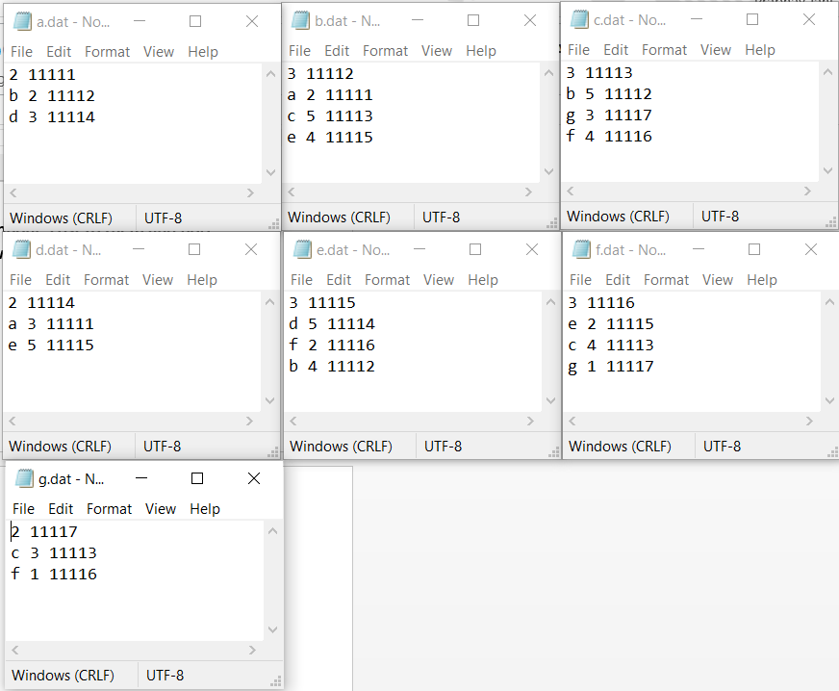

1. Open terminal for each node (or just run the program as it has infinite loop it will show the output) and provide name of the file
2. For given figure shortest path from “a” to every node will be

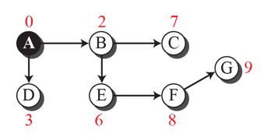

1. Routing table will be:

output of program.

**May not be in that sequence, as information may arrive out of order**

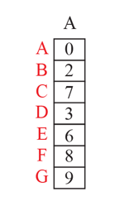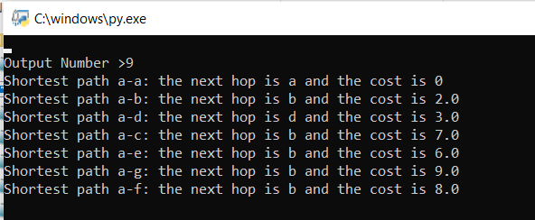

**Note:- It takes 15-20 second to compute packet arrive and print Shortest path**

**=>if you want to change the cost between the two nodes, make sure to change the cost in both nodes file.**

**=>It will detect the update**

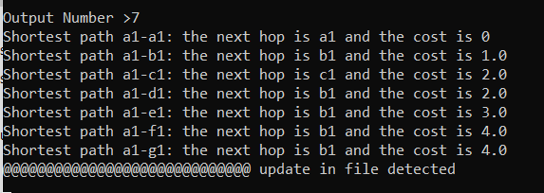

**=>If new update is not less than current cost it will show no changes.**

**=>It will also expect routing tables from node if it will not arrive it will say**

