Data Lakehouse | Data Lakes | Data Warehouses
A key advantage of a Data Lakehouse is that it merges the strengths of two older systems: data lakes and data warehouses.
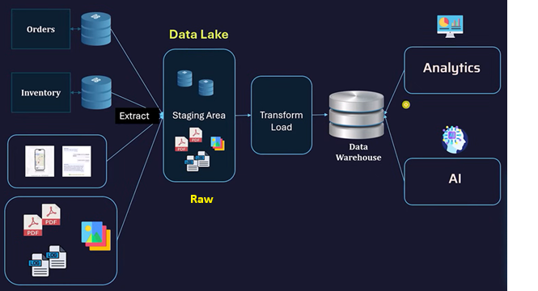
- Data lakes are great for storing massive amounts of raw data (structured, semi-structured, and unstructured) at low cost and high scalability. But they often lack strong data management, consistency, and performance for analytics.
- Data warehouses provide clean, structured data with strong governance, reliability, and fast query performance—but they can be expensive and less flexible when handling large or varied data types.
A Data Lakehouse combines both:
- It keeps the scalability and flexibility of data lakes, allowing you to store huge volumes of diverse data.
- At the same time, it adds reliability features like data consistency, schema enforcement, and optimized query performance—similar to data warehouses.
In simple terms:
You get the ability to store any kind of data at scale (like a data lake) while still being able to analyze it efficiently and reliably (like a data warehouse).
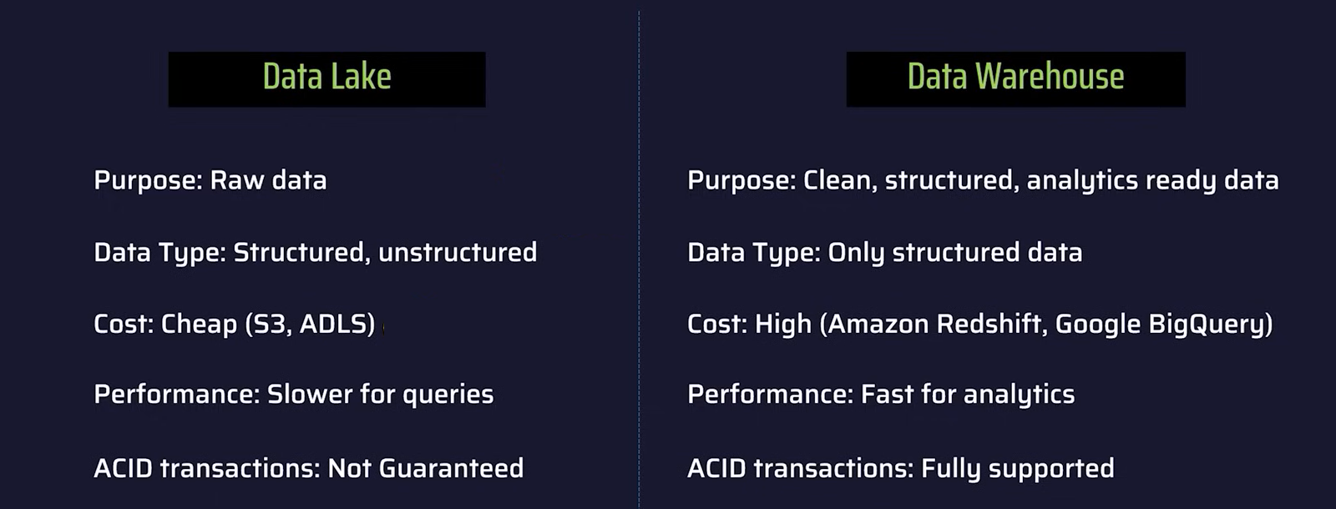
- 

References Material
Here are some good YouTube videos that explain Data Lakehouse concepts clearly:
- Data Lakehouses Explained | IBM Technology | YouTube
- Data Warehouse vs Data Lake vs Data Lakehouse | ETL, OLAP vs OLTP |
codebasics | YouTube

