Catalog Type
The “Catalog Type” in Unity Catalog refers to how and where the data in the catalog is stored and managed.
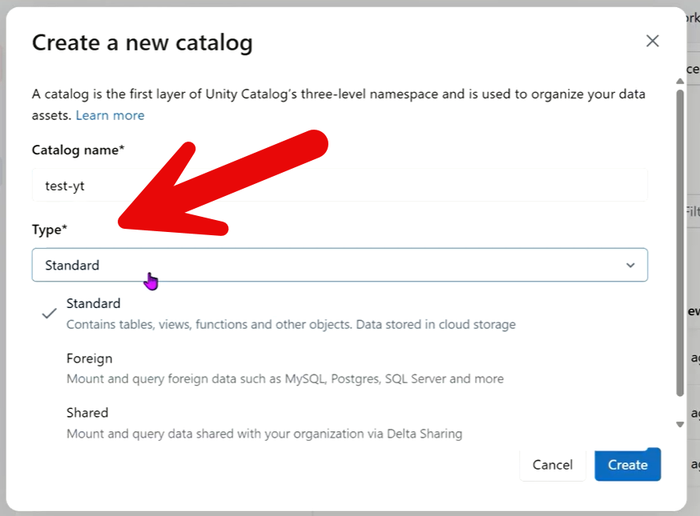
When you create a catalog, you’re not just naming a container—you’re also defining who manages the data and its storage location.
Here’s the key idea:
1. Managed Catalog (Databricks-managed)
- Databricks controls the storage location
- Data is stored in a default location configured in the metastore
- Easier to set up and maintain
- Best for most users who want simplicity
2. External Catalog (Customer-managed storage)
- You specify the storage location (e.g., AWS S3, Azure Data Lake, GCS)
- You manage the underlying data files
- Gives more control over storage, compliance, and integration
- Often used in enterprise environments
Why this matters:
The catalog type determines:
- Who controls the data (you vs. Databricks)
- Where the data physically lives
- How governance and access policies are applied
In simple terms:
“Catalog Type” = Who manages the data + where it is stored

References Material
Here are some useful YouTube videos specifically about Unity Catalog Catalog Types, Managed vs External Catalogs, and Catalog setup in Databricks:
- Catalog, External Location & Storage Credentials in Unity Catalog
Good explanation of managed vs external concepts and how catalog storage works in Databricks.
▶️ Watch Video
- Databricks Unity Catalog: Catalogs and Schemas
Focuses on catalog hierarchy, schemas, and how catalogs are organized in Unity Catalog.
▶️ Watch Video
- Create Unity Catalog in Databricks | Step-by-Step Tutorial
Shows how to create catalogs and explains governance and storage configuration.
▶️ Watch Video
- Unity Catalog Tutorial For Data Engineering Beginners
Long-form deep dive covering catalogs, schemas, tables, storage credentials, and access control.
▶️ Watch Full Tutorial
- Databricks Unity Catalog Explained
Explains the purpose of catalogs, governance, and Unity Catalog architecture in simpler terms.
▶️ Watch Overview
The most relevant one for your exact topic (“Catalog Type”) is probably:
- Video 1 for managed vs external storage
- Video 2 for understanding catalog hierarchy and structure.

