What is a Data Lakehouse?
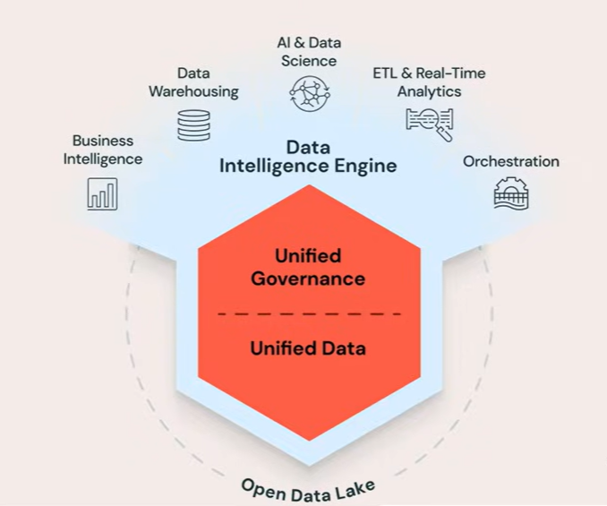
A Data Lakehouse is a modern data architecture that combines the benefits of:
- Data Lakes (cheap, scalable storage for raw data)
- Data Warehouses (fast analytics, ACID transactions, BI support)

Databricks built its platform around this concept and powers it using Delta Lake.

Main Problems in Traditional Data Platforms
Traditional enterprise data platforms often use many separate tools:
- ETL tools
- Data warehouses
- Spark processing tools
- AI/ML platforms
- BI dashboards
- Orchestration tools
- Governance/security systems

This creates several challenges:
1. Too Many Separate Tools
Each system must integrate correctly with every other system.
Problems include:
- Complex integrations
- Security risks
- Data inconsistencies
- Higher maintenance costs

Databricks Solution
Databricks provides a unified platform where:
- engineering
- analytics
- AI/ML
- governance
- orchestration

all work together in one ecosystem.

2. Vendor Lock-In Problem
Many traditional warehouses store data in proprietary formats.
This means:
- your data depends on a specific vendor
- you cannot easily move your data elsewhere
- you must use their engine to read your own data

Databricks/Open Format Approach
Databricks avoids vendor lock-in by storing data in:
- Parquet
- CSV
- Avro
- ORC
- other open formats

Data stays in your cloud storage:
- AWS
- Azure
- GCP

Delta Lake sits on top of the data and provides advanced functionality.
Because formats are open:
- you always own your data
- you can move to another platform anytime

3. Duplicate Data Problem
Traditional systems usually separate:
- Data Lakes (for AI/ML and ETL)
- Data Warehouses (for BI/reporting)
This creates:
- multiple copies of the same data
- different owners of the same data
- synchronization problems
- higher storage costs

What Databricks Did: Data Lake + Warehouse = Lakehouse
Databricks merged both systems into one architecture:
Data Lake + Data Warehouse = Data Lakehouse
Now:
- raw and analytical data can live together
- one copy of data serves many purposes
- AI/ML and BI use the same data source

Role of Delta Lake
Delta Lake is the engine powering the Lakehouse.
It adds warehouse-like capabilities to cloud storage.
Benefits include:
- ACID transactions
- Data versioning
- Time travel
- Audit history
- Transaction logs
- Reliability
- Scalability

This gives cloud storage the power of a database system.

Databricks Lakehouse Architecture
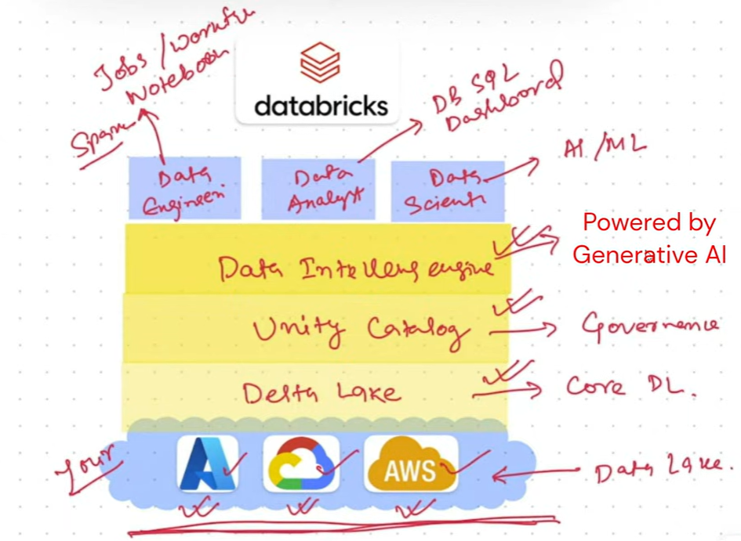
Bottom Layer — Cloud Storage
Data resides in:
- AWS
- Azure
- GCP

Middle Layer — Delta Lake
Delta Lake provides:
- Lakehouse functionality
- Transaction support
- Reliability
- Open-source storage layer

Governance Layer — Unity Catalog
Unity Catalog handles:
- security
- governance
- lineage
- metadata management

Intelligence Layer — Data Intelligence Engine
Provides:
- AI-powered insights
- natural language capabilities
- enterprise intelligence

Top Layer — User Personas & Tools
Data Engineers
Use:
- notebooks
- Spark jobs
- workflows
- pipelines

Data Analysts
Use:
- Databricks SQL
- dashboards
- BI tools
Data Scientists
Use:
- AI/ML tools
- model training
- experimentation

Key Idea of Databricks
Databricks is called a Data Intelligence Platform because it combines:
Data Lakehouse + Generative AI
And:
Data Lakehouse = Data Lake + Data Warehouse

Final Takeaway
A Data Lakehouse:
- combines the flexibility of a Data Lake
- with the reliability and analytics power of a Data Warehouse
- while keeping data in open cloud formats
Databricks uses:
- Delta Lake for the Lakehouse engine
- Unity Catalog for governance
- AI capabilities for data intelligence

All on a single unified platform.

