This introduction video launches a new “Databricks 0 to Hero” series focused on learning the Databricks platform from beginner to advanced concepts.
Topics Covered in the Series
The series plans to teach:
- Databricks Architecture
  - Understanding what Databricks is
  - How the platform is designed

- Setting Up Databricks on Azure
  - Environment configuration
  - Azure integration

- Lakehouse & Unity Catalog
  - Data Lakehouse concepts
  - Governance with Unity Catalog

- Data Engineering Features
  - Notebooks
  - Delta Live Tables (DLT)
  - Jobs & Workflows
  - Auto Loader

- Data Analytics Features
  - SQL Warehouses
  - Queries
  - Dashboards

- DevOps & CI/CD
  - Git integration
  - Azure DevOps
  - Databricks CLI & APIs

- Serverless Computing
  - Serverless offerings in Databricks
  - Benefits of serverless architecture

- Cost Optimization
  - Cost analysis
  - Platform optimization strategies

What Learners Will Gain
By the end of the series, learners should:
- Understand the major Databricks tools and services
- Gain practical knowledge of the platform
- Be prepared to attempt the Databricks Data Engineering Associate Certification

Prerequisites
The instructor recommends having basic knowledge of:
- Apache Spark
- PySpark
- Spark Streaming
- SQL
- Python

Recommended Learning Resources
The instructor suggests using the “Ease with Data” YouTube channel for prerequisite learning, especially:
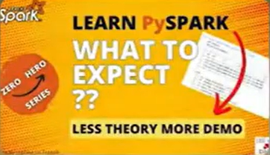
- PySpark 0 to Hero

- Spark Streaming with PySpark
These playlists cover topics from beginner concepts to advanced optimization techniques.

