Summary: What Is Kubernetes (K8s)?
Kubernetes (K8s) is an open-source container orchestration platform that automates the deployment, management, scaling, and recovery of containerized applications.
Kubernetes helps organizations run applications reliably across multiple servers, whether in cloud environments, on-premises data centers, or hybrid infrastructures.
1. History of Kubernetes
Topic | Description
Created by | Google
Announced | 2014
Open-source development | Began in 2014; version 1.0 released in 2015
Inspired by | Google's internal cluster management system, Borg
Programming language | Go (Golang)
Managed by | Cloud Native Computing Foundation (CNCF)
Abbreviation | K8s
Name meaning | Greek for pilot or helmsman
According to the 2021 CNCF survey cited in the lesson, 96% of organizations were using or evaluating Kubernetes. This is a historical statistic, not a current adoption figure.
2. What Does Kubernetes Do?
Kubernetes acts like a captain managing a fleet of ships. It coordinates containers and decides where and how applications should run.
Its primary responsibilities include:
- Container orchestration: Coordinates containerized applications across multiple servers.
- Automated deployment: Deploys applications without manually configuring every server.
- Auto-scaling: Increases or decreases application replicas based on demand.
- Self-healing: Restarts or replaces failed containers and reschedules workloads when nodes fail.
- Load balancing: Distributes network traffic across application instances.
- Resource optimization: Helps efficiently utilize CPU, memory, and infrastructure resources.
3. How Kubernetes Works
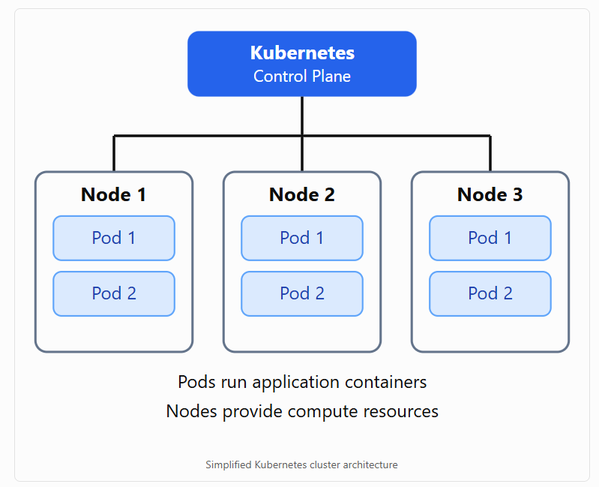
Simplified Kubernetes cluster architecture
Important components:
- Cluster: A collection of machines managed by Kubernetes.
- Control Plane: Manages the cluster and schedules workloads.
- Node: A physical or virtual machine that runs applications.
- Pod: The smallest deployable unit in Kubernetes, containing one or more containers.
- Container: A packaged application with its dependencies.
4. Real-World Example: Spotify
The lesson describes how Spotify migrated from its internal orchestration platform, Helios, to Kubernetes in 2018.
Before Kubernetes | After Kubernetes
Used internally developed Helios | Adopted Kubernetes
Required significant maintenance | Reduced custom orchestration maintenance
New services could take approximately an hour to provision | New services could be deployed in seconds or minutes
Scaling required more operational effort | Benefited from automatic scaling
The lesson reports that one Spotify service handled approximately 10 million requests per second, demonstrating the scalability of its Kubernetes-based infrastructure.
5. Kubernetes Deployment Environments
Kubernetes can run in several environments.
Environment | Description
On-premises | Kubernetes installed on company-owned servers
Public cloud | Kubernetes deployed on cloud infrastructure
Hybrid cloud | Combines on-premises and cloud resources
Managed Kubernetes | Cloud provider manages significant portions of the Kubernetes infrastructure
Examples of managed Kubernetes services include:
- Amazon Elastic Kubernetes Service (EKS)
- Azure Kubernetes Service (AKS)
- Google Kubernetes Engine (GKE)
6. Benefits of Kubernetes
Benefit | Explanation
Scalability | Automatically adjusts application replicas based on configured scaling rules
High availability | Helps maintain application availability when containers or servers fail
Portability | Runs across different cloud and on-premises environments
Automation | Reduces manual deployment and operational tasks
Cost optimization | Can reduce unused compute resources through scaling and efficient scheduling
Open source | Supported by a large community and the CNCF
7. Key Takeaways
- Kubernetes is an open-source container orchestration platform.
- Google originally developed Kubernetes, inspired by Borg.
- Kubernetes is written primarily in Go and maintained under the CNCF.
- Kubernetes manages application deployment, scaling, networking, and recovery.
- Applications run inside containers organized into Pods.
- Kubernetes supports on-premises, public cloud, and hybrid deployments.
- Companies such as Spotify use Kubernetes to operate large-scale applications.
Main takeaway: Kubernetes automates the management of containerized applications, helping organizations deploy software faster, scale applications as demand changes, recover from failures, and manage computing resources efficiently.

