Summary: Install Docker on Linux
This lesson explains how to install Docker Engine on Linux (Ubuntu 22.04) so you can run containers and prepare your computer for a local Kubernetes cluster.

Installation Steps
- Check your Linux version using:
bash
lsb_release -a
- Update package lists to ensure your system has the latest package information:

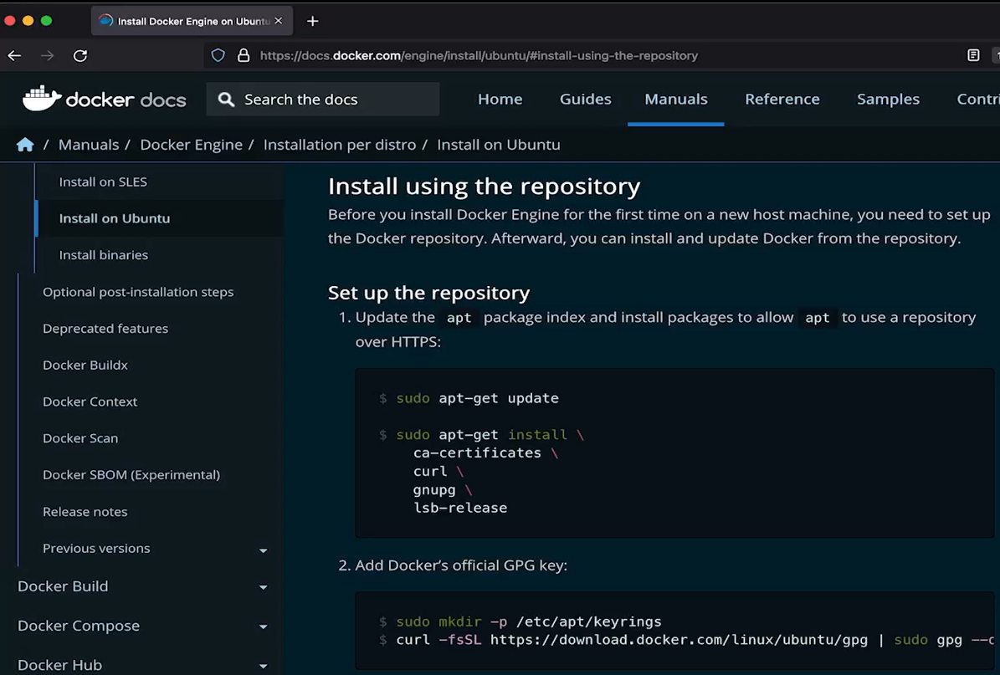
bash
sudo apt-get update
- Install prerequisites and configure the system to trust Docker's official repository.
- Add Docker's official GPG key to verify the authenticity of Docker packages.
- Set up Docker's APT repository so Ubuntu can download Docker packages from the official source.
- Update package lists again after adding the repository:
bash
sudo apt-get update
- Install Docker Engine using the installation command provided in Docker's official documentation.
- Verify the installation by running:
bash
docker
If Docker displays its help information and commonly used commands, the installation was successful.

Key Concepts
- Docker Engine: The core software responsible for running containers.
- APT repository: A source from which Ubuntu downloads and installs software packages.
- GPG key: Helps verify that downloaded packages come from a trusted source.
- Terminal: The command-line interface used to execute installation commands on Linux.

Why Is Docker Needed?
Docker provides the container runtime needed to run containerized applications. In this course, it helps prepare your environment for Minikube, which lets you run a Kubernetes cluster on your own computer.
Key takeaway: Identify your Linux distribution, configure Docker's official repository, install Docker Engine, and verify the installation before setting up Minikube.
For current installation commands, refer to the official Docker Engine installation guide for Ubuntu .

