Summary: Install Docker on macOS
This lesson explains how to install Docker Desktop on macOS so you can run containers and prepare your computer for a local Kubernetes cluster.
Installation Steps
- Visit Docker Docs: Open the official Docker Desktop installation page for Mac.
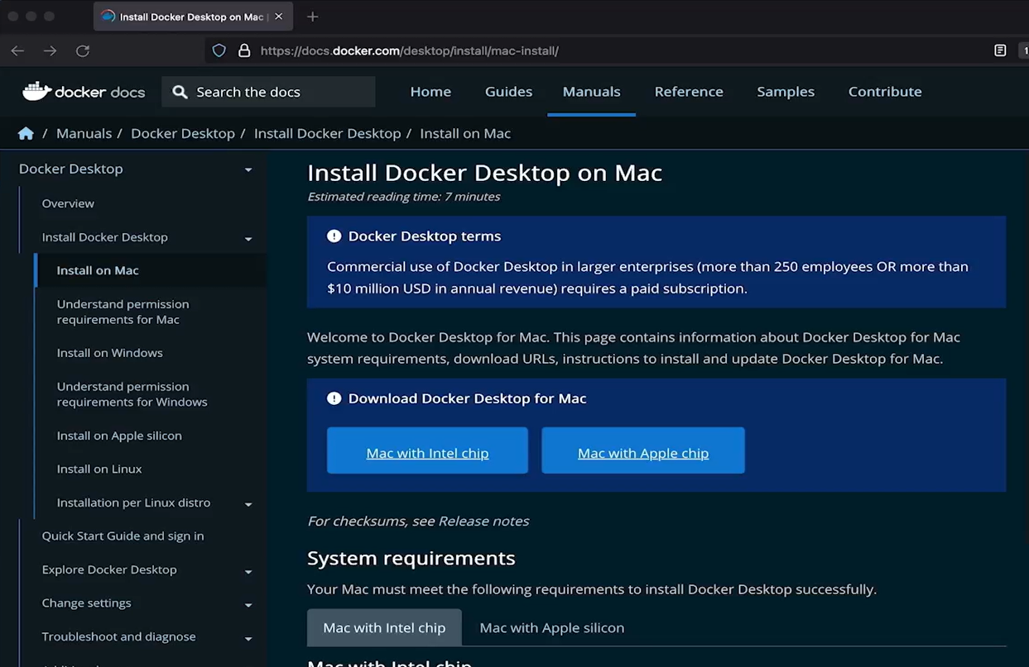
- Download Docker Desktop: Choose the correct version for your Mac's processor:
  - Intel chip
  - Apple silicon (such as M1, M2, M3, or newer)
- Open the downloaded file: Launch the Docker Desktop installer.
- Install Docker: Drag the Docker application into the Applications folder.
- Launch Docker Desktop: Open Docker from Applications and approve any security prompts.
- Wait for Docker to start: Initial startup may take some time.
- Verify the installation: Open Terminal and run:
bash
docker
If Docker displays its help information and commonly used commands, the installation is successful.
Why Is Docker Needed?
- Docker Desktop provides the tools needed to run containers on macOS.
- Docker acts as the container engine for running containerized applications.
- Minikube will use the local environment to run a Kubernetes cluster on your computer.
Key Takeaway
Docker installation differs slightly across Windows, Linux, and macOS, but the goal is the same: prepare your computer to run containers.
Next step: Install Minikube, which allows you to practice deploying and managing applications with Kubernetes locally.
Official guide: Install Docker Desktop on Mac

