Summary: Install Minikube on Windows
Minikube is a tool that lets you run a Kubernetes cluster locally on your computer. It is useful for learning Kubernetes without paying for cloud computing resources.

Installation Steps
- Install Docker Desktop: Minikube needs a container runtime, such as Docker or Podman.
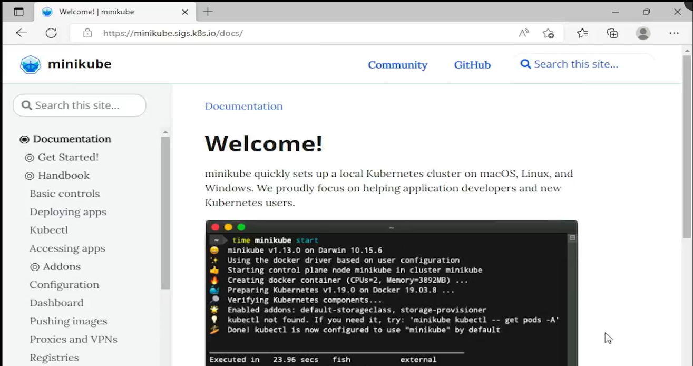
- Visit the official Minikube website: Go to the Minikube website .
- Select your configuration:
  - Operating system: Windows
  - Architecture: x86-64
  - Release: Stable
  - Download type: Installer executable
- Download the installer: Click the download link for the Windows installer.
- Run the installer: If Windows displays a security warning, verify that you downloaded the installer from the official Minikube website before proceeding.
- Complete the setup wizard: Accept the license agreement, click Install, and finish the installation.
- Verify the installation: Open Command Prompt and run:
bash
minikube
If Minikube displays its available commands, the installation was successful.

Important Concepts
- Minikube: Runs a local Kubernetes cluster for learning and development.
- Docker: Provides the container runtime that Minikube can use to run containers.
- Kubernetes cluster: A group of components that manage and run containerized applications.
- Command Prompt: The Windows terminal used to execute Minikube commands.

Limitations of Minikube
- It runs locally and uses your computer's resources.
- It is ideal for learning, testing, and development.
- It is not intended to replace a properly configured production Kubernetes cluster.

Key Takeaway
Docker runs containers, and Minikube runs a local Kubernetes cluster. Together, they provide an environment for practicing Kubernetes without needing a cloud provider.
Next step: Start your Minikube cluster using:
bash
minikube start
This command initializes your local Kubernetes cluster.

