Summary: Spin Up and Explore a Minikube Cluster

1. Overview
This lesson demonstrates how to create a local Kubernetes cluster using Minikube and explore its components using kubectl (Kubernetes command-line tool).
You will learn how to:
- Verify that Docker or Podman is running.
- Create a Kubernetes cluster using Minikube.
- Understand the difference between Minikube and kubectl.
- Inspect cluster information and nodes.
- Explore Kubernetes namespaces, pods, and services.

2. Prerequisites
Before starting, ensure the following tools are installed:
Tool | Purpose
Minikube | Creates and manages a local Kubernetes cluster
kubectl | Interacts with and manages Kubernetes resources
Docker or Podman | Provides the container runtime or driver
Terminal | Executes Kubernetes commands
Step 1: Verify Docker is running
docker info
This checks whether the Docker daemon is available.
If Docker is not running, start Docker Desktop or the Docker service.

3. Create a Kubernetes Cluster
Step 2: Start Minikube
minikube start
This command creates and starts a local Kubernetes cluster.
The process typically takes a few minutes.
Once the cluster is ready, Minikube displays a success message.

4. Minikube vs. kubectl
Although both tools are used with Kubernetes, they have different responsibilities.
Feature | Minikube | kubectl
Primary purpose | Create and manage local clusters | Interact with Kubernetes clusters
Create a local cluster | Yes | No
List Kubernetes nodes | Not its primary function | Yes
Manage pods | Limited helper functionality | Yes
Manage deployments | Not its primary function | Yes
Typical command | minikube start | kubectl get pods
Important concept:
- Minikube creates and manages the local Kubernetes environment.
- kubectl communicates with the Kubernetes API server to manage resources.
In cloud environments such as AWS, Azure, and Google Cloud, provider-specific tools can create Kubernetes clusters, while kubectl is used to interact with them.

5. Explore Cluster Information
Step 3: Display cluster information
kubectl cluster-info
This command displays information about the Kubernetes control plane and services such as CoreDNS.
Example output:
Kubernetes control plane is running at https://127.0.0.1:54321
CoreDNS is running at https://127.0.0.1:54321/api/v1/namespaces/kube-system/services/kube-dns:dns/proxy
The IP address 127.0.0.1 represents localhost. The actual address and port depend on your Minikube driver and configuration.
Troubleshooting: If you receive a connection-refused error, check whether Minikube has finished starting and whether kubectl is using the correct cluster context.
minikube status
kubectl config current-context

6. Explore Kubernetes Nodes
Step 4: List cluster nodes
kubectl get nodes
Example output:
NAME STATUS ROLES AGE VERSION
minikube Ready control-plane 5m v1.33.0
Column | Description
NAME | Kubernetes node name
STATUS | Indicates whether the node is ready
ROLES | Node responsibilities
AGE | How long the node has existed
VERSION | Kubernetes version
A default Minikube cluster typically has one node that runs both control-plane and workload components.

7. Explore Kubernetes Namespaces
Step 5: List namespaces
kubectl get namespaces
Kubernetes creates several namespaces by default.
Namespace | Purpose
default | Default namespace for user workloads
kube-system | Contains Kubernetes system components
kube-public | Contains resources intended to be publicly readable within the cluster
kube-node-lease | Stores node lease objects used for heartbeat tracking
Important concept: Namespaces provide logical separation of Kubernetes resources within a cluster. They help organize applications, teams, and environments, although they do not automatically provide complete security isolation.

8. Explore Kubernetes Pods
Step 6: List pods in all namespaces
kubectl get pods -A
The -A flag means all namespaces.
Example output:
NAMESPACE NAME READY STATUS
kube-system coredns-xxxxxxxx 1/1 Running
kube-system etcd-minikube 1/1 Running
kube-system kube-apiserver-minikube 1/1 Running
A Pod is the smallest deployable unit in Kubernetes. It contains one or more containers that share networking and storage resources.
System pods may include components such as CoreDNS, the API server, and etcd, depending on the cluster configuration.

9. Explore Kubernetes Services
Step 7: List services in all namespaces
kubectl get services -A
Example output:
NAMESPACE NAME TYPE CLUSTER-IP
default kubernetes ClusterIP 10.96.0.1
kube-system kube-dns ClusterIP 10.96.0.10
A Service provides a stable network endpoint for accessing a set of pods.
Services can direct and load-balance traffic to matching pods, even when individual pod IP addresses change.

10. Kubernetes Cluster Architecture
Conceptual view of a single-node Minikube cluster. The diagram simplifies Kubernetes networking and control-plane components.

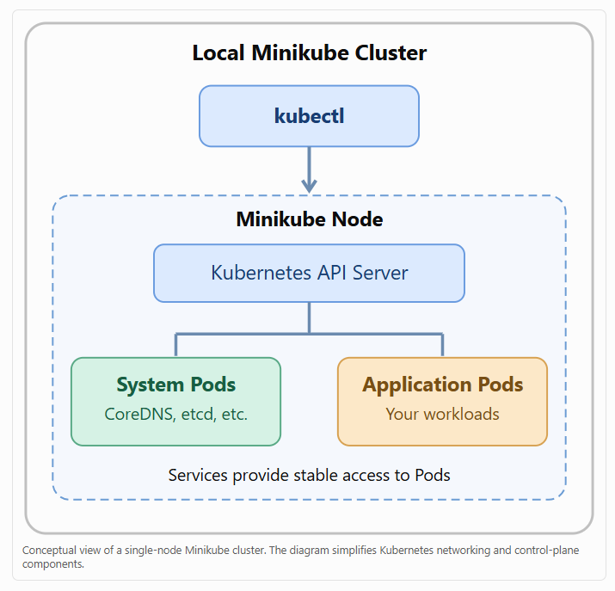

11. Important Kubernetes Commands
Command | Purpose
docker info | Verify Docker daemon availability
minikube start | Create and start a cluster
minikube status | Check Minikube status
kubectl cluster-info | Display control-plane information
kubectl get nodes | List cluster nodes
kubectl get namespaces | List namespaces
kubectl get pods -A | List pods across all namespaces
kubectl get services -A | List services across all namespaces
minikube stop | Stop the cluster
minikube delete | Delete the cluster

12. Key Takeaways and Exam Tips
- Minikube creates and manages a local Kubernetes cluster.
- kubectl communicates with the Kubernetes API server.
- Nodes are machines or virtual environments that run Kubernetes workloads.
- Namespaces logically organize Kubernetes resources.
- Pods are the smallest deployable units in Kubernetes.
- Services provide stable networking access to pods.
- The -A flag displays resources across all namespaces.
- The control plane manages the Kubernetes cluster.
Main concept: Minikube provides the local Kubernetes cluster, while kubectl allows administrators and developers to explore and manage its nodes, namespaces, pods, services, and other resources.
Official documentation: Minikube Getting Started | Kubernetes kubectl Reference

