Summary: Kubernetes Deployments and High Availability
1. What Is a Kubernetes Deployment?
A Kubernetes Deployment is a resource that manages Pods and ensures the desired number of application replicas are running.
Deployments help provide high availability, meaning an application can continue running even if one of its Pods fails.
For example, if a Deployment specifies three replicas, Kubernetes attempts to maintain three running Pods.
2. Key Benefits of Deployments
- High Availability: Runs multiple replicas of an application.
- Self-Healing: Automatically replaces failed or deleted Pods.
- Scaling: Allows increasing or decreasing the number of Pods.
- Rolling Updates: Updates applications gradually with minimal downtime.
- Desired State: Continuously works to maintain the specified number of replicas.
3. Kubernetes Deployment YAML Example
A Deployment is defined using a YAML manifest file.
File: deployment.yaml
apiVersion: apps/v1
kind: Deployment

metadata:
name: pod-info-deployment
namespace: development

spec:
replicas: 3

selector:
matchLabels:
app: pod-info

template:
metadata:
labels:
app: pod-info

spec:
containers:
- name: pod-info-container
image: your-dockerhub-user/pod-info:latest
ports:
- containerPort: 3000

env:
- name: POD_NAME
valueFrom:
fieldRef:
fieldPath: metadata.name

- name: POD_NAMESPACE
valueFrom:
fieldRef:
fieldPath: metadata.namespace

- name: POD_IP
valueFrom:
fieldRef:
fieldPath: status.podIP
Replace your-dockerhub-user/pod-info:latest with the actual Docker image.
Explanation of YAML Properties
Property | Description
apiVersion: apps/v1 | Specifies the Kubernetes API version.
kind: Deployment | Creates a Deployment resource.
metadata.name | Names the Deployment.
metadata.namespace | Specifies the namespace.
replicas: 3 | Requests three Pods.
selector.matchLabels | Identifies Pods managed by the Deployment.
template | Defines the Pods that Kubernetes creates.
containers.name | Names the container.
image | Specifies the Docker image.
containerPort: 3000 | Declares the container's application port.
env | Defines environment variables for the container.
4. Kubernetes Deployment Architecture
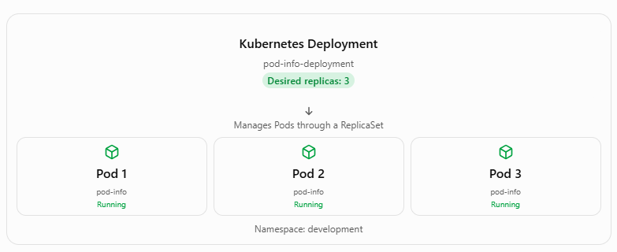
If one Pod fails, Kubernetes creates a replacement to restore the desired number of replicas.
5. Kubernetes Commands Used in the Lesson
Step 1: List namespaces
kubectl get ns
Displays all namespaces in the cluster.
Step 2: Create the development namespace
kubectl apply -f namespace.yaml
Creates the namespace defined in the YAML file if it does not already exist.
Step 3: Create the Deployment
kubectl apply -f deployment.yaml
Creates or updates the Deployment with three replicas.
Step 4: View Deployments
kubectl get deployments -n development
Example output:
NAME READY UP-TO-DATE AVAILABLE
pod-info-deployment 3/3 3 3
The 3/3 means three of the three desired replicas are ready.
Step 5: View Pods
kubectl get pods -n development
Example output:
NAME READY STATUS
pod-info-deployment-abc123 1/1 Running
pod-info-deployment-def456 1/1 Running
pod-info-deployment-ghi789 1/1 Running
Step 6: Delete a Pod to test self-healing
kubectl delete pod pod-info-deployment-abc123 -n development
Kubernetes automatically creates a replacement Pod because the Deployment still requires three replicas.
Step 7: Verify the replacement
kubectl get pods -n development
A newly created Pod should appear. It may briefly show Pending or ContainerCreating before becoming Running.
6. How Kubernetes Self-Healing Works
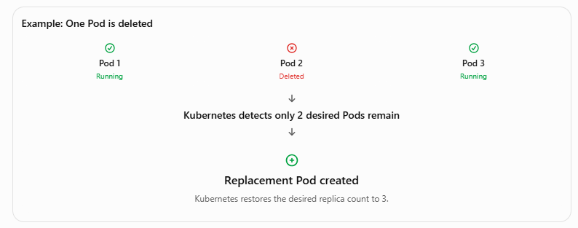
This process is managed by the Deployment's ReplicaSet controller.
7. Deployment vs. Pod
Feature | Pod | Deployment
Purpose | Runs application containers | Manages application Pods
Replicas | One Pod resource | Can manage multiple Pods
Self-healing | Standalone deleted Pod is not recreated | Replaces deleted Pods
Scaling | Manual Pod management | Supports replica scaling
Rolling updates | Not directly supported | Supported
Production use | Usually managed by a controller | Common for stateless applications
Key Takeaways
- Kubernetes Deployments manage Pods and help maintain application availability.
- The replicas property determines the desired number of Pods.
- Deployments automatically replace Pods that are deleted or fail.
- YAML manifests define Deployment configurations.
- The kubectl apply -f deployment.yaml command creates or updates a Deployment.
- The kubectl get pods -n development command displays Pods in the development namespace.
- A Deployment uses a ReplicaSet to maintain the desired number of Pods.
Important: Three replicas improve availability but do not guarantee uninterrupted service. Production applications also need appropriate readiness probes, traffic routing through Services, and sufficient cluster capacity.
Bottom line: A Kubernetes Deployment helps keep applications running by maintaining the desired number of Pods, automatically replacing failed Pods, and supporting scaling and updates.

