Add Resource Requests and Limits to Your Pods
In this lesson, we learn how to configure CPU and memory requests and limits for Kubernetes containers.
The goal is to prevent containers from consuming too many resources on worker nodes and causing performance problems or outages.
1. What Are Kubernetes Resources?
Resources refer to the CPU and memory available on a worker node.
Every container uses resources to run its application.
Without proper resource configuration:
- A pod might be scheduled on a node that doesn't have enough available resources.
- An application might consume too much CPU or memory.
- A worker node could become overloaded or fail.
- Other applications running on the same node could be affected.
2. Resource Requests vs. Resource Limits
Kubernetes provides two important resource settings.
Resource Requests
A request tells Kubernetes the minimum amount of CPU and memory to reserve for scheduling a container.
Example:
yaml
requests:
memory: "64Mi"
cpu: "250m"
This means:
- Memory: 64 mebibytes.
- CPU: 250 millicores (0.25 CPU).
Kubernetes uses these values when deciding which worker node has enough available resources to schedule the pod.
Resource Limits
A limit specifies the maximum amount of CPU and memory a container can use.
Example:
yaml
limits:
memory: "128Mi"
cpu: "500m"
This means:
- Memory: 128 mebibytes.
- CPU: 500 millicores (0.5 CPU).
If a container exceeds its memory limit, it can be terminated with an OOMKilled error.
If it reaches its CPU limit, Kubernetes throttles its CPU usage.
3. How to Configure Requests and Limits in YAML
Open your existing deployment.yaml file.
Under the container's image configuration, add a resources section.
Example:
yaml
apiVersion: apps/v1
kind: Deployment
metadata:
name: pod-info
namespace: development
spec:
replicas: 3
selector:
matchLabels:
app: pod-info
template:
metadata:
labels:
app: pod-info
spec:
containers:
- name: pod-info
image: stefanprodan/podinfo
resources:
requests:
memory: "64Mi"
cpu: "250m"
limits:
memory: "128Mi"
cpu: "500m"
ports:
- containerPort: 3000
The important part is:
yaml
resources:
requests:
memory: "64Mi"
cpu: "250m"
limits:
memory: "128Mi"
cpu: "500m"
4. Understanding CPU and Memory Units
Resource | Meaning
64Mi | 64 mebibytes of memory
128Mi | 128 mebibytes of memory
250m | 0.25 CPU core
500m | 0.5 CPU core
1000m | 1 full CPU core
Remember:
- Mi represents mebibytes of memory.
- m represents millicores of CPU.
- 1000 millicores equals 1 CPU core.
5. Apply the Updated Deployment
After saving your YAML file, run:
bash
kubectl apply -f deployment.yaml
Kubernetes updates the deployment configuration.
6. Verify the Updated Pods
Run:
bash
kubectl get pods -n development
You'll notice:
- Old pods are terminating.
- New pods are being created.
- New pods include the updated resource requests and limits.
This happens because Kubernetes Deployment performs a rolling update when the pod template changes.
7. Requests vs. Limits at a Glance
Feature | Requests | Limits
Purpose | Resource allocation for scheduling | Maximum resource usage
CPU | Scheduling requirement | CPU throttling threshold
Memory | Scheduling requirement | Memory usage ceiling
Required? | No | No
Key Takeaways
- Resource requests tell Kubernetes how much CPU and memory a container needs for scheduling.
- Resource limits prevent containers from consuming unlimited resources.
- CPU limits cause throttling when exceeded.
- Memory limits can cause containers to be terminated if exceeded.
- Resource configuration helps prevent resource exhaustion and worker node problems.
- Updating a Deployment's pod configuration causes Kubernetes to replace old pods with new ones.
Important Commands to Remember
Command | Purpose
kubectl apply -f deployment.yaml | Apply resource configuration
kubectl get pods -n development | Check pod status
kubectl describe pod <pod-name> -n development | Inspect pod details and resource configuration
Final Concept to Remember

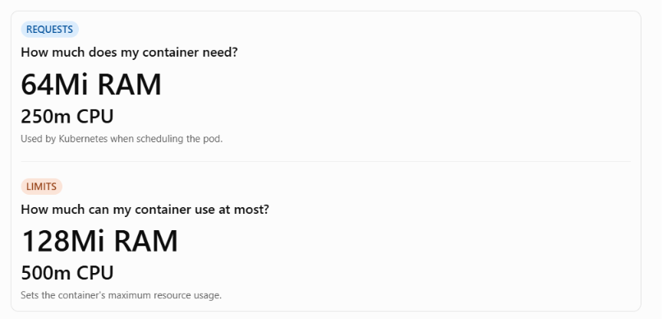
Main lesson: Resource requests help Kubernetes schedule pods properly, while resource limits help prevent containers from consuming excessive resources and affecting the stability of worker nodes.

