Kubernetes Worker Nodes
Kubernetes worker nodes are the machines where pods are scheduled and containers actually run.
Think of Kubernetes like an airport:
- Control plane: The air traffic control tower that manages the cluster.
- Worker nodes: The busy airport terminals where the actual activity takes place.
For high availability, many Kubernetes clusters use at least three worker nodes.
1. Three Main Components of a Worker Node
1. Kubelet
- An agent that runs on every worker node.
- Ensures containers inside pods are running and healthy.
- Communicates directly with the Kube API Server.
- Watches for newly assigned pods and makes sure they start correctly.
Remember: Kubelet makes sure pods and their containers are running as expected.
2. Container Runtime
- Responsible for starting and running containers.
- Works with the Kubelet through the Container Runtime Interface (CRI).
- Supports container runtimes such as:
  - containerd
  - CRI-O
  - Kata Containers
  - AWS Firecracker
Important Docker concept:
Starting with Kubernetes v1.24, Dockershim was removed.
This means Docker Engine is no longer directly supported as a Kubernetes container runtime through Dockershim.
However, Docker images still work in Kubernetes because Docker images and Docker containers are different things.
3. Kube-proxy
- Handles network communication between pods and services.
- Helps pods and services communicate across worker nodes.
- Communicates directly with the Kube API Server.
- Maintains networking rules that allow traffic to reach the correct destinations.
Remember: Kube-proxy helps manage networking and communication inside the cluster.
2. Worker Node Components at a Glance
Component | Main responsibility
Kubelet | Ensures pods and containers are running
Container Runtime | Starts and runs containers
Kube-proxy | Handles network communication
3. Control Plane vs. Worker Nodes
Control Plane | Worker Nodes
Manages the cluster | Run application workloads
Schedules pods | Host pods
Stores cluster state | Run containers
Monitors cluster resources | Maintain pod health
Includes API Server, etcd, Scheduler, Controller Manager | Includes Kubelet, Container Runtime, Kube-proxy
4. How the Components Work Together
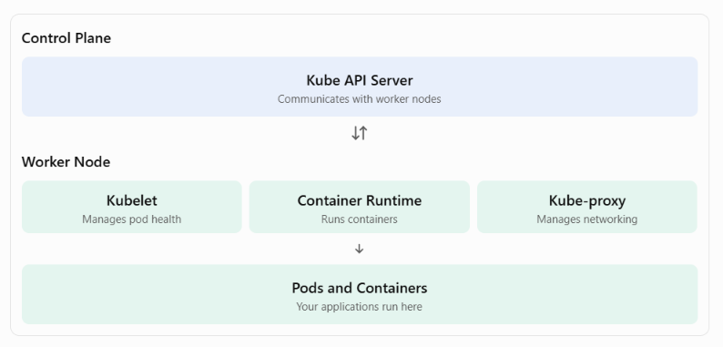

Key Takeaways
- Worker nodes are where Kubernetes applications actually run.
- Kubelet ensures pods and containers are running properly.
- Container Runtime starts and runs containers.
- Kube-proxy handles networking between pods and services.
- Worker nodes communicate with the control plane through the Kube API Server.
- Kubernetes supports container runtimes such as containerd and CRI-O.
Easy way to remember:
- Control Plane = The brain of Kubernetes.
- Kubelet = Makes sure containers are running.
- Container Runtime = Runs the containers.
- Kube-proxy = Handles networking.
- Worker Nodes = Where your applications run.

