Ways to Manage Kubernetes Pods
In this lesson, we learn about three Kubernetes objects used to create and manage groups of pods:
- Deployments
- DaemonSets
- Jobs
Each one serves a different purpose depending on how you want your application to run.
1. Deployment
Most commonly used
A Kubernetes Deployment is the most common way to deploy containerized applications.
Main features:
- Controls the number of pod replicas.
- Maintains the desired number of running pods.
- Supports application updates.
- Automatically replaces unhealthy or missing pods.
- Supports rolling updates with minimal or no downtime when configured appropriately.
Example:
If you configure a Deployment with three replicas, Kubernetes tries to maintain three running pods.
When updating your application:
- New pods are created.
- Kubernetes checks that the new pods are healthy.
- Old pods are gradually removed.
This process is called a rolling update.
2. DaemonSet
A DaemonSet ensures that a copy of a particular pod runs on every eligible worker node.
Main features:
- Automatically creates one pod per eligible node.
- You don't directly specify the replica count.
- Useful for background services and monitoring agents.
- New eligible nodes automatically receive the DaemonSet pod.
Common examples:
- Collecting node metrics.
- Monitoring container activity.
- Collecting application logs.
- Running networking agents.
Remember: DaemonSet = One copy of a pod on every eligible node.
3. Job
A Kubernetes Job creates one or more pods to complete a specific task.
Unlike Deployments, Jobs are designed for tasks that eventually finish.
Main features:
- Runs containers until a task successfully completes.
- Can create one or multiple pods.
- Tracks successful completion.
- Useful for temporary or one-time workloads.
Example:
Imagine you need to generate test data for an application.
You can:
- Create a Kubernetes Job.
- Run a container that generates the test data.
- Allow the container to finish its task.
- Keep the completion record or clean up the Job when it's no longer needed.
Remember: Job = Run a task until it completes successfully.
4. Comparison: Deployment vs. DaemonSet vs. Job
Feature | Deployment | DaemonSet | Job
Purpose | Run applications | Run agents on nodes | Complete specific tasks
Pod replicas | Configurable | One per eligible node | Configurable
Runs continuously | Yes | Yes | No, completes a task
Supports rolling updates | Yes | Supports controlled updates | Not its primary purpose
Common use | Web applications | Monitoring agents | Batch processing
5. Easy Way to Remember
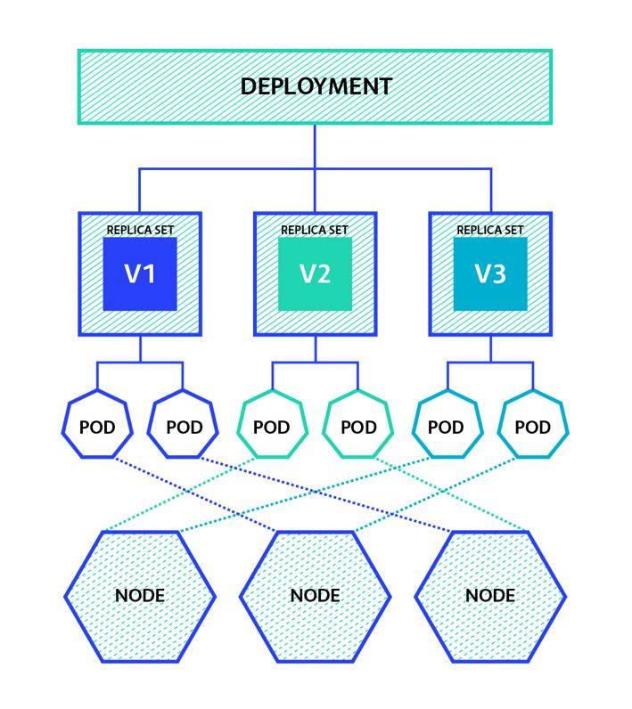
Deployment
Run and maintain a specified number of application pods.
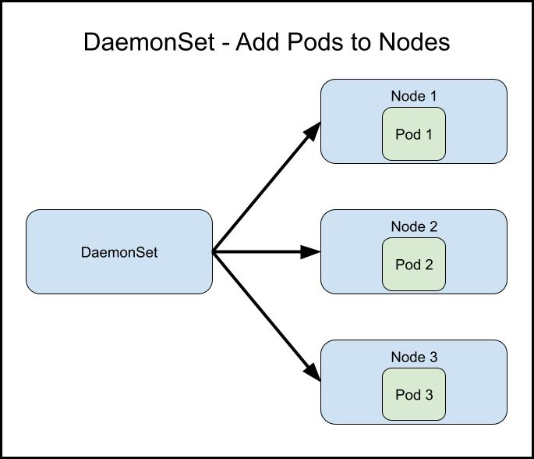
DaemonSet
Run a copy of a pod on every eligible worker node.
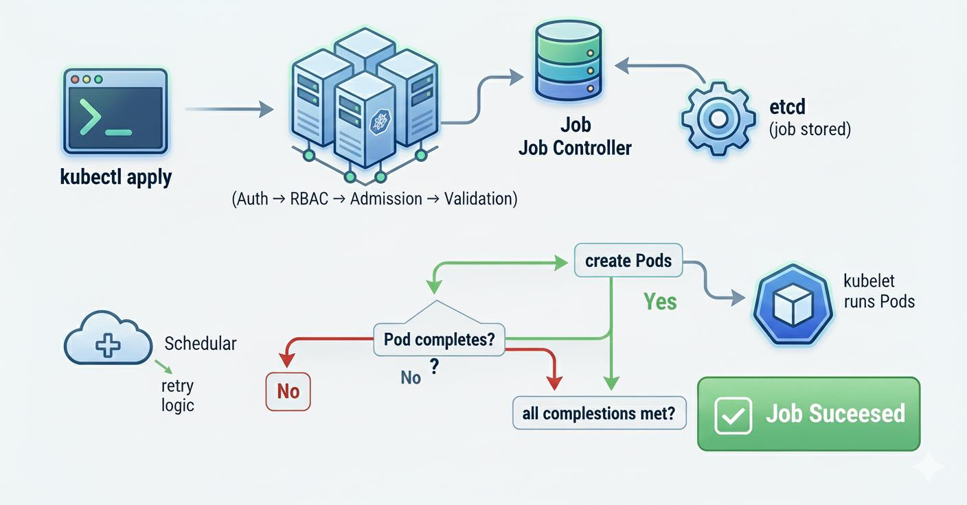
Job
Run pods to complete a specific task.
Key Takeaways
- Deployment: Best for applications that need to keep running.
- DaemonSet: Best for background agents that need to run on every eligible node.
- Job: Best for tasks that run until completion.
- Deployments support rolling updates, helping applications upgrade without downtime.
- DaemonSets automatically adjust when eligible nodes are added or removed.
- Jobs are useful for batch processing and one-time tasks.
Main lesson: Kubernetes provides different ways to manage pods depending on your workload. Use Deployments for applications, DaemonSets for node-level services, and Jobs for tasks that need to finish.

