Running Stateful Workloads in Kubernetes
In this lesson, we learn how Kubernetes handles applications that need to store data, such as applications connected to databases.
Previously, we deployed a stateless application, meaning it didn't need to store persistent data or communicate with a database.
Now we explore how to run stateful applications that need data to remain available even when pods are deleted or replaced.

1. What Is a Stateful Workload?
A stateful application needs to store and maintain data between application restarts.
Examples include:
- Databases (PostgreSQL, MySQL).
- Banking applications.
- E-commerce applications.
- Applications that store user information.
Important difference:
- Stateless application: Doesn't depend on persistent local data.
- Stateful application: Needs persistent storage to retain important data.

2. Two Ways to Handle Data Storage in Kubernetes

Option 1: Use an External Database
You can connect your Kubernetes application to a database running outside the Kubernetes cluster.
For example, your application runs inside Kubernetes while PostgreSQL runs on a separate server or managed database service.
Examples of managed database services:
- Amazon RDS
- Azure SQL
- Google Cloud SQL
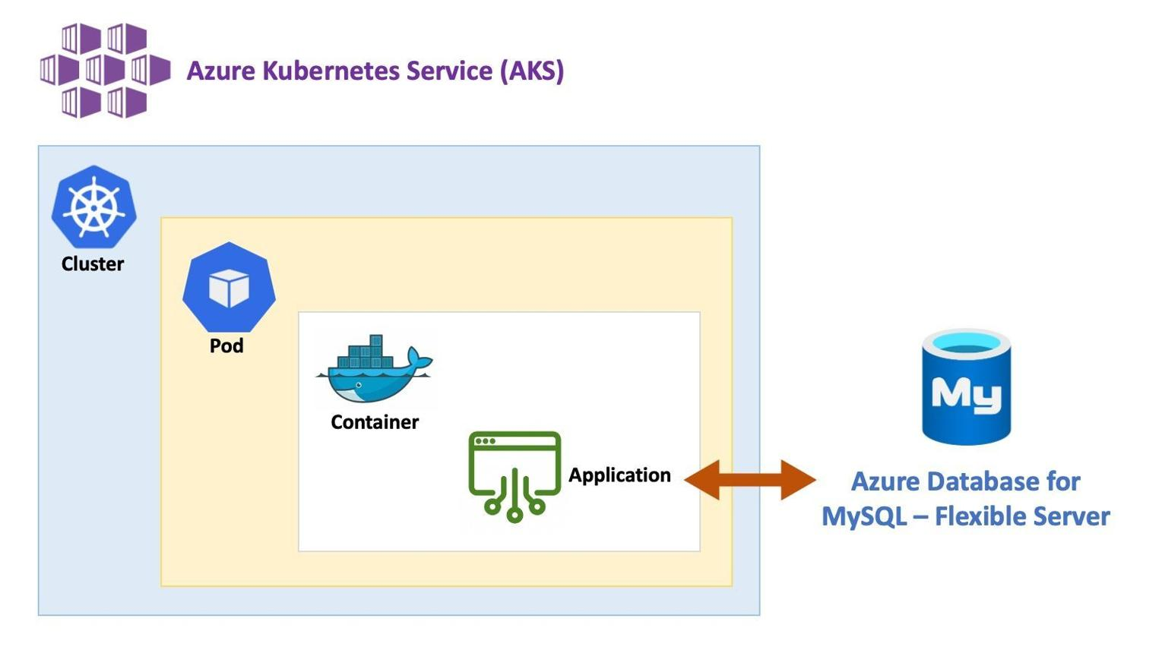
Advantages:
- Database storage is independent of Kubernetes pods.
- Database management can be handled by a cloud provider.
- Application pods can be replaced without deleting database data.

Option 2: Use Kubernetes Persistent Volumes
A Persistent Volume (PV) is storage that exists independently of an individual pod.
This means:
- Data can remain available after a pod is deleted.
- A replacement pod can access the existing data.
- Applications can retain important information between restarts.
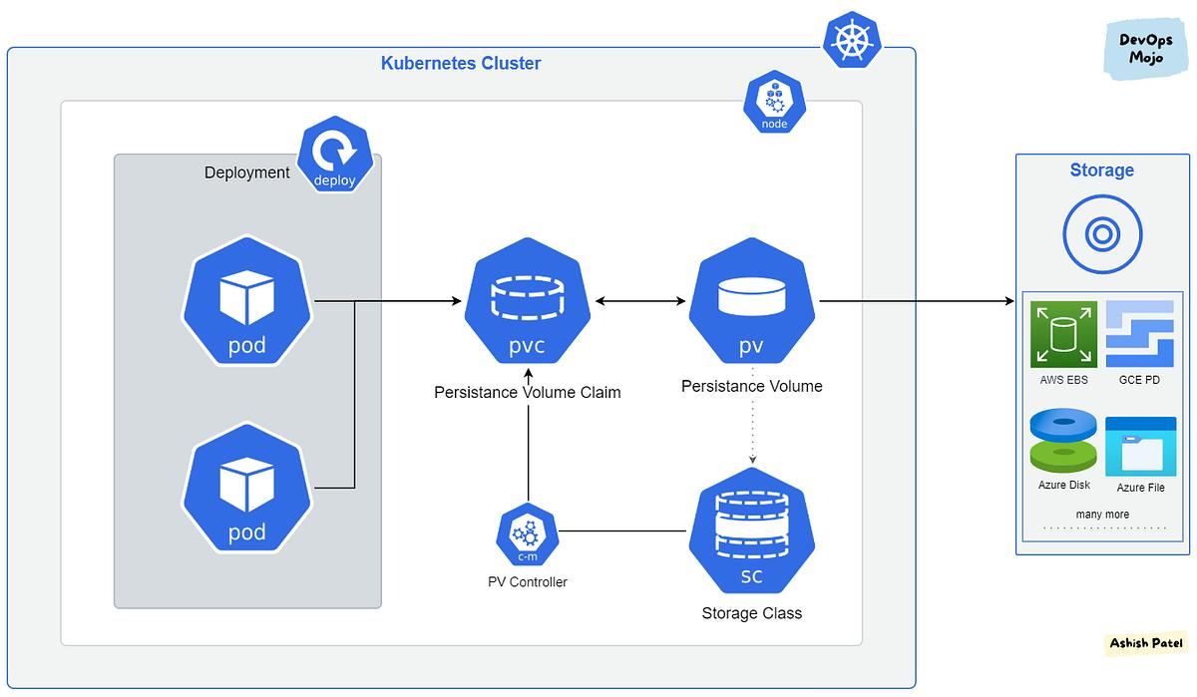
Kubernetes also provides an object called a StatefulSet.
A StatefulSet helps manage stateful applications by providing:
- Stable pod identities.
- Predictable pod creation and deletion.
- Persistent storage associations for individual pods.
This allows replacement pods to reconnect to their previously associated storage when configured correctly.

3. External Database vs. Persistent Volume
Feature | External Database | Persistent Volume
Storage location | Outside Kubernetes | Storage managed through Kubernetes
Data persistence | Managed independently | Survives pod deletion
Database management | Separate server or cloud provider | You manage the database workload
Common use | Production databases | Stateful applications inside Kubernetes

4. Important Kubernetes Terms
Term | Meaning
Stateless | Application doesn't depend on persistent local data
Stateful | Application needs persistent data
Persistent Volume (PV) | Storage resource that exists independently of a pod
Persistent Volume Claim (PVC) | A request for persistent storage
StatefulSet | Manages stateful applications and their identities

Key Takeaways
- Stateful applications need persistent storage.
- Kubernetes pods can be deleted and recreated, so important data shouldn't rely on temporary container storage.
- External databases are one way to store application data.
- Persistent Volumes allow data to survive pod deletion.
- StatefulSets help manage applications that need stable identities and persistent storage.
- Managed database services include Amazon RDS, Azure SQL, and Google Cloud SQL.
Main lesson: There are two primary approaches to running stateful applications in Kubernetes: connect to an external database or use Kubernetes Persistent Volumes. StatefulSets help manage applications that need consistent identities and storage across pod replacements.

