
NEW GERMARY
HISTORY

John Smith
November 30, 2024

Contents
Setting the Environment 3
Never give UP and Light it UP 4
E 4 Mafia 6

Setting the Environment
Before diving into this tale, remember it's all fiction. None of it is true. In the Progressive Pull Terms and Conditions, there's a form we need you to sign before watching the video, confirming you understand this is purely fictional. In today's polarized climate, we get things can get heated. But relax, this is just a story from a multiverse, not based on any real individual. Buckle up and strap on your jetpack enjoy the ride!

In the beginning there was a little boy quietly observing the world with wide eyes, his thoughts dancing between curiosity and caution named Orion Refactor. He was born in the Midwest. In the Midwest, the cold weather is a unifying force. Everyone's geared up for the frosty conditions, with jumper cables, a box of sand in the trunk for added weight and tire traction, and MREs stashed for those lengthy, snowy trips. The brisk air creates a special bond, transforming strangers into friends.
He had an older sister called Karen, a Redneck, Blue Blooded, White Republican. She was a big supporter of Don the Con, who ran for president in a multiverse universe. Karen began her career as a waitress at a cozy, local diner known for its hearty meat and potatoes dishes. Later, she switched gears and found work in construction on the opposite side of town. She lost her job when migrants began moving into the community, wanting to work for lower wages and longer hours. She nostalgically recalls the days when the Rust Belt thrived, and you could simply stroll down the street, apply at the local factory, and secure a high-paying union job. Those days are long gone, but she yearns for their return. After losing her low-paying construction job, she bounced from one temporary position to another, but none of them lasted very long.
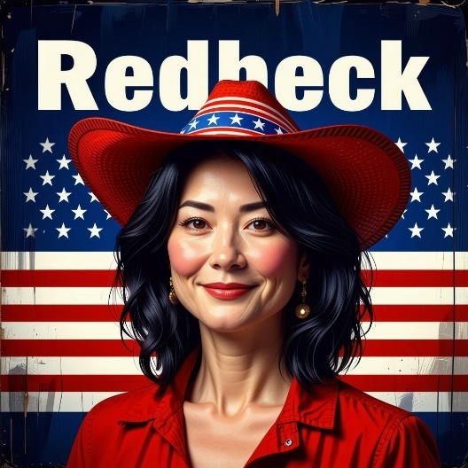
Orion was born with childhood dyslexia, but not the visual kind that most people think of, where letters are jumbled and difficult to see. Instead, he had auditory dyslexia, meaning his brain doesn't process sounds properly. This is often misunderstood by many. People would often joke about their own mistakes, claiming their dyslexia was acting up. To Orion, however, these jokes weren't funny after a lifetime of living and struggling with this learning disability. Throughout his life, he was diagnosed multiple times.
When he joined the military, they had him retake the ASVAB test and gave him an extensive reading comprehension test. He didn't perform well, so they placed him in the Dyslexia Train Section, where he spent an additional three months in boot camp. During the day, they subjected him to rigorous physical training. In the mornings, drill sergeants would sprint across the grinder, yelling at recruits and making them do push-ups.

Whenever the recruits spotted the sergeants approaching, they would immediately drop into push-up positions. The drill sergeants administered the reading comprehension test after two weeks of boot camp. Some recruits believed that failing the test would result in their dismissal and an early trip home. They didn't fully understand what lay ahead. After Orion failed the test, he was reassigned to a new company to attend phonics classes in the evenings. Following the phonics courses, the instructors retested the recruits, who generally achieved significantly higher scores on the final test. The training was deemed remarkably effective by the teachers. However, Orion's test results remained unchanged, as he scored the same as before.

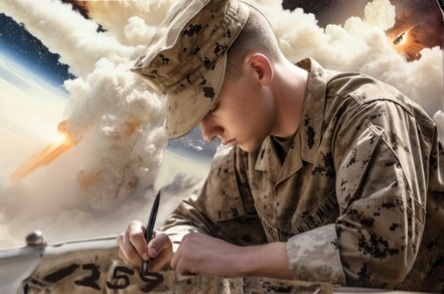
Never give UP and Light it UP
After completing the dyslexia training section, Orion was placed in a holding unit until he could be assigned to a new company. Each time Orion entered a new unit, he would stencil his uniform. After being assigned to a unit, the drill sergeant would come with liquid paint and a stencil card to mark Orion's uniform with the unit's number. Over time, his uniform accumulated several different company numbers as he moved from holding unit to holding unit before finally reaching his graduating unit. Upon arrival, the drill sergeant remarked, "Old man, you've been here a long time. We've got to get you graduated."
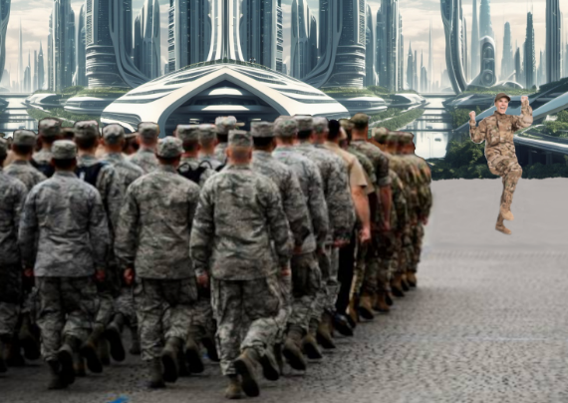
In the Navy, it was a tradition to give recruits nicknames to boost morale. Orion became known as "Old Man." There was another recruit who looked like Rocky, so they nicknamed him Rocky. When morale was low, the sergeant would call, "Rocky, front and center!" Rocky would run to the front and shout, "Adrian, Adrian!" Another recruit arrived in a suit and tie, earning the nickname "Corporate Bob." When the drill sergeant called, he'd run out and shouted, "Give me the money, give me the money!"
The Old Man would be called to the front and center by the drill sergeant. When he got to the front of the unit he would shout, "Light them up, never give up!" The soldiers would respond with chants of

"Yes, yes, yes, light them up, never give up!" This routine was all in good fun and kept morale high during grueling days of training. During training day at the enlisted military college, the soldiers would learn the soldier’s creed which the tired warriors would sing before hitting the rack, combat tactics, and story about Ivan, their Soviet enemy. Drill sergeants would come to the front of the classroom and yell what makes the grass grow green. The recruits would respond back “Ivan's blood, Ivan’s blood”.

The drill sergeants used a variety of methods to motivate the soldiers. One soldier, who struggled with the swimming portion of the training, was waiting in line at the diving board with the others. The soldiers were required to jump into the pool and swim across in full combat gear. Observing this anxious soldier flapping his arms like a bird at the pool's edge, Old Man asked, 'What are you doing?' The soldier replied, 'I'm practicing swimming. This is my third attempt, and I must pass this part of the training...or else.'"
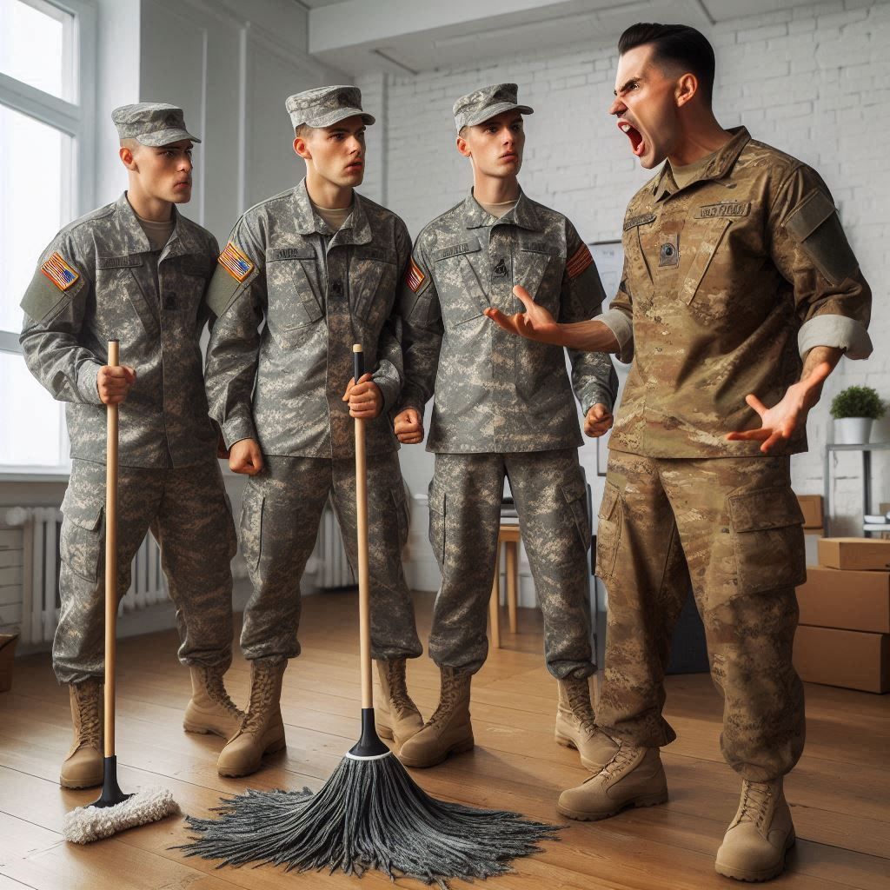
The phrase "or else," especially when used by a drill sergeant, always struck fear into the hearts of recruits. Drill sergeants often used various phrases, such as "I've got something for you later." Another tactic they employed was catching trainees misbehaving. They would scold them, make them do push-ups, and then walk away. Five minutes later, they would wait around the corner and return to see if they could catch the trainees again, ensuring they spent more time in the dirt.

At the training facility, the old man had mastered all the tactics and never got caught doing anything wrong. Because of this, the drill sergeants began to like him and showed him respect. Orion, never one to give up, always pushed through despite the challenges, determined to get the GI Bill and go overseas. Orion saw his way of getting out of small-town America. In America, there are two distinct groups: those who live in big cities and attend college, and those who reside in small, rural areas and graduate from high school. Orion was acutely aware of this divide.

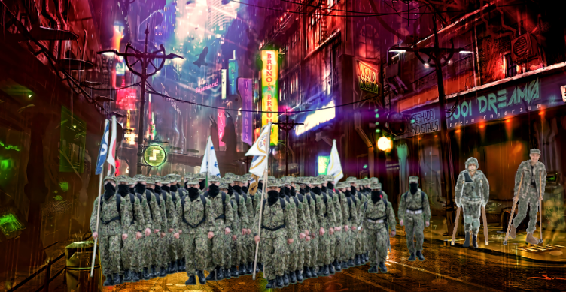
Some soldiers tried to escape the military by faking injuries. Marching ahead were the able-bodied soldiers but trailing behind them were the ones known as the "disabled." You could see these soldiers following with crutches, bandages, and various signs of injury, forming a distinct group at the rear. Over time, there was an epidemic of "whiplash," with soldiers claiming it to get discharged. The drill sergeants were baffled by the sudden outbreak, humorously questioning its contagious nature.

E 4 Mafia
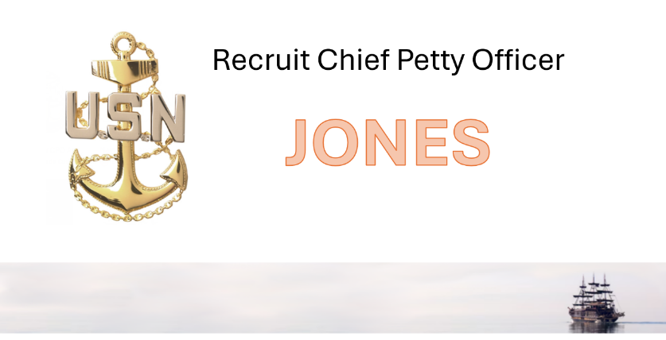
As I pen this chapter, I find myself reflecting deeply on this part of the book from a writer's perspective. Will readers question its truth? To be honest, none of what I write is rooted in truth. It's a blend of various ideas and inspirations. The grand event where everyone learns if they've been selected for a special assignment. The Chief Drill Sergeant announces each name, and as the recruits come forward, they receive a plaque engraved with their rank and signature.
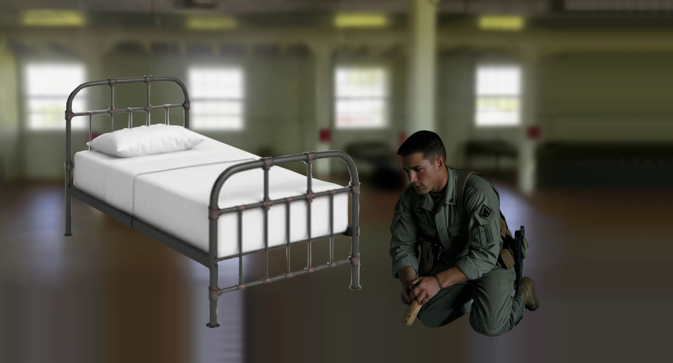
The recruit arrived at boot camp sharply dressed in a suit and tie. Recognizing his potential, they appointed him as the Recruit Chief Petty Officer. In honor of his new position, he received a plaque adorned with a golden anchor. The plaque proudly bore the inscription, " Recruit Chief Petty Officer Jones" in bold letters, ready to be displayed at the end of his bed. Jones's primary duty was to call out all the commands while leading the formation as we marched across the grinder. And, naturally, he had to shout, "Show me the money!" whenever the drill sergeant called for it.
The company recruits held Orion in high regard. When he joined the previous company, his hair was transitioning from a crew cut, and his sunburned face gave him a seasoned, battle-hardened appearance. His willingness to assist and mentor the other recruits earned him their admiration. Even the drill sergeants recognized his leadership qualities. The Chief Drill Sergeant appointed him as Recruit Yeoman, a role of significant responsibility and respect, within the deeply hierarchical traditions of the Navy fleet.

