

Sit With Git By John Smith Smith



Contents
Introduction 2
Basic Git Commands 3
Initialize Git Repository (git init) 3
What is the Staging Area in Git (git add) 3
How to Rename and Remove file (git mv and git commit) 4
Shows you a list of files in your repository (git ls-files) 5
Configuration Variables (git config) 5
Review the files to be committed and which are not (git status) 6
Introduction of Branching and Merging 9
Lists all branches (git branch) 10
Creates a new branch (git branch <branch-name>) 10
Switches to the specified branch (git checkout <branch-name>) 10
Delete Branch (git branch <branch-name> -D) 11
Merges the specified branch into the current branch (git merge <branch-name>) 11
Merge Folder 11
GitHub Branches 12
Cloning HelloWorld from GitHub 13
Git Merge Example 15
Git Commit Example 16
Delete Branch Example 16
Sourcetree 17
Add or Clone Repository 17
Add Repository 17
Clone Repository 18
Overview of File Status, History, and Search 18
Search 18
History 19
File Status 19
References 19

Introduction
Git is a distributed version control system that allows multiple people to work on a project simultaneously without overwriting each other's changes. It was created by Linus Torvalds in 2005 and has since become an essential tool for developers.
Every developer has a complete copy of the repository, including its history, on their local machine. This ensures that the project is not dependent on a central server and reduces the risk of data loss.
Git supports powerful branching and merging capabilities, allowing developers to work on different features or fixes simultaneously. Branches are lightweight and easy to create, which encourages experimentation and parallel development.
Before committing changes to the repository, developers can add files to a staging area. This allows them to review and selectively commit changes, providing greater control over the project's history.
Git maintains a history of all changes made to the repository. Each commit is identified by a unique hash, and developers can view the history to track changes, revert to previous states, and understand the evolution of the project.
Git enables collaboration through remote repositories hosted on platforms like GitHub, GitLab, and Bitbucket. Developers can clone repositories, push and pull changes, and collaborate on code through pull requests and code reviews.

Basic Git Commands

Initialize Git Repository (git init)
The git init command creates a hidden directory named .git inside your current directory. This directory contains all the necessary files and subdirectories that Git uses to manage and track changes in your project. The .git directory includes subdirectories for objects, refs, and template files. It also creates essential files like HEAD, config, and description.
Simply type the following command to initialize Git repository and press enter:
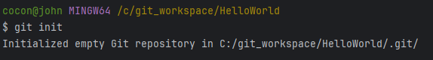

What is the Staging Area in Git (git add)
The staging area is a file, generally contained in your Git directory, that stores information about what will go into your next commit. It allows you to review and control changes before they are committed.
Stage a File: To stage a specific file, run:
Stage All Changes: To stage all changes at once, you can use:

How to Rename and Remove file (git mv and git commit)
First, you need to initialize and stage the file in the Git repository. This command essentially stages the changes required to rename or move the file, and then you can commit those changes to the repository. For renaming, it's a simple two-step process:
- Rename or move a file or directory within a Git repository.
• git mv: This is the command to rename or move a file in the Git repository.
• old_file_name: This is the current name or path of the file or directory you want to rename or move.
• new_file_name: This is the new name or path for the file or directory.

- Commit the changes.
• git commit: This command is used to commit your staged changes to the repository. A commit captures a snapshot of the project's currently staged changes.
• -m: This flag specifies that the commit message will be provided directly in the command line, rather than opening an editor.
• “Renamed file": This is the commit message. It describes the changes that are being committed. In this case, it indicates that a file was renamed.
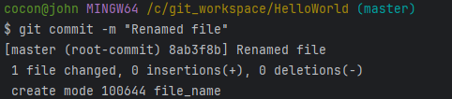

For removing a file:
- Use the following command to delete the file.

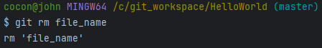

- Commit the removal.

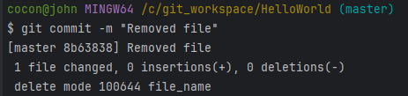

Shows you a list of files in your repository (git ls-files)
Git ls-files is like Git's inventory checker. It shows you a list of files in your repository that Git knows about. This includes tracked files, which means files that are part of your Git history, and optionally, files that would be excluded by .gitignore. It's super handy to get a quick overview of what's in your repo.
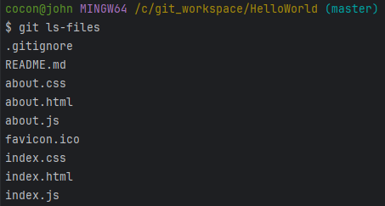

Configuration Variables (git config)
- To check the variables configured in Git, you can use the following command:

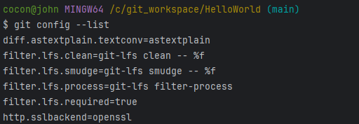
- To set the username in the configuration file for commits, you can use the following command.

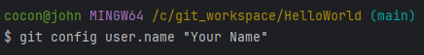
- To set the email in the configuration file for commits, you can use the following command.
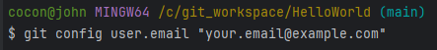

Review the files to be committed and which are not (git status)
The git status command is a fundamental tool for understanding the current state of your Git repository. When you run git status in your terminal, it provides a detailed report on the following:
- Changes to be committed: These are modifications that have been staged using git add and are ready to be committed to the repository.
- Changes not staged for commit: These are modifications that have been made to tracked files but have not yet been staged.
- Untracked files: These are files that are not currently being tracked by Git and haven't been added to the repository.
In summary, git status helps you keep track of your progress and understand what changes have been made, which ones are ready to be committed, and which ones still need to be staged or committed.
We begin with nothing being staged, meaning no files have been put into the staging environment. Staging is where you place code that is waiting to be pushed to a remote server like GitHub. You'll see that your main branch is up to date with no pending commits.
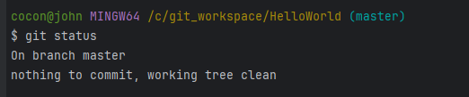
Next, I updated the Navigation Bar on the Index Page by adding a link to the new About Page. Then I copied the About files into JetBrains WebStorm.
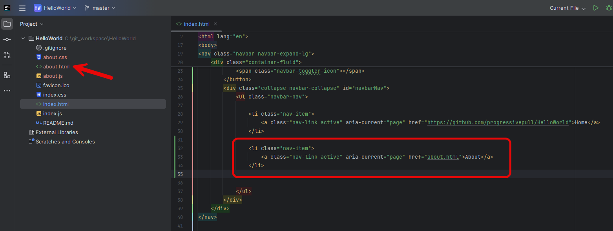
After saving all changes, I check the status again. This time, the status indicates that the Index file has been modified, but no changes have been staged for commitment. This means I haven't yet placed the files into the staging area to prepare them for commitment to my remote repository.
In Git, an untracked file is a file that exists in your working directory but hasn’t yet been added to the repository’s tracking system. Essentially, Git is unaware of this file. Untracked files are typically new files that you've created but haven’t yet added to version control. The three About Files are untracked.
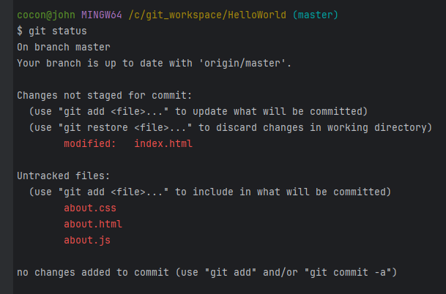
I staged the index file but not the about files.
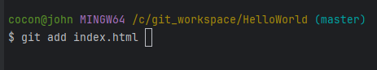
Observe that the index file is highlighted in green. This indicates that the file has been moved into the staging environment, but it has not yet been committed.
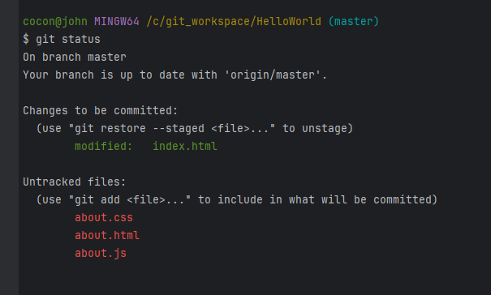
Finally, I commit whatever has been staged, which in this case is the Index file. The About files remain untracked.
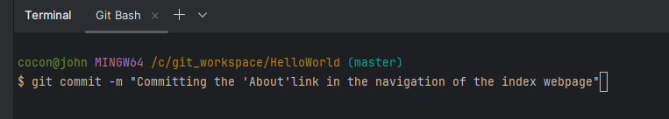
Checking the status once more, it confirms that changes to the About files have still been untracked.
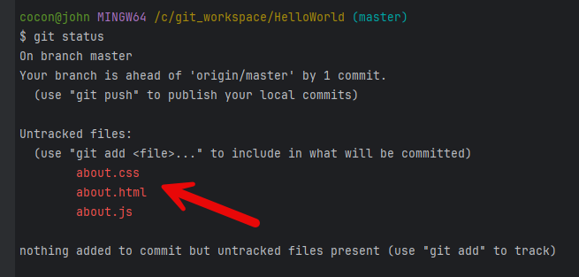
I stage all the About files command, where the asterisk () means to commit all the files.
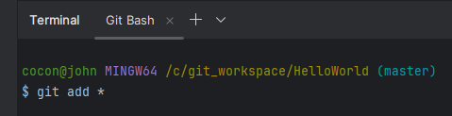
Now, I check the status again to see all the files are staged.
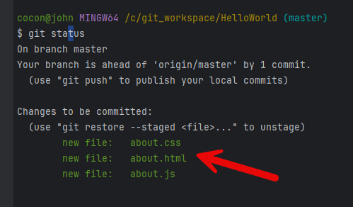
After staging the files, I commit them.
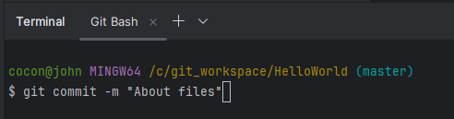
You'll notice that I am two commits behind the main branch on the GitHub remote. This is because I made two separate commits: one for the Index file and another for the About files. That’s why I'm behind two commits.
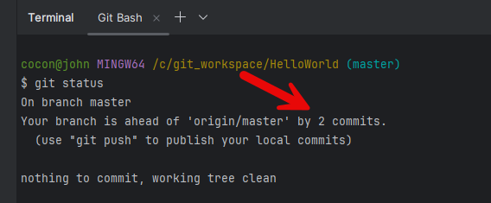

Introduction of Branching and Merging
A git branch is a key feature in Git, a version control system used by developers to manage and track changes in their code. Think of a branch as a separate line of development that diverges from the main project. This allows you to work on new features, bug fixes, or experiments without affecting the main codebase.

Lists all branches (git branch)
By typing git branch without any arguments, you can see a list of all the branches in your repository. The current branch will be highlighted with an asterisk (*) next to its name.
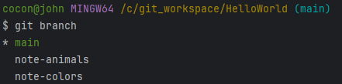

Creates a new branch (git branch <branch-name>)
You can create a new branch by specifying the branch name after the git branch command. The command git branch temp-animals will create a new branch in your Git repository called temp-animals.
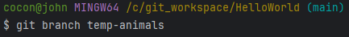
The current branch is the main, not temp-animals.
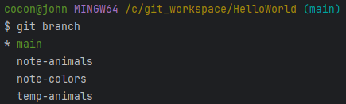

Switches to the specified branch (git checkout <branch-name>)
In Git, the checkout command is used to switch between branches or restore working tree files. When you use git checkout temp-animals, you are switching your working directory to the branch named temp-animals.
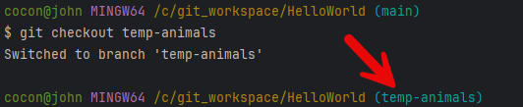

Delete Branch (git branch <branch-name> -D)
The command git branch <branch-name> -D is used to delete a branch in Git forcefully. Here’s a breakdown of the command:
- git branch: This is the Git command used to manage branches.
- <branch-name>: This is a placeholder for the name of the branch you want to delete.
- -D: This flag is used to forcefully delete the branch, even if it has unmerged changes.
For example, if you have a branch named temp-colors that you want to delete, you will use the command git branch temp-colors -D. This will remove the feature-x branch from your repository, even if it has changes that haven't been merged into any other branch.
Keep in mind that using the -D flag can be risky, as it will permanently delete the branch and its changes, so be sure you no longer need it before running this command.
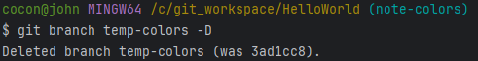

Merges the specified branch into the current branch (git merge <branch-name>)
I've created a playground on GitHub that you can freely clone. Avoid modifying the main, note-animals, or note-colors branches. Instead, create temporary branches in your local git playground to practice git merging.

Merge Folder
I start out with this example by adding a new folder called "merge." In the "merge" folder, I have two folders. One folder is called animals, and the other is called colors. Both folders contain a file named note. You can use the Note file to practice merging.
The Animals folder contains a note file, and at the bottom, there is a list of animals.
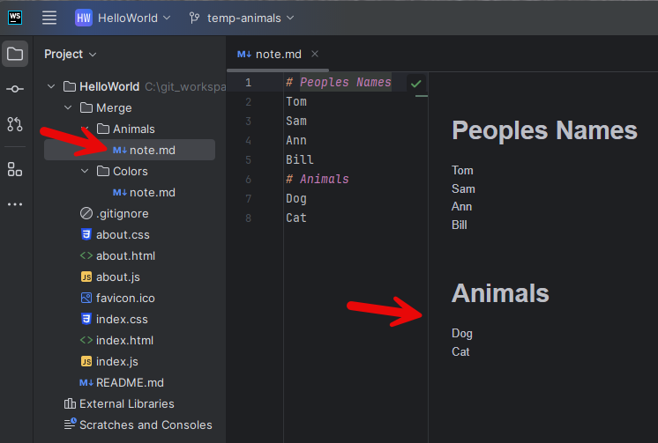
The Colors folder contains a note file, and at the bottom, there is a list of colors.
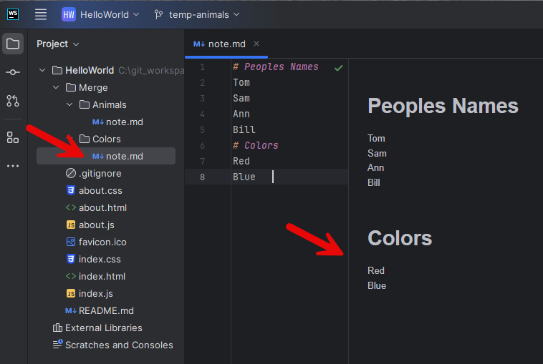
We're going to create two branches and then merge them to demonstrate how to deal with conflicts.

GitHub Branches
Go into my GitHub site and access the HelloWorld repository. You'll notice I have three different branches here.
- The Main Branch has the "Merger" folder in it, but it doesn't have the notes file.
- The note-animals branch does have the notes file, and at the bottom, it has the animal information.
- The note-colors branch has a notes file with colors at the bottom of the file.
So, to summarize:
- The main branch does not have the notes file.
- The note-colors branch has the notes file with colors.
- The note-animals branch has the notes file with animal information at the bottom.
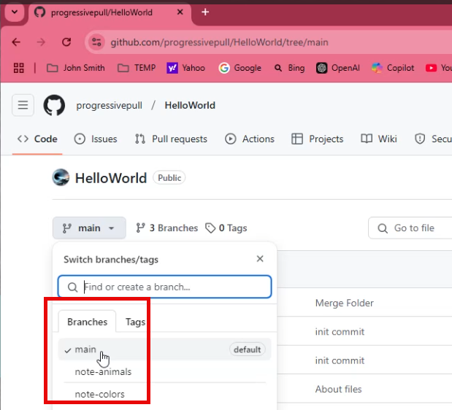
These are the three branches I have set up.

Cloning HelloWorld from GitHub
Now, let's clone this repository. The first step is to run git clone and get the clone URL from GitHub. Once we have the clone URL, we'll paste it into our terminal and clone the repository.
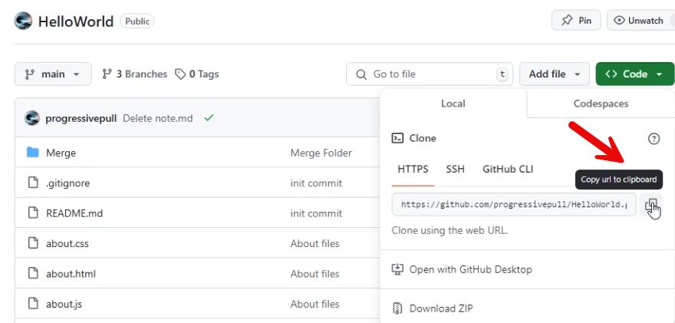
https://github.com/progressivepull/HelloWorld.git

After cloning, if you run git branch, you might notice there's no repository here because we need to change directories into the "HelloWorld" folder. That's a common mistake.
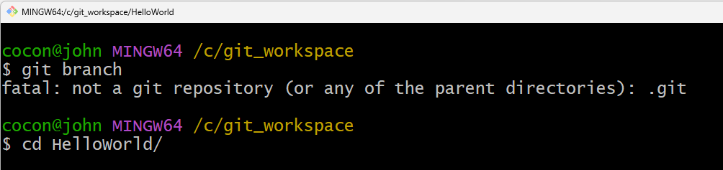
Once inside the "HelloWorld" directory, the running git branch will show that there's only one local branch.
To view remote branches in GitHub, use git branch -r.
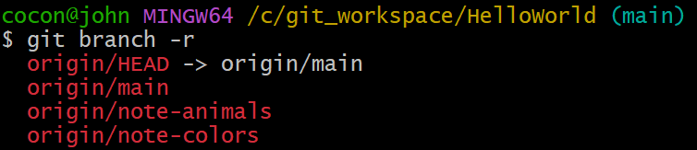
To check out a specific branch, such as the note-animals branch, use git checkout note-animals. Repeat this process for other branches like "notes-colors" by using git checkout notes-color.
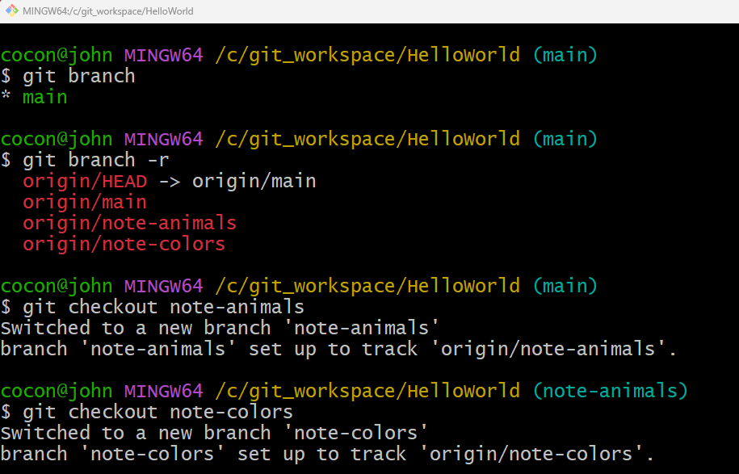
The git branch will show all branches on your local machine after checking out all branches.
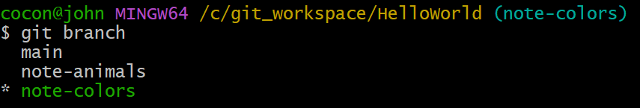
To avoid modifying any of the three branches directly, I'll create a temporary branch for practice. In the terminal, switch to git bash (the preferred environment). Assuming you're on the "notes-color" branch, create a temporary branch with git branch temp-colors.
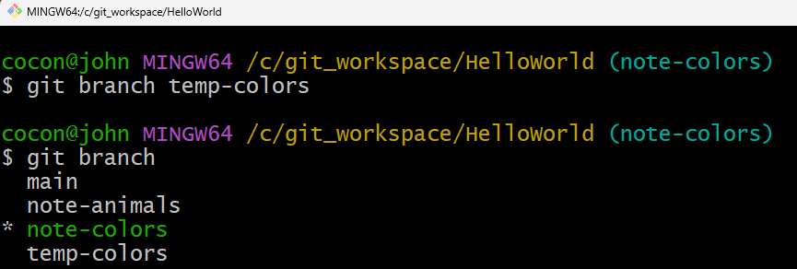
Switch to the new branch using git checkout temp-colors. Now, to practice merging, try merging the "notes-animal" branch into "temp-colors" with git merge notes-animal.
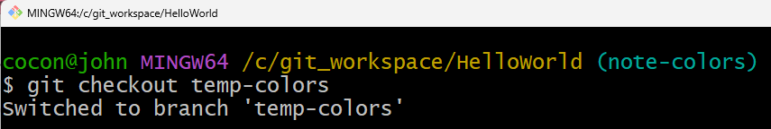
Let's open JetBrains WebStorm. Different editors handle Git merge operations uniquely, which is why I'll be using WebStorm for this demonstration.
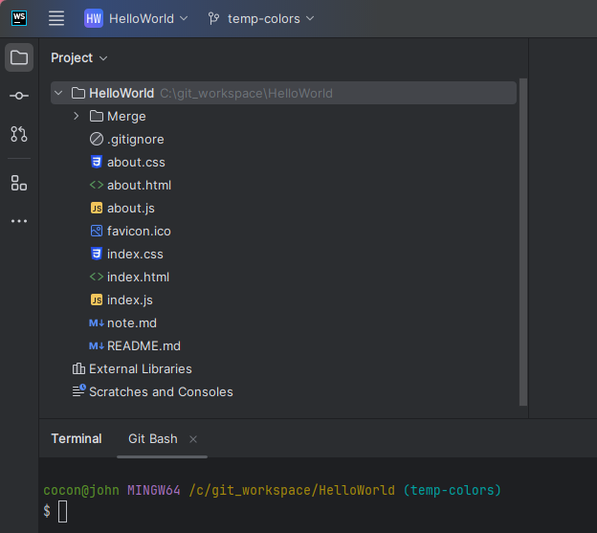

Git Merge Example
If you examine it, you'll see that you're currently on the temp-colors branch. This is your active branch, and you want to merge it into their branch, which is the notes-animals branch.
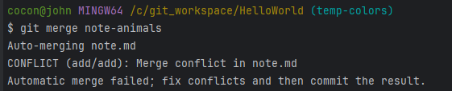

You can review the merge conflict by opening the note.md file.
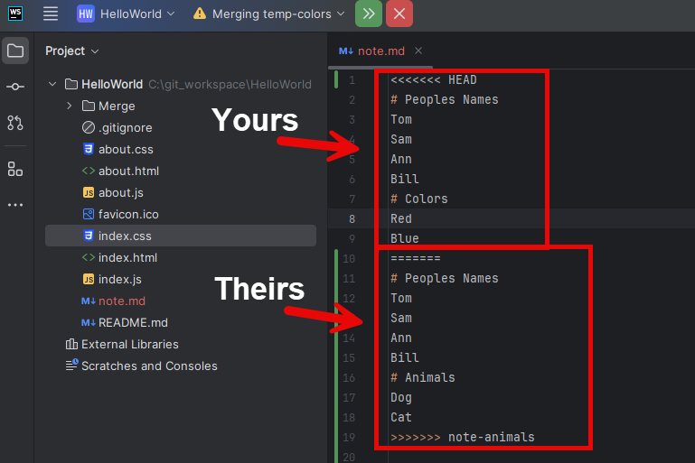
If there's a conflict during the merge, Git will prompt you to resolve it by accepting either "Accept Yours" or "Accept Theirs". You can abort the merge operation.
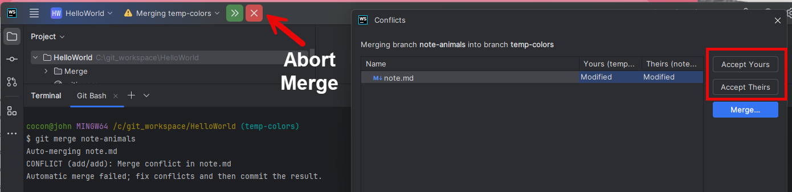

Git Commit Example
Accept the appropriate changes staging with git add * and then commit them with git commit -m "Committing changes after the merge".
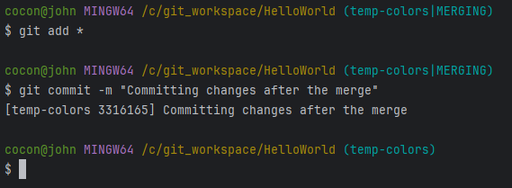

Delete Branch Example
Once you’re done practicing, you can delete the temporary branch with git branch temp-colors -D. Before deleting temp-colors must change to another branch. This allows you to continue practicing in a safe environment without affecting the original branches.
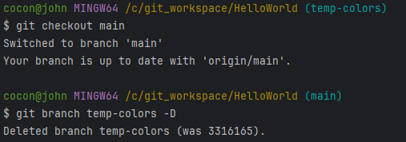

Sourcetree

Add or Clone Repository
Let's start with Sourcetree. Open Sourcetree, where you have two options: add a local repository or clone one from a cloud-based server like GitHub.
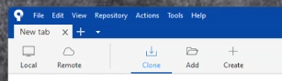

Add Repository
Once you clone the repository using a tool like GitHub Desktop, you can open the codebase with the Add feature.
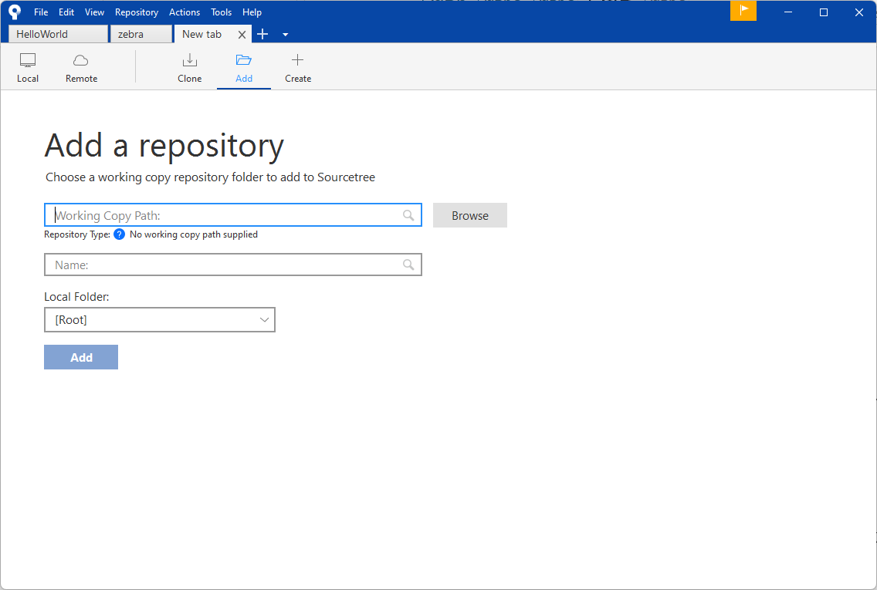

Clone Repository
We'll begin with cloning one. Copy the URL into Sourcetree and give it a name. Create a folder to save the code you download from the Git repository.
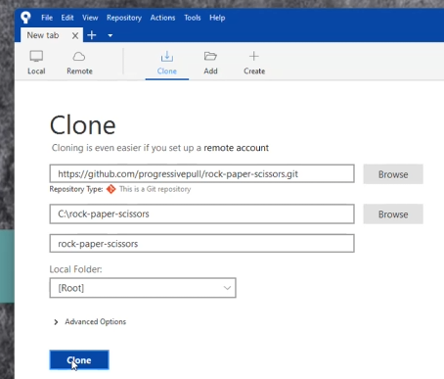

Overview of File Status, History, and Search
In the Workspace Menu you can check the status, view the history, and search for commit messages.
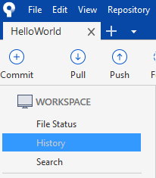

Search
By selecting the search area, you can type the name of the author in the search bar and then you can pull up all the commit done by the author.
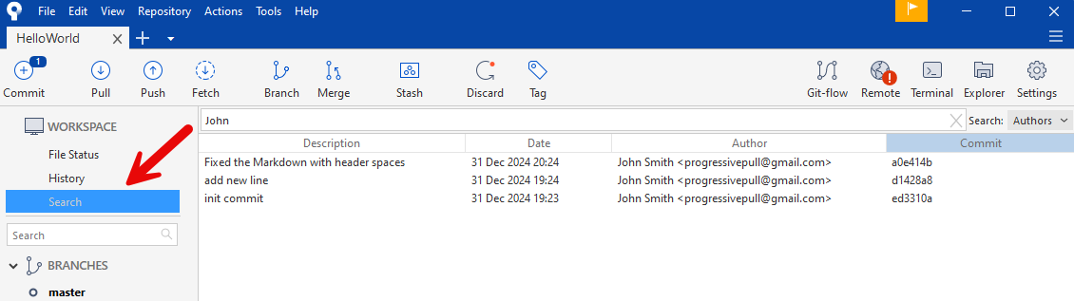

History
By choosing 'History' in the Workspace, you can view all changes along with their corresponding commit messages.
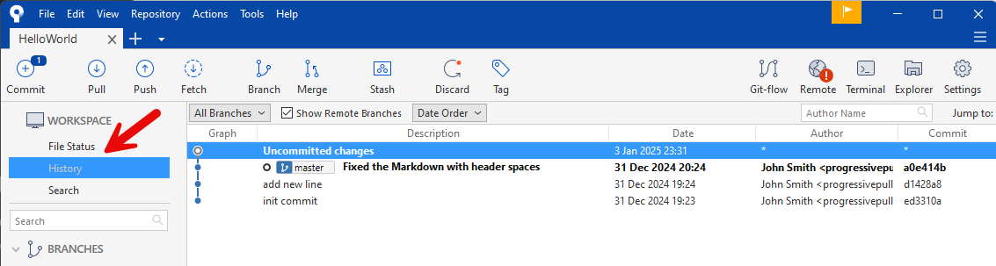

File Status
To commit in Sourcetree, stage your file changes first, then add a commit message and make the commit. New changes will be highlighted in green, and modified parts in pink, showing what's been added or removed.
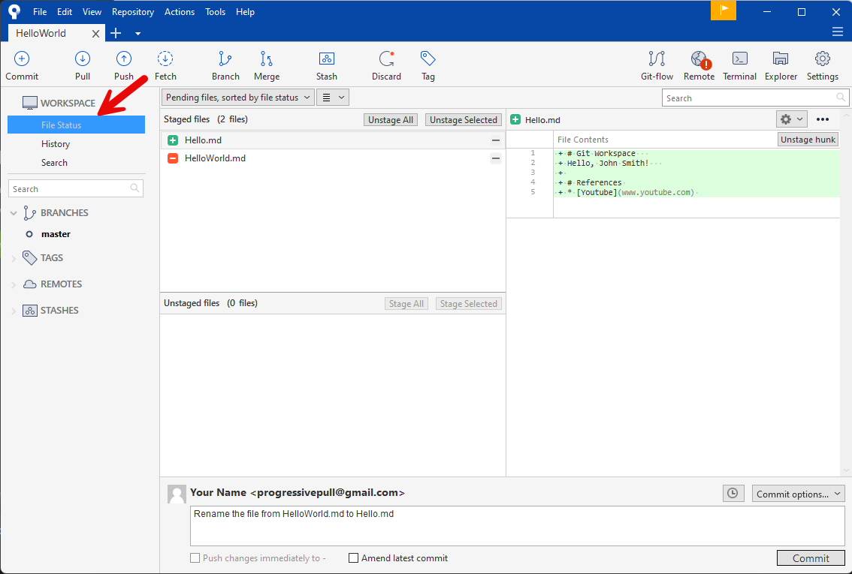

References
- Get started with Sourcetree - Sourcetree Support
- Git Official Reference Documentation
- GitHub tutorial - Cameron McKenzie - YouTube

