TO
JAY KHEMKA

EXECUTIVE SUMMARY & SYSTEM HIGHLIGHTS
PolyStock is a dedicated on-premise Inventory, Godown, and Billing management software. It provides instant offline billing, real-time dual-unit stock calculation (Bags & Loose Kg), and ledger reconciliation with zero recurring cloud mandates.
It will have modules like Purchase, Sales, Payments, receipts, Ledger reports of Party and Supplier
Godown wise stock tracking of Full and Partial bags
Reports on the basis of Headgroup, Brand, Size etc

POLYSTOCK
Inventory, Godown & Billing System& Ledger reports Software

COMMERCIAL PROPOSAL & PRICING (INR)
Package Edition | Features & User Capacity | Type | Base (INR)
PolyStock Single  Desktop only | 1 PC Standalone • Full Godown & Billing & Ledgers • 1 Yr Support | Perpetual | ₹ 42,000/-

COMMERCIAL TERMS & SUPPORT•  Payment: 50% advance with PO,  50% within 15days of implementation  Initial Development: 20days  Changes Within: 15days  Warranty & Support: 1 Year Free Remote Desktop Support (AnyDesk).•  Optional AMC After Year 1: 15% of total software cost | BANK REMITTANCE DETAILS•  Beneficiary: TAURAS TECHNOLOGY  A/C NO: 9202001302377  Branch: Deulasahi  IFSC: UTIB0006010  UPI: taurastechnology@axisbank

For TAURAS TECHNOLOGY  _________________________________  Authorized Signatory | Client Acceptance & Confirmation  _________________________________  Selected Edition: ____________ | Stamp & Sign

THE IMAGES ARE SAMPLES FOR YOU TO VIEW, WE CAN CHANGE AS PER YOUR FEEDBACK
LEDGER CREATION SCREEN
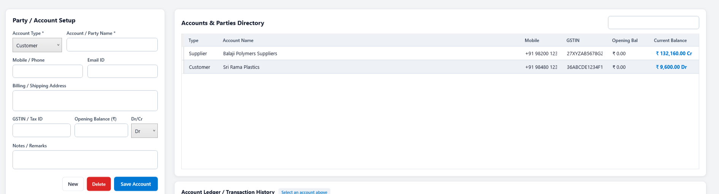

ITEM CREATION SCREEN
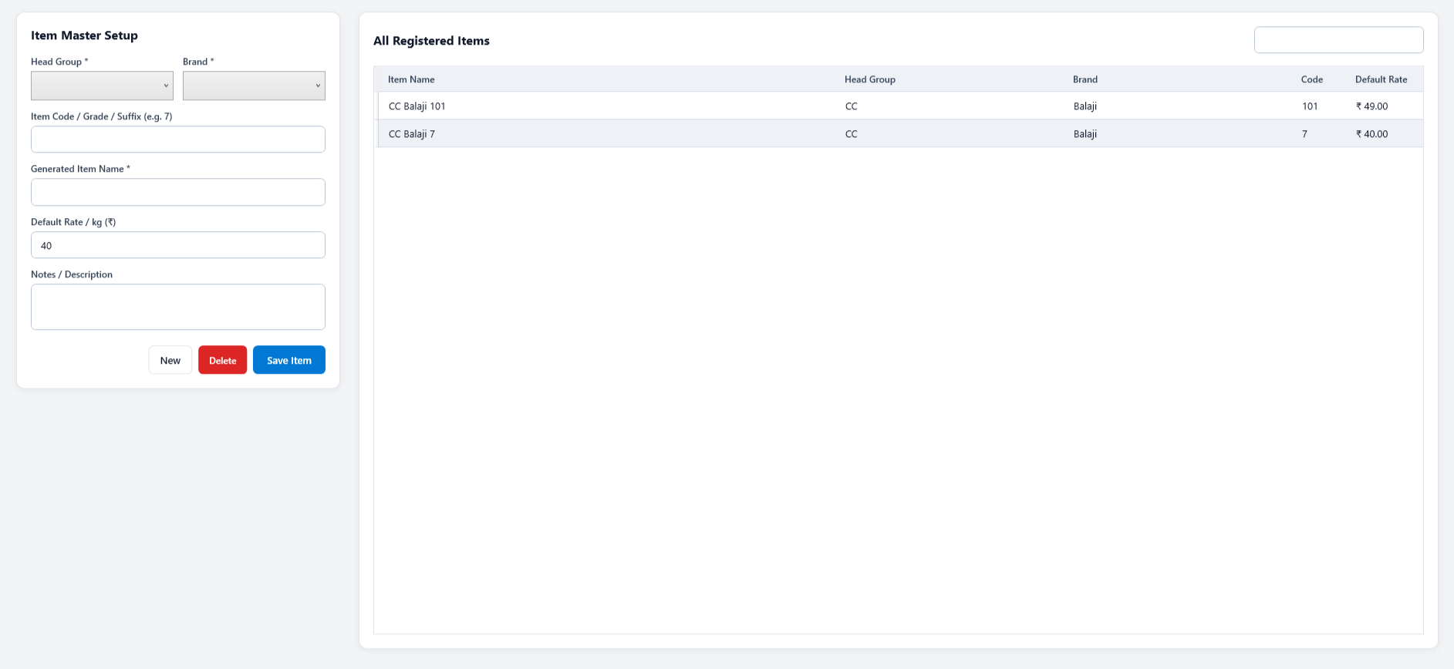

PURCHASE / INWARD
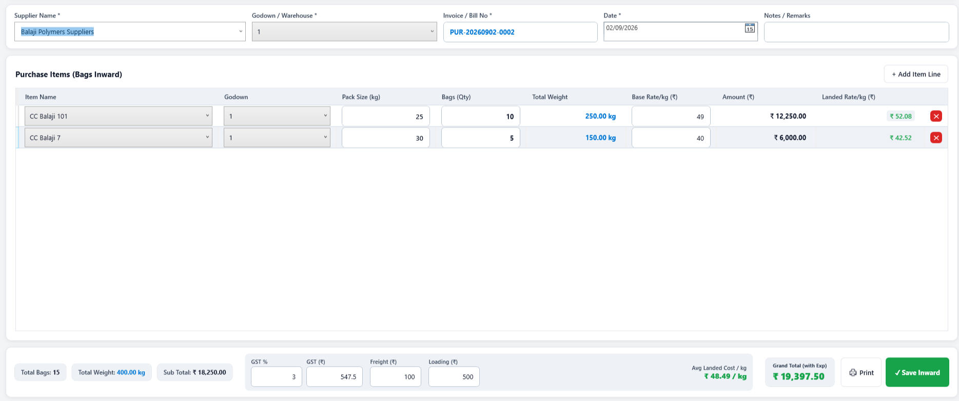

SALES / OUTWARD
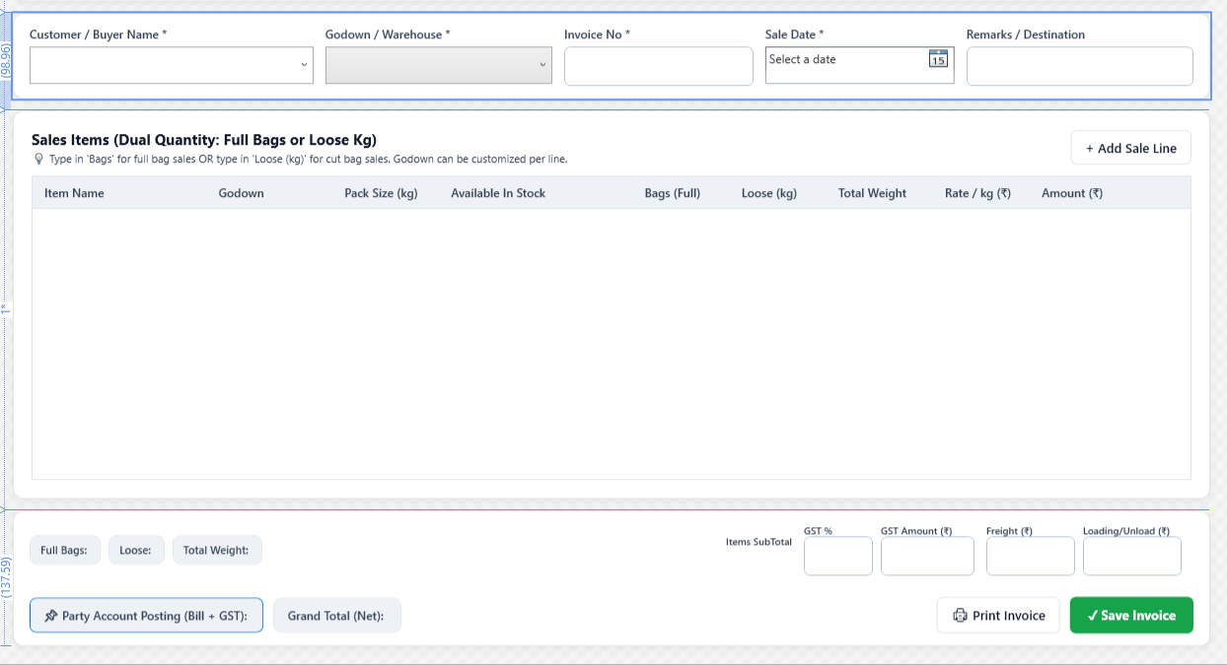
REPORT SAMPLES (SUMMARY)
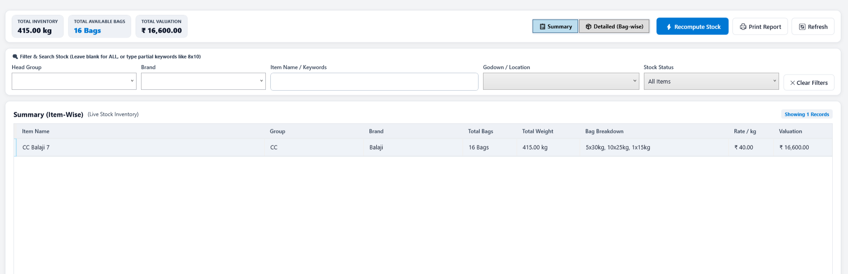

REPORT SAMPLES (DETAILED)


