Git-Tutorial

For the TU Graz Git server.

# Login

Login to <https://git.tugraz.at/repos/gitadmin/list.php> using your TU Graz login data.

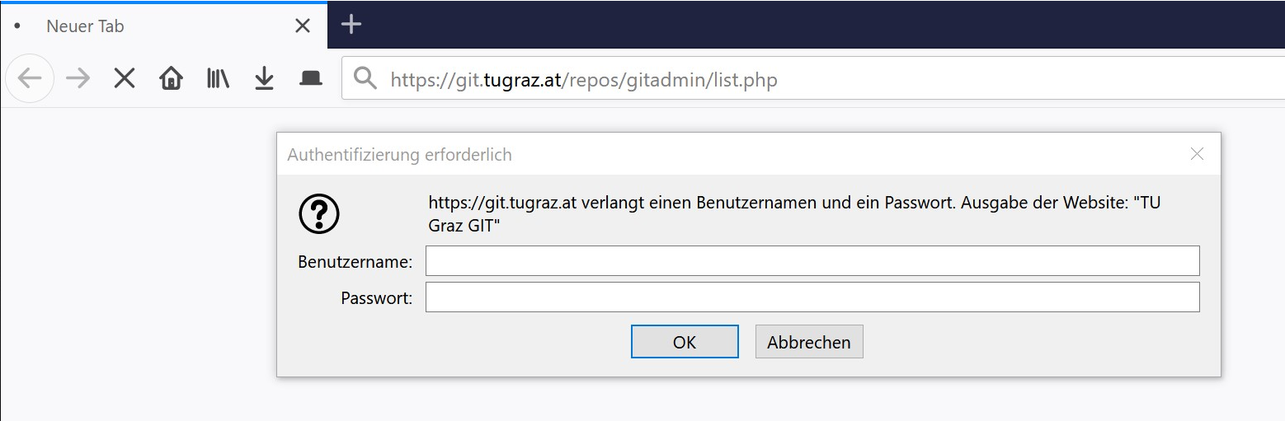

# Create Repository

Create your repository *using the naming convention given by the lecturer*. Klick submit.

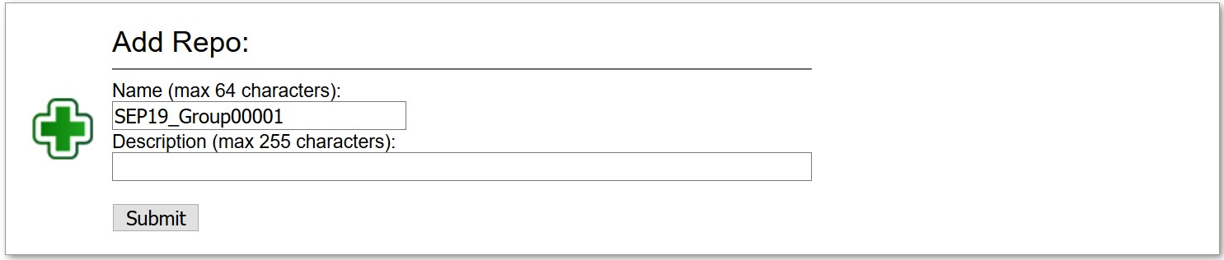

# Invite Members

Klick the spanner Modify to maintain the repository.

In the section “modify”, invite your colleagues by e-mail-address. Do not forget to invite your tutor!

# Clone Repository

On your command line, run *git clone* [*https://git.tugraz.at/SEP10_Group00001*](https://git.tugraz.at/SEP10_Group00001) using your TU Graz Online login.

# Git Commands

* git status – see status of your local repository, staged files, …
* git add – add files to the staging area to commit them later
* git commit -m “message” – prepare files to be pushed to server
* git push – push commits from your local to the remote repository
* git fetch – update references to remote repositories
* git pull – get changes from remote repository

For more information have a look at <https://git-scm.com/docs>.